LAB 8
Do the following questions using Company Sales Dataset(company_sales_data.csv)
Exercise 1:
Read Total profit of all months and show it using a line plot

OUTPUT:
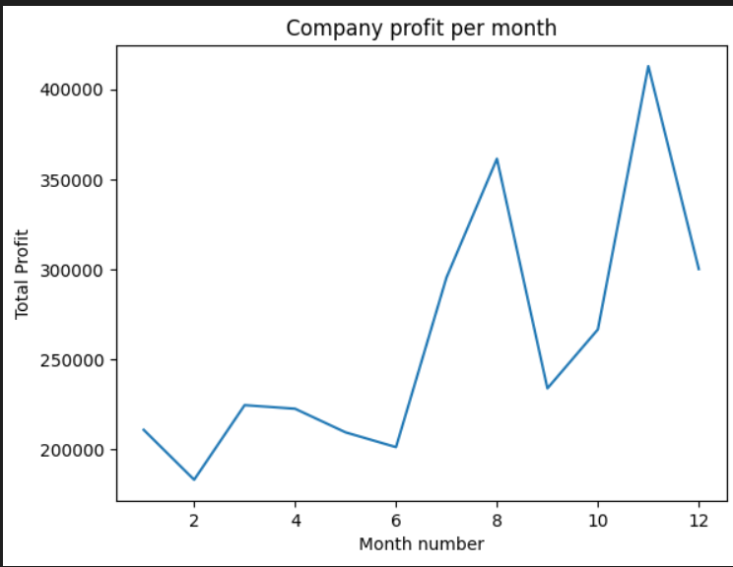
Exercise 2:
Get total profit of all months and show line plot with the following Style properties
Generated line plot must include following Style properties: –
Line Style dotted and Line-color should be red
Show legend at the lower right location.
X label name = Month Number
Y label name = Sold units number
Add a circle marker.
Line marker color as read
Line width should be
OUTPUT:

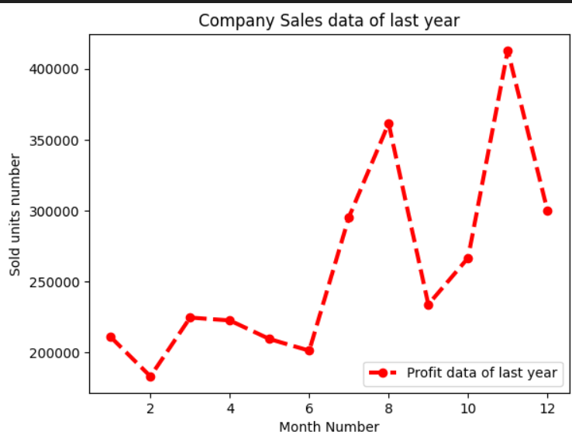
Exercise 3:
Read all product sales data and show it using a multiline plot
Display the number of units sold per month for each product using multiline plots. (i.e., Separate
Plotline for each product.
OUTPUT:

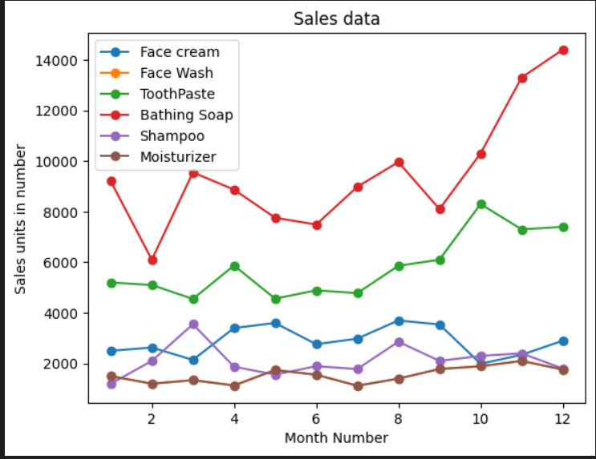
Exercise 4:
Read toothpaste sales data of each month and show it using a scatter plot
OUTPUT:

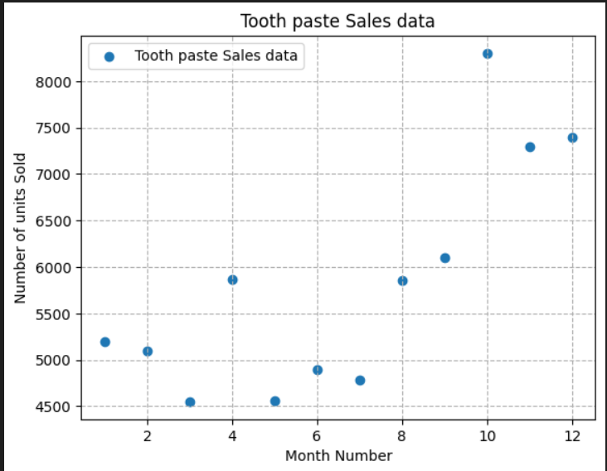
Exercise 5:
Read face cream and facewash product sales data and show it using the bar chart
OUTPUT:

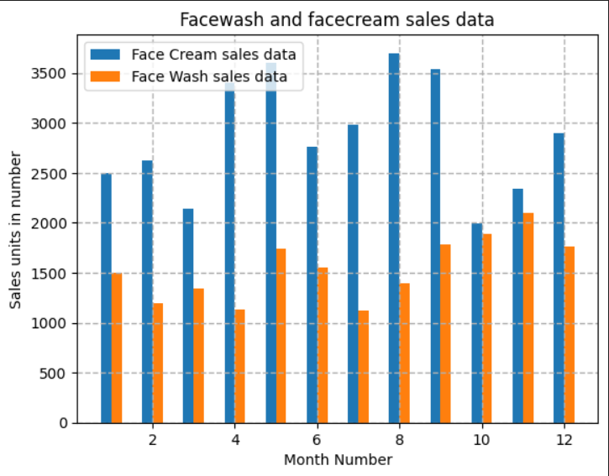
Exercise 6:
Read sales data of bathing soap of all months and show it using a bar chart. Save this plot to your
hard disk
OUTPUT:

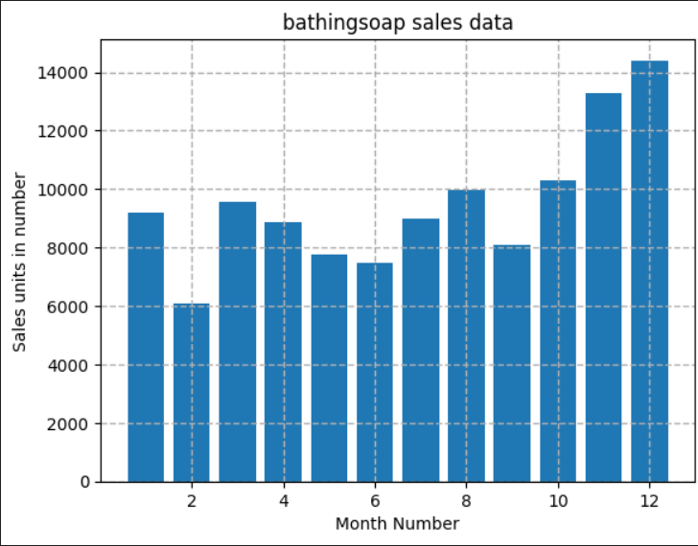
Exercise 7:
Read the total profit of each month and show it using the histogram to see the most common profit
Ranges
OUTPUT:

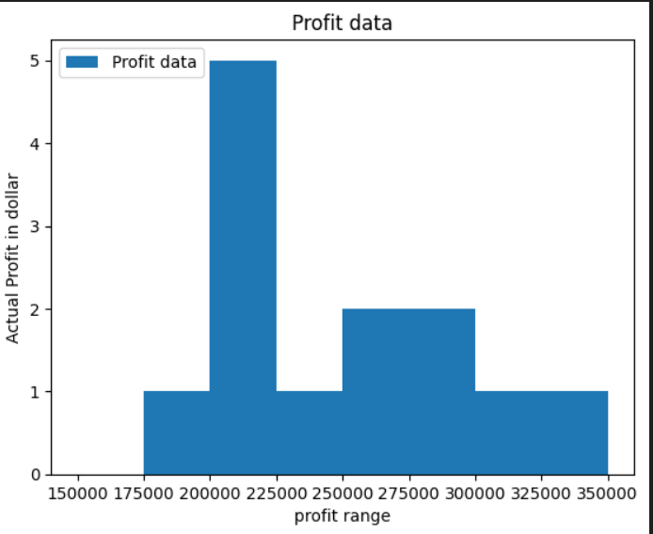
Exercise 8:
Calculate total sale data for last year for each product and show it using a Pie chart
OUTPUT:

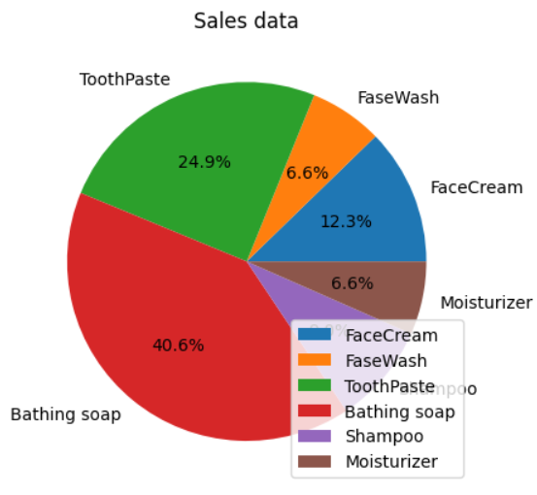
Exercise 9:
Read Bathing soap facewash of all months and display it using the Subplot
OUTPUT:

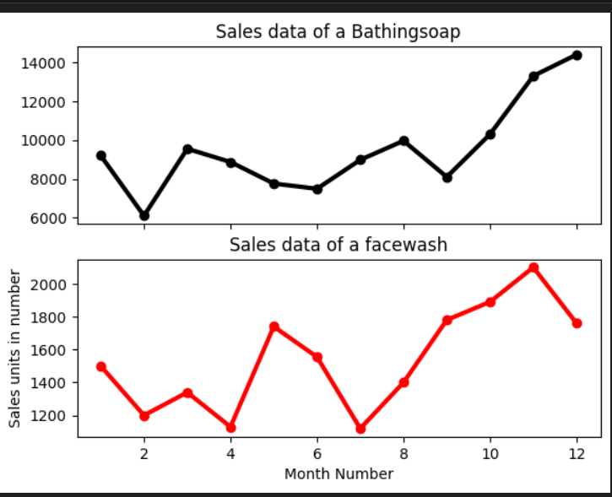
Exercise 10:
Read all product sales data and show it using the stack plot
OUTPUT:

