KAVACH
AI-Powered Industrial Safety Intelligence for Zero-Harm Operations
A Compound-Risk Intelligence Layer for Indian Heavy Industry
Project Report — Phase 2 Prototype Submission
ET AI Hackathon 2.0 | Problem Statement 1 | The Economic Times × Unstop
Team SlideHustlers
Satyam Kumar
satyamkumarsk676@gmail.com
Repository: github.com/satyam11081998-lab/slidehustlers_et
20 July 2026

Abstract
India's heavy industry does not suffer from an absence of safety technology. It suffers from an absence of integration. In January 2025, eight workers died in a coke-oven gas explosion at a plant equipped with functioning gas detectors, permit-to-work controls and SCADA; the subsequent investigation concluded that warning signals existed in the data, but that no intelligence layer connected those readings to operational decisions in time. A 2024 FICCI survey found that more than 60 per cent of large Indian facilities still coordinate their own digital safety tools through manual handoffs.
This report presents KAVACH, a compound-risk intelligence layer that fuses sensor trends with operational context — active work permits, applied isolations, gas-test quality, maintenance work orders, shift handovers and plant connectivity — to detect hazardous combinations of conditions that no single-sensor alarm can, by construction, observe. KAVACH was evaluated on a deterministic digital twin of a coke-oven and by-products complex comprising eleven zones and thirty-four tagged instruments, across two scenarios with labelled ground truth.
On a composite incident scenario, KAVACH raised a CRITICAL compound-risk alert at 06:30, whereas the conventional single-sensor baseline produced its first uncleared alarm only at 09:39 — a prediction lead time of 189 minutes (3 hours 9 minutes), and 240 minutes of warning before the incident threshold against the baseline's 51. KAVACH recorded zero missed hazards and zero false alerts; on a deliberately benign scenario the baseline raised one false alarm on a calibration test that KAVACH correctly suppressed using work-order context. Every reported figure is computed against ground truth by an in-built metrics module and asserted by an automated verification suite that ships with the source code.

1. Introduction

1.1 Background and Motivation
According to the Directorate General Factory Advice Service and Labour Institutes (DGFASLI), over 6,500 fatal workplace accidents were recorded in India in FY2023, a figure that excludes most of the mining and construction sectors. Fatalities in process industries are rarely caused by the failure of a single instrument. They are typically the product of several individually tolerable conditions occurring together: a slow pressure drift that never breaches an alarm limit; a confined-space entry authorised on the basis of a single-point gas test; an isolation step deferred as a matter of routine; a shift handover that omits an unresolved observation; hot work permitted nearby.
Each of these conditions is visible to some system in the plant. None of those systems can see the others. Distributed control systems raise alarms per tag, and are deliberately kept simple because safety-instrumented functions must be certifiable — no regulator certifies judgement. Permit-to-work software governs paperwork and signatures but is blind to live process data. Maintenance systems track work orders but not the presence of personnel. The only component in the plant that integrates these streams is the shift supervisor, precisely the component most degraded by fatigue, alarm saturation and production pressure.

1.2 Problem Statement
This work addresses Problem Statement 1 of the ET AI Hackathon 2.0, which calls for an AI-powered industrial safety intelligence platform that unifies IoT sensor data, SCADA, permit-to-work logs and shift records into a predictive layer capable of detecting compound risk conditions and triggering preemptive interventions. The stated evaluation focus is compound risk detection accuracy versus single-sensor baselines, prediction lead time before the incident threshold, geospatial evidence quality, regulatory compliance coverage, and demonstrated reduction in false negative rate.
The system described here was designed against that evaluation focus directly: the single-sensor baseline is implemented as a first-class component of the product rather than as an external point of comparison, so that lead time and error rates are measured continuously and reproducibly on identical input data.

1.3 Objectives
- To detect compound risk conditions materially earlier than threshold-based alarms, and to quantify that improvement against labelled ground truth.
- To make every alert explainable, carrying the rules that fired, the signal values that triggered them, the operational context involved, and the statutory provision that governs the recommended response.
- To demonstrate false-positive discipline, on the premise that a safety system which raises unjustified alarms will be muted by its operators and thereby rendered useless.
- To progress from detection to orchestrated response, including permit suspension, isolation, notification, evacuation sequencing and automatic generation of a regulator-ready incident-prevention record.
- To remain fully deterministic and free of external runtime dependencies, so that results are reproducible on any machine and a live demonstration cannot fail.

2. Why Existing Plant Systems Do Not Solve This
A recurring and legitimate challenge to this work is that industrial plants already possess extensive safety technology. They do. The distinction KAVACH draws is between systems that monitor signals and a system that reasons over their combination. Table 1 summarises the systems typically present in an Indian coke-oven complex and the specific blind spot each retains.
Table 1. Plant systems and their structural blind spots.
Existing system | What it observes | Structural blind spot
Distributed control system / SCADA | One tag against one threshold | Cannot express a condition involving a permit, a crew or a maintenance state
Safety instrumented systems / trips | Hard limits, deliberately simple logic | Simplicity is a certification requirement; judgement is out of scope by design
Fixed gas detection network | Concentration at a fixed point | Unaware of who is present, or whether an isolation was applied
Electronic permit-to-work | Authorisations and signatures | No connection to live process data at the time of entry
Computerised maintenance management | Work orders and schedules | No awareness of concurrent operations or personnel exposure
Shift handover records | Narrative notes between shifts | Unstructured, incomplete, and dependent on the outgoing supervisor's recall

The consequence is that the integration function — the act of holding six facts in mind simultaneously and recognising their joint significance — is performed by a human being, unaided, at the end of a night shift. KAVACH does not replace any of the systems above and does not interact with safety-instrumented functions. It reads from them and adds the reasoning layer that has been missing.

3. System Architecture
KAVACH is organised as a deterministic core with optional generative components at its edges. The core comprises a plant digital twin, a derived-signal layer, a compound-risk engine, a single-sensor baseline engine, a metrics module, a regulatory-intelligence layer, an emergency-response orchestrator and a what-if sandbox. The delivery layer is a control-room web application communicating over REST and WebSocket.
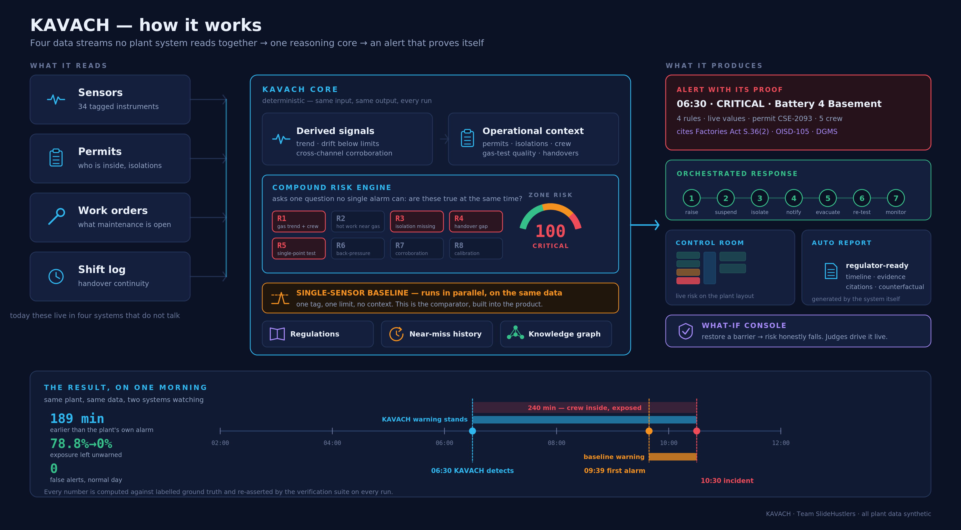
Figure 1. How KAVACH works: the four data streams it reads, the deterministic reasoning core, what it produces, and the resulting timeline on the incident morning.

3.1 Design Principles
Deterministic first. Every sensor stream is generated from a seed derived by CRC-32 from the scenario and the sensor identifier, so a given scenario produces bit-identical data on every machine and every run. The full evaluation horizon is materialised once and cached, which makes scrubbing to any instant an O(1) operation and permits both engines to be evaluated offline over the entire timeline.
Explainability as a requirement, not a feature. Every alert carries an evidence bundle: the identifiers and labels of the rules that fired, the derived signals with their numeric values, the permits and crews involved, a confidence figure and the applicable regulatory citations. In a statutory environment an unexplainable recommendation is not actionable.
Measurement over assertion. Lead time, false negatives and false positives are computed by the metrics module against scenario ground truth and exposed through the API, rather than being quoted from a design document.
Language models at the edge only. An optional component narrates alerts in natural language. It is guarded by a deterministic template fallback and disabled by default, so the system operates fully without network access or an API key.

3.2 Technology Stack
Table 2. Implementation stack and rationale.
Layer | Technology | Rationale
Backend | Python 3.10+, FastAPI, Uvicorn | Deterministic pure-Python engines; no ML runtime is required because the intelligence is signal fusion and causal rules
Frontend | Next.js 14.2.35, React 18, TypeScript | Server-rendered control room; all visualisations are inline SVG, giving a ~91 kB first load with no charting dependency
Transport | REST plus WebSocket at 4 Hz | Live state, risk block and metrics stream to the control room; playback controls apply instantly
Verification | Custom assertion suite (verify.py) | Every published number is asserted on each run; the suite is part of the repository

4. The Plant Digital Twin and Evaluation Scenarios

4.1 Rationale for Synthetic Data
Real SCADA histories, permit registers and incident records in Indian heavy industry are governed by non-disclosure agreements and are not obtainable within a hackathon timeframe by any participant. Rather than weaken the problem to fit available public data, this work constructs a high-fidelity digital twin and states that provenance openly on every surface of the product, the repository and this report. Two properties make the approach defensible. First, the risk engines receive only what a real plant emits — tag values, permits, work orders, shift records — so the interface between the twin and a production connector layer is identical. Second, ground-truth labels permit honest measurement of both detection and restraint, which real unlabelled data would not.

4.2 Plant Model
The modelled facility is a coke-oven and by-products complex containing eleven zones with an explicit connectivity graph, six items of major equipment and thirty-four instruments carrying realistic tag names and alarm limits. Instrumentation includes gas-main pressure transmitters, carbon-monoxide, hydrogen-sulphide and methane detectors, oven-crown thermocouples, flow transmitters, valve-position indicators and a differential-pressure transmitter. The zone connectivity graph is used by the risk rules to establish whether an abnormality in one zone can physically propagate into another.
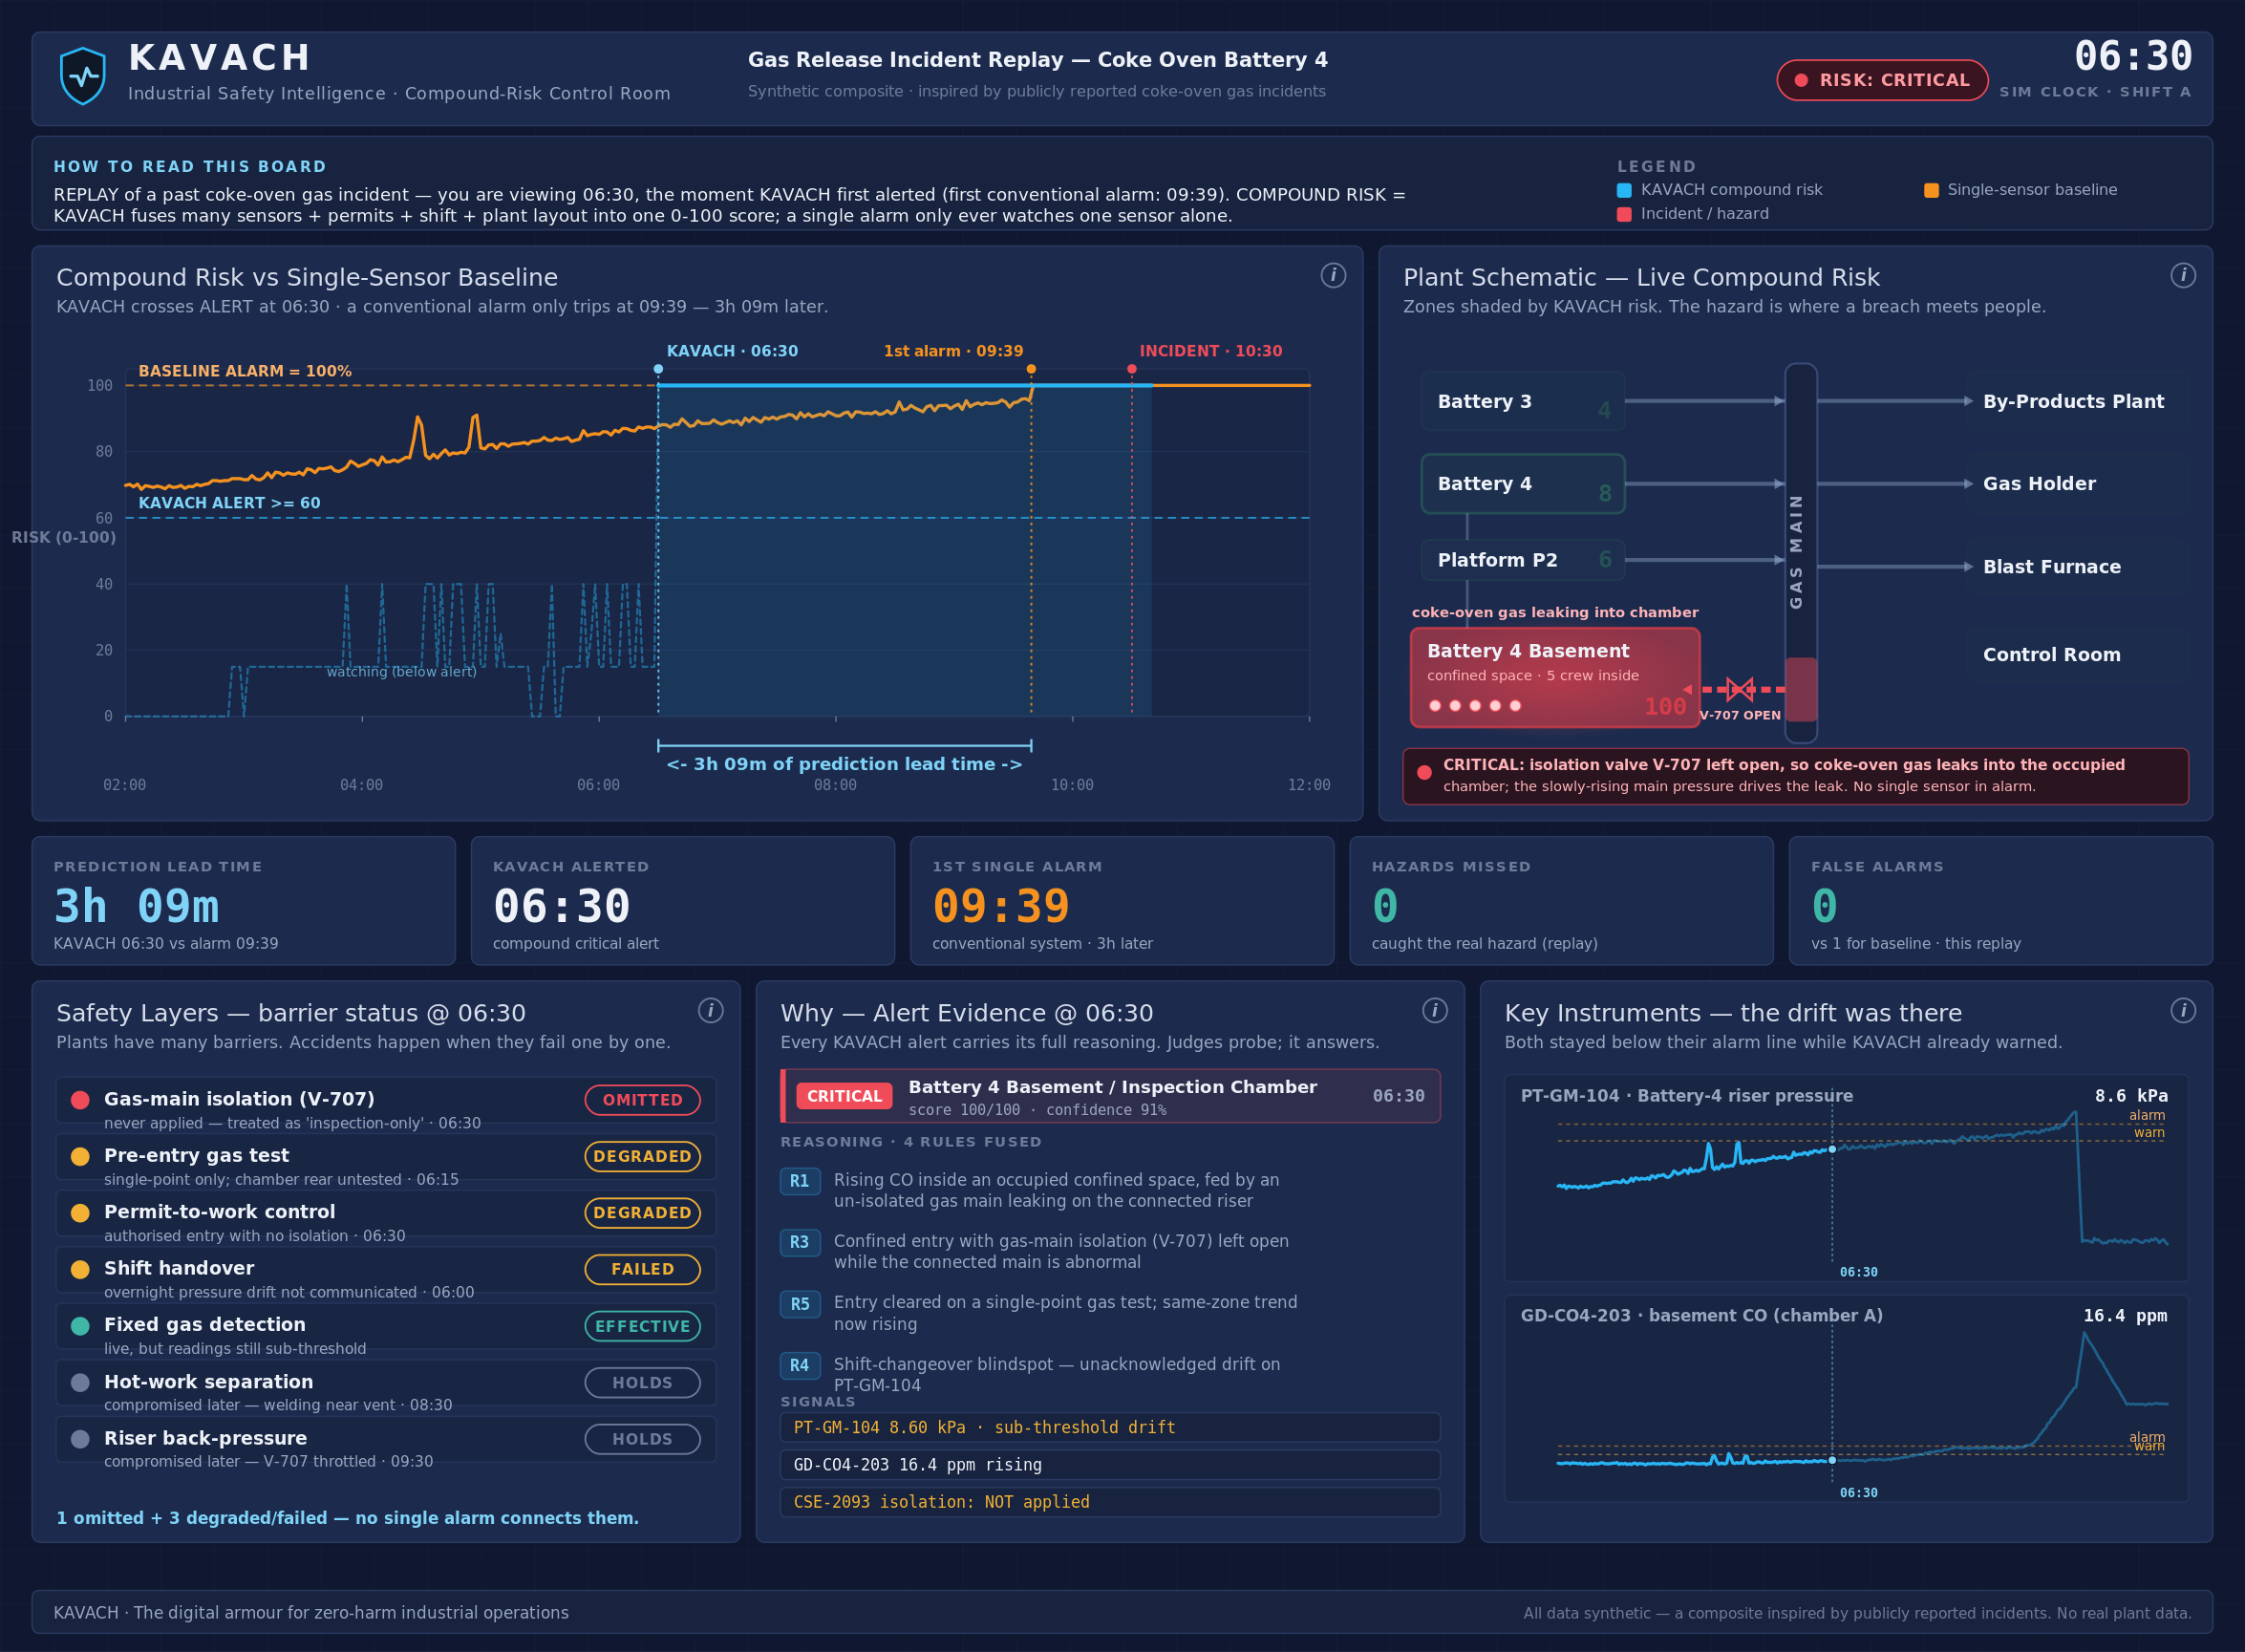
Figure 2. The KAVACH control room. Live plant schematic with compound-risk shading, the risk-versus-baseline chart, the safety-barrier panel, alert evidence and the metrics strip.

4.3 Scenario 1 — Incident Replay
The primary scenario is a fictional composite spanning 02:00 to 12:00 (600 simulated minutes), assembled from failure modes documented in publicly reported investigations of coke-oven gas incidents. Six individually explicable conditions compound over eight hours, as set out in Table 3.
Table 3. Incident replay: the compounding sequence with ground-truth annotations.
Time | Event | Significance
02:30 | Gas-main pressure begins a slow upward drift on the Battery 4 riser | Sub-threshold throughout; invisible to any alarm limit
04:25 / 04:55 | Two transient pressure excursions logged and cleared | Establishes alarm fatigue; no trend review is triggered
06:00 | Shift changeover; handover note omits the drift | Loss of continuity across the shift boundary
06:15 | Gas test GT-1121 passes, but at a single point only | Chamber rear and riser side untested
06:30 | Confined-space entry CSE-2093 activated; five crew enter; gas-main isolation not applied | Ground-truth hazard onset
08:30 | Hot-work permit issued on Platform P2, ~20 m from the basement vent | Ignition source introduced near an accumulating atmosphere
09:30 | Isolation valve V-707 throttled to 45 per cent | Back-pressure on the affected leg accelerates
09:39 | Carbon monoxide crosses 50 ppm and persists | First uncleared single-sensor alarm
10:30 | Incident marker | Ground-truth incident time

4.4 Scenario 2 — Normal Day (False-Positive Discipline)
The second scenario spans 06:00 to 14:00 and contains no hazard. It is deliberately populated with conditions that a naive correlation-based system would flag: a confined-space entry conducted correctly with a multi-point gas test and isolations applied; hot work in a non-classified workshop; a brief carbon-monoxide excursion during tanker loading; and, critically, a calibration test that drives a pressure transmitter above its alarm limit for approximately six minutes under work order WO-8820. This scenario measures restraint rather than detection, and is weighted accordingly in the evaluation.

5. Detection Methodology

5.1 Derived Signals
Raw instrument values are insufficient to express the conditions of interest, because the defining characteristic of the incident is that no raw value breaches its limit until the situation is already unrecoverable. KAVACH therefore computes a derived-signal layer: a rolling trend slope over a 45-minute window to establish whether a channel is rising; an exponentially weighted moving average deviation; a sub-threshold drift detector operating on a 60-minute window that identifies a sustained positive slope while the value remains below its warning limit; a cross-channel corroboration signal that establishes whether two or more gas channels in a zone are rising together; and a valve-position and back-pressure correlation.

5.2 Compound Risk Rules
Eight rules operate over the derived signals and the operational context. The rules encode the causal reasoning that experienced safety engineers apply — barrier analysis — rather than statistical association, which is appropriate given that fatal-incident data is far too scarce to support supervised learning and that safety decisions must be auditable.
Table 4. The compound-risk rule set.
ID | Rule | Effect
R1 | Rising gas or pressure trend in, or connected to, a zone with an active confined-space entry | High
R2 | Hot work adjacent to elevated or rising gas | High
R3 | Confined-space entry without gas-main isolation while the connected network is abnormal | Medium rising to high
R4 | Shift changeover within ±30 minutes with an unacknowledged active drift | Severity escalator
R5 | Single-point gas test combined with a rising trend in the same zone | Severity escalator
R6 | Valve closure with differential-pressure rise and an occupied confined space | High
R7 | Multi-channel corroboration across sensors in one zone | Confidence boost
R8 | Active calibration work order on a sensor suppresses that sensor's contribution | Suppression

Zone risk is scored from 0 to 100 by weighted summation with clamping, and mapped onto advisory, alert and critical bands at 40, 60 and 80 respectively, with hysteresis on the exit thresholds to prevent oscillation. Rule R8 is what distinguishes a usable system from an unusable one: it is the mechanism by which maintenance context suppresses an alarm that a threshold system would raise.

5.3 The Single-Sensor Baseline
To measure improvement honestly, the comparator must be implemented rather than assumed. The baseline engine replays the same instrument data and raises an alarm when any channel crosses its configured alarm limit and persists there for at least three minutes, which reproduces the behaviour of a conventional alarm system including its persistence filtering. It receives no context whatsoever: no permits, no work orders, no shift information. Both engines consume identical data over identical horizons, so the comparison is like-for-like.

6. Results

6.1 Detection Performance on the Incident Scenario
KAVACH raised a CRITICAL compound-risk alert on the Battery 4 basement at t = 270 minutes (06:30), scoring 100 of 100, with rules R1, R3 and R5 firing simultaneously and R4 acting as an escalator. The alert coincides exactly with the ground-truth hazard onset — the moment the crew entered an unisolated confined space connected to a drifting gas main. The single-sensor baseline produced its first uncleared alarm at t = 459 (09:39). Importantly, the basement zone remained below the alert band at t = 269, confirming that the system does not merely activate on the presence of a permit.
Table 5. Measured performance against labelled ground truth.
Metric | Baseline (single-sensor) | KAVACH | Improvement
First actionable warning | 09:39 | 06:30 | 189 minutes earlier
Prediction lead time | — | 3 h 09 m | —
Warning before incident threshold | 51 min | 240 min | 4.7×
Hazards missed (false negatives) | — | 0 | —
False alerts, incident scenario | — | 0 | —
False alerts, benign scenario | 1 | 0 | eliminated
Context-based suppressions, benign day | 0 | 9 | —

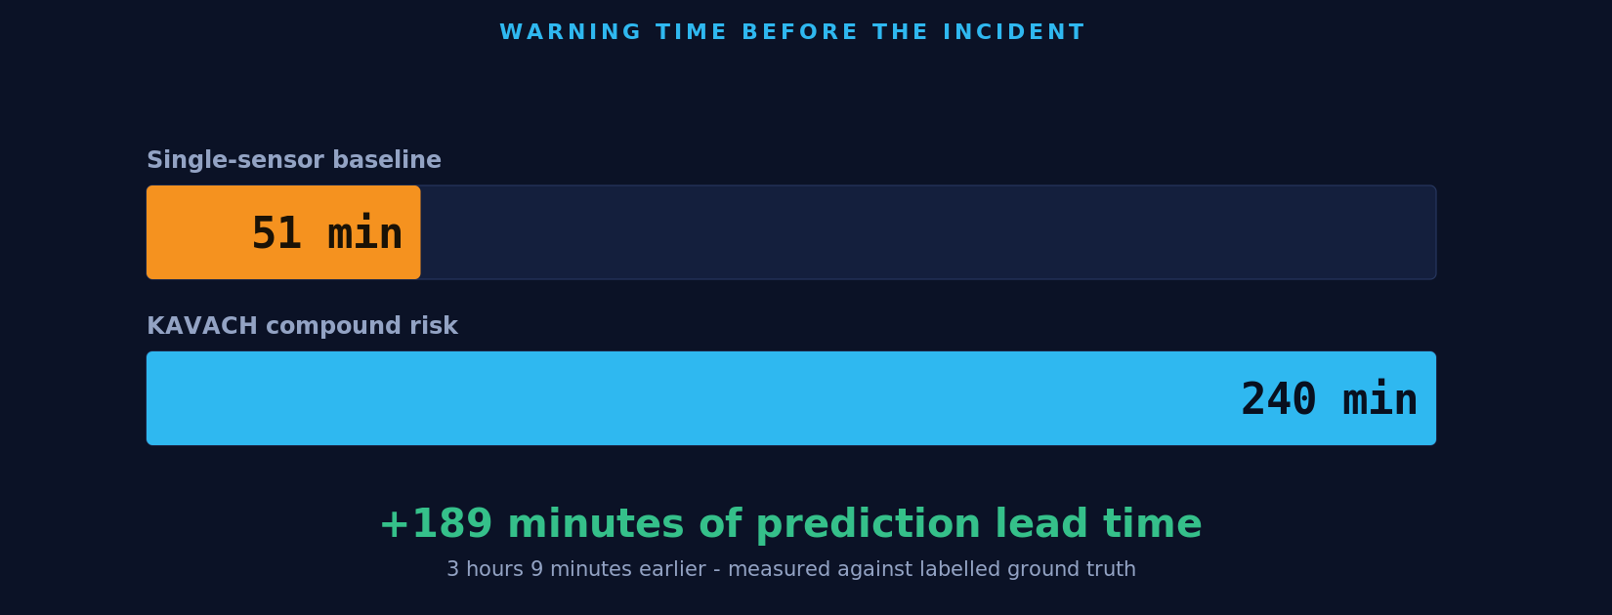
Figure 3. Warning time before the incident threshold: 240 minutes for KAVACH against 51 minutes for the single-sensor baseline.
Figure 3 contrasts the two engines at the moments that matter. In the baseline view at 09:39 the plant has just received its first uncleared alarm, with fifty-one minutes remaining. In the KAVACH view at 06:30 the same underlying data has already produced a critical alert with a complete evidence bundle, three hours and nine minutes earlier.
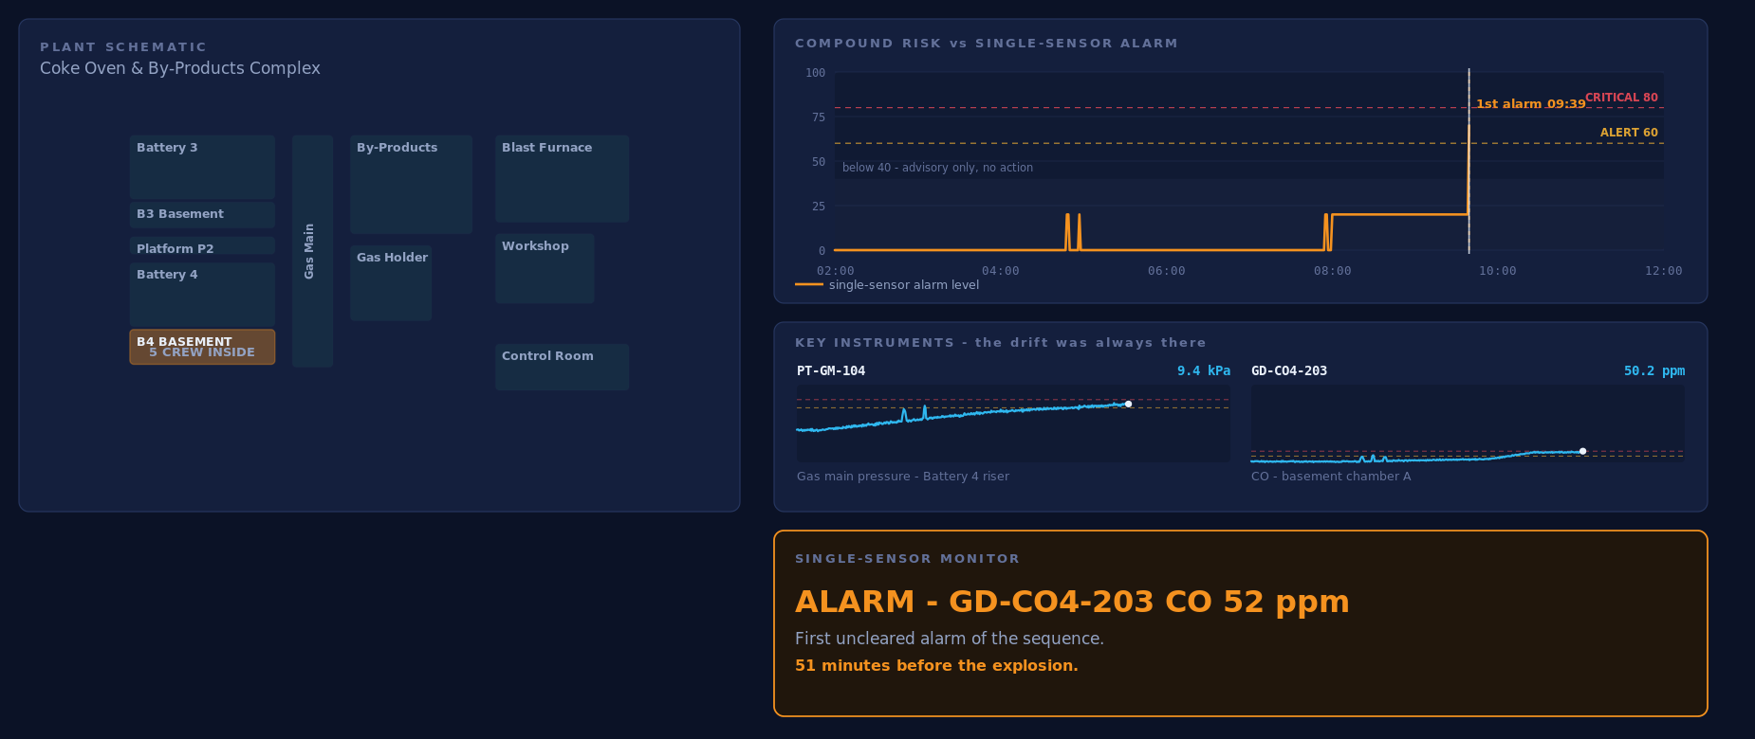
Figure 4. Baseline view at 09:39. The single-sensor monitor has just raised its first uncleared alarm; until this moment the board reported no uncleared alarms.
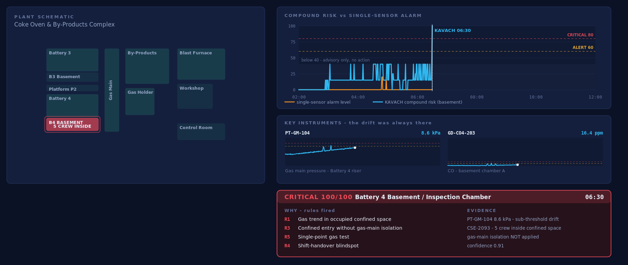
Figure 5. KAVACH view at 06:30 on identical data. Compound risk is CRITICAL at 100/100 with four rules fired, the driving instrument values, the confined-space permit and a confidence figure.

6.2 Escalation Behaviour
Following the initial detection, the engine escalated as further barriers were compromised: rule R2 joined at 08:30 when the hot-work permit opened near the basement vent, and rule R6 joined at approximately 09:30 when valve throttling drove back-pressure upward. Per-rule activation counts across the horizon were R1 379, R2 259, R3 280, R4 31, R5 311, R6 63 and R7 96. The escalation path demonstrates that the system tracks a developing hazard rather than emitting a single classification.
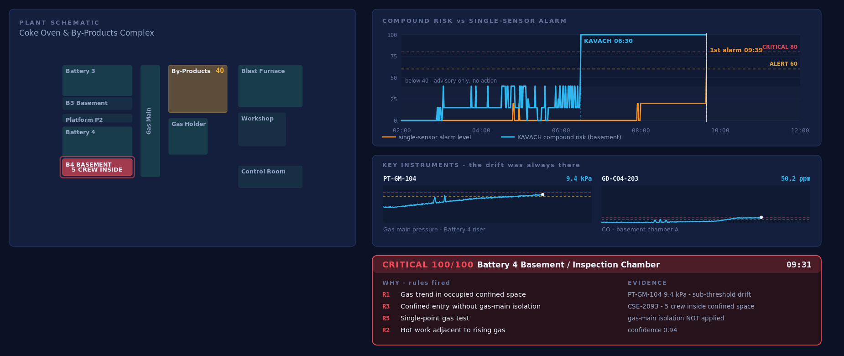
Figure 6. KAVACH view at 09:39, the moment the conventional alarm finally fires, the compound risk has been critical for over three hours and has escalated twice.

6.3 Held-Out Evaluation on Unseen Scenarios
The results reported above are drawn from a scenario this team authored, scored against a baseline this team implemented. That is a fair objection to any hand-built demonstration, and the appropriate answer is not argument but a further experiment. A generator was therefore written that produces scenarios the rule set has never encountered: the hazard zone, the particular barriers that fail, the drift onset and gradient, permit hours, incident time and instrument noise are all randomised, and a controlled proportion of scenarios contain no hazard at all. The unmodified engines were then scored across 120 such scenarios, 68 containing a hazard and 52 benign. The procedure is reproducible by any reader, because scenarios are generated from seeds: `python eval_run.py 120`.
Table 6. Held-out performance across 120 generated scenarios.
Measure (120 unseen scenarios) | KAVACH | Single-sensor baseline
Hazards detected | 100% | 100%
Median lead time over the baseline | +85 min | —
Median warning before the incident | 204 min | 126 min
Median false-negative rate (exposure unwarned) | 0.0% | 39.4%
False alerts on unseen benign days | 0.0% | 0.0%
Warned earlier than the baseline | 67 of 68 hazard scenarios | —

The first execution of this experiment did not produce those figures. It exposed two defects, and both were genuine rather than statistical noise.
Four missed hazards, all in the Battery 3 basement. The rule governing gas abnormality inspected only directly-connected zones. Battery 4's basement adjoins the gas main; Battery 3's does not. The rule had therefore acquired a silent dependency on the topology of the zone used to develop it, and an identical hazard elsewhere in the plant was invisible to it. Gas propagates through the connected network rather than a single adjacency, so reachability was made multi-hop.
A false-alert rate of 13.5% on unseen benign days. The trend rule was firing with carbon monoxide at 13 ppm against a warning limit of 30, with isolation applied and a representative multi-point test completed — that is to say, with the entry crew fully protected. The engine was not crediting intact barriers. Where isolation, a representative test and continuous monitoring are all in place and no reading has reached a warning limit, a rising trend is now advisory and cannot reach the alert band on its own.
Following those two corrections, detection rose from 94.1% to 100%, false alerts on benign days fell from 13.5% to 0.0%, median lead time improved from 78 to 85 minutes, and the worst observed case improved from 142 minutes late to 12 minutes late. The demonstration scenario was unaffected and the full assertion suite continued to pass. In one scenario of sixty-eight KAVACH still warns approximately twelve minutes later than the threshold baseline, in a case where gas rose quickly enough to breach an alarm limit before the compound pattern assembled; the evaluation tool prints such cases explicitly. Compound reasoning is not a superset of threshold alarming, which is precisely why the baseline remains a component of the product rather than something it replaces.

6.3 False-Positive Discipline
On the benign scenario the baseline raised one uncleared alarm at 10:00, triggered by a calibration test that drove transmitter PT-GM-103 above its alarm limit. KAVACH raised no alerts. The distinction is contextual rather than statistical: work order WO-8820 records an active calibration on that exact instrument, so rule R8 suppressed its contribution and the interface displayed the suppression together with its justification. Nine such suppressions occurred during the day.
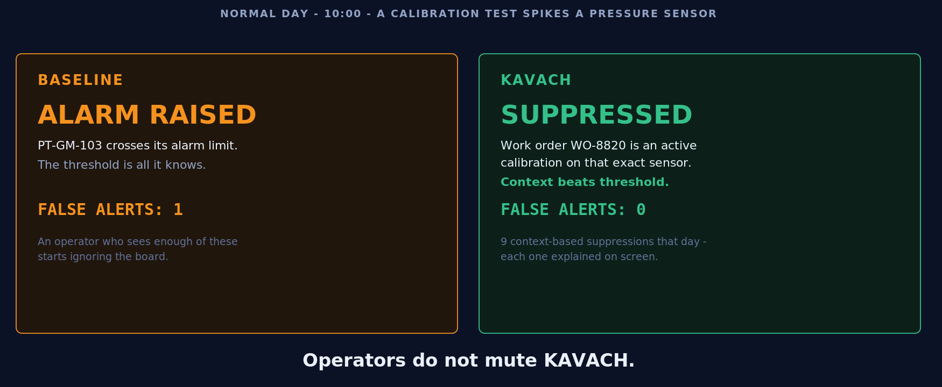
Figure 7. False-positive discipline on a normal day. The threshold baseline alarms on a calibration test; KAVACH reads the governing work order and remains silent.
This result carries disproportionate weight. Alarm systems in industry fail predominantly through desensitisation rather than through insufficient sensitivity; a platform that raises unjustified critical alerts will be disabled by its operators within weeks. Reporting a zero false-alert rate on a scenario constructed specifically to provoke false alerts is therefore a stronger claim than the lead-time figure.
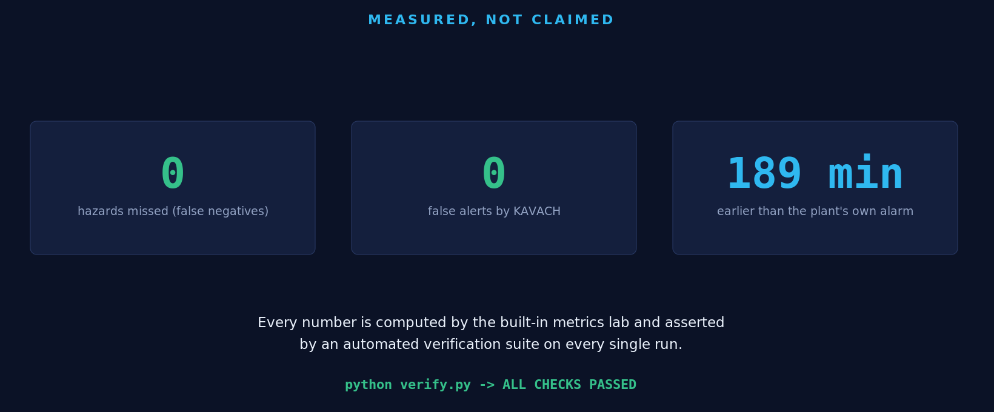
Figure 8. Summary of measured outcomes, each asserted by the automated verification suite on every run.

7. From Detection to Orchestrated Response

7.1 Regulatory Intelligence
A recommendation that a plant cannot justify to an inspector has limited operational value. KAVACH maintains a curated clause library covering OISD-STD-105 (work permit systems), the Factories Act 1948 — in particular Section 36(2) concerning entry into confined spaces containing dangerous fumes — and DGMS guidance on gas testing by competent persons and continuous monitoring. Retrieval is deterministic and keyword-based, requiring no network access, and every alert and every orchestrated action carries its governing citations.

7.2 Emergency Response Orchestrator
On a confirmed critical alert the orchestrator executes a deterministic playbook: raise the alert with its evidence bundle; suspend the affected permits, in this case CSE-2093; recommend isolation of the implicated gas-main leg; notify the shift supervisor, safety officer and control room; derive the evacuation set from the zone connectivity graph; require a representative multi-point gas re-test; and hold monitoring until the trend clears. Each action carries a regulatory basis, and each is subject to a human gate above defined thresholds.
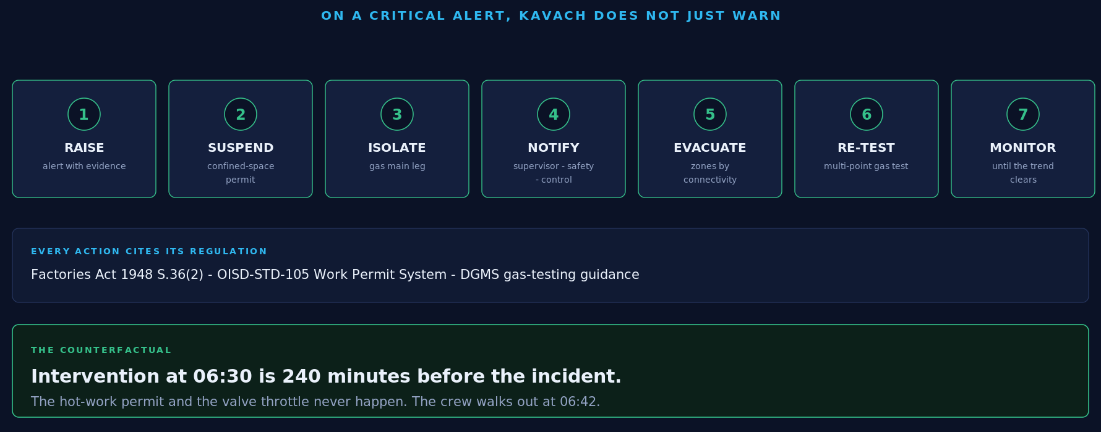
Figure 9. The orchestrated response sequence with its statutory basis and the computed counterfactual.

7.3 Counterfactual and Automated Reporting
The system computes the counterfactual of its own intervention. Acting at 06:30 places the response 240 minutes before the incident threshold; the hot-work permit issued at 08:30 and the valve throttling at 09:30 do not occur, because the entry permit under which the work proceeded has already been suspended. KAVACH also generates an incident-prevention report in Markdown and PDF containing the timeline, the evidence, the rules fired, the statutory citations and the comparison between the recorded sequence and the intervention sequence. Verification confirms the generated report cites the measured lead-time value.

7.4 What-If Console
A sandbox console allows conditions to be injected into the scenario and the full engine re-evaluated deterministically over the same code path. Applying the omitted gas-main isolation at 06:30 clears rule R3 and reduces the zone score from 100 to 70, moving the band from critical to alert. Substituting a representative multi-point gas test clears R5. Introducing a second rising carbon-monoxide channel adds corroboration through R7 and raises confidence without inflating the score. This behaviour — risk decreasing when a barrier is restored and confidence increasing when evidence accumulates — is evidence that the engine reasons about causes rather than correlations, and the results are bit-identical on recomputation.

8. Verification and Reproducibility
The repository includes an assertion suite, verify.py, which is executed as part of the development workflow and which asserts every quantitative claim made in this report. Its coverage includes curve checkpoints at defined instants; the exact minute at which carbon monoxide first crosses 50 ppm; rebuild-identical determinism of all sensor series; permit, zone and ramp integrity against the plant model; the absence of unscripted alarm crossings on the benign day; the compound-alert time and rule composition; the lead-time value within tolerance; false-negative and false-positive counts on both scenarios; the presence of regulatory citations on the critical alert and on every orchestrator action; the counterfactual interval; the content of the generated report; and the determinism of what-if recomputation.
The suite was executed against a clean anonymous clone of the public repository during preparation of this report, reproducing every figure quoted here and terminating with ALL CHECKS PASSED. Any reader may repeat this by cloning the repository and running the same command; because the twin is seeded, the output is identical on any machine.
Table 7. Reproducibility guarantees.
Property | Guarantee
Determinism | Per-sensor CRC-32 seeding; identical output on every machine and run
External dependencies | None at runtime; no dataset, API or network access required
Language model use | Optional narration only, with a deterministic template fallback; disabled by default
Reproducibility of results | Clone the repository and run verify.py

9. Discussion

9.1 Deployment Pathway
KAVACH is designed as a retrofit. In the first phase it consumes read-only feeds — an OPC-UA or historian export, together with electronic permit and maintenance exports — and writes nothing to the process, so no re-certification of safety-instrumented functions is required. In the second phase alerts are presented to the control room in an advisory capacity while false-negative and false-positive rates are monitored on the plant's own data. Only in the third phase are pre-approved orchestration playbooks enabled, with human gates above defined blast-radius thresholds. Because the digital twin and a production connector present the same interface to the engines, this progression requires no re-architecture.

9.2 Scalability
The rules are expressed over categories — confined space, gas network, hot work, isolation, changeover — rather than over the specific instrument tags of this facility. Onboarding a new plant consists of supplying a zone layout with its connectivity graph, an instrument list with limits, and connector mappings. This is configuration rather than a data-science engagement, which is the principal determinant of whether such a system can be deployed across an industrial group. The digital twin itself has independent value for operator training, HAZOP-style exercises and regression-testing of rule changes before they reach production.

9.3 Limitations
- All data is synthetic. Fidelity has been prioritised and provenance disclosed, but validation against a real plant history remains outstanding and would be the first activity of any pilot.
- The computer-vision and CCTV analytics component suggested by the problem statement was scoped to future work rather than mocked, on the grounds that an unvalidated demonstration would misrepresent the system's capability.
- The twin models one plant section. Multi-unit deployment requires a streaming ingestion backbone; this is an engineering exercise rather than a research risk, and the engine core is unaffected.
- Rule weights were established analytically from the scenario rather than fitted to a corpus of historical incidents, which is the natural next step once such a corpus is accessible under a pilot agreement.

9.4 Future Work
- Computer-vision module for personal protective equipment and exclusion-zone monitoring, feeding the existing evidence model.
- Worker positioning through ultra-wideband or Bluetooth tags, enabling per-person evacuation routing on the plant schematic.
- Pattern mining over near-miss and incident corpora to propose new candidate rules for human approval, extending rather than replacing the explainable rule base.
- Multi-plant aggregation for corporate health, safety and environment functions.

10. Conclusion
The evidence assembled in this report supports a single claim. Every safety system presently installed in an Indian coke-oven complex observes one signal correctly; none observes the combination, and it is the combination that produces fatalities. KAVACH supplies that missing layer. On a composite incident scenario constructed from documented failure modes it detected the hazardous combination 189 minutes before the plant's own alarm system, providing 240 minutes of warning against 51, with no missed hazards and no false alerts, and on a benign scenario designed to provoke false alarms it remained silent where a threshold system did not.
Every one of those figures is computed against labelled ground truth by a module that ships with the source code and is asserted by an automated suite that any reader can execute. The system explains each alert in terms of the rules that fired, the values that triggered them and the statutory provision that governs the response; it proceeds from detection to an orchestrated, citation-bearing response; and it invites challenge through a live what-if console in which restoring a safety barrier visibly reduces the computed risk.
In the incident that motivated this work, the data required to prevent eight deaths was already present in the plant. It was simply never assembled into a single picture in time. That assembly is a software problem, and it is solvable today.

References
[1] Directorate General Factory Advice Service and Labour Institutes (DGFASLI), statistics on fatal workplace accidents, FY2023.
[2] Published investigative reporting into the January 2025 coke-oven gas incident at a Visakhapatnam steel facility.
[3] FICCI, survey of digital safety tool coordination in large Indian industrial facilities, 2024.
[4] Oil Industry Safety Directorate, OISD-STD-105: Work Permit System.
[5] The Factories Act, 1948, Government of India — Section 36, precautions against dangerous fumes and confined spaces.
[6] Directorate General of Mines Safety (DGMS), circulars and guidance on gas testing and continuous monitoring.
[7] ET AI Hackathon 2.0, Problem Statement 1: AI-Powered Industrial Safety Intelligence for Zero-Harm Operations.

Appendix A — Repository and Deliverables
Table 8. Repository map of submitted deliverables.
Artefact | Location in repository
Source code — digital twin | backend/app/simulator/
Source code — risk engines, orchestrator, regulatory layer, what-if | backend/app/risk/
Verification suite | backend/verify.py
Control room, what-if console, developer console | frontend/app/
Plant model, scenarios with ground truth, regulatory clause library | data/
Demonstration video (2 min 16 s, rendered from live engine output) | docs/KAVACH_demo.mp4
Pitch deck and architecture diagram | docs/kavach_pitch_deck.pptx, docs/architecture.svg
Auto-generated incident-prevention report | reports/
Deployment guide, jury preparation, narration script | docs/

Public repository: github.com/satyam11081998-lab/slidehustlers_et
Declaration: all ideas, code, documents and assets in this submission were created during the hackathon period. All plant data is synthetic and generated by the simulation engine in this repository; the incident scenario is a fictional composite informed by publicly reported investigations and public regulatory standards. No real plant data, and no licensed or third-party dataset, has been used.

