Snowflake, Seamlessly Secured: How Smart Authentication Is Reimagining Access Control

As modern enterprises rapidly adopt cloud data platforms like Snowflake, securing user access without slowing down productivity is no longer optional — it’s mission-critical.
Today, we’re introducing two game-changing methods that not only fortify your Snowflake environment but also streamline user experience. Whether you're an enterprise security leader or a savvy business analyst, these solutions strike the perfect balance between security, efficiency, and flexibility.
Let’s explore how automated credential management and a user-friendly interface are transforming the way we access Snowflake.

Option 1: Automated Authentication with Tokens and Keys (Powered by AWS)
The Problem It Solves:
Manually managing passwords and access keys? Risky. Forgetting to rotate credentials? Dangerous. Audit trails? Incomplete. This method eliminates those gaps.
The Solution:
Using Personal Access Tokens (PAT) and Key Pair Authentication, this approach builds a fully automated, zero-touch authentication flow that’s secure and audit-friendly.
What Powers It:
This system leverages AWS Lambda, Secrets Manager, and Snowflake Stored Procedures to automatically create, rotate, and update credentials.
How It Works (At a Glance):
- Triggering the Flow:
When credentials need rotation, an AWS Lambda function is triggered — either by a schedule or an event.
- Calling Snowflake Securely:
The Lambda function calls a Snowflake Master Procedure, which evaluates the type of credential needed — Token or Key Pair.
- Creating New Credentials:
Depending on the source type, the right child procedure is called:
  - PAT: Issues a new Token.
  - RSA: Generates a new Private Key.
- Securely Updating AWS:
The new credentials are returned to Lambda and securely stored in AWS Secrets Manager, ready for apps and users to retrieve — safely and instantly.
- Bonus:
A cleanup process periodically removes expired keys to maintain hygiene and compliance.
Business Benefits:
- Security First: Automatic rotation means secrets aren’t left stale or vulnerable.
- Compliance Ready: Full traceability for audits and governance.
- Hands-Free: Zero manual involvement reduces human error.
- Scalable: Supports multiple authentication types across teams and tools.

Option 2: Manual Control via Snowflake Streamlit UI
The Problem It Solves:
Sometimes, teams want visibility and control. Not everyone wants fully automated credential management — especially in regulated industries or hands-on departments.
The Solution:
Enter Snowflake Streamlit, a built-in app that gives users a simple, intuitive interface to manage credentials themselves — no engineering ticket required.
How It Works:
- User Launches the App:
Within the Snowflake UI, users open the Streamlit credential management dashboard.
- Credential Updates with a Click:
Users can generate new tokens or keys manually by selecting the service they want to access.
- System-Driven Workflow:
Behind the scenes, each request is logged. Child procedures (PAT or RSA) are called, and responses are written back into a secure table.
- Streamlit Stream Monitors Responses:
A Snowflake Stream continuously watches for new credential responses and displays them back to the user in real time.
Business Benefits:
- Transparency: Users can see and control what’s happening.
- Flexibility: Ideal for power users or teams with specific compliance needs.
- Ease of Use: No scripts. No CLI. Just a button click inside Snowflake.
- Control with Safety: Still follows structured backend workflows, so security isn't compromised.

One Unified, Secure Ecosystem
The beauty of this dual-approach architecture is in its synergy. Whether credentials are generated automatically or manually, both methods follow a shared process of:
- Logging requests for traceability.
- Using standardized Snowflake procedures for credential lifecycle management.
- Storing results in secured tables and updating secrets responsibly.
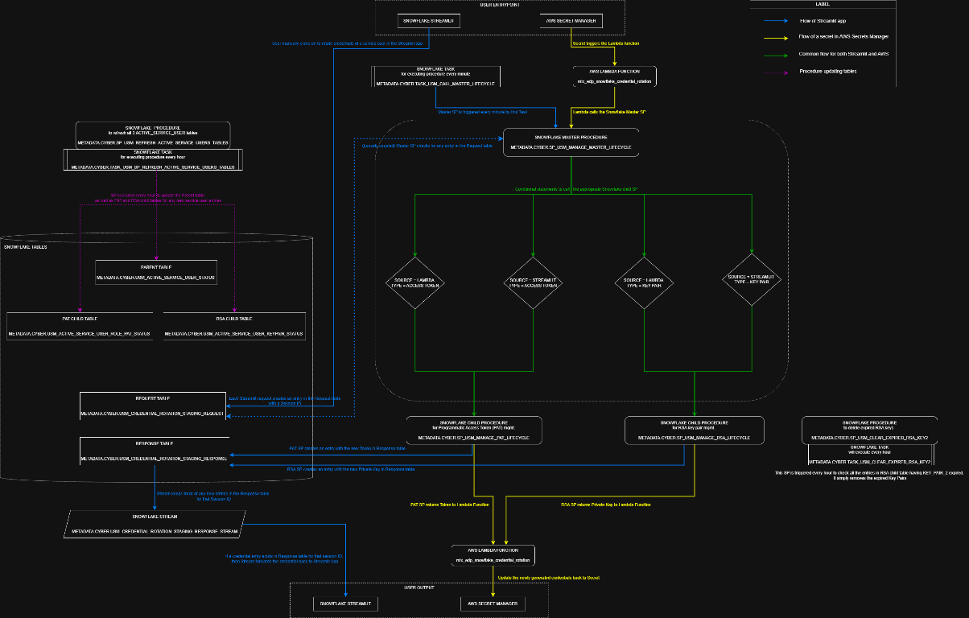
(Overview from the architecture diagram)
This visual flow shows how credentials move from user request → Snowflake processing → AWS secrets — and back. The green, yellow, and blue flows represent different credential paths, but they all unify under a secure, scalable system.

🏁 Final Thoughts: Security That Doesn't Slow You Down
With rising cyber threats and growing data governance requirements, authentication isn’t just a technical concern — it’s a business imperative.
Whether your team prefers hands-off automation or hands-on visibility, these Snowflake authentication methods ensure you're secure, compliant, and future-ready.
So go ahead — innovate faster, sleep better, and let smart authentication handle the heavy lifting.

Next Steps:
- ✅ Talk to your data or security team about enabling PAT or RSA flows.
- ✅ Explore Snowflake Streamlit for user-driven credential updates.
- ✅ Embrace modern identity management in your data stack.
Stay secure. Stay agile. Snowflake is ready — are you?

