An Internship Report
Of
Data Science Master Virtual Internship
Submitted To
School of Computer Science and Engineering IILM University, Greater Noida, U.P.
In partial fulfilment of the requirement of degree of
B.Tech (Computer Science and Engineering )

By
Roll Number of Student: 2410031528
Name of Student: SATYAM RAJ
Batch: 2024-2028

CANDIDATE'S DECLARATION
I hereby declare that this internship report entitled “Data Science Master Virtual Internship” is my original work, completed as part of my internship program. The information presented in this report is based on the knowledge and practical experience gained during the internship.
I further declare that this report has not been submitted elsewhere for any academic qualification.
Signature:-
Student Name: SATYAM RAJ Roll No.: 2410031528

ACKNOWLEDGEMENT
I take this opportunity to express my sincere gratitude to everyone who supported and guided me throughout my internship program. I am thankful for their valuable guidance, constructive feedback, and encouragement, which helped me enhance my knowledge and practical skills.
I would like to thank the Data Science Master Virtual Internship Program team for providing me with the opportunity and structured platform to learn and gain practical exposure in the field of Data Science. I am also grateful to my institute, IILM University, Greater Noida, and the faculty of the School of Computer Science and Engineering for their continuous support and encouragement.
Finally, I express my heartfelt gratitude to my parents, friends, and everyone who supported me throughout this learning journey.
Signature:-
Student Name: SATYAM RAJ Roll No.: 2410031528

TABLE OF CONTENTS
1. Candidate's Declaration i
2. Acknowledgement ii

- Internship Completion Certificate .......................................................................... -
- Project Description ............................................................................................... 1
  - Introduction ................................................................................................... 1
  - Organization Profile ....................................................................................... 2
  - Problem Statement ......................................................................................... 3
  - Project Objectives .......................................................................................... 3
  - Scope of the Project ....................................................................................... 4
  - Technologies and Tools Used......................................................................... 4
  - System Architecture ....................................................................................... 5
  - Methodology .................................................................................................. 6
  - Expected Outcomes........................................................................................ 7
  - Certificates of Completion and Communication Proof .................................. 8
- Bibliography/References ....................................................................................... 9

3. INTERNSHIP COMPLETION CERTIFICATE
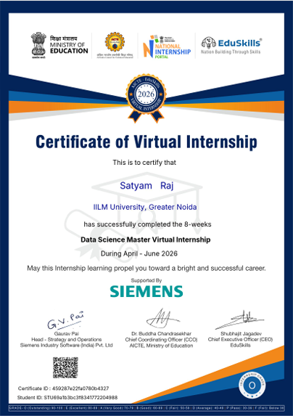

Internship Offer Letter
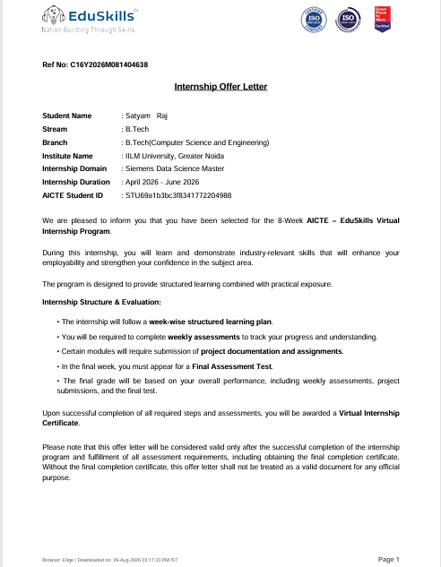

4. PROJECT DESCRIPTION

4.1 Introduction
4. PROJECT DESCRIPTION
4.1 Introduction
This report presents a detailed account of the Data Science Master Virtual Internship undertaken as part of the Bachelor of Technology (Computer Science and Engineering) programme at IILM University, Greater Noida. The primary objective of this internship was to develop a strong practical foundation in the field of Data Science and to understand how data can be collected, processed, analyzed, and transformed into meaningful insights.
The internship provided an opportunity to gain practical exposure to important concepts and techniques used in Data Science, including data preprocessing, data cleaning, exploratory data analysis, data visualization, statistical analysis, and machine learning. The learning process focused on understanding real-world datasets and applying appropriate techniques to identify patterns, trends, relationships, and useful information from data.
The internship followed a structured learning approach that combined theoretical concepts with hands-on practical activities and project-based learning. Through these activities, I developed practical skills in handling datasets, performing data analysis, identifying data-quality issues, and applying analytical techniques to solve real-world problems. The internship also helped in improving my problem-solving, programming, analytical, and technical skills, providing a strong foundation for further learning and development in the field of Data Science.

4.2 Organization Profile
EduSkills Academy is an ISO 9001:2015 and ISO/IEC 20000-1:2018 certified organization working under the theme “Nation Building Through Skills”. EduSkills partners with the All India Council for Technical Education (AICTE) to run the AICTE – EduSkills Virtual Internship Program under the patronage of the AICTE National Internship Portal.
Developer Program’s learning pathways, quizzes, and skill badges, that helps engineering students build practical machine-learning and computer-vision capability.

4.3 Problem Statement
Although a large number of engineering students learn the theoretical foundations of data science, statistics, and machine learning during their academic coursework, very few get structured, hands-on exposure to working with real-world datasets and applying data science techniques in practical scenarios. Concepts such as data preprocessing, data cleaning, exploratory data analysis, anomaly detection, and machine learning are often understood only at a theoretical level, with limited practice in handling imperfect datasets and extracting meaningful insights. The problem addressed by this internship was to practically learn and apply the data science workflow – from collecting and loading datasets, to cleaning and preprocessing data, performing exploratory analysis and visualization, identifying data-quality issues and anomalies, and applying suitable analytical and machine-learning techniques to generate meaningful insights.

4.4 Project Objectives
• To understand the fundamental concepts of Data Science and its applications in real-world problems.
• To develop practical programming skills using Python for data analysis and manipulation.
• To learn and apply NumPy and Pandas for handling, processing, and analyzing datasets.
• To perform data cleaning and preprocessing by handling missing values, duplicate records, inconsistent data, and invalid values.
• To perform Exploratory Data Analysis (EDA) to identify patterns, trends, and relationships within datasets.
• To use data visualization techniques to represent and understand important information from datasets.
• To understand and apply basic statistical techniques for analyzing numerical data.
• To identify outliers and anomalies in datasets using appropriate statistical and analytical methods.
• To develop reusable data-quality checks for automatically identifying common issues in datasets.
• To understand the basic workflow of machine learning and its application to real-world datasets.
• To strengthen problem-solving, analytical, and data-driven decision-making skills through hands-on practical work.

4.5 Scope of the Project
The scope of this internship spans the complete Data Science workflow – starting from understanding fundamental concepts of data science and Python programming, moving to data collection, cleaning, preprocessing, and exploratory data analysis, and extending into data visualization, statistical analysis, and anomaly detection. It further covers working with real-world datasets, identifying data-quality issues such as missing values, duplicate records, invalid values, and outliers, and applying suitable analytical and machine-learning techniques to obtain meaningful insights from data.
The internship also provides practical exposure to commonly used data science tools and libraries such as Python, NumPy, Pandas, Matplotlib, and Scikit-learn. The work is focused on developing practical skills in data handling, analysis, visualization, and problem-solving. The internship was conducted within a virtual, simulation/lab-based learning environment and did not involve deployment or implementation on any live organizational production system.
.

4.6 Technologies and Tools Used
• Programming Language: Python
• Data Analysis & Manipulation: Pandas, NumPy
• Data Visualization: Matplotlib
• Data Science Techniques: Data Cleaning, Data Preprocessing, Exploratory Data Analysis (EDA), Statistical Analysis, Outlier Detection, Anomaly Detection
• Machine Learning: Scikit-learn, basic machine-learning algorithms and model evaluation techniques
• Data Quality: Missing-value detection, duplicate detection, invalid-value identification, data profiling, and reusable quality-check functions
• Development Environment: Jupyter Notebook / Python development environment
• Dataset Handling: CSV files, structured datasets, DataFrames, numerical and categorical data

4.7 System Architecture
The general architecture followed during the internship for the Data Science learning track can be summarized in the following layers:
• Data Input Layer: The system accepts structured datasets, primarily in formats such as CSV, which serve as the input for data analysis and processing.
• Data Processing Layer: Raw datasets are processed using Python, Pandas, and NumPy to perform data cleaning, preprocessing, handling of missing values, duplicate records, and invalid data.
• Data Quality Layer: The processed dataset is analyzed to identify common data-quality issues such as missing values, duplicate records, inconsistent values, negative or invalid values, and other quality-related problems.
• Analysis Layer: Exploratory Data Analysis (EDA) and statistical techniques are applied to understand the structure of the dataset, identify patterns, relationships, and important characteristics of the data.
• Visualization Layer: Matplotlib and other visualization techniques are used to represent important patterns and trends in the dataset through suitable charts and graphical representations.
• Anomaly Detection Layer: Statistical methods such as outlier detection and Z-score analysis are applied to identify unusual or abnormal observations within numerical columns.
• Machine Learning Layer: Suitable machine-learning techniques using Scikit-learn can be applied to datasets for prediction, classification, or other analytical tasks based on the problem requirements.
• Reporting Layer: The results of data-quality checks, analysis, detected anomalies, and other findings are organized into meaningful reports to help users understand the overall condition and insights of the dataset.

4.8 Methodology
The internship followed a structured, week-wise methodology combining conceptual learning, hands-on practical work, data analysis exercises, and assessments. The methodology gradually progressed from basic data science concepts to data preprocessing, exploratory analysis, data-quality assessment, anomaly detection, and machine-learning concepts, as summarized below.

Week | Module | Description
1 | Introduction to Data Science & Python | Understanding the fundamentals of Data Science, Python programming, datasets, DataFrames, and basic data handling using Pandas and NumPy.
2 | Data Loading & Dataset Profiling | Loading datasets from CSV files, examining rows and columns, identifying data types, and performing basic dataset profiling.
3 | Data Cleaning & Preprocessing | Handling missing values, duplicate records, invalid values, inconsistent data, and preparing datasets for further analysis.
4 | Generalized Data Quality Checks | Developing reusable functions to automatically identify common data-quality issues across different datasets.
5 | Exploratory Data Analysis | Performing EDA to understand distributions, patterns, relationships, and important characteristics of numerical and categorical data.
6 | Data Visualization & Statistical Analysis | Using visualization techniques and basic statistical methods to understand trends and relationships within datasets.
7 | Outlier & Anomaly Detection | Identifying unusual observations using statistical techniques such as Z-score and analyzing detected anomalies in numerical columns.
8 | Data Quality & Anomaly Detection Platform | Combining data profiling, quality checks, anomaly detection, and analysis into a structured workflow for automatically analyzing datasets.
Final | Final Assessment & Project Review | Reviewing the concepts and practical work completed during the internship and evaluating the overall learning outcomes.
Note: There was no stipend associated with this internship.
Each phase of the internship focused on combining conceptual understanding with practical implementation. The practical activities helped in developing skills in Python-based data analysis, data cleaning, quality assessment, exploratory analysis, visualization, and anomaly detection. The final phase consolidated the knowledge gained throughout the internship into a structured Data Science workflow.

4.9 Expected Outcomes
• Strong understanding of Data Science fundamentals, including the complete data analysis workflow and its application to real-world datasets.
• Practical proficiency in Python and commonly used libraries such as Pandas and NumPy for data manipulation, processing, and analysis.
• Hands-on experience in data cleaning and preprocessing, including handling missing values, duplicate records, inconsistent data, and invalid values.
• Ability to perform Exploratory Data Analysis (EDA) and use statistical techniques to identify patterns, trends, and relationships within datasets.
• Practical understanding of data visualization using tools such as Matplotlib to present analytical findings in a clear and meaningful manner.
• Ability to identify outliers and anomalies using statistical techniques such as Z-score and interpret unusual observations in numerical datasets.
• Capability to develop reusable data-quality checking functions for automatically identifying common quality issues across different datasets.
• Improved analytical, programming, and problem-solving skills through hands-on implementation and project-based learning.
• Development of a structured Data Quality and Anomaly Detection workflow capable of profiling datasets, identifying quality issues, detecting anomalies, and generating meaningful analysis results.

4.10 Certificates of Completion and Communication Proof
The Internship Offer Letter and the Internship Completion Certificate issued by EduSkills Academy, confirming successful completion of the 8-week AICTE – EduSkills Virtual Internship Program in Google AI-ML, are attached in Chapter 3 of this report.
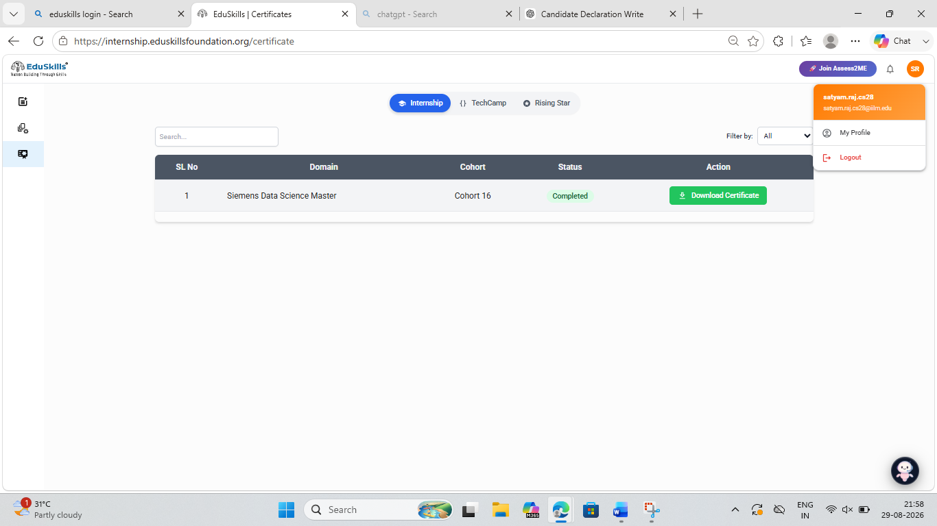
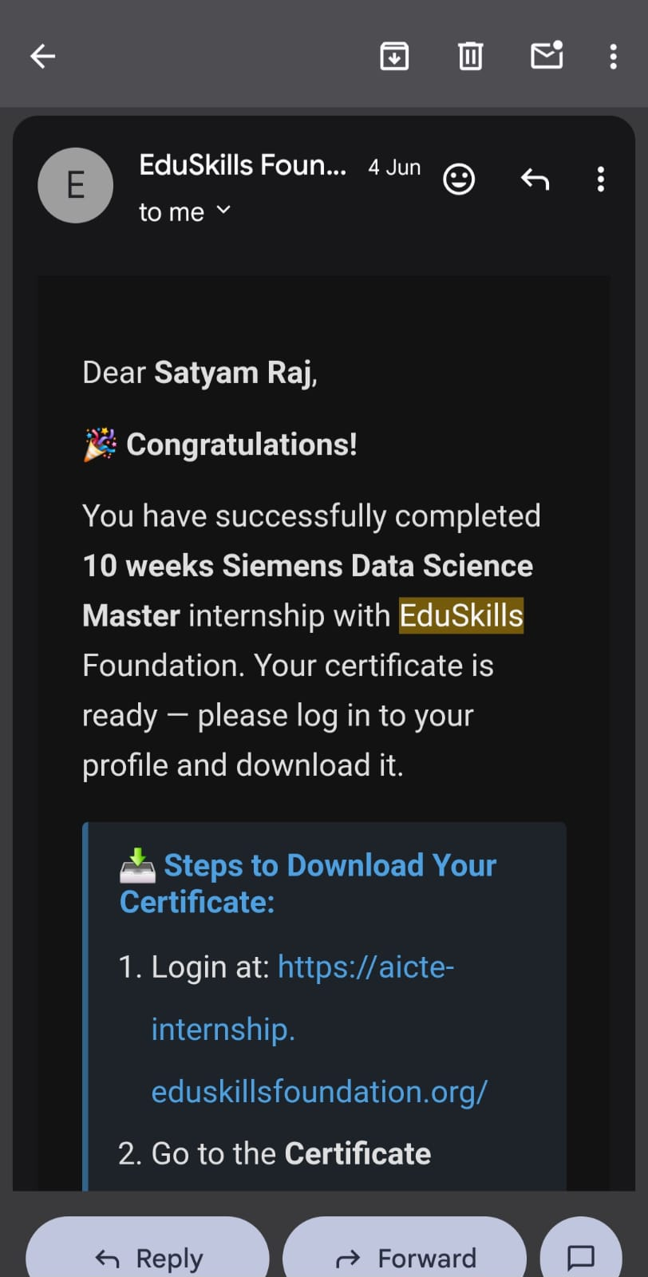

5. BIBLIOGRAPHY/REFERENCES

• EduSkills Academy, “Data Science Master Virtual Internship,” Internship/Program Documentation, 2026.
• EduSkills Academy, “Certificate of Virtual Internship – Data Science Master,” 2026.
• Python Documentation, https://docs.python.org/3/
• Pandas Documentation, https://pandas.pydata.org/docs/
• NumPy Documentation, https://numpy.org/doc/
• Matplotlib Documentation, https://matplotlib.org/stable/
• Scikit-learn Documentation, https://scikit-learn.org/stable/
• Python Data Science Handbook, Jake VanderPlas, O’Reilly Media.
• Hands-On Machine Learning with Scikit-Learn, Keras, and TensorFlow, Aurélien Géron, O’Reilly Media.

