***NamName – Satyam Maddeshiya 200896***

**Satyam Maddeshiya 200896**

**Introduction:** In this report, we perform an exploratory data analysis (EDA) on the Telco Customer Churn dataset. The goal is to gain insights into the data, identify patterns, and explore relationships among different variables

* The Telco Customer Churn dataset consists total of **7043** rows and **21** columns.
* 20 independent and 1 dependent attribute
* No null value or empty row

**1) Male and Female Comprison**

* **Male and Female are approximately equal in the dataset**

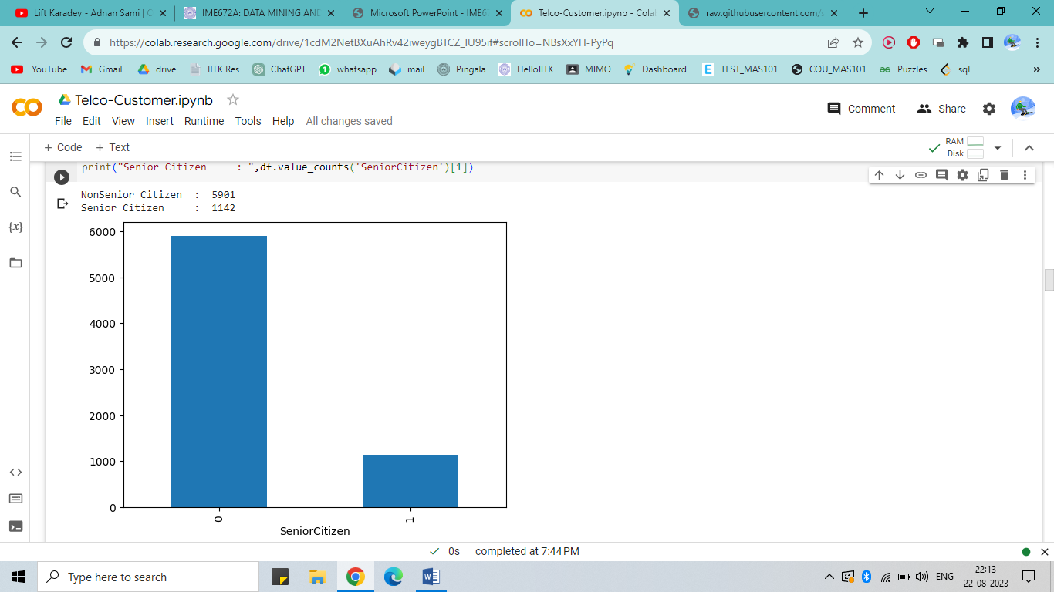

**2) Count of Senior and Non Senior Citizen:**

* Non Senior Citizen are graeter in number

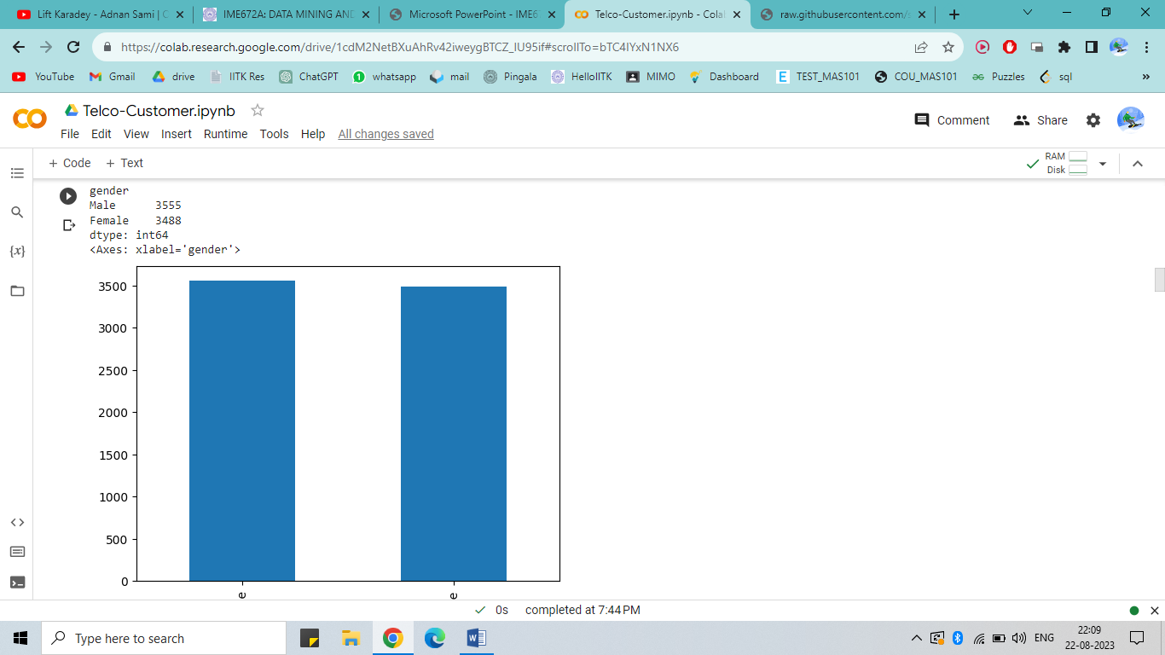

**3) Churn and Citizens Relation**

* Senior Citizen are more Churning as comprison to Non Senior Citizen

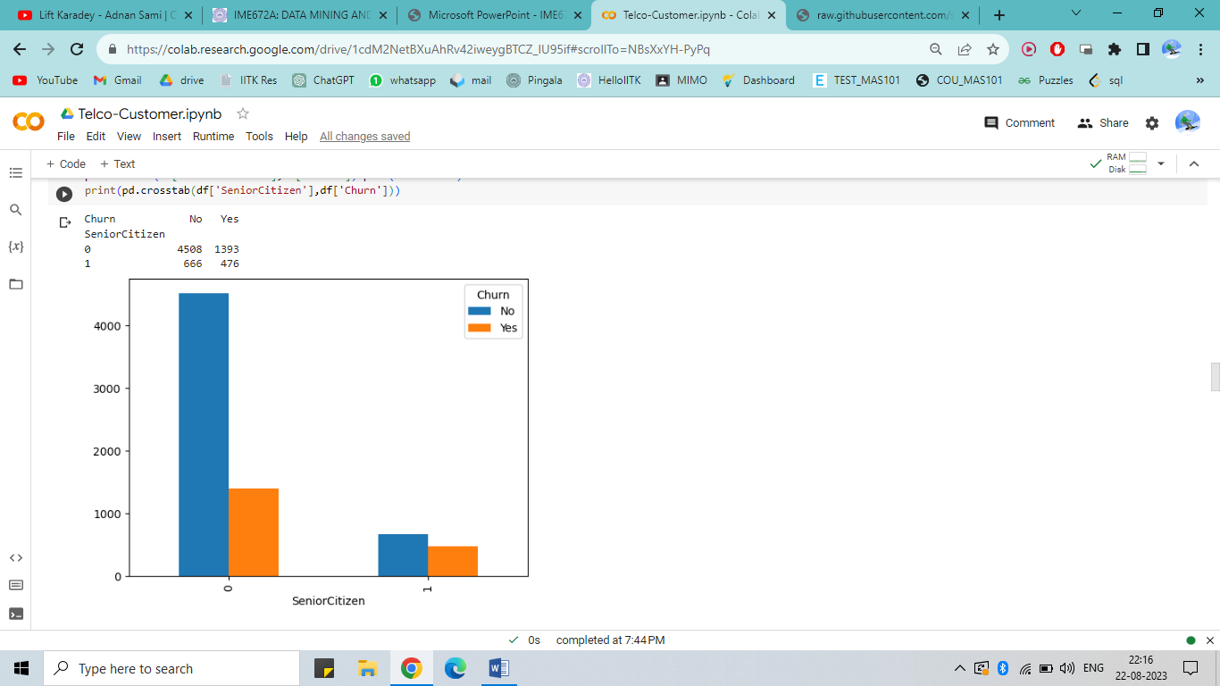

**3) Churn and Gender Relation**

* Male(939) and female(930) are approximatelity same Churn Ratio.

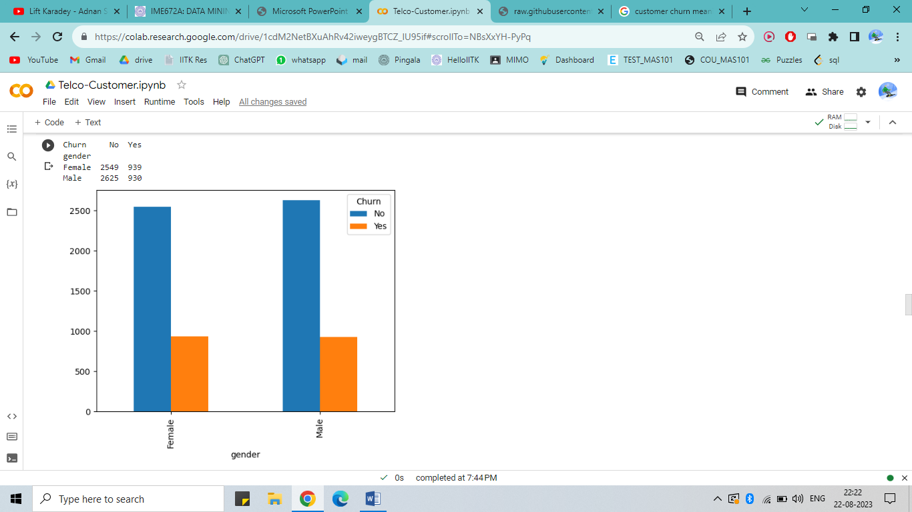

**5) BOX PLOT – Citizen / Monthly Charges**

* Senior Citizen Monthly Chrages are more , the Median of Senior Citizen Monthly are eqal to the 3rd Quartile of Non Senior Citizen.
* Senior Citizen have **Outlier,** some are spending below first Quartile
* Non Senior Citzen have high dispersion of data as compared to Senior Citizen

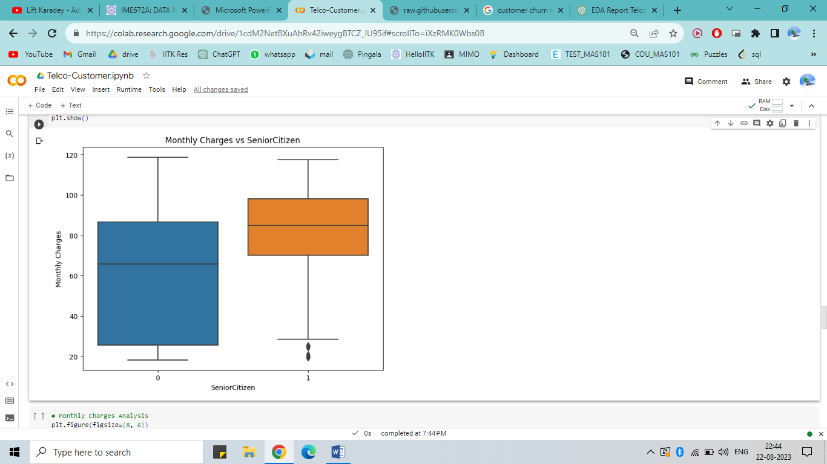

**5) BOX PLOT – Gender / Monthly Charges**

* Seems Equal for both gender , male and female monthly charges are approx same.

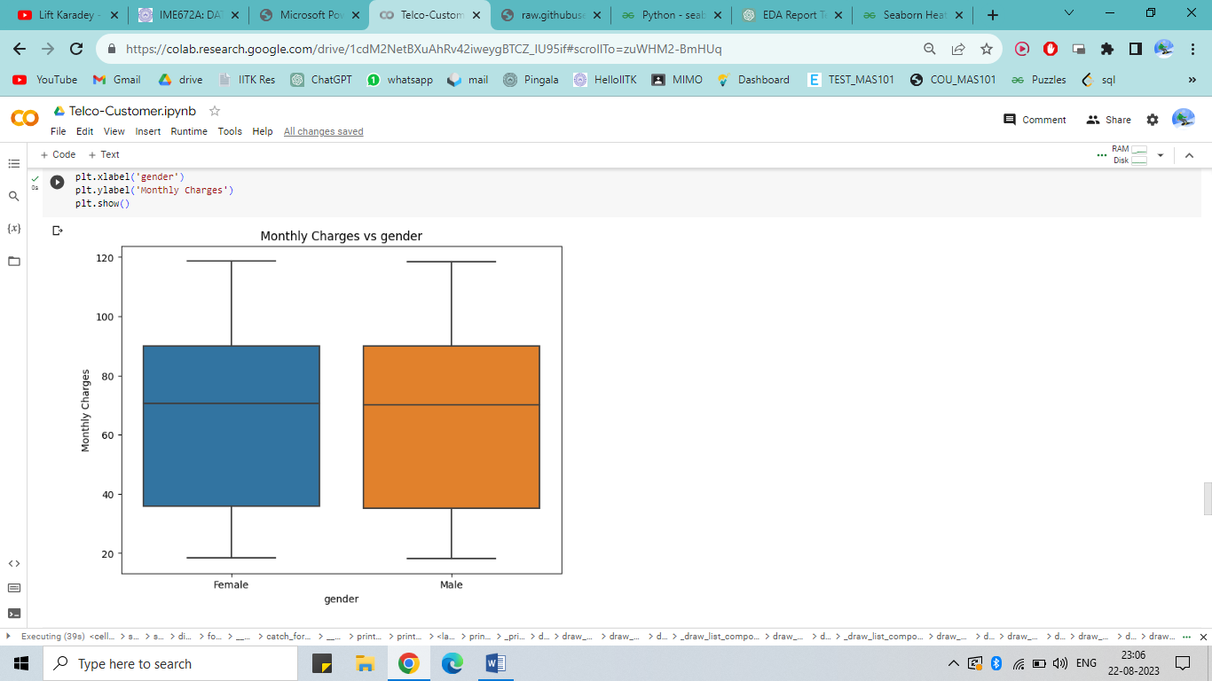

**6) 5) BOX PLOT – Citizen / Total Charges**

* Median for Total charges Senior Citizen are greater than non Senior Citizzen , Senior Citizen spend more totally
* Total Charges of both male and female are nearby same
* Non senior citizen have some outlier

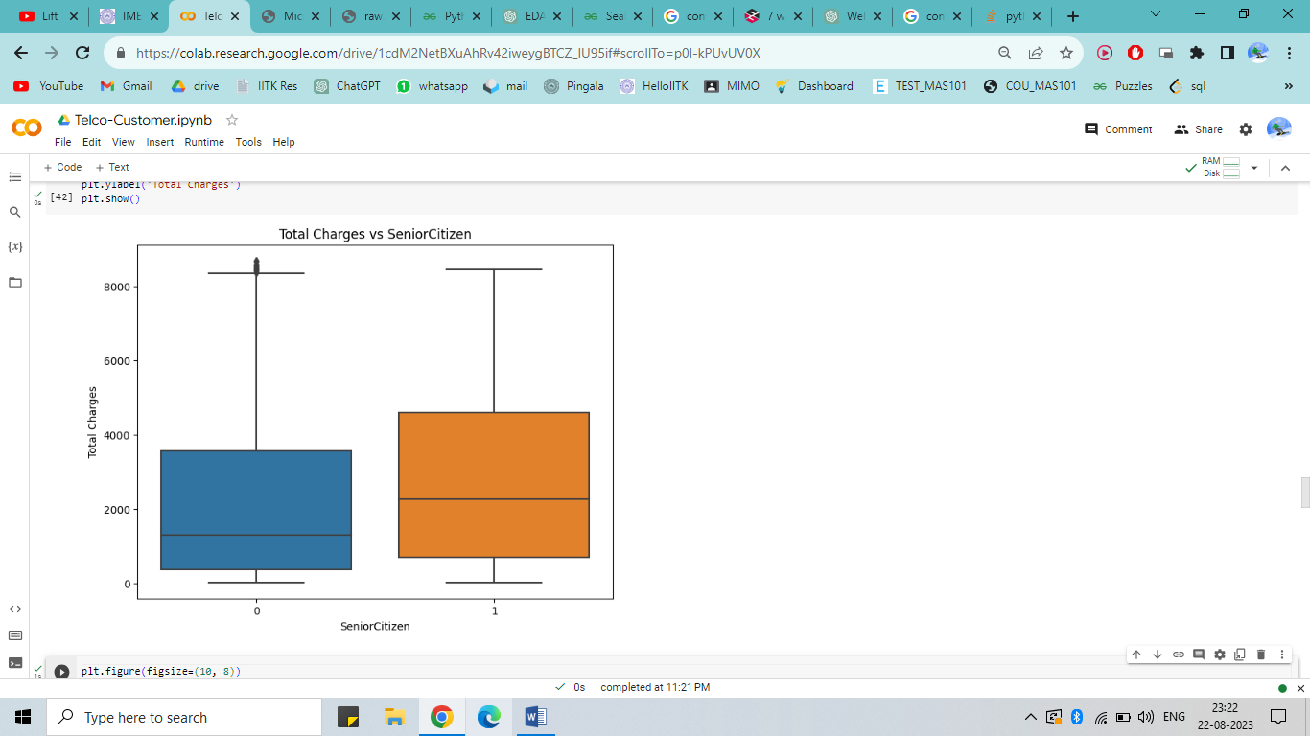

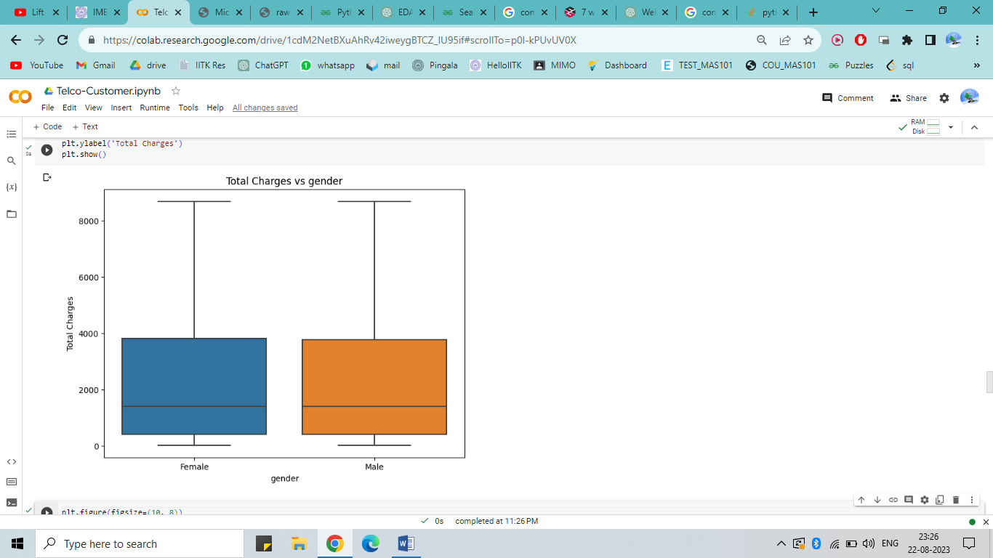

**7) Scatter Plot – Citizen vs Total Charges**

* Non Senior Citizen having Total Chrges greater than 4000 are very less who are Churning
* Senior citizen having total charges less than 3000 are churnig more

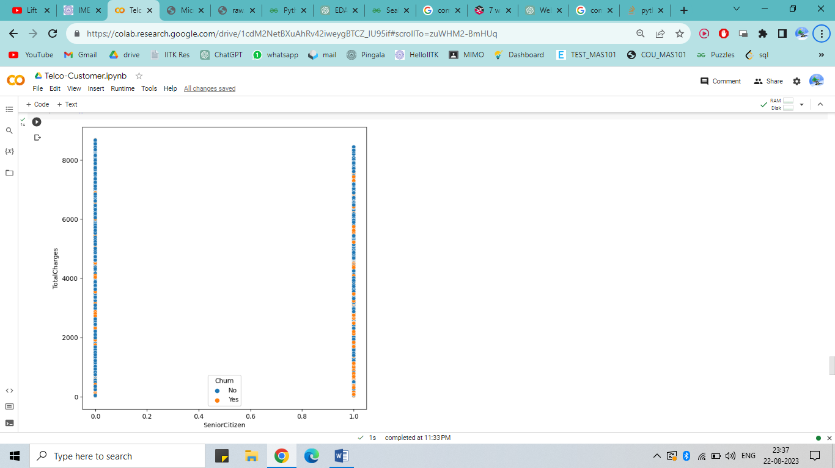

**8) Scatter Plot –Gender vs Total Charges**

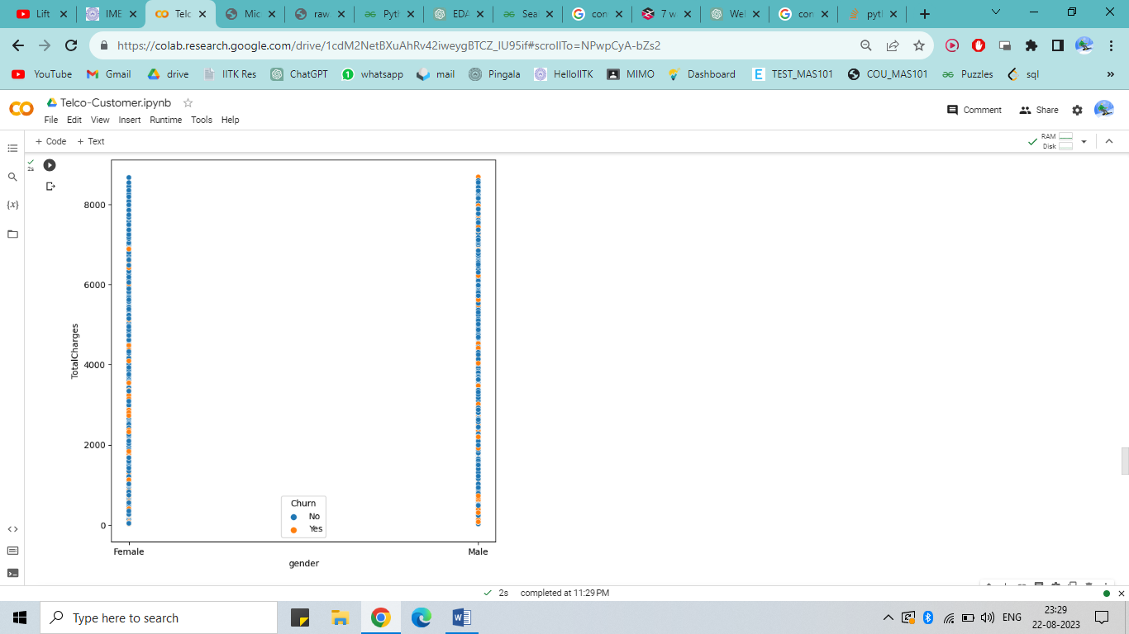

**9) Pair Plot - Churn**

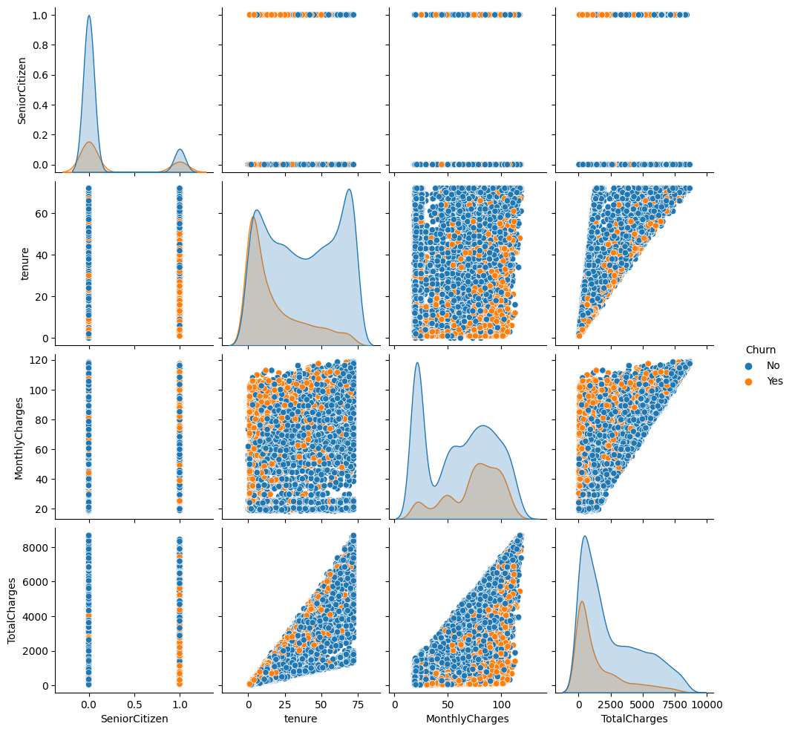

**10) Pair Plot – Gender**

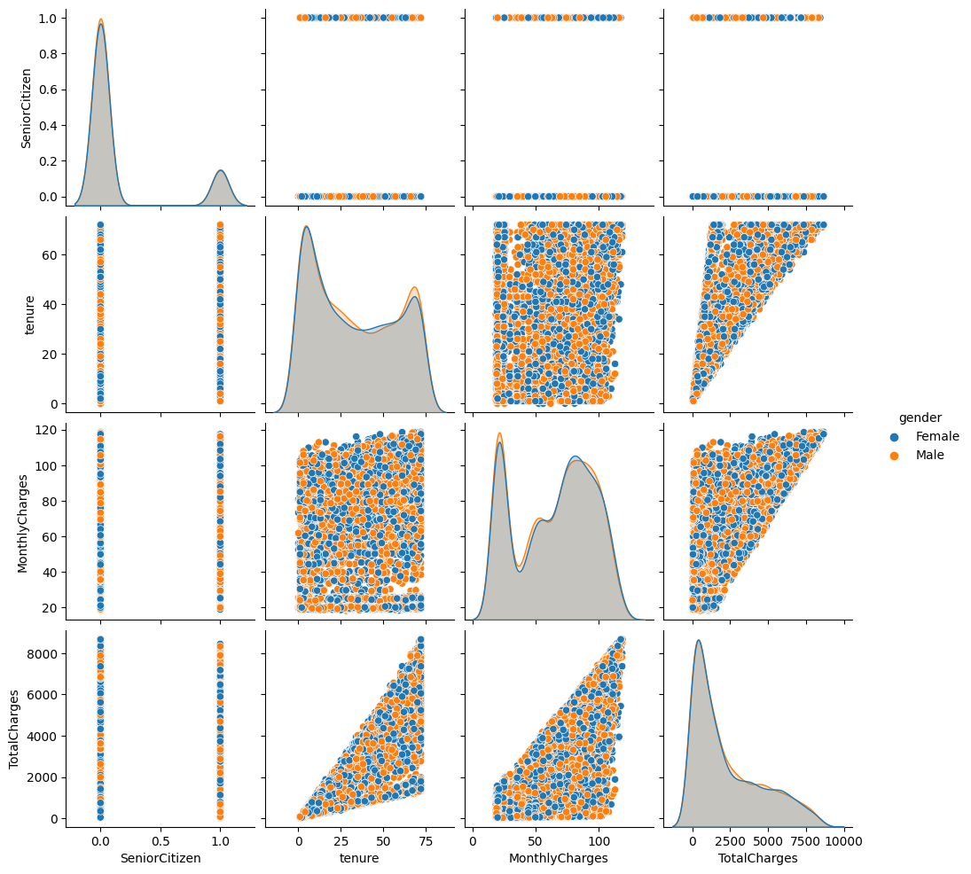

**10) Q-Q Plot : Monthly Charges/ Citizen**

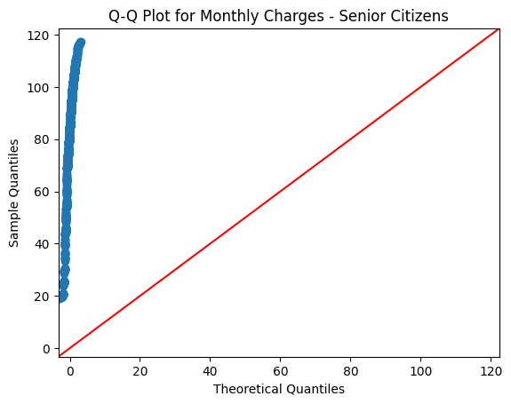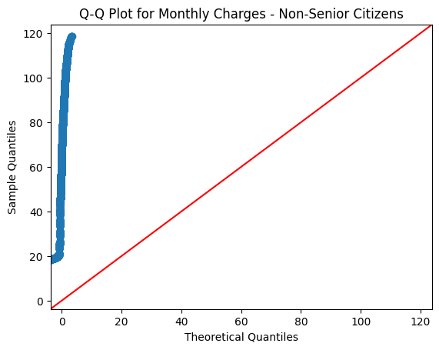

**11) Q-Q Plot - total charges/ citizen**

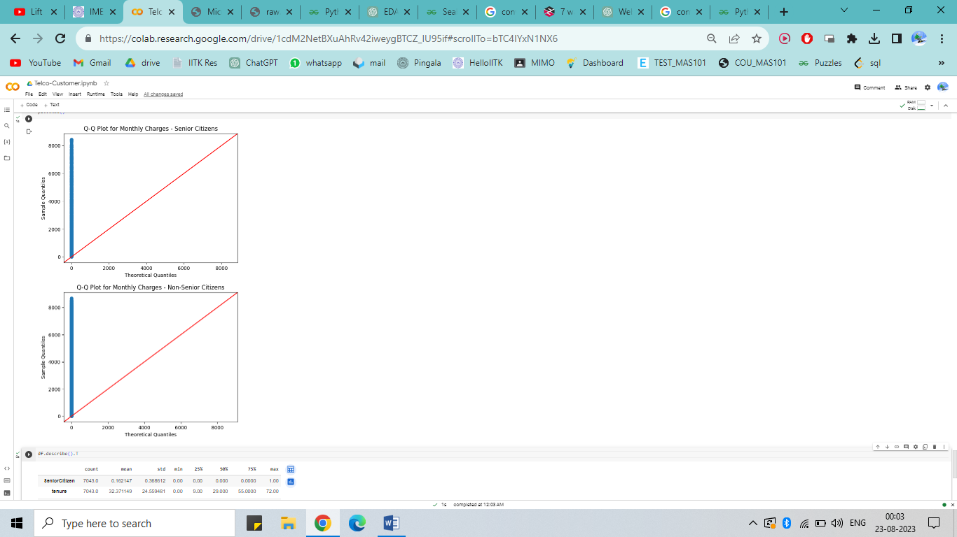

**12) Correlation**

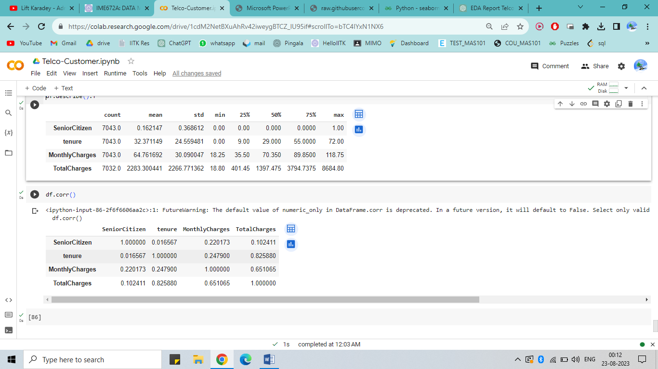

**Senior Citizens** are **less likely to churn** as can be seen from the distribution above.