**PROJECT REPORT**

# **GROWING ENERGY NEEDS AND CONSERVATION**

**SUBMITTED BY-**

# ANANY TALWAD (19BEC004)

# KSHIRSAGAR UDDESH SHYAM (19BEC021)

# SATYAM KUMAR (19BEC040)

**UNDER THE GUIDENCE OF-**

Dr. RAMESH ATHE



INDIAN INSTITUTE OF INFORMATION TECHNOLOGY

DHARWAD

# **Preface**

This report consists of the present energy demands along with all the problems and crisis faced by the present world. We are using our energy resources at very high and fast rate and that’s something to be worried about. However there are certain ways of energy harvesting though which we can save our limited energy resources to some extent.

This is called conservation of energy. All along the report there are stats and points that prove how foolishly we are exhausting our natural resources especially the ones that provide us essential energy to complete our daily operations. At this point we really need to self realize the seriousness of this problem and take active participation to help this world out of the coming energy crisis.

Hope this report will make our point clear about energy resources and conservation so that you may get the real idea about the situation and the ways to tackle with it



**Chapter 1**

**Energy as a Resource**

Energy is the capacity to do work and is required for life processes. An energy resource is something that can produce heat, power life, move objects, or produce electricity.  
 Matter that stores energy is called a fuel.  Human energy consumption has grown steadily. throughout human history. Early humans had modest energy requirements, mostly food and fuel for fires to cook and keep warm. In today's society, humans consume as much as 110 times as much energy per person as early humans.   Most of the energy we use today come from fossil fuels (stored solar energy).   But fossils fuels have a disadvantage in that they are non-renewable on a human time scale, and cause other potentially harmful effects on the environment.  In any event, the exploitation of  all energy sources (with the possible exception of direct solar energy used for heating), ultimately rely on materials on planet Earth.

Some of the questions we want to answer in this discussion are:

1. What sources of Energy are available?
2. How do the energy sources rely on resources available on Earth?
3. Which energy sources are renewable on a human time scale?
4. Since fossil fuels (oil, natural gas, coal) are our main source of energy, how are they formed, how do we find them and exploit them?
5. What is the future for our energy needs?

**Energy Sources**

There are 5 fundamental sources of energy:

1. Nuclear fusion in the Sun (solar energy)
2. Gravity generated by the Earth & Moon.
3. Nuclear fission reactions.
4. Energy in the interior of the Earth.
5. Energy stored in chemical bonds.

**Energy for the Future**

Currently, society relies mostly on fossil fuels for energy (39% natural gas, 24% natural gas, 23% Coal, 8 % nuclear, and 6% other).  Since fossil fuels are non-renewable sources of energy, at least in human lifetimes), we need to ask how much longer society can rely on this source.   Further, what are the options for the future?

**Non-Renewable Resources**

First we look at the reserves of various non-renewable energy resources.  Look at figure 14.28b in your text.   Note that Uranium (for nuclear energy) and Coal appear to be most plentiful, while Tar sands and oil shale are currently not economical.  The current known oil reserves will likely run out sometime between 2050 and 2150.

Currently we are consuming oil at a rate 3 times that of the discovery of new resources. Even in terms of 4,000 years of human history, the oil age will be very short lasting only 150 to 200 years.

Coal reserves could last for about 300 years if we can cope with the associated pollution. Natural Gas is cleaner and can probably last for another 200 years.  
  
Nuclear seems like a good bet in terms of available resources, but can it be made cheap, clean, and safe?  Will the recent problems with nuclear reactors during the March 11, 2011 earthquake have an effect on the future of nuclear energy?  
  
Tar Sands and Oil Shale will require research to find more efficient way to extract, the resource, but will likely be necessary to replace oil in the short term.

**Renewable Resources**

Wind power is limited to areas with high consistent winds, and so is limited to very specific areas. The wind mills are not aesthetically pleasing to look at at, make a lot of noise and kill large numbers of birds,  all problems that would need to be overcome to expand this resource.

As for hydroelectric resources, they will not likely increase, since most rivers are already dammed and there are few places left where new hydroelectric facilities could be built.

Geothermal energy is limited to areas of known thermal activity (mainly recently active volcanic areas).   It is a great local resource, but will never play a major role as an energy resource.

Solar energy is a huge source, but requires other resources (Li, Rare Earth Elements) to exploit.  Many of these problems might be overcome with new research and the development of new technologies.

Hydrogen Fuel Cells are another promising resources with plenty of supply, but needs further research and technological development.

Future energy resources have huge environmental, political and economic implications that could change the world order.  Still, the geologic aspects of energy resources will play a large role.

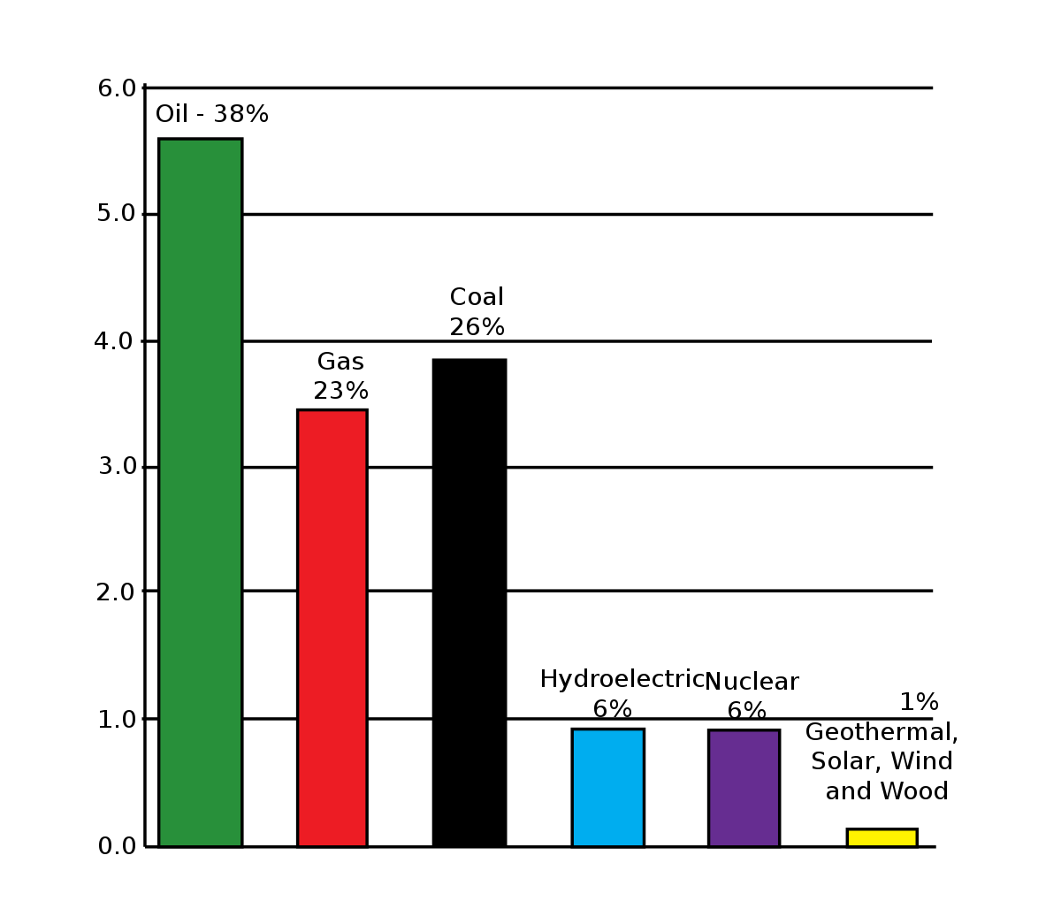

**Chapter 2**

**The Growing Energy Needs in India!**

Energy is derived from non renewable (conventional) and renewable (non conventional) resources and the former are in the process of depletion. These are fossil fuels — oil, coal and natural gas. It took million of years to build up these resources. Renewable resources are solar energy, wind energy, water energy and biomass.

Approximately 80% of the world’s energy is produced by fossil fuels. However, in France, the French Atomic Energy Commission established nuclear reactors which produce enough energy to meet 70% of country’s requirement.

World demand for oil (according to UN reports) rose from 436 million tonnes in 1960 to 2189 million tonnes in 1970 and to 3200 million tonnes in 1999. The corresponding figures for coal are 1043, 1635 and 2146 and for natural gas the figures are 187, 1022 and 2301. The demand will continue to grow. Of the developing countries, China has the highest per capita consumption of energy. For India, per capita consumption is lower than that of China.

It may be mentioned that consumption figures represent commercial energy and do not take into account the non-commercial energy used by developing countries where poor people use wood that is acquired by gathering without any payment.

Among non-conventional resources, hydropower is the largest. Hydropower projects are in operation both in developed and developing countries — notable among the latter are China, India and Brazil. Hydropower potential is huge and at present only 15 percent of the potential in the developing world is being utilised. Wind power has also a great potential Wind mills and sails have been in use since ancient times.

It is a fast-growing resource. In 1980s, wind energy generation of the world was 10 megawatts. In the year 2000 it was 14000 megawatts. Green Piece International estimates that if the present trend continues wind power could supply 10% of world’s electricity by 2020.

The use of solar energy is through photovoltaic cells. The photovoltaic news reported that world’s photovoltaic production climbed from 0.1 megawatt to 200 megawatts in 1999. The biomass resources are various types of cultivated or uncultivated vegetation. Wood forms the chief resource and is the primary fuel for the people in Africa and Asia. Excessive use of wood has led to depletion of forests.

**Indian Scenario:**

Coal, oil, gas and water constitute the main sources of energy in our country. The share of various energy sources in the commercial consumption of energy is mostly from coal (56%) and petroleum (32%), the other sources being nuclear natural gas and water. Apart from commercial energy, a large amount of traditional energy sources in the form of fuel wood, agriculture waste and animal residue are used.

Commercial energy consumption has grown from 130.7 MTOE (million tonnes of oil equivalent) in 1991-92 to 176.08 MTOE in 1997-98. The main drivers of this increase are the accompanying structural change of economic growth and a rise in population together with rapid urbanization. Industrial sector is the largest consumer of energy consuming about 50% of the total commercial energy produced in the country followed by the transport sector.

Among the most energy intensive industries which together account for

nearly 80% of the total industrial energy consumption are the fertilizer,

aluminum, textiles, cement, iron and steel, pulp and paper and chloro-alkali.

Transport sector is the largest consumer of petroleum products — mainly in the form of high speed diesel and gasoline and accounts for nearly 50% of the total consumption. With increase mechanisation and modernization of its activities, the agricultural sector’s consumption of commercial energy has grown considerably. The share of the farm sector in electrical energy consumption has increased from a mere 3.9% in 1950-51 to about 32.5% in 1996-97.

In the domestic sector, the consumption of natural fuel (mostly wood) energy is very high. Around 78% of rural and 30% of urban households depend on fire wood. However, the mix of traditional fuels in the national energy mix is decreasing as more efficient commercial fuels are increasingly substituting these.

In particular between 1970-71 and 1994-95, the annual consumption of

electricity per household went-up from 7 kwh to 53 kwh; of kerosene from 6.6 kg to 9.9 kg and of cooking gas from 0.33 kg to 3.8 kg. There is, however, a marked disparity in the level of energy and type of fuel consumed in rural and urban areas

**Energy Production and Reserves:**

India ranks third amongst the coal producing countries of the world. Coal

production has grown considerably from 100 mt (million tonnes) in 1975-76 to 306 mt in 1998-99. Only about 15% of the coal produced domestically has coking properties and is used in the iron and steel industry.

The bulk of the coal produced is inferior grade non-coking coal used to meet the demands of the power sector. This coal is of poor quality with high ash contents (40-50%) and low calorific value (1300-4200 Kcl/kg). India is one of the least explored regions with an oil well density of 20 per 10,000 sq. km against a world average of 100.

In-spite of a significant growth, domestic production has not matched demand, tending to a constant growth in net imports which were estimated at 39.81 mt. of crude oil and 17.4 mt of petroleum products in 1998-99.

The country’s self-reliance in petroleum products has declined from 56% in 1990-91 to about 34% in 1998-99. The share of hydro in the hydro-thermal capacity mix has changed significantly since the early 1970s. It was 43% in 1970-71 which has now come down to about 24%. India also has substantial reservoir of nuclear fuels — the world’s largest deposits of thorium, about 363 thousand tonnes and about 34 thousands tonnes of the Uranium ore.Traditionally India has been deficient in power generation vis-a-vis its demand.

The following table 2.9. shows deficit and capacity additions during various

plan periods.



The country’s power demand supply deficit position for different periods isshown in the following table 2.10.

Table 2.10.: Power Demand, Supply and Deficit for different periods at National level.

# 

In our country, the picture so far has been a steady growth in energy demand of over 6% in the eighties corresponding to a GDP growth rate of 5.6%. There has been a gradual shift to commercial sources of energy from 35% of total energy supply 1970 to 50% in 1990. The pattern of final energy consumption has also changed with power generation using 55% of the commercial energy supply as compared to 36% in 1970.

The following table 2.11 illustrates the changes:



In India with the high rate of growth in population and increasing development needs the growth in the demand of primary energy has been accompanied by a shift to an increase in the share of commercial energy in the total energy demand.

The domestic sources of commercial energy supply have not kept pace

with growing requirements as may be seen from the following table 2.12.

# 

# C:\Users\Sir\Desktop\images.png

**Chapter 3**

**Conservation of Energy Resources**

**3.1**. ALTERNATIVE SOURCES OF ENERGY :-

**3.1.1. Solar Power**

When most people think of alternative energy sources they tend to use solar power as an example. The technology has evolved massively over the years and is now used for large-scale energy production and power generation for single homes.

A number of countries have introduced initiatives to promote the growth of solar power. The United Kingdom’s ‘Feed-in Tariff’ is one example, as is the United States’ ‘Solar Investment Tax Credit’.

This energy source is completely renewable and the costs of installation are outweighed by the money saved in energy bills from traditional suppliers. Nevertheless, solar cells are prone to deterioration over large periods of time and are not as effective in un-ideal weather conditions.

**3.1.2. Nuclear Power**

Nuclear power is amongst the most abundant forms of alternative energy. It creates a number of direct benefits in terms of emissions and efficiency, while also boosting the economy by creating jobs in plant creation and operation.

Thirteen countries relied on nuclear power to produce at least a quarter of their electricity as of 2015 and there are currently 450 plants in operation throughout the world.

The drawback is that when something goes wrong with a nuclear power plant the potential for catastrophe exists. The situations in Chernobyl and Fukushima are examples of this.

**3.1.3. Hydroelectric Energy**

Hydroelectric methods actually are some of the earliest means of creating energy, though their use began to decline with the rise of fossil fuels. Despite this, they still account for approximately seven percent of the energy produced in the United States.

Hydroelectric energy carries with it a number of benefits. Not only is it a clean source of energy, which means it doesn’t create pollution and the myriad issues that arise from it, but it is also a renewable energy source.

Better yet, it also offers a number of secondary benefits that are not immediately apparent. The dams used in generating hydroelectric power also contribute to flood control and irrigation techniques.

**3.1.4. Wave Energy**

Water again proves itself to be a valuable contributor to alternative energy fuel sources with wave energy converters. These hold an advantage over tidal energy sources because they can be placed in the ocean in various situations and locations.

Much like with tidal energy, the benefits come in the lack of waste produced. It is also more reliable than many other forms of alternative energy and has enormous potential when used properly.

Again, the cost of such systems is a major contributing factor to slow uptake. We also don’t yet have enough data to find out how wave energy converters affect natural ecosystems.

**3.1.5. Biofuels**

In contrast to biomass energy sources, biofuels make use of animal and plant life to create energy. In essence they are fuels that can be obtained from some form of organic matter.

They are renewable in cases where plants are used, as these can be regrown on a yearly basis. However, they do require dedicated machinery for extraction, which can contribute to increased emissions even if biofuels themselves don’t.

Biofuels are increasingly being adopted, particularly in the United States. They accounted for approximately seven percent of transport fuel consumption as of 2012.

**3.1.6. Natural Gas**

Natural gas sources have been in use for a number of decades, but it is through the progression of compression techniques that it is becoming a more viable alternative energy source. In particular, it is being used in cars to reduce carbon emissions.

Demand for this energy source has been increasing. In 2016, the lower 48 states of the United States reached record levels of demand and consumption.

Despite this, natural gas does come with some issues. The potential for contamination is larger than with other alternative fuel sources and natural gas still emits greenhouse gases, even if the amount is lower than with fossil fuels.

**3.1.7. Geothermal Power**

At its most basic, geothermal power is about extracting energy from the ground around us. It is growing increasingly popular, with the sector as a whole experiencing [five percent growth](http://geo-energy.org/reports/2015/2015%20Annual%20US%20%20Global%20Geothermal%20Power%20Production%20Report%20Draft%20final.pdf) in 2015.

The World Bank currently estimates that around forty countries could meet most of their power demands using geothermal power.

This power source has massive potential while doing little to disrupt the land. However, the heavy upfront costs of creating geothermal power plants has led to slower adoption than may have been expected for a fuel source with so much promise.

**3.1.8. Wind Energy**

This form of energy generation has become increasingly popular in recent years. It offers much the same benefits that many other alternative fuel sources do in that it makes use of a renewable source and generates no waste.

Current wind energy installations power roughly twenty million homes in the United States per year and that number is growing. Most states in the nation now have some form of wind energy set-up and investment into the technology continues to grow.

Unfortunately, this form of energy generation also presents challenges. Wind turbines restrict views and may be dangerous to some forms of wildlife.

**3.1.9. Biomass Energy**

Biomass energy comes in a number of forms. Burning wood has been used for thousands of years to create heat, but more recent advancements have also seen waste, such as that in landfills, and alcohol products used for similar purposes.

Focusing on burning wood, the heat generated can be equivalent to that of a central heating system. Furthermore, the costs involved tend to be lower and the amount of carbon released by this kind of fuel falls below the amount released by fossil fuels.

However, there are a number of issues that you need to consider with these systems, especially if installed in the home. Maintenance can be a factor, plus you may need to acquire permission from a local authority to install one.

**3.1.10. Hydrogen Gas**

Unlike other forms of natural gas, hydrogen is a completely clean burning fuel. Once produced, hydrogen gas cells emit only water vapor and warm air when in use.

The major issue with this form of alternative energy is that it is mostly derived from the use of natural gas and fossil fuels. As such, it could be argued that the emissions created to extract it counteract the benefits of its use.

The process of electrolysis, which is essential for the splitting of water into hydrogen and oxygen, makes this less of an issue. However, electrolysis still ranks below the previously mentioned methods for obtaining hydrogen, though research continues to make it more efficient and cost-effective.

**3.1.11. Tidal Energy**

While tidal energy uses the power of water to generate energy, much like with hydroelectric methods, its application actually has more in common with wind turbines in many cases.

Though it is a fairly new technology, its potential is enormous. A report produced in the United Kingdom estimated that tidal energy could meet as much as 20% of the UK’s current electricity demands.

The most common form of tidal energy generation is the use of Tidal Stream Generators. These use the kinetic energy of the ocean to power turbines, without producing the waste of fossil fuels or being as susceptible to the elements as other forms of alternative energy.

**3.2**. CONVENTIONAL SOURCES OF ENERGY:-

**3.2.1. Fossil Fuels**

## Conventional energy sources come primarily from fossil fuels. These are organic compounds created by the remains of plants and animals whose organic "biomass," over time, creates substances we know as coal, natural gas and petroleum. The U.S. Energy Information Administration indicates that as of 2012, fossil fuels account for 84 percent of U.S. energy consumption. These fuels are used in manufacturing and transportation and support the electrical and power systems of homes and businesses.

Oil is perhaps one of the most common and conventional sources of fossil-fuel energy production. It keeps the nation's transportation systems moving -- through the production of gasoline, diesel and aviation fuel -- and the cost effectiveness of these fuels is a critical element of small-business operations. Coal is a biofuel that serves as an effective heat-energy source, and it is used in electricity generation and as fuel for power plants. Natural gas is growing in popularity as a conventional energy source because of the vast underground reserves in the U.S.

**3.3.2. Renewable Energy**

## Sun, wind and water are considered semi-conventional, renewable, non-polluting energy sources because they are continually replenished. Although the concept of harnessing renewable energy sources has become mainstream, its full implementation is still taking place, primarily because of cost considerations. Although renewable energy comes from "free" sources, it still requires a great deal of manpower and machinery to turn these resources into energy. Hydropower generates electricity by using water, the most common renewable energy source in the U.S.

Solar power harnesses energy from the sun for electricity and heating. Wind energy is produced through high-tech turbines, with the energy distributed through an electrical grid. Many small businesses are finding value in creating their own energy sources through use of solar panels and wind turbines on their property. These methods reduce energy costs, and businesses may also generate a profit by selling unused energy to the power companies in their region.

**3.2.3. Bio-Mass**

## Biomass is another semi-conventional energy source because it is in the process of becoming mainstream. Biomass energy comes from plant material. Biomass also serves as a waste-management system. Many small agricultural and farming businesses are able to save on energy costs by converting the by-products of their operations into biofuel. Biomass energy can be used for heating and generating electricity, and it is becoming increasingly available as liquid biofuel for powering engines. Biomass has an added benefit of reducing some forms of pollution.

**3.2.4. Electro-Fuels And Engineered Fuels**

## Electro-fuels are innovative unconventional renewable liquids that use microorganisms to create chemical or electrical energy necessary for converting carbon dioxide into liquid fuels. As of 2012, Columbia University scientists are searching for natural ways to create a fuel similar to gasoline. Researchers at the Office of Science's Joint Bio-Energy Institute are developing a renewable alternative to diesel fuel, too, using a metabolic engineering process. Unlike biodiesel that originates in vegetable oil, metabolically engineered fuels are made from the chemical compound bisabolane. JBEI researchers use an evergreen tree, yeast, microbes and E. coli bacteria to produce the compound. This technology has the potential for employing emerging biotech start-up companies and small-scale

tyam Thakur