\\172.17.11.241\tt

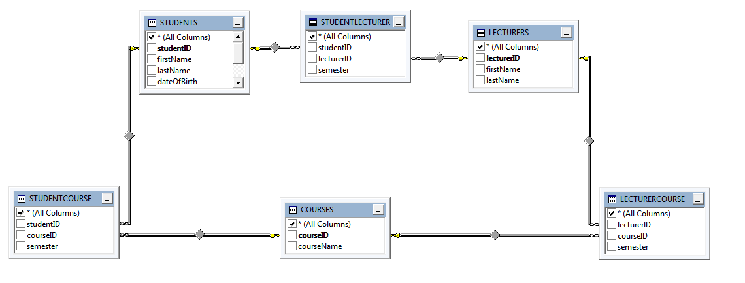

SELECT Person.Title, Person.FirstName FROM Person.Person WHERE Person.Title LIKE 'Ms.'

SELECT Person.Title, Person.FirstName FROM Person.Person WHERE Person.Title = 'Ms.'

SELECT BusinessEntityID as 'Employee ID', VacationHours as 'Vacation', SickLeaveHours as 'Sick Time' FROM HumanResources.Employee

select * from Sales.SalesOrderHeader where DueDate between '2011-07-24T00:00:00' and '2013-07-24T23:59:59'

select ProductID,Name,Color from Production.Product where Color = 'Silver' or Color= 'Black' or color='Red'

Employee Management System

create table EMPLOYEE_DETAILS
(User_name varchar(20),
Password varchar(20),
Sex varchar(8),
State varchar(20),
DOB datetime,
Contact_no varchar(11)
)

alter table employee_details add Emp_id int not null

alter table employee_details add constraint [PK_1] primary key (Emp_id)

create table userLogin (
User_id int primary key,
Password varchar(30),
UserName varchar(30),
)

stored procedures

create proc usp_EmployeeDetails
@Emp_id int,
@UserName varchar(30),
@Password varchar(30) null,
@Sex varchar(8) null,
@State varchar(20) null,
@DOB datetime null,
@Contact_no varchar(11) null,
@status int output,
@userid int output

as
begin
set @status=0
if not exists(select UserName from userLogin where UserName=@UserName)
begin
insert into EMPLOYEE_DETAILS values
(
@Emp_id,
@UserName,
@Password,
@Sex,
@State,
@DOB,
@Contact_no
)
set @userid=SCOPE_IDENTITY()
set @status=@@ROWCOUNT
end
end

create proc usp_Login
@User_id int,
@UserName varchar(30) null,
@Password varchar(30) null,
@status int output,
@userid int output
as
begin
select UserName from userLogin where UserName=@UserName and Password=@Password
set @userid = (select @userid from userLogin where UserName=@UserName and Password=@Password)
set @status = @@ROWCOUNT
end

