using System;
using System.Collections.Generic;
using System.Linq;
using System.Web;
using System.Web.UI;
using System.Web.UI.WebControls;

namespace inHeritance
{
public partial class WebForm1 : System.Web.UI.Page
{
protected void Page_Load(object sender, EventArgs e)
{
int[] nums = new int[5];
try
{
lblException.Text = "<br/>Before exception";
//generate an index out-of-bounds exception
for (int i = 0; i < 10; i++)
{
nums[i] = i;
lblException.Text += "<br/>Num[" + i + "] --> " + nums[i];
}
lblException.Text += "<br/>This won't happen again";
}
catch(IndexOutOfRangeException)
{
//catch the exception
lblException.Text += "<br/>Index Out Of Range";
}
lblException.Text += "<br/>After catch statement";
}
}

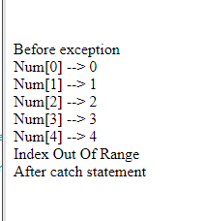
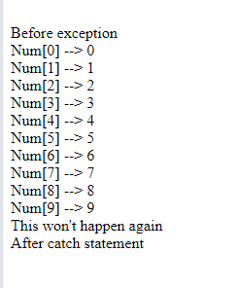

int[] numerator = { 4,8,16,32,64,128,256,512 };
int[] denominator = { 2, 0, 4, 0, 8 };
for (int i = 0; i < numerator.Length; i++)
{
try
{
double temp=numerator[i] / denominator[i];

lblException.Text += "<br/>" +temp + "<br/>";
}
catch (DivideByZeroException)
{
lblException.Text += "<br>DivideByZeroException";
}
catch (IndexOutOfRangeException)
{
lblException.Text += "<br>IndexOutOfRangeException";
}

}

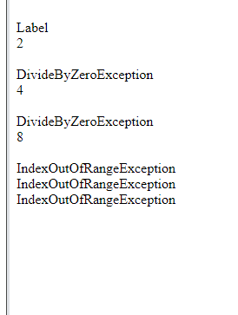

int[] numerator = { 4,8,16,32,64,128,256,512 };
int[] denominator = { 2, 0, 4, 0, 8 };
for (int i = 0; i < numerator.Length; i++)
{
try
{
double temp = numerator[i] / denominator[i];

lblException.Text += "<br/>" + temp;
}
catch (DivideByZeroException)
{
lblException.Text += "<br>DivideByZeroException";
}
catch (IndexOutOfRangeException)
{
lblException.Text += "<br>IndexOutOfRangeException";
}
finally
{
lblException.Text += "<br/>Finally Blocked";
}
}

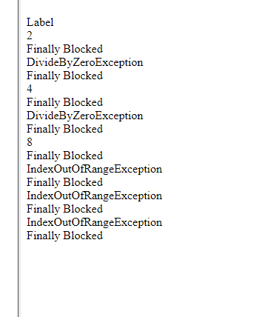

MyException.cs

using System;
using System.Collections.Generic;
using System.Linq;
using System.Web;

namespace inHeritance
{
public class MyException: Exception
{
public MyException(string Message) : base(Message) { }
public MyException() { }
public MyException(string Message, Exception inner) : base(Message, inner) { }

}
}

WebForm1.aspx.cs

using System;
using System.Collections.Generic;
using System.Linq;
using System.Web;
using System.Web.UI;
using System.Web.UI.WebControls;

namespace inHeritance
{
public partial class WebForm1 : System.Web.UI.Page
{
protected void Page_Load(object sender, EventArgs e)
{
int a = 50;
int b = 10;
int k = a / b;
try
{
if (k < 10)
{
throw new MyException("value of k is less than 10");
}
}
catch (MyException e1)
{
lblException.Text = "<br/>caught My Exception";
lblException.Text += e1.Message;
}
}
}
}
