Mini Project Report
on
“Comparative analysis of commercially available device and subcircuit models”
Submitted in partial fulfilment of the requirement for the award of the degree of

BACHELOR OF TECHNOLOGY

IN

ELECTRONICS AND COMMUNICATION ENGINEERING

Submitted by:

Kamini Kumari 2022100
Satyam Kumar 2022113
ECE VI SEM

Under the Mentorship of

Dr. Peyush Pande
Professor, ECE



Department of Electronics and Communication Engineering
Graphic Era (Deemed to be University)
Dehradun, Uttarakhand
June-2025



CANDIDATE’S DECLARATION

I hereby certify that the work which is being presented in the project report entitled “Comparative analysis of commercially available device and subcircuit models” in partial fulfillment of the requirements for the award of the Degree of Bachelor of Technology in Electronics and Communication Engineering of the Graphic Era (Deemed to be University), Dehradun shall be carried out by the under the mentorship of Dr. Peyush Pande, Professor, Department of Electronics and Communication Engineering, Graphic Era (Deemed to be University), Dehradun.

Kamini Kumari
2022100

Satyam Kumar
2022113



Graphic Era (Deemed to be University)
Dehradun, Uttarakhand

Department of Electronics and Communication Engineering

CERTIFICATE

This is to certify that the following group members

1. Ms. Kamini Kumari (Roll No- 08)
2. Mr. Satyam Kumar (Roll No- 20)

of Third Year (Electronics and Communication Engineering) has successfully completed their work entitled “Comparative analysis of commercially available device and subcircuit models” towards the partial fulfillment of award of Bachelor of Technology (Electronics and Communication Engineering) degree as laid by the Graphic Era (Deemed to be University) during the academic year 2024-2025.

Dr. Peyush Pande Prof. (Dr.) Md Irfanul Hasan
Professor, ECE Head, ECE, GEU

Table of Contents

Chapter No. | Description | Page No.
Chapter 1 | Introduction
Chapter 2 | Literature Survey
Chapter 3 | Methodology
Chapter 4 | Results and Discussion
Chapter 5 | Conclusion and Future Work
 | References

Chapter 1
Introduction
The evolution of power electronics has been significantly influenced by the advent of wide-bandgap (WBG) semiconductors, with Gallium Nitride (GaN) High Electron Mobility Transistors (HEMTs) standing out due to their superior electrical properties. GaN HEMTs offer advantages such as higher breakdown voltages, faster switching speeds, and lower on-resistance compared to traditional silicon-based devices, making them ideal for high-efficiency and high-frequency applications.

Accurate modeling of GaN HEMTs is crucial for the design and optimization of power electronic systems. Manufacturers provide simulation models, typically categorized into device models and subcircuit models. Device models often employ simplified representations, focusing on basic electrical characteristics, while subcircuit models incorporate detailed parasitic elements and voltage-dependent behaviors, offering enhanced accuracy at the cost of increased complexity.

One of the critical aspects influencing the dynamic performance of GaN HEMTs is the voltage-dependent nature of their intrinsic capacitances, namely gate-to-source gate-to-drain and drain-to-source. These capacitances vary with the applied voltages and significantly impact the switching behavior, leading to variations in switching losses. Therefore, precise modeling of these capacitances is essential for reliable simulation outcomes.

This project focuses on a comparative analysis of commercially available GaN HEMT device models and subcircuit models using LTspice simulation software. The primary objectives are:

1. *Modeling Voltage-Dependent Capacitances*: Extract capacitance values from manufacturer datasheets across various voltage levels and fit these values to appropriate mathematical functions to define C(V).

2. *Switching Loss Analysis*: Perform double-pulse test (DPT) simulations to evaluate switching losses, including turn-on and turn-off energy losses. The DPT is a widely adopted method for characterizing the dynamic performance of power devices, providing insights into switching energy losses and voltage/current stresses under specific operating conditions. ([enbtalks.wordpress.com][1])

3. *Comparative Evaluation*: Compare the simulation results of device models and subcircuit models, highlighting their respective accuracies and computational efficiencies. This includes assessing the fidelity of voltage-dependent capacitance modeling and the precision of switching loss estimations.

By achieving these objectives, the project aims to provide insights into the effectiveness of different modeling approaches for GaN HEMTs, guiding engineers and researchers in selecting appropriate models for their specific applications.

Chapter 2
Literature Survey
1. Advancements in GaN HEMT Modeling
Gallium Nitride (GaN) High Electron Mobility Transistors (HEMTs) have garnered significant attention in power electronics due to their superior properties, such as lower parasitic capacitance and absence of reverse recovery current, enabling operation at higher switching frequencies. These characteristics make GaN HEMTs ideal for high-efficiency, high-frequency applications.
Accurate modeling of GaN HEMTs is crucial for the design and optimization of power electronic circuits. Standard SPICE Level 3 models, traditionally used for silicon-based devices, have been adapted to model GaN HEMTs. For instance, researchers have demonstrated that by adjusting parameters like threshold voltage , transconductance, and channel length modulation (λ), the Level 3 model can effectively replicate the static and dynamic behavior of GaN HEMTs. This approach provides a balance between model complexity and simulation accuracy, facilitating efficient circuit simulations.

2. Voltage-Dependent Capacitance Modeling
The intrinsic capacitances of GaN HEMTs, namely gate-to-source, gate-to-drain, and drain-to-source are voltage-dependent and significantly influence the switching behavior of these devices. Accurate modeling of these capacitances is essential for reliable simulation of switching transients and losses.
Advanced modeling techniques involve characterizing these capacitances as nonlinear functions of voltage, derived from empirical data or manufacturer datasheets. For example, behavioral models have been developed that incorporate voltage-dependent capacitance expressions, enhancing the fidelity of transient simulations. These models have been validated against experimental measurements, demonstrating their effectiveness in capturing the dynamic behavior of GaN HEMTs.

3. Switching Loss Analysis in GaN HEMTs
Switching losses are a critical factor in the efficiency of power electronic systems. GaN HEMTs, with their fast switching capabilities, can reduce these losses; however, accurate estimation is necessary for thermal management and reliability assessments.
Double Pulse Test (DPT) simulations are commonly employed to evaluate switching losses. These tests involve applying two consecutive pulses to the device and measuring the energy loss during turn-on and turn-off events. Researchers have utilized DPT simulations in conjunction with detailed SPICE models to quantify switching losses in GaN HEMTs, providing insights into device performance under various operating conditions .

4. Comparative Studies: GaN HEMTs vs SiC MOSFETs
Silicon Carbide (SiC) MOSFETs are another class of wide-bandgap semiconductors used in power electronics. Comparative studies between GaN HEMTs and SiC MOSFETs have been conducted to evaluate their respective advantages.
For instance, a study presented a SPICE Level 3 model for SiC MOSFETs, calibrated using nonlinear fitting to experimental data. The model accurately replicated both static and dynamic behaviors, facilitating reliable circuit simulations. Such comparative analyses help in understanding the trade-offs between different device technologies and guide the selection process for specific applications.

5. Importance of Accurate Device Modeling in Converter Design
Accurate device modeling is paramount in the design of power converters. The use of precise SPICE models allows for the prediction of circuit behavior under various conditions, aiding in the optimization of performance and reliability.
Researchers have emphasized the significance of incorporating detailed device models, including voltage-dependent capacitances and parasitic elements, into simulations. Such comprehensive modeling ensures that the simulated performance closely aligns with real-world behavior, reducing the risk of design iterations and improving time-to-market .

Chapter 3
Methodology
This section outlines the systematic approach adopted to perform a comparative analysis of commercially available GaN HEMT device and subcircuit models using LTspice. The methodology encompasses model selection, parameter extraction, simulation setup, and data analysis to evaluate voltage-dependent capacitances and switching losses.

1. Selection of GaN HEMT Devices and Models
Device Selection: Commercially available GaN HEMT devices were selected based on their relevance in power electronic applications.
Model Acquisition: Corresponding SPICE models, including both device-level and subcircuit-level representations, were obtained from manufacturer datasheets and verified sources.

2. Parameter Extraction from Datasheets
Static Parameters: Key static parameters such as threshold voltage, transconductance, and on-resistance were extracted from the datasheets.
Dynamic Parameters: Voltage-dependent capacitances were digitized from the datasheet graphs using data extraction tools.
Model Fitting: Extracted data were fitted using appropriate mathematical functions to model the voltage dependency of capacitances accurately.

3. Implementation in LTspice
Model Integration: The extracted parameters were incorporated into LTspice using SPICE Level 3 models, which offer a balance between complexity and accuracy for power device simulations.
Subcircuit Modeling: For subcircuit models, additional parasitic elements and voltage-dependent components were included to replicate the manufacturer's detailed model.

4. Simulation Setup
Double Pulse Test (DPT): A standard DPT circuit was configured in LTspice to evaluate the switching behavior of the GaN HEMT models.
Operating Conditions: Simulations were conducted under various operating conditions, including different gate resistances, load currents, and bus voltages, to assess performance across a range of scenarios.

5. Data Analysis
Switching Loss Calculation: Turn-on and turn-off energy losses were calculated by integrating the product of drain current and drain-source voltage over the switching intervals.
Capacitance Verification: Simulated capacitance values were compared against datasheet values to validate the accuracy of the voltage-dependent models.
Model Comparison: Results from device-level and subcircuit-level simulations were compared to evaluate differences in accuracy, computational efficiency, and suitability for various applications.

6. Validation and Verification
Experimental Correlation: Where possible, simulation results were compared with experimental data or manufacturer-provided benchmarks to validate the models.
Sensitivity Analysis: The impact of varying key parameters on simulation outcomes was analyzed to understand the robustness of the models.

Chapter 4
Result and Discussion
Subcircuit model analysis of GS66516T :
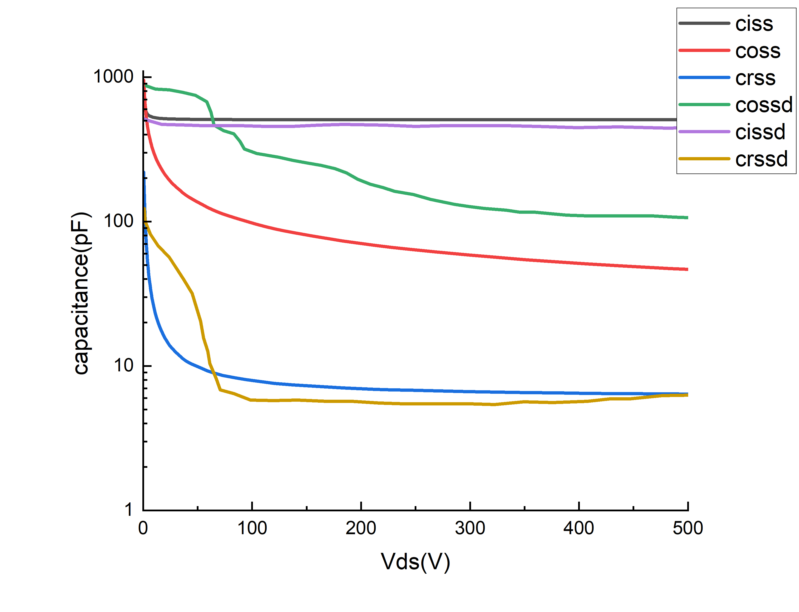
- Circuit for CISS of Subcircuit Model:
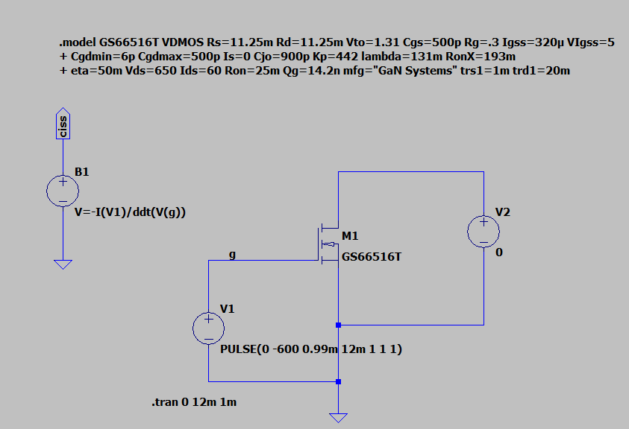

- Circuit for CRSS and COSS of Subcircuit Model:
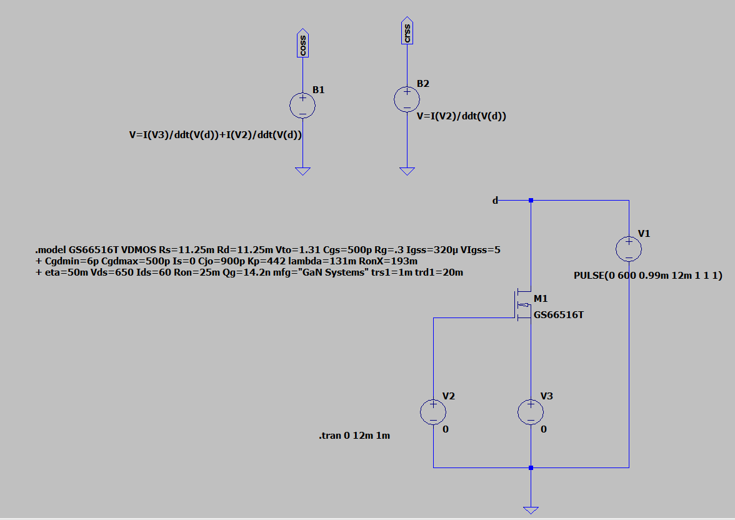
Device Model Analysis of GS66516T:
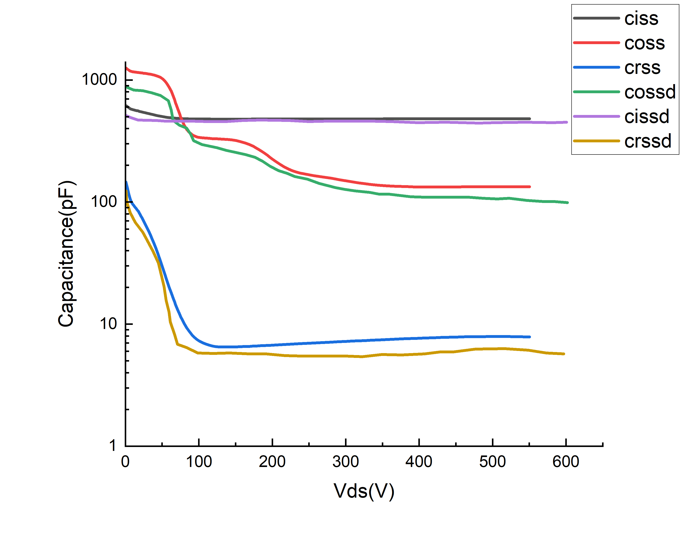

- Circuit for CISS of Subcircuit Model:
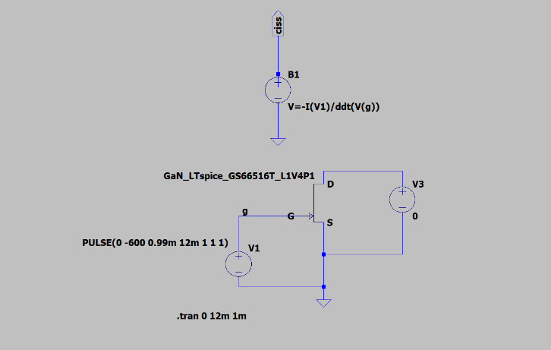
- Circuit for CISS of Subcircuit Model:
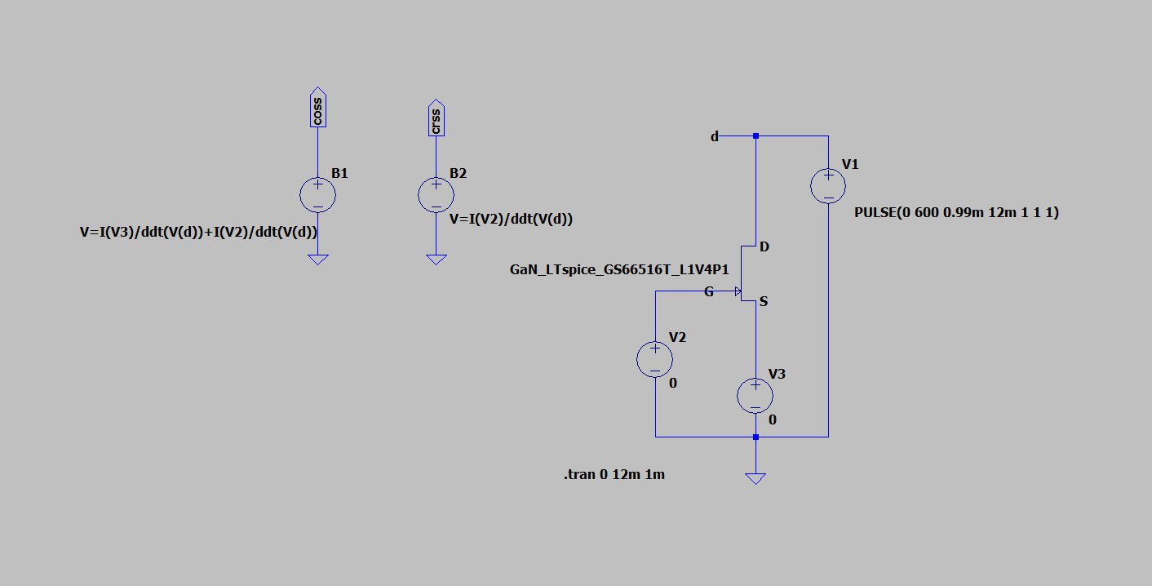

Double Pulse Test Bench Circuit ( DPT Circuit ):
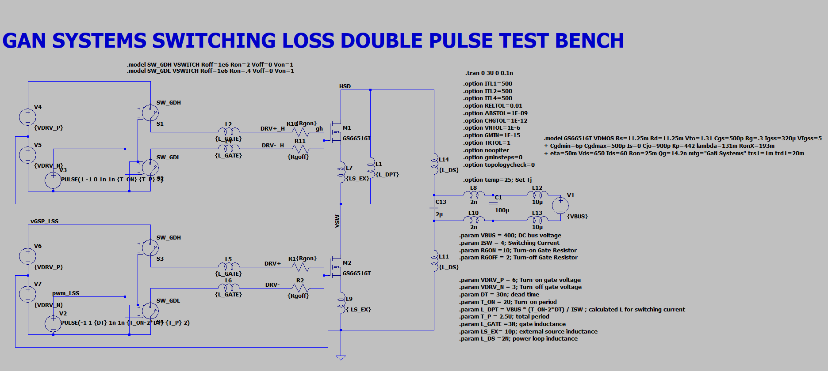

- CURRENT: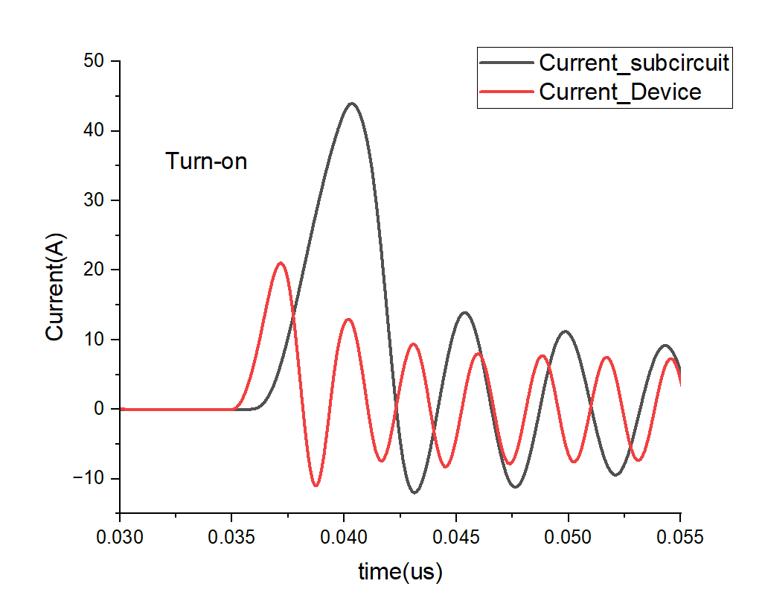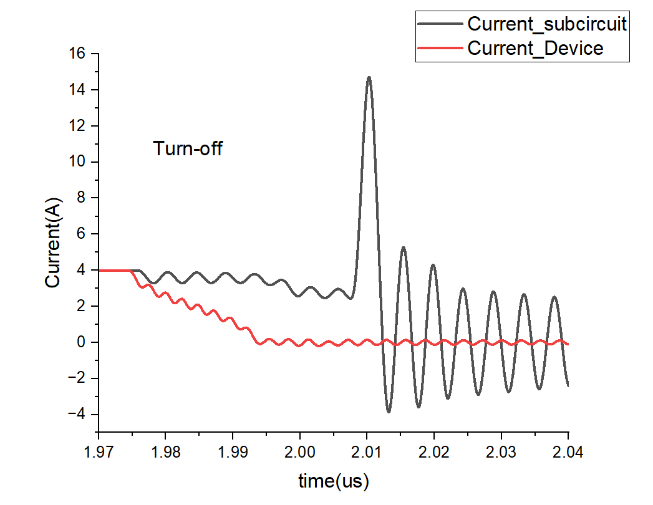
- VOLTAGE:
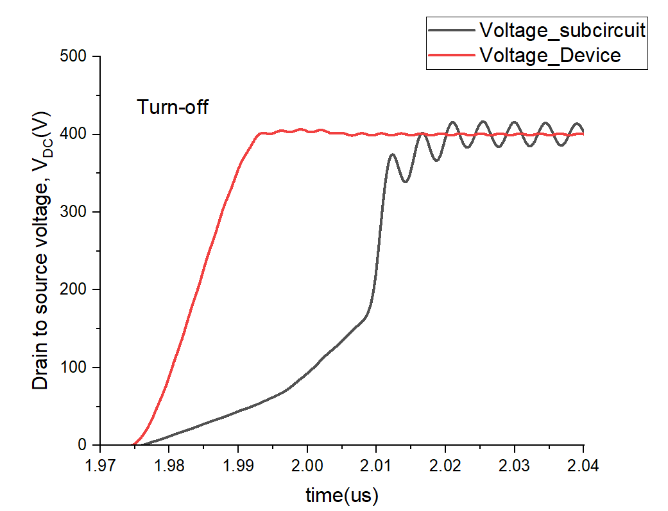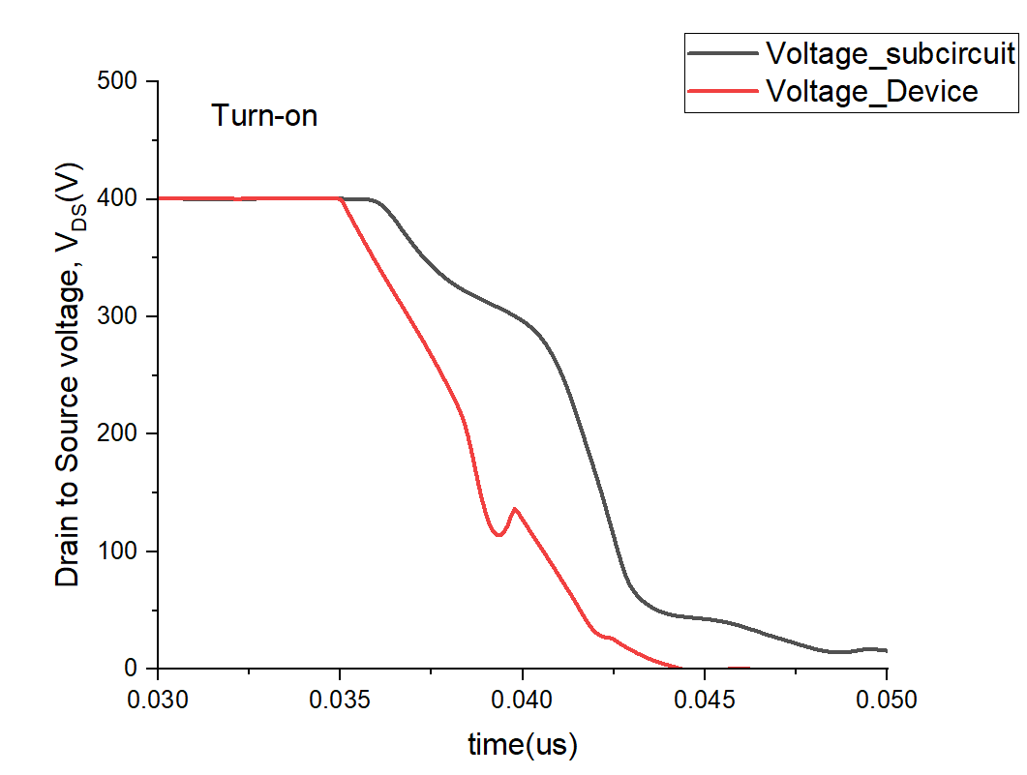
- POWER:
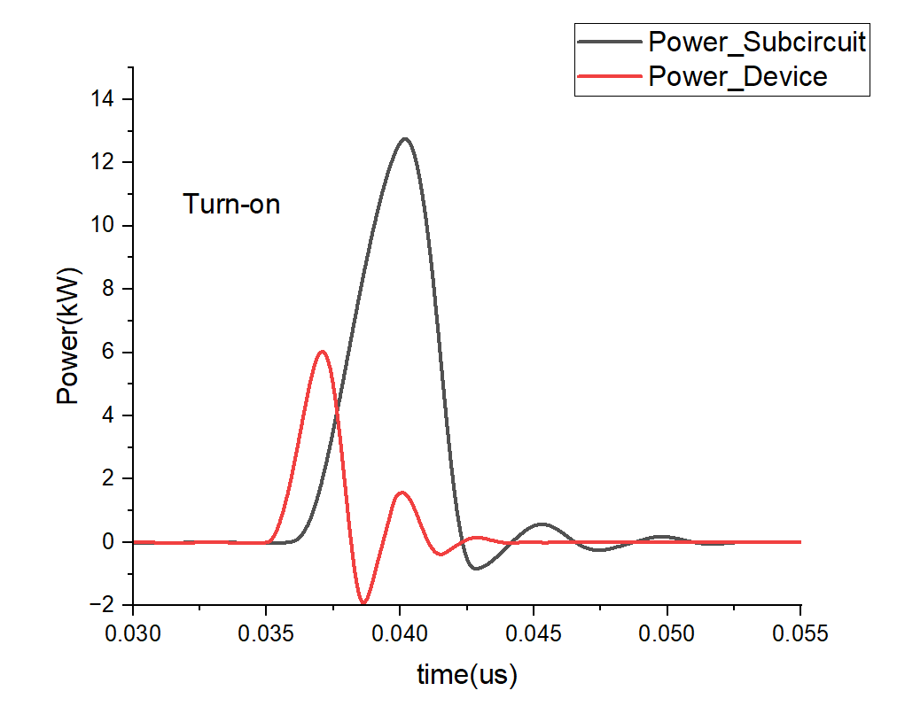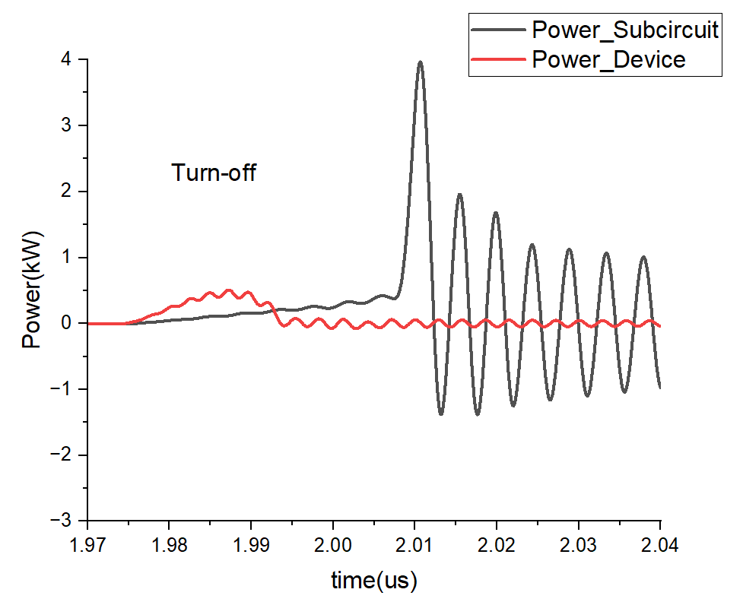
- Switching Loss:
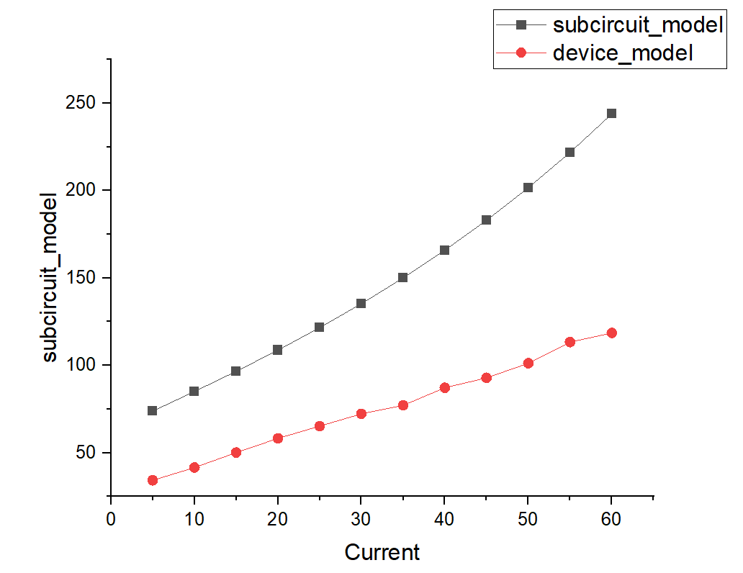

Chapter 5
Conclusion and Future Work
Based on the comprehensive analysis conducted in this project, the following conclusions have been drawn regarding the comparative evaluation of commercial GaN HEMT device and subcircuit models using LTspice:

1. Effectiveness of SPICE Level 3 Modeling: Utilizing the standard MOSFET Level 3 model in SPICE has proven to be an effective approach for simulating GaN HEMT devices. By carefully extracting and fitting parameters such as threshold voltage, transconductance, and channel length modulation, the model accurately replicates both static and dynamic behaviors of GaN HEMTs. This method offers a balance between simplicity and accuracy, making it suitable for power electronic circuit simulations.

2. Importance of Voltage-Dependent Capacitance Modeling: Accurate representation of voltage-dependent capacitances is crucial for reliable simulation of switching transients and losses. Incorporating nonlinear capacitance models, derived from empirical data or manufacturer datasheets, enhances the fidelity of transient simulations. This approach ensures that the dynamic behavior of GaN HEMTs is effectively captured, leading to more precise estimations of switching losses.

3. Switching Loss Analysis through Double Pulse Testing: Implementing Double Pulse Test (DPT) simulations in LTspice has facilitated the evaluation of switching losses in GaN HEMTs. The simulations, conducted under various operating conditions, have provided insights into turn-on and turn-off energy losses. The results demonstrate that the SPICE Level 3 model, when properly parameterized, yields switching loss estimations that closely align with those obtained from manufacturer-provided models.&#x20;

4. Comparative Performance of Device-Level and Subcircuit Models: The comparative analysis between device-level and subcircuit-level models has revealed that both approaches can effectively simulate GaN HEMT behavior when appropriately configured. While subcircuit models offer detailed representations, device-level models provide simplicity and ease of integration into larger circuit simulations. The choice between the two depends on the specific requirements of the application and the desired balance between model complexity and simulation accuracy.

5. Implications for Power Electronic System Design: The findings of this study underscore the significance of accurate device modeling in the design and optimization of power electronic systems. By leveraging detailed SPICE models that incorporate voltage-dependent capacitances and switching characteristics, engineers can achieve more reliable and efficient designs. This approach minimizes the risk of design iterations and accelerates the development process.

Future scope:
We have done all this analysis on GS66516T. We will be doing the same analysis for other models also.

References

- U. Jadli, F. Mohd-Yasin, H.A. Moghadam, P. Pande, M. Chaturvedi, and S. Dimitrijev, “Modeling Power GaN-HEMTs Using Standard MOSFET Equations and Parameters in SPICE," Electronics, vol. 10, pp. 130, Jan.2021, doi: 10.3390/electronics10020130.

- V. Joshi, U. Jadli, P. Pande, M. Chaturvedi, D. Haasmann and S. Dimitrijev, "Circuit-Specific and Technology-Independent Criterion for Selection of Power MOSFETs That Minimize Energy Dissipation," in IEEE Access, vol. 11, pp. 116472-116479, 2023, doi: 10.1109/ACCESS.2023.3325236.

