SSO Microservices Architecture
Cloud Computing Lab Project — Docker Hub Deployment

1. Project Links

GitHub Repository
URL: https://github.com/satyam7535/sso-project

Docker Hub Repositories
All microservice images are publicly hosted on Docker Hub:
Service | Docker Hub URL | Pull Command
Auth Service | https://hub.docker.com/r/kesharisatyam/sso-auth-service | docker pull kesharisatyam/sso-auth-service
App 1 (Login & OAuth) | https://hub.docker.com/r/kesharisatyam/sso-app1 | docker pull kesharisatyam/sso-app1
App 2 (Protected App) | https://hub.docker.com/r/kesharisatyam/sso-app2 | docker pull kesharisatyam/sso-app2

Docker Hub Screenshot
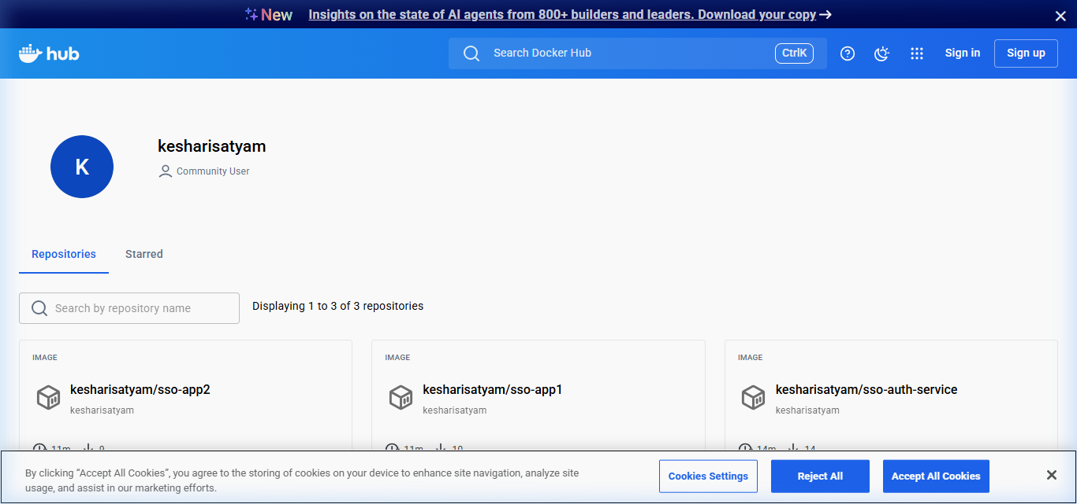
Figure: Docker Hub profile showing all 3 repositories

GitHub Repository Screenshot
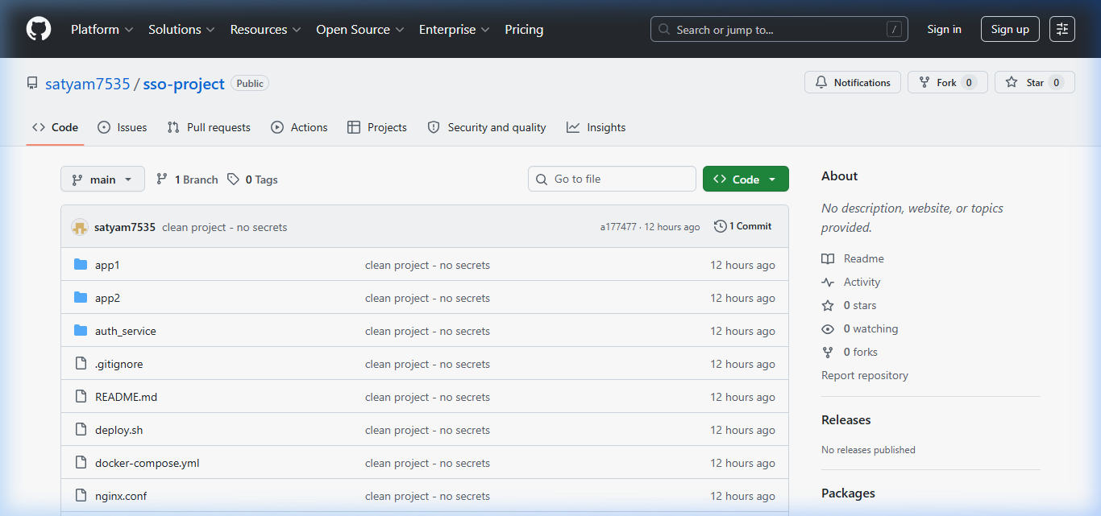
Figure: GitHub repository — satyam7535/sso-project

2. Environment Variables (.env File)
The project requires a .env file in the root directory with the following Google OAuth 2.0 credentials for social login functionality:
# .env file
GOOGLE_CLIENT_ID=795307984050-9b0uecp675vc44n6c0qj1olqksrs7irm.apps.googleusercontent.com
GOOGLE_CLIENT_SECRET=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

.env File Screenshot
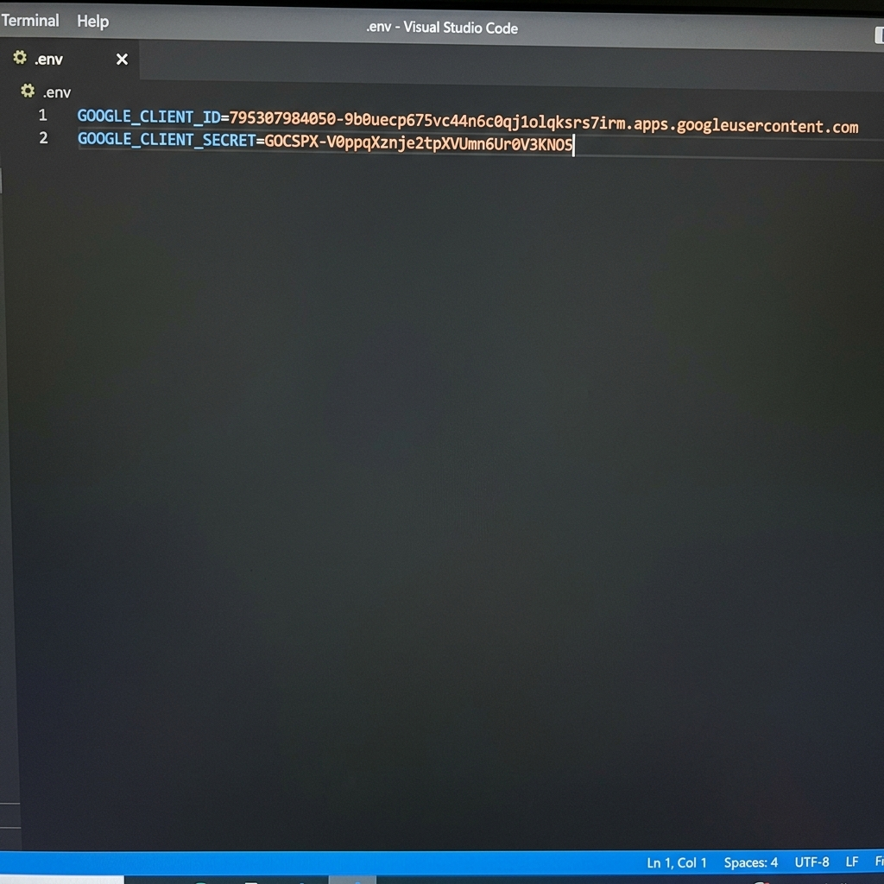
Figure: .env file containing Google OAuth credentials

3. Prerequisites (What You Need)
Requirement | Purpose | Download Link
Docker Desktop | Runs containers on your machine | https://www.docker.com/products/docker-desktop
Docker Compose | Orchestrates multi-container apps (included with Docker Desktop) | Included with Docker Desktop
Git (Optional) | Clone the project source code | https://git-scm.com/downloads
.env File | Google OAuth credentials for social login | Create manually (see Section 2)
Internet Connection | Pull images from Docker Hub | N/A

4. How to Run the Project

Step 1: Install Docker Desktop
Download and install Docker Desktop from https://www.docker.com/products/docker-desktop
Make sure Docker Desktop is running before proceeding.

Step 2: Create docker-compose.yml
Create a new folder and save the following as docker-compose.yml:
services:
db:
image: postgres:15-alpine
environment:
POSTGRES_USER: sso_user
POSTGRES_PASSWORD: sso_password
POSTGRES_DB: sso_db
ports:
- "5432:5432"
volumes:
- postgres_data:/var/lib/postgresql/data
auth-service:
image: kesharisatyam/sso-auth-service:latest
ports:
- "8000:8000"
environment:
- DATABASE_URL=postgres://sso_user:sso_password@db:5432/sso_db
- DEBUG=False
- ALLOWED_HOSTS=*
- TOKEN_EXPIRY_MINUTES=30
- INTERNAL_SSO_KEY=your-internal-sso-key-here
depends_on:
- db
app1:
image: kesharisatyam/sso-app1:latest
ports:
- "8001:8001"
environment:
- DATABASE_URL=postgres://sso_user:sso_password@db:5432/sso_db
- DEBUG=True
- ALLOWED_HOSTS=*
- AUTH_SERVICE_URL=http://auth-service:8000
- APP2_URL=http://127.0.0.1:8002
- GOOGLE_CLIENT_ID=<your-google-client-id>
- GOOGLE_CLIENT_SECRET=<your-google-client-secret>
- SSO_COOKIE_DOMAIN=localhost
- INTERNAL_SSO_KEY=your-internal-sso-key-here
- SITE_DOMAIN=127.0.0.1:8001
depends_on:
- auth-service
app2:
image: kesharisatyam/sso-app2:latest
ports:
- "8002:8002"
environment:
- DATABASE_URL=postgres://sso_user:sso_password@db:5432/sso_db
- DEBUG=False
- ALLOWED_HOSTS=*
- AUTH_SERVICE_URL=http://auth-service:8000
- APP1_LOGIN_URL=http://127.0.0.1:8001/login/
depends_on:
- auth-service
volumes:
postgres_data:

Step 3: Run the Project
Open a terminal/PowerShell in the folder containing docker-compose.yml and run:
docker-compose up
Docker will automatically pull all images from Docker Hub and start the services.

Step 4: Access the Application
Service | URL | Description
App 1 (Login) | http://127.0.0.1:8001 | Main login page with Google OAuth
App 2 (Dashboard) | http://127.0.0.1:8002 | Protected app — requires SSO login
Auth Service (API) | http://127.0.0.1:8000 | Token validation API (backend)

5. Technology Stack
Technology | Purpose
Python / Django | Backend web framework for all 3 services
PostgreSQL | Relational database for user & token storage
Docker & Docker Compose | Containerization and orchestration
Google OAuth 2.0 | Social authentication (Sign in with Google)
Gunicorn | Production-grade WSGI HTTP server
REST APIs | Inter-service communication for token validation
Nginx (optional) | Reverse proxy for production deployment

6. Architecture Overview
The system follows a microservices architecture with three independent Django services:
- Auth Service (Port 8000) — Central authentication server that manages user accounts and SSO tokens. All token creation and validation goes through this service.
- App 1 (Port 8001) — The login portal with both traditional username/password and Google OAuth. After successful authentication, it obtains a token from Auth Service and sets it as a cookie.
- App 2 (Port 8002) — A protected application that validates the SSO cookie by calling Auth Service. If the token is valid, the user gets access; otherwise, they are redirected to App 1 for login.

Database: All services share a single PostgreSQL database for user and token data.

