

**Dear Sir/Ma’am,**

Thank you for connecting with **TripzyGO** International!

We are happy and grateful to have this opportunity to plan your holidays. Planning someone's holidays is a huge responsibility and it is important to deliver great experiences. We do that by following one simple motto - You, the customer comes first. With us, you will always have fun loving holiday experiences because that is our utmost priority.

Promising a memorable trip to you on your holidays!

**Travel Details:**

## Destination:

Maldives

## Date of Travel:

11th Feb 2023

## Number of Travelers:

02 Adults

## Tour Duration:

04 nights / 05 Days

Accommodation Details: (04 Star) (Subject to availability) .

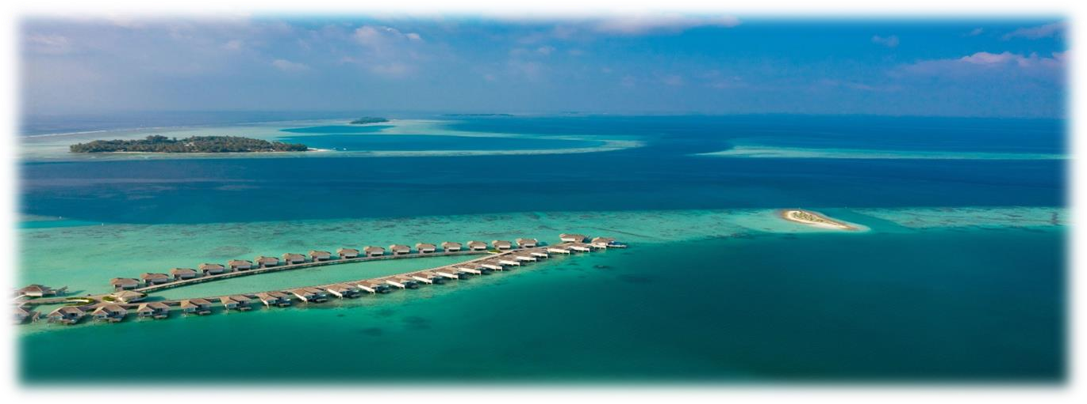

**Option: 01 – Medhufushi Island Resort .**

# Check-in/Out – 11th Jan to 15th Jan 2023

Room Category – 03 Nights Beach Villa + 01 Nights Water Villa

# Meal Plan: Full Board (Breakfast, Lunch, Dinner)

# Transfers: By Speed Boat

|  |  |
| --- | --- |
| TOTAL COST: | |
| **Total Cost For 02 Adults With Flights** | **INR 1,99,000/-** |

Inclusions: .

* Meet and Greet at the airport.
* Welcome drink on arrival at the resort
* Complimentary 24 hrs. High speed WIFI.
* 24 Hrs. Services at the resort.
* 03 Night accommodation at the resort/hotel as per above mentioned.
* Dinning Meal as per above mentioned.
* Airport to Resort Transfer As per above mentioned.
* Complimentary Daily 02 Water bottles ( 01.5 L ) will be replenished in the Room.
* Scuba Diving is Direct to chargeable to the resort.
* Gymnasium area for workout ( **As per resort only)**
* Floating Breakfast As per selected resort **( Extra chargeable)**
* Complementary SPA massage ( **As per selected resort only**)
* Honeymoons Freebies must be conducted within 6 months of wedding date. Wedding Certificate or Copy must be presented upon check-in. This are the

* Honeymoon Freebies: Cake, Bed Decoration, Fruit Platter , One Bottle Sparkling Wine ETC. (**As per selected resort**)
* Above Mentioned cost as per Couple (Inclusive of accommodation, Meal, Transfers, and Taxes) other things which are mentioned in inclusions.
* Green Tax
* GST included.
* Flights Cost

**FLIGHT DETAILS**

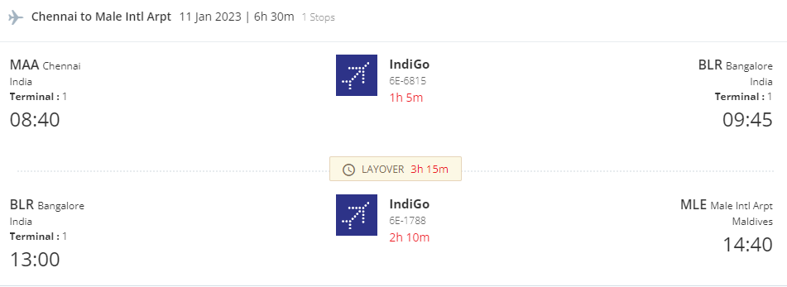

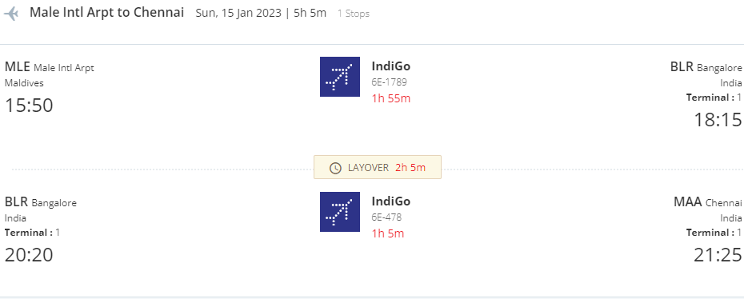

**Exclusions:**

* Any fluctuations in the dollar component will affect the costing.
* Visa on arrival
* RT-PCR test
* 05% TCS **( Refundable at the time of ITR filling** )
* Travel Insurance
* Any extra meal not mentioned on the above program during the tour.
* Early check in or late checkout charges.
* Expenses of a personal nature.
* Any service not specifically mentioned in the inclusion.
* Any extra meal not mentioned on the above program during the tour.
* Camera or Video permits.
* Early check in and late check out at the Hotels as per availability (extra charges may apply)
* Items of personal nature such as phone calls, pay movies, room services, mini bars laundries or

other expenditures during the tour.

* Additional costs due to Flight cancellations, road blocks, natural calamities

## Note:

* Standard Hotel Check-in Time 1400 hrs.
* Standard Hotel Check-out Time 1100 hrs.
* Airfare is subject to availability. It can fluctuate anytime.
* We have not blocked or hold any service as of now

Terms and Condition: . .

* The above is only a quote and no bookings have been made yet.
* Surcharges applicable during Conventions, Special Events and Trade fairs.
* Issuance of visa is solely under the discretion of the Consulates / Embassies. Our roleis to assist you in submission of visa and guide you with the formalities. We do not hold any responsibility in case of any rejection of visas. Cancellation policywill be still applicable even if the visas are rejected.
* If the Covid Test (PCR) is positive, then as per government quarantine stay mightextend as per rules.
* Customer have to reach the specified pickup point for the tours.
* Customer has to reach 10 – 15 minutes prior to the allotted time at the pickup point.
* Any requests such as (Interconnecting Room, adjacent Rooms, rooms on the same floor, 1 king size / 1 double bed/ twin bed, floor map, early check in, non/ smoking room, etc.) is subject to availability on first come first serve basis up on your guest arrival at the hotel and it is totally discretionary and up to the hotel toassign. However, we will request this for you as priority.
* Most hotels check in time is between 1400-1500hrs & check out time is between1000-1100hrs and varies from hotel to hotel. If necessary, we will request an earlycheck in or late checkout but this is subject to availability. For guaranteed early check – in, please pre-book your stay for the previous night and for guaranteed late check – out, please pre-book your stay for the next night.

The above quotation has been based on specific hotels. According to occupancies, hotels are subject to change. In case the hotel rooms are not available as specified above the alternate hotels will be suggested. The difference in cost is payable extra

Booking Deposit is non-refundable . .

* All confirmations are subject to availability at the time of booking.
* Rates are subject to change without prior notice due to circumstances beyond our control e.g. Rate Fluctuations, Fuel Increases, Government Regulations, Government Levies, Duties, etc.
* All Banks Charge to your account. Rate of Exchange will be given at the time of making payments, Subject to change without any prior notice.
* Please do not store money and valuables in your checked in baggage.
* All Rates are Valid for Indian Passport Holders
* Due to any Natural Calamities / unavoidable circumstances / Political or Socialunrest, if client postpone or cancel the journey in case of any liability from Airline or Hotel client will be charged for the same. Any waiver request or reduction in cancellation amount request will be at airline or hotel discretion.
* On certain days, due to some unavoidable conditions we may sometimes amend/ reverse the itinerary and keep you informed. However, all the services/ inclusions will remain the same.
* Tours and transfers depart strictly as per the time mentioned on final itinerary.
* Mid night surcharge is applicable as per flight details.
* Issuance of visa is solely under the discretion of the Consulates / Embassies. Our role is to assist you in submission of visa and guide you with the formalities. We do not hold any responsibility in case of any rejection of visas. Cancellation policy wilbe still applicable even if the visa is rejected.
* We strongly advise passengers to take out insurance covering cancellations, medical expenses, and loss of baggage, curtailment and default at the time ofbooking.
* In case of any last minute registrations received for a single person or non- availability of finding a twin partner for a single person, single room supplement will have to be borne by the passengers mandatory.
* No refund will be provided for any unutilized services.

Payment Policy: . .

|  |  |
| --- | --- |
|  | |
| At The time of booking | 25% of land package cost |
| 30 days before | 75% of Land package cost |
| Hotel | 100% Room cost in case of non- refundable |
| Airfare | Deposit 100% of flight tickets cost at the time of booking |
| Cruise | 100% advance payment at the time of booking |

Cancellation Policy: .

* Date of booking to 30 days before check in the cancellation charges will be 25% of the package cost.
* 30 to 15 days before check in the cancellation charges will be 50% of the package cost.
* 15 to 7 days before check in the cancellation charges will be 75% of the package cost.
* Less than 7 days before check in Total amount will be forfeited and no refund shall be given.
* No show Total amount will be forfeited and no refund shall be given.
* No refunds shall be given in case of any cancellations due to natural calamities.

**Bank details:** .

|  |  |
| --- | --- |
| **Bank Name** | **HDFC BANK** |
| **Account Type** | **Current Account** |
| **Account Name** | **Tripzygo International** |
| **Account Number** | **50200068661036** |
| **IFSC Code** | **HDFC0005246** |

## May you have an amazing vacation!

To know more about the unexplored places, follow us on

