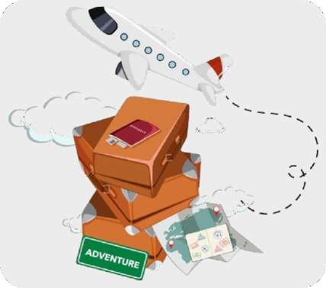

**Dear Sir**

**Greetings from Tripzygo International !**

Thank you for giving us the opportunity to let us plan your holidays. Over the years, not only have we changed the way people travel but in relatively short period of time, have grown to become India's largest online travel company. This growth stems from the belief instilled in all of us - You, the customer, come first! With this promise from all of us to make your holiday an unparalleled experience, we hope you enjoy your

Holiday as much as we enjoyed bringing it to you.

Travel Details:

**Destination: Manali**

**Date of travel: Numbers of Travelers: Tour duration:**

**03 Nights / 04 Days**

### Accommodation Details:

|  |  |  |  |
| --- | --- | --- | --- |
| **Destination** | **Hotel Name** | **Room Category** | **Nights** |
| **Manali** | **Elena Astha Regency/Similar** | **Deluxe** | **03** |

**Total Land Package INR /- For 02 Adults**

### Inclusions:

* Meet and greet upon arrival.
* Pick up & drop services from Delhi to Delhi.
* Stay for 3 Nights on Double occupancy and having 2 room in hotel.
* 24/7 over the Phone Support.
* MAP Meal Plan – 3 Breakfasts and 3 Dinners (Same as number of nights).
* Transfer and Sightseeing by Individual Cab(Sedan)
* NGT Terms will apply for all vehicles at Himachal.
* Transfer taxes, parking, fuel & driver charges.

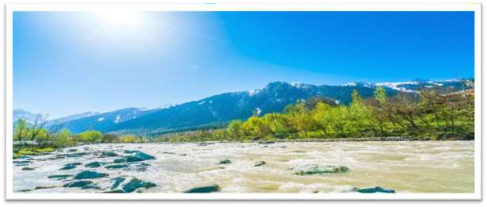

03 Night 04 days Manali Tour (Tentative Itinerary)

**DAY 1: CHANDHIGARH *–* MANALI**

**Day Services: Car Transfer**

On arrival at Chandhigarh Airport /Railway / Bus stand, you will meet and greet and assist. After this we start our journey towards Manali from Delhi, on the sightseeing of kullu Valley depend on your arrival at Delhi. After reaching Manali, first check-inat Manali hotel. After having delicious dinner, spend night in hotel.

Exotic Manali offers something special for everyone. It gives peace to mediators; inspiration to artists, daring Activities for adventure Seekers and this list just goes on. As soon as you enter into the terrains of Manali, you will feel the cool breeze already taking all your stress away and surprising you from its jaw- dropping landscapes.

**DAY 2: ARRIVAL IN MANALI + LOCAL CITY TOUR (3 - 4 HRS TOUR)**

**Day Services: Stay, Dinner & Car**

Major Attractions: Hadimba Mata Temple, Club House, Tibetan Monastery, Vashisht’s Hot Springs.

Wake up to the beauty of Manali, after Lunch, proceed for the day tour which includes your local sightseeing. Every new beginning should be honored with folded hands and so the first place to visit will be Hadimba Mata Temple along with Ghatotkacha Temple then a short visit to Club House where you can enjoy some Indoor activities and then further to Tibetan Monastery. Later take a bath in Sage Vashisht’s Hot Springs containing Medical properties (Do carry a towel). Right across the Hot spring are temples of Lord Shiva and Lord Ram. Evening you are free to roam on the famed Mall Road and indulge in local shopping and also try some of the native cuisines. Return to the hotel for dinner and overnight stay.

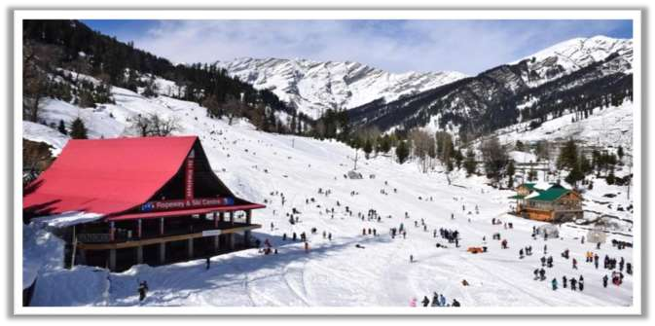

**DAY 3: MANALI *–* SOLANG VALLEY / ROHTANG OR ATAL TUNNEL**

**Day Services: Stay, Breakfast, Dinner & Car**

Major Attractions: Solang Valley, Adventure activities. After breakfast it is time for some adventures!

Wake up to the sweet sound of nature and after breakfast head towards Solang Valley. This valley is famous for its adventure activities and you can try your hand at Paragliding, Zorbing, ATV Rides, Horse-riding, Trail-rides and so much more.

Before indulging in these activities make sure to understand all safety protocols and measures.

Winter Note: During Snowfall Solang valley sightseeing point will be covered if weather, road condition is clear and possibilities of vehicles to reach there, otherwise sightseeing up to Barrier Point will be provided.

Option1. (Rohtang Pass)

You can also visit Rohtang Pass – this will be solely at the discretion of the local & NGT governing authorities and **at extra cost.**

Option2. (Atal Tunnel)

You can also visit and drive – through the newly built Atal Tunnel, one of the highest Tunnels in the World. This tunnel acts as a gateway to the Lahaul & Spiti Valley. You can make a stop at the North-Portal of the tunnel for an amazing photo- shoot. This option will be **at extra cost.**

Afterwards return to the hotel for dinner and a comfortable stay. Note: Kindly inform us to add these options at the time of booking.

**DAY 4: MANALI *–* CHANDHIGARH DEPARTURE**

**Day Services: Breakfast**

Today after breakfast, check-out from the hotel. Start your journey from Manali to Delhi by seeing on the way sightseeing of the Kullu valley and after that our driver drop you at Chandhigarh Airport /Railway Station / Bus Stand. Filled with beautiful moments and memories, we wish to see you once again on another journey.

# Tour Ends but Sweet Memories Always Remains same*………..*



**Exclusions:**

* Flights, Trains, Ferries etc.
* Monument Entrance Fees & Camera Fees.
* Personal Expenses - Laundry, Shopping, Telephone bills, tips etc.
* Adventure Activities - Safari, Rides, Surfing, Paragliding etc.
* Any Extra services - Permits, Volvo Luggage Charges, Heater, Meals etc
* Anything else not listed in above details.
* 5% GST (Goods & Services Tax).

**BOOKING PROCEDURE :**

* + For Hotel booking You have to deposit 25k initially as a booking token amount to lock the price and process your booking which you can make instantly through the below link using your credit/ debit card .
  + then you have to clear 25% of the hotel cost within 2-3 DAYS and rest remaining 75% you have to clear 01monthprior to your travelling dates via NEFT/Cash Deposit.
  + For Air Tickets you need to pay full amount via NEFT / Cash Transfer as we will instantly book & forward the tickets to you at the same time. To book tickets we need full payment in below bank details +your passport
  + have to clear 01monthprior to your travelling dates via NEFT/Cash Deposit.
  + have to clear 01monthprior to your travelling dates via NEFT/Cash Deposit.
  + For Air Tickets you need to pay full amount via NEFT / Cash Transfer as we will instantly book & forward the tickets to you at the same time. To book tickets we need full payment in below bank details +your passport copies.
  + For more information step by step on booking procedure/ cancellation etc kindly go through the below link:-
  + Payments Booking Procedure & FAQ
  + For all your further payments, below are our a/c details : ADD THE BELOW DETAILS AS BENEFICIARY/PAY TO MAKE FLIGHT PAYMENTS / PENDING HOTEL PAYMENT

# Bank Details:

|  |  |
| --- | --- |
| **Bank Name HDFC BANK** | |
| **Account Type** | **Current Account** |
| **Account Name** | **Tripzygo international** |
| **Account Number** | **50200068661036** |
| **IFSC Code** | **HDFC0005246** |
| **Bank Name HDFC BANK** | |

**Credit Card Payments Note** : If you wish to pay any amount after 25k through credit card , then gateway charges of 2.5% will be additional, but no extra charges are there on NEFT/Cash Deposit/Cheque/RTGS

**Note** : We don’t sell only flights , we have break up cost for flights only if you will take total package with hotel with us. Also after booking final vouchers will be shared as a pdf on mail 15 days before the travel.

### CANCELLATION POLICY

* + - Date of booking to 30 days the cancellation charges will be 25% of the tour cost.
    - 30 to 15 days - the cancellation charges will be 50% of the tour cost
    - 15 to 7 days - the cancellation charges will be 75% of the tour cost
    - Less than 7 days -Total amount will be forfeited and no refund shall be given.
    - No show - Total amount will be forfeited and no refund shall be given.

### TERMS AND CONDITIONS

* Date of booking to 30 days the cancellation charges will be 25% of the tour cost.
* 30 to 15 days - the cancellation charges will be 50% of the tour cost
* 15 to 7 days - the cancellation charges will be 75% of the tour cost
* Less than 7 days -Total amount will be forfeited and no refund shall be given.
* No show - Total amount will be forfeited and no refund shall be given.
  + **KINDLY NOTE: -** Cancellation Policy is subject to change. It's purely depends upon the cancellation policy of respective hotels. In Peaks seasons, some hotels may charge 100% cancellation
  + Refunds normally take 10 working days after the cancellation request has been raised & transferred electronicallyto your bank account
  + Customers are our asset. We are obliged to do the best for them. Please let us know if want any modification.
  + Customer satisfaction is valued a lot for us. We will give you the best advice and services for making your holiday wonderful experience.

Waiting for your kind response...!!!!!!!!

Regard with Thanks

## Pallavi Rana

M- 7814694253

## W- [TripzyGo - Book Best Tour Packages For Memorable Vacation Plans](https://www.tripzygo.in/)