

Dear Sir,

## Greetings from Tripzygo International!!!!!!!!!

Thank you for giving us the opportunity to let us plan your holidays. Over the years, not only have we changed the way people travel but in relatively short period of time, have grown to become India's largest online travel company. This growth stems from the belief instilled in all of us-

You, the customer, come first! With this promise from all of us to make your holiday an unparalleled experience, we hope you enjoy your

Holiday as much as we enjoyed bringing it to you.

Travel dates

**05th Of April 2023**

No of nights

**4 nights 5 days**

No of adults

**2 adults 1 room**



**Accommodations:-**

**Whispering meadows ***Munnar**

**Check in date – 5th of April 2023**

**Check out date – 7th of April 2023**

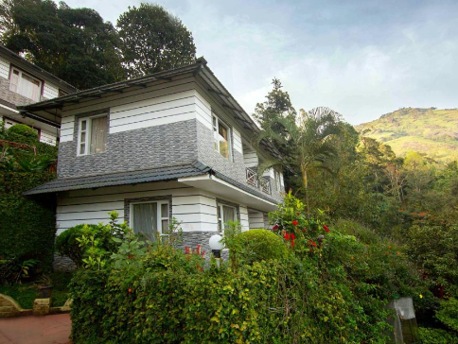

**Room Included**

#### Deluxe Room

Meals included - Breakfast,

EARLYCHECK IN AND LATE CHECK OUT ARE SUBJECT TO AVILAIBILITY



**Accommodations:-**

**Grand Thekkedy –Thekkedy**

**Check in date 7th of April 2023**

**Check out date 8th of April 2023**

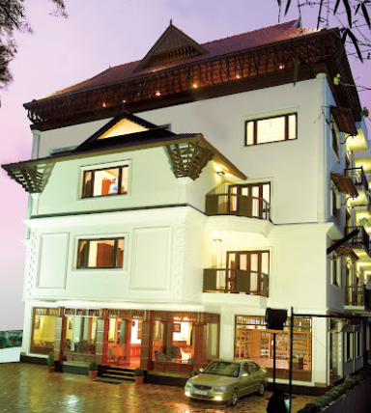

#### Deluxe Room

Meals included - Breakfast

**Accommodations**

**Houseboat – Allepey**

**Check in date – 8th of April 2023**

**Check out date -9th of April 2023**

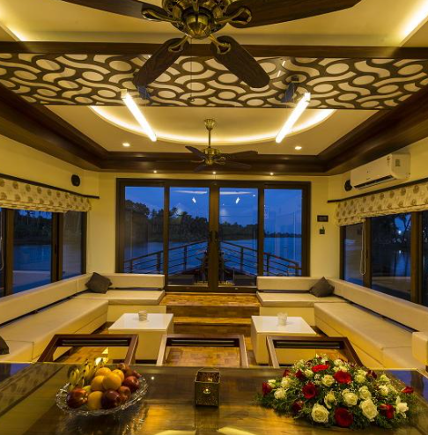

#### Deluxe Room

Meal –plan  **Breakfast lunch dinner**

**Day wide itenery:-**

**Day-1 Arrival at Cochin & Proceed to Munnar – (130 Kms – Approx 4 Hrs)**

On arrival at Cochin, proceed to Munnar. A breathtakingly beautiful - haven of peace and tranquility which cannot be portrayed in a single canvas. Situated at 1,600m above sea level with unending expanse of tea plantations - pristine valleys and mountains, you’re often up above the clouds watching veils of mist clinging to the mountain tops. Among the exotic flora found in the forests and grasslands here is the Neelakurinji/Strobilanthes. This flower which bathes the hills in blue once in every twelve years, will bloom next in 2018. On the way to Munnar visit Cheeyappara & Valara waterfalls. The Cheeyappara Waterfall cascades down in seven steps. Valara has a chain of waterfalls surrounded by thick green forests. Overnight stay at Hotel

**Day-2 Munnar Sightseeing**

* After breakfast proceed for sightseeing of Munnar. Visit Mattupetty Dam (ticket price extra), a storage concrete gravity dam built in the mountains. Mattupetty offers many fascinating sights to relish. Besides the tea plantations & the rolling grasslands, the Shola forests in and around Mattupetty are ideal for trekking and are habitat to a variety of birds.
* Later visit Kundala Dam (ticket price extra), the famous Neela Kurunji flowers which bloom once in twelve years, bloom in the hills and valleys around Kundala Lake.
* Enroute visit Echo Point & Pothamedu View Point. Echo Point always has a greenish look as it is covered with abundant green sceneries. View Point is perfect to enjoy the spectacular beauty of the coffee, tea & cardamom plantations. They are an adventurous destination, which will be a perfect choice for those who love to have a nature walk or trekking. Overnight stay at Hotel.

**Day-3 Munnar to Thekkady - (85 Kms - Approx 3 Hrs)**

* After breakfast, check out from hotel & proceed to Thekkady.
* Thekkady is considered as a heaven for natural spices. The Periyar forests of Thekkady is one of the finest wildlife reserves in India. Periyar encompasses 777 sq km & a 26-sq-km artificial lake.
* Check-in at hotel & later head out for sightseeing to visit the Periyar Wildlife Sanctuary (ticket price extra), it is home to herds of wild Elephants, Sambar, Tigers, Gaur, Lion-tailed Macaques, Nilgiri Langurs & more. The place can sometimes feel a bit like Disneyland-in-the-Ghats, but its mountain scenery & jungle walks make for an enjoyable visit. Evening enjoy the boat cruise in the lake (at additional cost) to spot wild animals. Overnight stay at Hotel.

**Day-4 Thekkady to Alleppey - (135 Kms - Approx 4 Hrs)**

After breakfast, check out from hotel and proceed to Alleppey which has an immense natural beauty and is also known as the “Venice of the East”. It is famous for backwater cruising and boat race. Check into your hotel/houseboat & cruise (if staying in houseboat) through the Narrow Canal amidst the Paddy Fields, Coconut Lagoons and Coir Villages in Alleppey. Overnight stay in Alleppey.

# **Day-5 Departure from Alleppey to Kochi airport.**

# Today after breakfast proceed to Kochi airport to get your return flight for home.

**INCLUSION**

# Inclusion

Road Transport

**AC Sedan from Kochi - Drop at Kochi (Covering Munnar, Thekkady, Alleppey as per Itinerary)**

All taxes, toll and parking charges and driver expenses are included

**2 nights stay in Whispering meadows Munnar**

**Breakfast included for 2 day**

**1night stay in Grand Thekkedy**

**Breakfast included for 1 day**

**1night stay in Allepey**

**Houseboat deluxe room**

**Breakfast lunch dinner INCLUDED.**

**Total cost =*41,000 INR*** *included with all the taxes*

# **Exclusions**

Optional enhancements like room or flight upgrades, or local camera or video fees

Additional sightseeing, activities and experiences outside of the itinerary

Early check-in or late check-out from hotels (unless otherwise specified)

Breakfast, lunches, dinners and drinks (alcoholic and non-alcoholic), unless specified in the itinerary

Any international and/or domestic flights, unless explicitly mentioned as an inclusion

Excess baggage charges, and where applicable, baggage not included in your fare

Tips for services and experiences

Read useful information and terms for more on what is included and excluded

# **Useful Tips before Booking**

Please note vehicle is available for use between 7 am to 7 pm which covers the sightseeing and journey time.

If you wish to go out beyond 7 pm, vehicle charges would be extra or you will need to arrange on your own.

Most hotels in Munnar (3 star and lower) offer Non AC rooms. Please double check the room category in case you are looking for AC rooms.

Tickets for Periyar Wildlife Reserve are not included in the price and needs to be booked prior before travel.

In case you are opting for houseboat, please note AC would run only between 9 pm to 6 am in the morning.

At the time of check-in to your hotel, hotel may ask you to make an advance/security deposit (amount depends upon hotel policy). This amount is refunded at the time of check-out, minus the cost of any items taken from the mini-bar or other charges (like late check-out or any damages done to the accommodation).

Any ticket to attractions, museums, train, cable car, ferries, rides, safari, etc. are not included unless explicitly mentioned as an inclusion.

For queries regarding cancellations and refunds, please refer to our Cancellation Policy.

We reserve the right to issue a full refund in case we believe that we are unable to fulfil the services for any technical reasons

**BOOKING PROCEDURE:**

* For Hotel booking You have to deposit initially as a booking token amount to lock the price and process your booking which you can make instantly through the below link using your credit/ debit card .
* Then you have to clear 25% of the hotel cost within 2-3 DAYS and rest remaining 75% you have to clear 01monthprior to your travelling dates via NEFT/Cash Deposit.
* For Air Tickets you need to pay full amount via NEFT / Cash Transfer as we will instantly book & forward the tickets to you at the same time. To book tickets we need full payment in below bank details +your passport
* Have to clear 01monthprior to your travelling dates via NEFT/Cash Deposit.
* Have to clear 01monthprior to your travelling dates via NEFT/Cash Deposit.
* For Air Tickets you need to pay full amount via NEFT / Cash Transfer as we will instantly book & forward the tickets to you at the same time. To book tickets we need full payment in below bank details +your passport copies.
* For more information step by step on booking procedure/ cancellation etc. kindly go through the below link:-
* Payments Booking Procedure & FAQ
* For all your further payments, below are our a/c details : ADD THE BELOW DETAILS ASBENEFICIARY/PAYEE TOMAKE FLIGHT PAYMENTS / PENDING HOTEL PAYMENT

**Bank Details:**

|  |  |
| --- | --- |
| Bank Name | HDFC BANK |
| Account Type | Current Account |
| Account Name | Tripzygo international |
| Account Number | 50200068661036 |
| IFSC Code | HDFC0005246 |
| Bank Name | HDFC BANK |

**Credit Card Payments Note**: If you wish to pay any amount through credit card, then gateway charges of 2.5% will be additional, but no extra charges are there on NEFT/Cash Deposit/Cheque/RTGS.

**Note**: We don’t sell only flights, we have break up cost for flights only if you will take total package with hotel with us. Also after booking final vouchers will be shared as a pdf on mail 15 days before the travel.

### **CANCELLATION POLICY**

* + Date of booking to 30 days the cancellation charges will be 25% of the tour cost.
  + 30 to 15 days - the cancellation charges will be 50% of the tour cost
  + 15 to 7 days - the cancellation charges will be 75% of the tour cost
  + Less than 7 days -Total amount will be forfeited and no refund shall be given.
  + No show - Total amount will be forfeited and no refund shall be given.

### **TERMS AND CONDITIONS**

* Date of booking to 30 days the cancellation charges will be 25% of the tour cost.
* 30 to 15 days - the cancellation charges will be 50% of the tour cost
* 15 to 7 days - the cancellation charges will be 75% of the tour cost
* Less than 7 days -Total amount will be forfeited and no refund shall be given.
* No show - Total amount will be forfeited and no refund shall be given.

**KINDLY NOTE: -** Cancellation Policy is subject to change. It's purely depends upon the cancellation policy of respective hotels. In Peaks seasons, some hotels may charge 100% cancellation

* Refunds normally take 10 working days after the cancellation request has been raised & transferred electronically to your bank account
* Customers are our asset. We are obliged to do the best for them. Please let us know if want any modification.
* Customer satisfaction is valued a lot for us. We will give you the best advice and services for making your holiday wonderful experience.

**Waiting for your kind response...!!!!!!!!**

**Regard with Thanks**

Vinay Sharma

M-88940 25503

W- [TripzyGo - Book Best Tour Packages For Memorable Vacation Plans](https://www.tripzygo.in/)

