

Dear Sir,Mam

## Greetings from TripzyGO International!!!

Thank you for giving us the opportunity to let us plan your holidays. Over the years, not only have we changed the way people travel but in relatively short period of time, have grown to become India's largest online travel company. This growth stems from the belief instilled in all of us you, the customer, come first! With this promise from all of us to make your holiday an unparalleled experience, we hope you enjoy your Holiday as much as we enjoyed bringing it to you.

## 

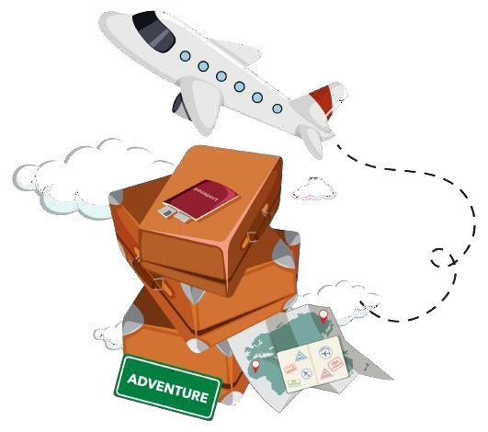

## Travel Details

## Destination:

Manali

## Date of travel:

## 26 Jan, 2023

## Numbers of Travelers:

## 02 Adult 01 kid (5year)

## 

## Tour duration:

03 Nights / 04 Days

# ACCOMMODATION DETAILS:

# (SUBJECT TO AVAILABILITY)

|  |  |  |  |
| --- | --- | --- | --- |
| **Destination** | **Hotel Name** | **Room Category** | **Nights** |
| **Manali** | **Elena Astha Regency / Similar**  **Gautam cottage / Similar** | **Deluxe Room** | **03** |

**Total Package Cost INR 20,000/- for 2 Adults & 1 Child**

**INCLUSIONS:**

* 01 Rooms for 02 Adults 01 kid (5 year) for 03 Nights Stay.
* Pickup and Drop from Chandigarh.
* Accommodation as mentioned above with Meal Plan (Breakfast & Dinner).
* Parking charges.
* Driver allowances.
* 24/7 over the Phone support.
* Transfers & sightseeing by Individual sedan

03 Night 04 Days Manali Tour Tentative Itinerary

# 

# DAY 01 – ARRIVAL CHANDIGARH AND TRANSFER TO MANALI

On arrival @ Chandigarh Airport or Railway station you will be meet and assist and we start our journey towards Manali form Chandigarh, after reaching Manali first check in @Manali Hotel (Overnight Stay at Manali).

# DAY 02 - MANALI - SOLANG VALLEY

Today after breakfast we proceed to Solang valley, Solang Valley derives its name from combination of words Solang and Nallah. It is a side valley at the top of the Kullu Valley in Himachal Pradesh, India 14 km northwest of the resort town Manali on the way to Rohtang Pass, and is known for its summer and winter sport conditions. It’s also popular for adventure activities.

# DAY 03 – MANALI CITY TOUR

Today after breakfast we start our day with Manali city, Manali is a high-altitude Himalayan resort town in India’s northern Himachal Pradesh state. It has a reputation as a backpacking center and honeymoon destination Visit: - Hadimba Mata Temple, Vashist Temple, Club House, Van Vihar, Tibetan monastery, Manali Mall Road in evening after completing all the sights driven back to Hotel (Overnight Stay at Manali).

# DAY 04 - DELHI (DEPARTURE)

Today after breakfast first check out from the Hotel and leave for Chandigarh from Manali, our driver drop you @ Chandigarh Airport or railway station to catch onwards flights and trains.

Tour Ends but Sweet Memories Always Remains same!!!!!!!!

# EXCLUSIONS:

* Lunch or Extra meals
* 5% GST.
* Flights and Train Tickets
* Travel Insurance
* Tips and porter chargers
* Early check in and late check out at the hotel.
* Expenses of personal nature
* Any other services not specified above
* Additional Costs due to Flight Cancellations, Road blocks, natural calamities and nature's

# BOOKING PROCEDURE:

* For Hotel booking You have to deposit 25k initially as a booking token amount to lock the price and process your booking which you can make instantly through the below link using your credit/ debit card.
* then you have to clear 25% of the hotel cost within 2-3 DAYS and rest remaining 75% you have to clear 01monthprior to your travelling dates via NEFT/Cash Deposit.
* For Air Tickets you need to pay full amount via NEFT / Cash Transfer as we will instantly book & forward the tickets to you at the same time. To book tickets we need full payment in below bank details +your passport
* have to clear 01monthprior to your travelling dates via NEFT/Cash Deposit.
* have to clear 01monthprior to your travelling dates via NEFT/Cash Deposit.
* For Air Tickets you need to pay full amount via NEFT / Cash Transfer as we will instantly book & forward the tickets to you at the same time. To book tickets we need full payment in below bank details +your passport copies.
* For more information step by step on booking procedure/ cancellation etc. kindly go through the below link: -
* Payments Booking Procedure & FAQ
* For all your further payments, below are our a/c details: ADD THE BELOW DETAILS ASBENEFICIARY/PAYEE TOMAKE FLIGHT PAYMENTS / PENDING HOTEL PAYMENT

# TERMS AND CONDITION:

* The above is only a quote and no bookings have been made yet.
* No-Show Guests would not be given any refunds nor would their tours be re- scheduled.
* Tour can be cancelled or postpone due to natural calamities
* SIC means Seat-In-Coach Basis. Drivers would communicate with the Guests if there is a change in the assigned pick - up time.
* If guest fails to reach within the time arranged, there will be no replacement given.
* Guide will be available only for some specific tours/Excursions
* If there is any change in flight by airlines then tours and transfers rescheduling will not be done

# BOOKING DEPOSIT IS NON-REFUNDABLE

* All confirmations are subject to availability at the time of booking.
* Rates are subject to change without prior notice due to circumstances beyond our control e.g., Rate Fluctuations, Fuel Increases, Government Regulations, Government Levies, Duties, etc.
* Rates/itineraries/payment terms as per present RBI regulations and are subject to change without any prior notice.
* Please do not store money and valuables in you’re checked in baggage.
* All Rates are Valid for Indian Passport Holders
* All Previous quotes (if any) NULL & VOID.
* Tours and transfers depart strictly as per time mentioned on final itinerary.
* Mid night surcharge is applicable as per flight details
* No refund will be provided for any unutilized service

# PAYMENT POLICY:

|  |  |
| --- | --- |
| **At The time of booking** | **25% of land package cost** |
| **30 days before** | **75% of Land package cost** |
| **Hotel** | **100% Room cost in case of cancellation non-refundable** |
| **Airfare** | **Deposit 100% of flight tickets cost at the time of booking** |

**CANCELLATION POLICY:**

* Date of booking to 30 days before check in the cancellation charges will be 25% of the package cost.
* 30 to 15 days before check in the cancellation charges will be 50% of the package cost.
* 15 to 7 days before check in the cancellation charges will be 75% of the package cost.
* Less than 7 days before check in Total amount will be forfeited and no refund shall be given.
* No show Total amount will be forfeited and no refund shall be given.
* No refunds shall be given in case of any cancellations due to natural calamities

# BANK DETAILS:

|  |  |
| --- | --- |
| **Bank Name** | **HDFC BANK** |
| **Account Type** | **Current Account** |
| **Account Name** | **TripzyGO international** |
| **Account Number** | **50200068661036** |
| **IFSC Code** | **HDFC0005246** |
| **Bank Name** | **HDFC BANK** |

**WAITING FOR YOUR KIND RESPONSE...!!!**

**REGARDS WITH THANKS**

Pallavi Rana

M- 78146-94253

E- [cc31@tripzygo.in](mailto:cc31@tripzygo.in)

W- [TripzyGO - Book Best Tour Packages for Memorable Vacation Plans](https://www.tripzygo.in/)