



**Dear Sir/Ma’am,**

Thank you for connecting with TripzyGO International!

We are happy and grateful to have this opportunity to plan your holidays. Planning someone's holidays is a huge responsibility and it is important to deliver great experiences. We do that by following one simple motto - You, the customer comes first. With us, you will always have fun loving holiday experiences because that is our utmost priority.

Promising a memorable trip to you on your holidays!

### Travel Details:

### Destination:

### Japan (Hiroshima, Osaka,)

### Date of Travel:

29 Apr, 2023

### Number of Travelers:

02 Adults

### Tour Duration:

### 06 Nights/ 07 Days



**Accommodation Details ( Subject to availability ):**

|  |  |  |
| --- | --- | --- |
| Destination | Hotel | No. of Nights |
| Hiroshima | Keio Presso Inn Tokyo Station Yaesu or Similar | 03 |
| Osaka | Hotel New Hankyu Osaka or Similar | 03 |

**Flights Details ( Subject to availability ) :**

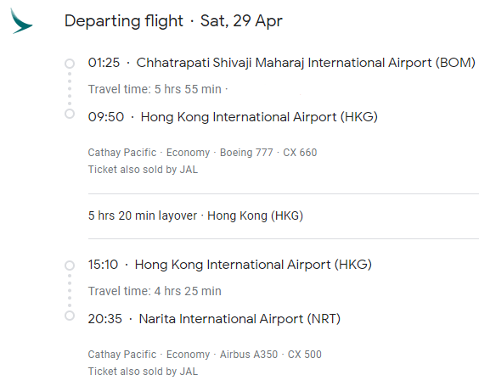 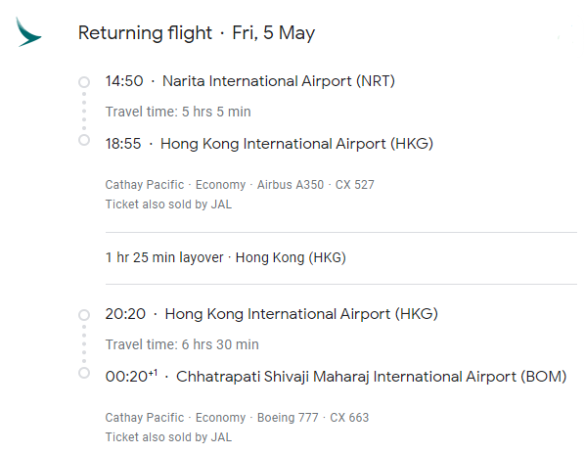

**Total land package price – 2,45,073/- For 02 Adults**

**( With Flights )**

**Day Wise Itinerary of the trip:**

**Day 1 Arrival at Tokyo airport**

Arrival at Tokyo airport. Meeting and greeting at the airport. Private Tokyo airport to hotel. Evening will be free for leisure. Overnight at hotel.

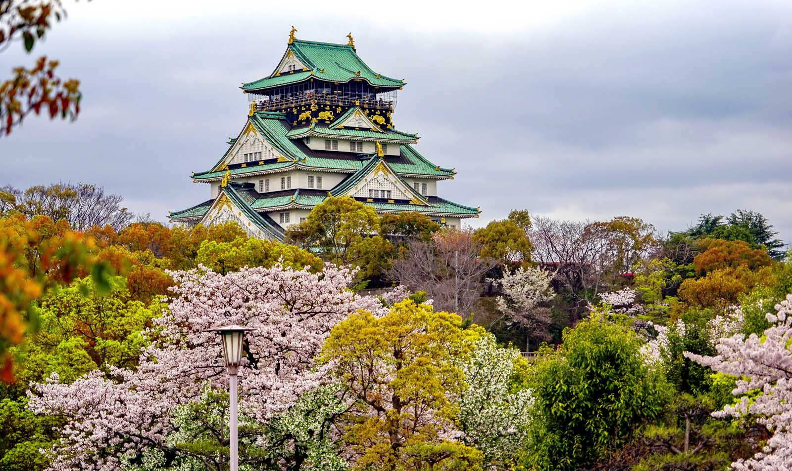

**Day 2 Mount Fuji and Hakone Full Day Tour**

Morning breakfast at the hotel. Discover Japan's natural miracle, Mt. Fuji and Hakone in 1 day! Climb Mt. Fuji and feel the enrgy of Japan, take a refreshing Lake Ashi cruise and head to Owakudani valley with stunning cablecar.Overnight at hotel.

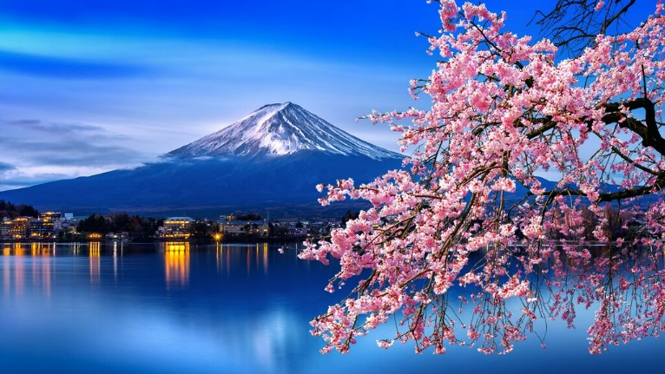

**Day 3 : Tokyo Signature Sightseeing Tour - Full Day**

Explore the most famous and signature sightseeing spots in Tokyo city. See Tokyo from a different perspective. Visit the Meiji Shrine, with the largest wooden Torii in the world

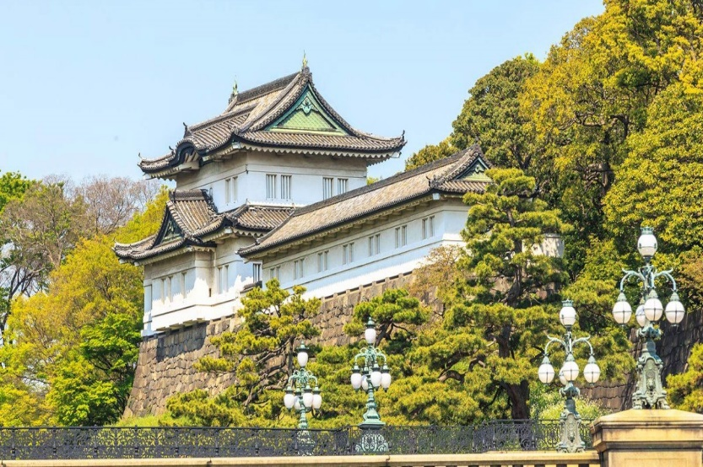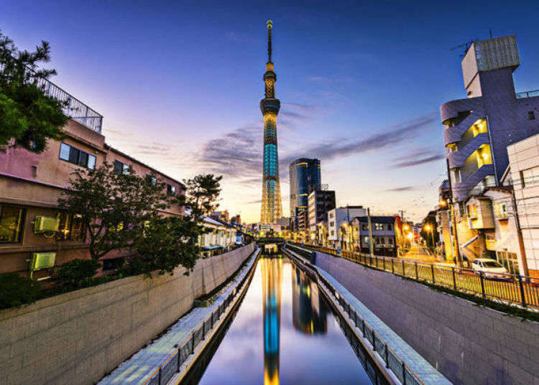Visit Imperial Palace and learn about the history of Japan's Emperor and more

**Day 4 : Tokyo to Osaka**

Morning breakfast at the hotel. Today you will be traveling to Osaka from Tokyo by train. Check in to the hotel which will be nearest to your train station. In the evening you can explore the city at your own. Overnight at hotel.

**Day 5 Kyoto and Nara 1 Day Bus Tour**

Morning breakfast at the hotel. Proceed for affordable yet culturally-enriching bus trip to Kyoto and Nara. Tour stops at Kyoto Arashiyama, Kinkakuji-temple and Nara park. With several convenient pickup points in Osaka, this tour will be a great addition to your trip to Japan.

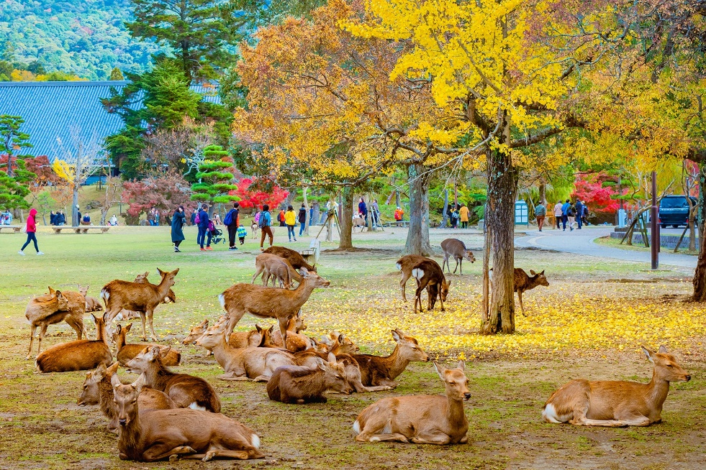

**Day 6 Universal Studios**

Spend a fun-filled day with the family at Universal Studios Japan and take in the many rides, shows, movies and attractions. Shop and stop to dine.

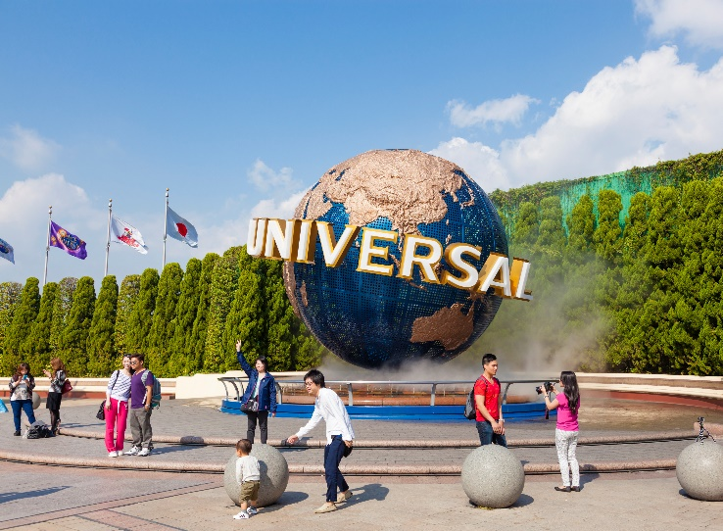

**Day 7 : Depart from Tokyo**

Morning breakfast at the hotel. After that you will be transferred to Tokyo airport. Take flight back to home.

**Inclusions:**

1. 06 nights’ accommodation with breakfast
2. Private transfers from Narita airport to Tokyo Hotel
3. Private transfers from Tokyo Station to Narita Airport
4. Mount Fuji and Hakone Full Day Tour
5. Kyoto and Nara 1 Day Bus Tour
6. Tokyo Signature Sightseeing Tour
7. Osaka: Universal Studios Japan Entry Ticket
8. JR Pass
9. Travel Insurance
10. Visa Assistance
11. International Flight Tickets
12. GST
13. TCS 5% of Land Part (Refundable at time of ITR filling)

**Exclusions:**

1. Visa Fee
2. Any expenses of personal nature such as Porterage, laundry, and alcohol, food or drink not in the regular menus provided by mini bar, telephone calls and us.
3. Any extra meals not included in the itinerary. Meals are pre-set and a choice of menu is not available.
4. Cost of excursions, city sightseeing, entrance fees and local guides availed of by the passengers, other than that mentioned in ‘what your tour price includes’.
5. Anything that is not specified in the Itinerary.
6. Any extra cost incurred on behalf of an individual due to illness, accident, hospitalization, or any personal emergency.
7. Scattered arrival and departure transfer & Sightseeing.
8. Early check-in and late checkout are on request basis only and subject to room availability [Standard International Check – in time is 1500 hrs. and check out time is 1100 hrs. (**Subject to change as per Hotel’s policy)]
9. Cost of foreign exchange for personal expenses.
10. Surcharges applicable during conventions, special events and trade fairs.
11. Cost of any other services not specifically mentioned in inclusions.
12. Any increase in the cost that may come into force prior to the departure date including change in price owing to fluctuation in the rate of exchange.

**Note:**

* + Standard Hotel Check-in Time 1400 hrs.
  + Standard Hotel Check-out Time 1100 hrs.
  + Airfare is subject to availability. It can fluctuate anytime.
  + We have not blocked or hold any service as of now

**Terms & Conditions:**

* The above is only a quote and no bookings have been made yet.
* Surcharges applicable during Conventions, Special Events and Trade fairs.
* Issuance of visa is solely under the discretion of the Consulates / Embassies. Our role is to assist you in submission of visa and guide you with the formalities. We do not hold any responsibility in case of any rejection of visas. Cancellation policy will be still applicable even if the visas are rejected.
* If the Covid Test (PCR) is positive, then as per government quarantine stay might extend as per rules.
* Customer have to reach the specified pickup point for the tours.
* Customer has to reach 10 – 15 minutes prior to the allotted time at the pickup point.
* Any requests such as (Interconnecting Room, adjacent Rooms, rooms on the same floor, 1 king size / 1 double bed/ twin bed, floor map, early check in, non/ smoking room, etc.) is subject to availability on first come first serve basis up on your guest arrival at the hotel and it is totally discretionary and up to the hotel to assign. However, we will request this for you as priority.
* Most hotels check in time is between 1400-1500hrs & check out time is between 1000-1100hrs and varies from hotel to hotel. If necessary, we will request an early check in or late checkout but this is subject to availability. For guaranteed early check – in, please pre-book your stay for the previous night and for guaranteed late check – out, please pre-book your stay for the next night.
* The above quotation has been based on specific hotels. According to occupancies, hotels are subject to change. In case the hotel rooms are not available as specified above the alternate hotels will be suggested. The difference in cost is payable extra.
* Booking amount is non - refundable
* All confirmations are subject to availability at the time of booking.
* Rates are subject to change without prior notice due to circumstances beyond our control e.g. Rate Fluctuations, Fuel Increases, Government Regulations, Government Levies, Duties, etc.
* All Banks Charge to your account. Rate of Exchange will be given at the time of making payments, Subject to change without any prior notice.
* Please do not store money and valuables in your checked in baggage.
* All Rates are Valid for Indian Passport Holders
* Due to any Natural Calamities / unavoidable circumstances / Political or Social unrest, if client postpone or cancel the journey in case of any liability from Airline or Hotel client will be charged for the same. Any waiver request or reduction in cancellation amount request will be at airline or hotel discretion.
* On certain days, due to some unavoidable conditions we may sometimes amend/ reverse the itinerary and keep you informed. However, all the services/ inclusions will remain the same.
* Tours and transfers depart strictly as per the time mentioned on final itinerary.
* Mid night surcharge is applicable as per flight details.
* Issuance of visa is solely under the discretion of the Consulates / Embassies. Our role is to assist you in submission of visa and guide you with the formalities. We do not hold any responsibility in case of any rejection of visas. Cancellation policy will be still applicable even if the visa is rejected.
* We strongly advise passengers to take out insurance covering cancellations, medical expenses, and loss of baggage, curtailment and default at the time of booking.
* In case of any last minute registrations received for a single person or non- availability of finding a twin partner for a single person, single room supplement will have to be borne by the passengers mandatory.
* No refund will be provided for any unutilized services.

**Payment Policy:**

|  |  |
| --- | --- |
| Days before departure | Package amount to be paid |
| 35 days | 100% |
| 45 – 60 days | 25% |
| Hotel | 100% Room cost in case of non- refundable |
| Airfare | 100% flight cost required at the time of booking |

**Cancellation Policy:**

* Date of booking to 30 days before check in the cancellation charges will be 25% of the package cost.
* 30 to 15 days before check in the cancellation charges will be 50% of the package cost.
* 15 to 7 days before check in the cancellation charges will be 75% of the package cost.
* Less than 7 days before check in Total amount will be forfeited and no refund shall be given.
* No show Total amount will be forfeited and no refund shall be given.
* No refunds shall be given in case of any cancellations due to natural calamities.

**Bank Details:**

|  |  |
| --- | --- |
| Bank Name | HDFC BANK |
| Account Type | Current Account |
| Account Name | Tripzygo International |
| Account Number | 50200068661036 |
| IFSC Code | HDFC0005246 |

**May you have an amazing vacation!**

To know more about the unexplored places, follow us on

**Tricity Plaza, Office number 336 - 338 Third floor, Peer Muchalla, Zirakpur, Punjab 140603**