

Dear Sir/Ma’am,

Thank you for connecting with **TripzyGO International!**

We are happy and grateful to have this opportunity to plan your holidays. Planning someone's holidays is a huge responsibility and it is important to deliver great experiences. We do that by following one simple motto - You, the customer comes first. With us, you will always have fun loving holiday experiences because that is our utmost priority.

Promising a memorable trip to you on your holidays!

**Travel Details:**

## 

## Destination: Kashmir

**Date of Travel:**

05th June.2023

## Number of Travelers:

02 Adults

## Tour Duration:

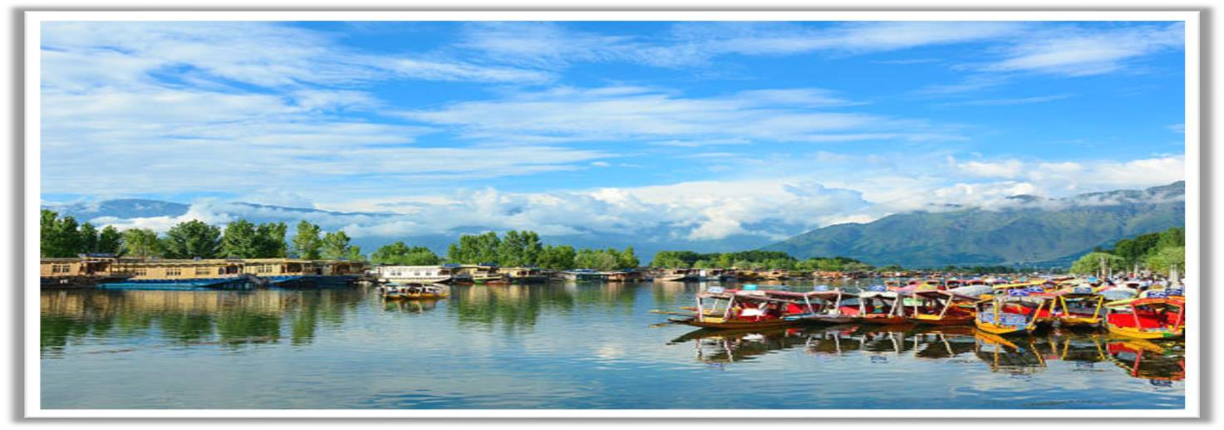05 Nights / 06 Days

**ACCOMMODATION DETAILS (SUBJECT TO AVAILABILITY)**

|  |  |  |
| --- | --- | --- |
| **Destination** | **Hotels** | **Nights** |
| Srinagar | ASIAN PARK/ ADLIFE LUXURY/ HOTEL MILAN/ GRAND MIR INTERNATIONAL/ SOJOUR LUXURY / ENNCO RESORT & SIMILAR | 03 |
| Pahalgam | PAHALGAM RETREAT / SOJOURN COTTAGE/ GREEN HEIGHTS/ OUTLOOK & SIMILAR | 01 |
| Houseboat | WANGOO SHERATON/ ANARKALI/ AKBER HERITAGE / HURMUKH & SIMILAR | 01 |

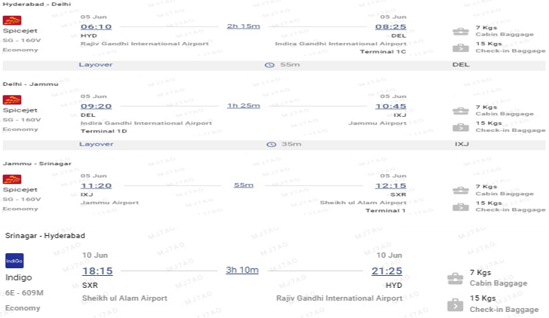**FLIGHTS DETAILS (Dynamic in Nature)**

**Total Cost with Flights INR 1,23,500/-**

**INCLUSIONS:**

* Pick up and drop from Srinagar airport
* Welcome drink on arrival in hotel.
* Meal Plan- 5 Breakfasts & 5 Dinners for each traveler + Room
* O1 Night Stay in Deluxe Houseboat.
* All transfers and sightseeing by Individual cab Sedan.
* Transfer Taxes, Parking, Fuel & Driver Expenses included.
* One-hour shikara ride over Dal Lake is complimentary.
* 5% GST Included

**Complementary Honeymoon Inclusion @ Houseboat**

* Candle Light Dinner
* Flower decoration
* Honeymoon Cake

**DAY WISE ITINERARY OF THE TRIP:**

# DAY 01: WELCOME TO SRINAGAR

## Day Services: Stay, Dinner & Car

Upon arrival at Srinagar Airport, meet our representative and get transferred to the hotel. Afterwards visit famous Mughal Gardens like Nishat Garden, Shalimar Garden, Chashma Shahi, Pari Mahal/ Shakar Acharya Temple. Evening will be freefor leisure activities. Overnight Stay in a Hotel.

Srinagar, the summer capital of Jammu and Kashmir is located in the heart of the Kashmir valley at an altitude of 1850 m above sea level. Spread on both sides of the river Jhelum the city is famous for its natural beauty, gardens, and waterfronts and houseboats. Srinagar is called the city of lakes and the Venice of the East, fascinating tourists from centuries with its beautiful picturesque Himalayan backdrop, glittering lakes that are surrounded by houseboats and Shikaras and the majesty of Mughal architecture. The very absence of order in the location of the houses and their tumbled down appearance add a peculiar charm to the scenery. It has its own quaint lifestyle, telling a panoramic fairytale tour through the snow-capped mountains and Chinar trees, while enjoying the adventurous pleasures of hiking, mountain biking, and rafting. The city is also famous for traditional Kashmiri handicrafts and dried fruits.

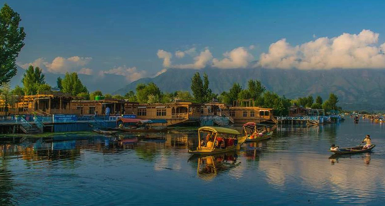

# DAY 02: SRINAGAR – DAY TRIP/GULMARG

## Day Services: Stay, Breakfast, Dinner & Car

After breakfast, journeyed to Gulmarg. Gulmarg has one of the best ski slopes in the world and the highest golf course with 18 holes. If weather permits one can also have the view of Nanga Parbat, the naked mountain that is over 26,000 feet’s and dominates the entire region, Full day leisure visit around amazing scenery of Gulmarg and visit to Apharwat by Asia’s largest cable car (Gondola ticket at Your Own) have Two Phases Namely Gulmarg to Kungdoor (Phase I) Kungdoor to Apharwat (Phase II). In the Evening return to hotel. Dinner & Overnight stay at Hotel in Srinagar

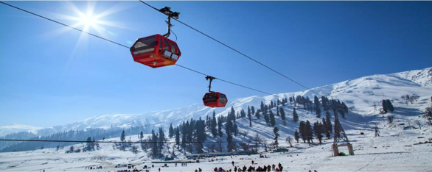NOTE: During Winters our vehicle will drop and pick you up at Tangmarg car stand, client has to pay directly snow cab Chain Sumo on sharing basis from Tangmarg to Gulmarg and for local convenience one has to rely on Poneys and ATV rides payable directly to explore other places in Gulmarg.

# DAY 03: SRINAGAR-SONAMARG-SRINAGAR

## Day Services: Stay, Breakfast, Dinner & Car

Morning after breakfast, you will proceed towards Srinagar & after this towards Sonmarg (97 kms from Srinagar), Sonmarg lies in Sindh Valley streamed with flowers and surrounded by mountains. Sonmarg is also the base for some

Interesting treks to the high-altitude Himalayan lakes. Visit to world’s famous thajiwas glacier by pony (on your own), and evening back to Srinagar hotel. Dinner and overnight stay at Srinagar hotel.

NOTE: Thajiwas Glacier trip at Sonmarg (as this sightseeing is done by local taxi stand at Sonmarg only or by ponies and is on direct payment basis.)

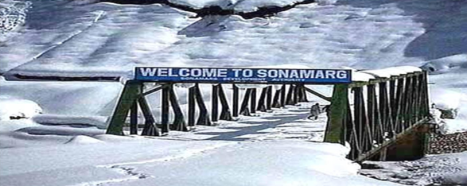

# DAY 04: SRINAGAR - PAHALGAM

## Day Services: Breakfast, Stay, Dinner & Car

After breakfast, you will check out from the Hotel and proceed to Pahalgam (The Valley of Shepherds) on the National Highway 1A. This road connects the Valley to the rest of the country. You will drive past the Saffron Fields of Pampore, the marvelous Avanti Pura Ruins, and the village of Bijbehara which remains famous as the breadbasket of Kashmir. You can even sample a few exotic loaves of bread sold by vendors near the road. You will then switch to the national highway at Khanabad and drive through the second largest city of Anantnag. Drive through the pine forests to arrive at Pahalgam which is unarguably one of the most beautiful places on earth. On arrival check in to the hotel in Pahalgam.

After reaching Pahalgam you can visit Kashmir Valley, Debian, and Baisaran by pony, or can also visit Aru/Betaab Valley in Chandanwari by Private Jeep (at your own expense). Stay overnight at a Pahalgam hotel.

# Top 5 places in India where you can enjoy the houseboat experience | Travel - Hindustan Times

# DAY 05: PAHALGAM - SRINAGAR

**Day Services: Breakfast, transfer to Srinagar.**

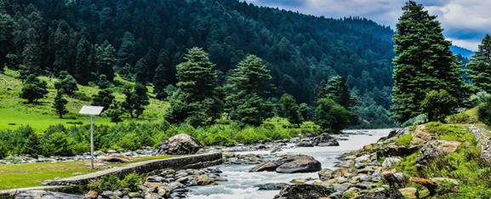On arrival check in to the Houseboat. Later some half a day of local sightseeing of Srinagar which includes the Mughal Gardens, visiting Chashma Shahi. The garden was developed on the orders of Emperor Shah Jahan in 1632 by Ali Mardan Khan around an abundant spring emerging from the slopes of the Zabarwan Mountains. The waters of the spring are renowned for their cool and rejuvenating qualities; Nishat Bagh was built by Asaf Khan, the brother-in-law of Jehangir in 1632 AD, and Shalimar Bagh was built by Jehangir for his wife empress Nur Jahan. Built between a periods of 14 years the two gardens are a heritage left behind by the erstwhile Mughals, whose taste for laying exquisite gardens was fascinating. In the evening enjoy shopping at the Local Market. Dinner and overnight stay in the Houseboat.

# DAY 06: SRINAGAR AIRPORT

## Day Services: Breakfast & Car

After breakfast check out from the Houseboat and then you will be dropped at Srinagar Airport for your onward journey with ever memorable Moments……….

## END OF TOUR WITH MEMORABLE MOMENTS…….

**EXCLUSIONS:**

* Any other meal than mentioned in itinerary (Alcohol another beverages)
* Any other destination than mentioned in itinerary
* Lunch during the trip.
* Expenses of personal nature like laundry, telephone/ fax calls, mineral water, alcoholic beverages, entrance and camera fee at monuments/ museums, medical expenses, gratuities etc.
* Any item, activity or facility other than clearly mentioned within the inclusions & itinerary above.
* Any entry fees, any tips, porter pony charges or any other expenses incurred by the porter/ participants during the sightseeing trips.
* Other than as clearly mentioned within the sightseeing in inclusions and itinerary.
* Any extra costs incurred due to extension/ change of the itinerary due to
* Natural calamities, road blocks, vehicle breakdown etc. Factors beyond our control.
* ABC Valley at Pahalgham
* Cable car (Gondola ride) not included in this, you can book this online or you can avail there in Gulmarg

**Note:**

* Standard Hotel Check-in Time 1400 hrs.
* Standard Hotel Check-out Time 1100 hrs.
* Airfare is subject to availability. It can fluctuate anytime.
* We have not blocked or hold any service as of now



**Terms & Conditions:**

* The above is only a quote and no bookings have been made yet.
* Surcharges applicable during Conventions, Special Events and Trade fairs.
* If the Covid Test (PCR) is positive, then as per government quarantine stay might extend as per rules.
* The above quotation has been based on specific hotels. According to occupancies, hotels are subject to change. In case the hotel rooms are not available as specified above the alternate hotels will be suggested. The difference in cost is payable extra.
* Booking amount is non - refundable
* All confirmations are subject to availability at the time of booking.
* Rates are subject to change without prior notice due to circumstances beyond our control e.g. Rate Fluctuations, Fuel Increases, Government Regulations, Government Levies, Duties, etc.
* Please do not store money and valuables in your checked in baggage.
* All Rates are Valid for Indian Passport Holders
* Issuance of visa is solely under the discretion of the Consulates / Embassies. Our role is to assist you in submission of visa and guide you with the formalities. We do not hold any responsibility in case of any rejection of visas. Cancellation policy will be still applicable even if the visas are rejected.
* Due to any Natural Calamities / unavoidable circumstances / Political or Social unrest, if client postpone or cancel the journey in case of any liability from Airline or Hotel client will be charged for the same. Any waiver request or reduction in cancellation amount request will be at airline or hotel discretion.
* On certain days, due to some unavoidable conditions we may sometimes amend/ reverse the itinerary and keep you informed. However, all the services/ inclusions will remain the same.
* Tours and transfers depart strictly as per the time mentioned on final itinerary.
* Mid night surcharge is applicable as per flight details.
* We strongly advise passengers to take out insurance covering cancellations, medical expenses, and loss of baggage, curtailment and default at the time of booking.
* No refund will be provided for any unutilized services.

**Payment Policy:**

|  |  |
| --- | --- |
| Days before departure | Package amount to be paid |
| Booking Confirmation | 25 % of the land package |
| 30 days | 100% |
| Hotel | 100% Room cost in case of non- refundable |
| Airfare | 100% flight cost required at the time of booking |

**Cancelation Policy**

* Date of booking to 30 days before check in the cancellation charges will be 25% of the package cost.
* 30 to 15 days before check in the cancellation charges will be 50% of the package cost.
* 15 to 7 days before check in the cancellation charges will be 75% of the package cost.
* Less than 7 days before check in Total amount will be forfeited and no refund shall be given.
* No show Total amount will be forfeited and no refund shall be given.
* No refunds shall be given in case of any cancellations due to natural calamities.

**Bank Details:**

|  |  |
| --- | --- |
| Bank Name | HDFC BANK |
| Account Type | Current Account |
| Account Name | TripzyGo International |
| Account Number | 50200068661036 |
| IFSC Code | HDFC0005246 |

**May you have an amazing vacation!**

To know more about the unexplored places, follow us on

**Tricity Plaza, Office number 336 - 338 Third floor, Peer Muchalla, Zirakpur, Punjab 140603**

# WAITING FOR YOUR KIND RESPONSE...!!!!!!!! REGARDS WITH THANKS