Create a Role “MyEC2role” with policy “[AmazonEC2FullAccess](https://console.aws.amazon.com/iam/home?region=ap-south-1#/policies/arn%3Aaws%3Aiam%3A%3Aaws%3Apolicy%2FAmazonEC2FullAccess)”

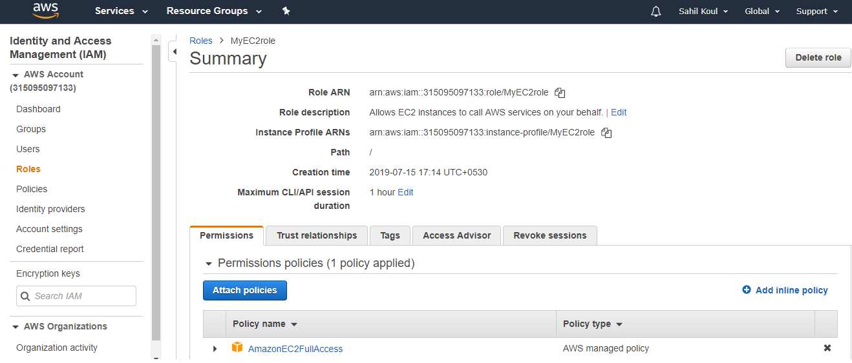

Launch an EC2 instance

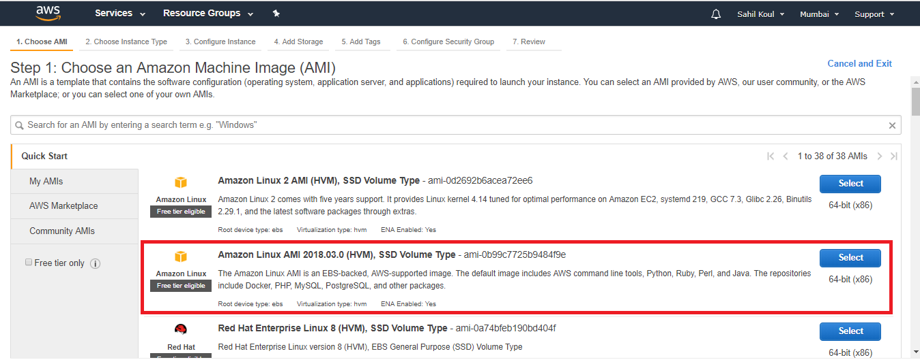

Select free tier VM

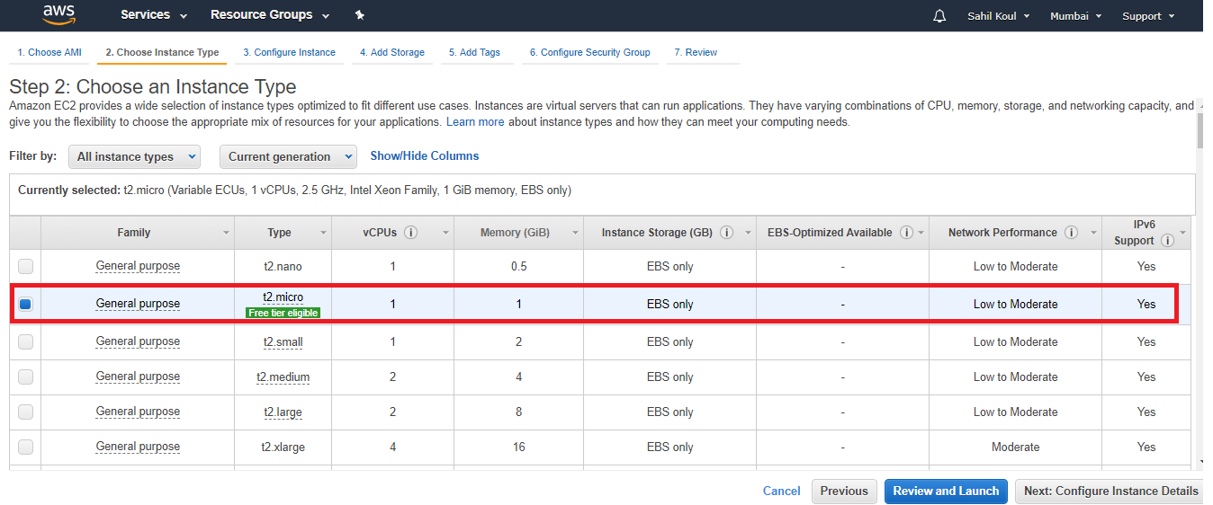

Select “Configure instance” , Go to “IAM role” and select the role “MyEC2role”. Review and Launch instance.

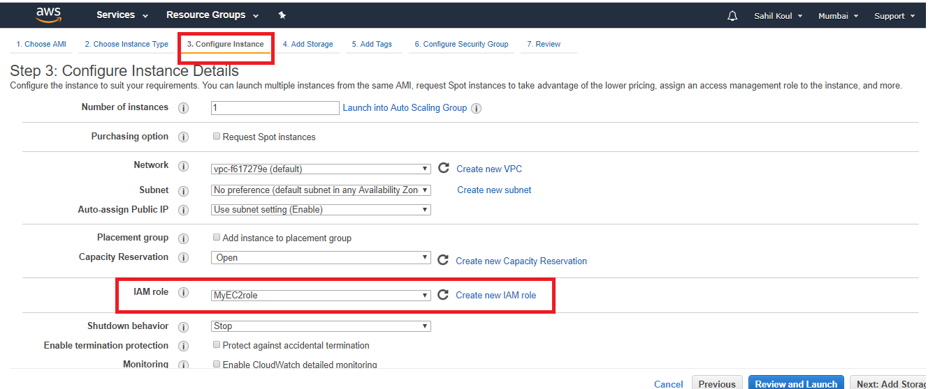

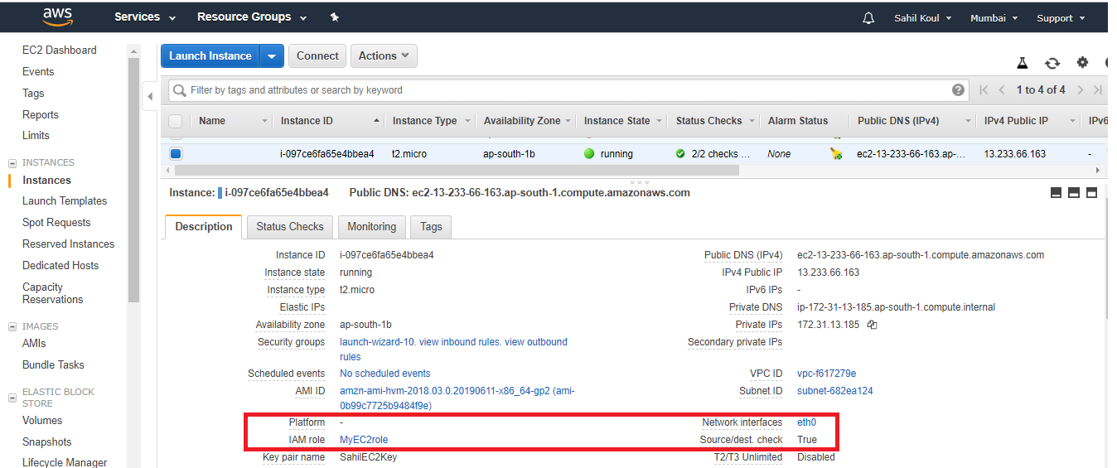

Connect to the Instance using putty

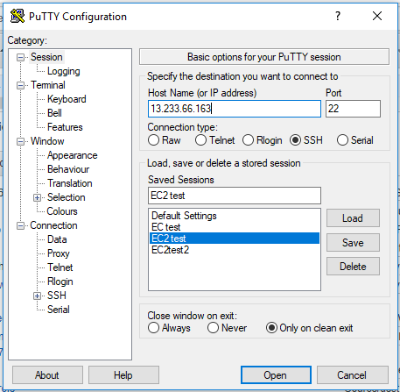

Sudo su

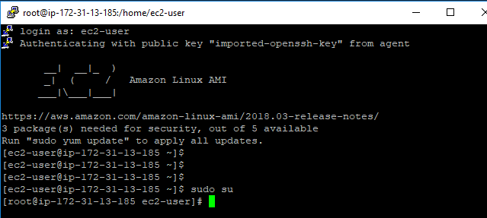

Run the below cmd to create an EC2 instance from cmd-line

aws ec2 run-instances --image-id ami-0b99c7725b9484f9e --instance-type t2.micro --count 1 --key-name “yourKeyPair” --security-group-ids sg-056a3d41d338ab57e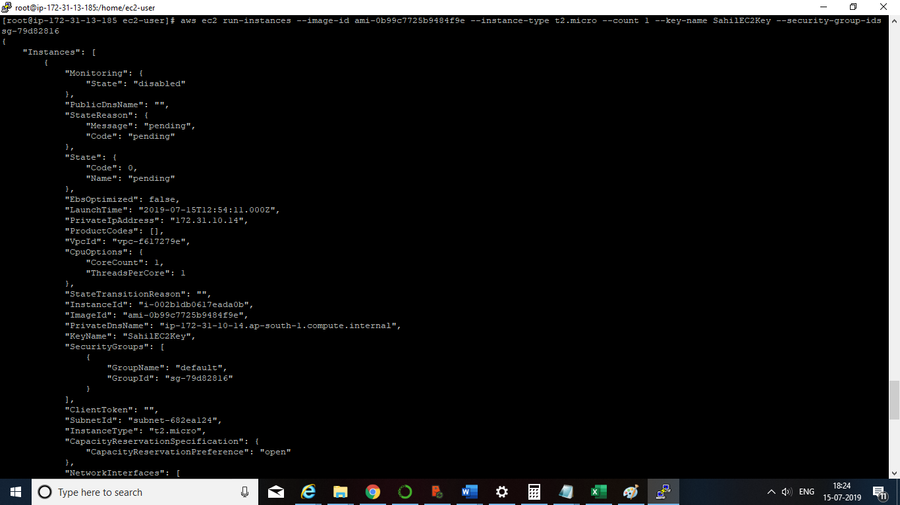

Check your EC2 dashboard and a new instance will be there.

Also check below link for more cmd options:

<https://docs.aws.amazon.com/cli/latest/userguide/cli-services-ec2-instances.html>

aws ec2 run-instances --image-id ami-0b99c7725b9484f9e --instance-type t2.micro --count 1 --region ap-south-1 --key-name mynewkeypair-july --security-group-ids sg-0312dc0d5ea5e1b65

aws ec2 create-tags --resources i-060022f026affd07e --tags Key=Name,Value=Production

aws ec2 run-instances --image-id ami-04125d804acca5692 --count 1 --instance-type t2.micro --key-name mynewkeypair-july --subnet-id subnet-dfe15993 --tag-specifications 'ResourceType=instance,Tags=[{Key=Name,Value=Production}]' 'ResourceType=volume,Tags=[{Key=cost-center,Value=cc123}]'