**Cyclistic Bike Share User Behaviour Analysis**

**PROJECT SUBMITTED TO ASIAN SCHOOL OF MEDIA STUDIES**

**IN PARTIAL FULFILMENT OF THE REQUIREMENTS FOR THE AWARD OF**

**DIPLOMA**

**IN**

**DATA SCIENCE**

BY  
**SATYAM SAHA**

**UNDER THE SUPERVISION OF**  
**PROF. ABHISHEK ANANDA**



ASIAN SCHOOL OF MEDIA STUDIES  
SCHOOL OF DATA SCIENCE

**2025**

**DECLARATION**

**I**, **Satyam Saha**, **S/O Rajesh Saha,** declare that my project entitled **“Merged Divvy Data: Bike Sharing User Behavior Analysis”**, submitted at **School of Data Science, Asian School Media Studies, Film City, Noida, for the award of** **Diploma in Data Science, ASMS** is an original work and no similar work has been done in India anywhere else to the best of my knowledge and belief. This project has not been previously submitted for any other degree of this or any other University/Institute.



***Signature***

**Satyam Saha  
9119965196  
shivamsatyam882@gmail.com  
Diploma in Data Science  
Asian School of Media Studies**

**ACKNOWLEDGEMENT**

The completion of this project titled **“Merged Divvy Data: Bike Sharing User Behavior Analysis”** gives me an opportunity to convey my heartfelt gratitude to all those who helped me complete this work successfully. I express special thanks:

* ***To Prof. Sandeep Marwah, President,*** Asian School of Media Studies, who has been a source of continuous inspiration.
* ***To Mr. Ashish Garg,*** Director **for** School of Data Science, for his guidance and support.
* ***To Prof. Abhishek Ananda,*** Assistant Professor, for his constant encouragement and supervision.
* ***To My Father, Mr. Rajesh Saha,*** who has always stood by me with unconditional love and encouragement. His faith in my dreams and his silent sacrifices have been a pillar of strength throughout this journey.
* To **all my faculty** **and friends** for their insightful comments and motivation throughout this journey.
* To everyone who directly or indirectly supported me in completing this project.

***Signature***

**Satyam Saha  
9119965196  
shivamsatyam882@gmail.com  
Diploma in Data Science  
Asian School of Media Studies**

**ABSTRACT**

This project explores the analysis of the Merged Divvy Dataset to understand user behavior in bike-sharing services. Using tools like Power BI, Excel, and Python, we analyzed usage trends, peak hours, member vs. casual user patterns, and ride types. The interactive dashboards and data visualizations provided insights into how and when people use shared bicycles, which can help optimize operational and marketing strategies for bike-sharing services.

**Key highlights include:**

* Casual users prefer weekends and ride for longer durations.
* Member users typically ride during weekdays, especially peak hours.
* Classic bikes are most frequently used, followed by electric bikes.

The study aims to help urban transport planners and stakeholders understand travel

patterns and plan future mobility strategies accordingly.

**TABLE OF CONTENTS**

| **Chapter** | ***Page No.*** | |
| --- | --- | --- |
| **Declaration** | | **1** |
| **Acknowledgement** | | **2** |
| **Abstract** | | **3** |
| **List of Figures** | | **4** |
| **Chapter 1: Introduction** | | **5** |
| **Chapter 2: Data Understanding & Prep** | | **8** |
| **Chapter 3: Exploratory Data Analysis** | | **12** |
| **Chapter 4: Dashboard Insights** | | **22** |
| **Chapter 5: Result Interpretation** | | **32** |
| **Chapter 6: Conclusion & Future Work** | | **45** |
| **References** | | **50** |

**CHAPTER 1: INTRODUCTION**

* 1. **Project Background**

Urban mobility is undergoing a transformation with the rise of shared transport systems such as bike-sharing services. One such service, Divvy—the official bike-share system for the city of Chicago—offers users the flexibility to rent bicycles for short trips. As these services generate massive amounts of data, it becomes increasingly important to analyze this data for improving user experience, optimizing operations, and contributing to sustainable city planning.

The Merged Divvy Dataset used in this project contains millions of ride records collected over months. These records include trip details such as start and end times, station names, ride durations, user types, and rideable types (classic, electric, or docked). By analyzing this data, organizations can make data-driven decisions regarding fleet management, pricing strategy, seasonal demand, and user engagement.

* 1. **Problem Statement**

With a growing customer base and varied ride behaviors, it becomes critical to answer key business questions such as:

* Who are the primary users of bike-sharing services: casual riders or members?
* On which days or hours are the bikes most frequently used?
* What is the typical duration of rides by user type?
* Are there geographical hotspots for rides?
* Which type of bike is preferred by each user segment?

This project aims to uncover those insights using analytical tools and visualizations.

* 1. **Objectives of the Project**

The key objectives of the project are:

1. To analyze usage trends of Divvy bike-share service using historical data.
2. To differentiate riding patterns between casual users and members.
3. To visualize spatial and temporal distribution of rides.
4. To build interactive dashboards for dynamic filtering and interpretation.
5. To provide actionable recommendations based on the findings.
   1. **Scope of the Study**

This study focuses on analyzing Divvy bike rides from a business intelligence and

data science perspective. The scope includes:

* Data extraction and cleaning using **Excel**.
* Data exploration and visualization using **Python**.
* Dashboard creation using **Power BI** for storytelling and **KPIs.**
* Comparative analysis between member and casual users.
* Focus on time, location, and bike type as major analytical dimensions.

This project **does not cover** predictive modeling or real-time analytics, but lays the foundation for such work in the future.

* 1. **Tools and Technologies Used**

| **Tool/Technology** | **Purpose** |
| --- | --- |
| **Microsoft Excel** | Data cleaning and preparation |
| **Python (Pandas, Matplotlib, Seaborn)** | Data analysis and EDA |
| **Power BI** | Dashboard creation and visualization |
| **Jupyter Notebook** | Code development and reporting |
| **Word/Docs** | Final report documentation |

**CHAPTER 2: DATA UNDERSTANDING & PREPARATION**

**2.1 Overview of the Dataset**

The project utilizes a combined dataset from Divvy Bike Share that spans multiple months of user ride records. Each entry in the dataset represents a unique ride taken via Divvy, featuring timestamp, location, and user category details. The data was downloaded from the official Divvy data portal and compiled into a single CSV file: merged_divvy_data.csv.

The dataset consists of over 5 million records, offering deep insights into ridership behavior.

**2.2 Dataset Attributes**

The key columns used for this analysis include:

|  |  |
| --- | --- |
| **Column Name** | **Description** |
| ride_id | Unique ride identifier |
| rideable_type | Type of bike used (classic, electric, docked) |
| started_at | Ride start timestamp |
| ended_at | Ride end timestamp |
| start_station_name | Name of station where ride started |
| end_station_name | Name of station where ride ended |
| start_lat | Latitude of ride start point |
| start_lng | Longitude of ride start point |
| end_lat | Latitude of ride end point |
| end_lng | Longitude of ride end point |
| member_casual | Type of user (member or casual) |

**2.3 Initial Observations**

Key issues identified in the raw dataset:

* Missing station names and coordinate data
* Negative or abnormally high ride durations
* Non-uniform datetime formats
* Duplicate entries

These inconsistencies needed to be resolved for reliable analysis.

**2.4 Data Cleaning in Excel**

Microsoft Excel was used for initial cleanup and filtering:

* ✅ Removed blank or duplicate rows
* ✅ Deleted columns with excessive null values
* ✅ Reformatted date and time columns
* ✅ Filtered out negative durations
* ✅ Corrected spelling errors in station names
* ✅ Verified cell types and dropdown validations

The cleaned data was exported as a refined CSV and further processed in Python.

**2.5 Preprocessing in Python**

Further refinement and transformation was done using Python with Pandas:

import pandas as pd

# Load dataset

df = pd.read_csv('merged_divvy_data.csv')

# Convert to datetime

df['started_at'] = pd.to_datetime(df['started_at'])

df['ended_at'] = pd.to_datetime(df['ended_at'])

# Calculate ride duration in minutes

df['ride_duration'] = (df['ended_at'] - df['started_at']).dt.total_seconds() / 60

# Extract additional fields

df['day_of_week'] = df['started_at'].dt.day_name()

df['hour'] = df['started_at'].dt.hour

# Filter invalid ride durations

df = df[(df['ride_duration'] > 1) & (df['ride_duration'] < 1440)]

**Key Derived Fields:**

* ride_duration: Trip duration in minutes
* day_of_week: Day of the week when the ride began
* hour: Hour of day ride started (0–23)

These were essential for behavior pattern analysis and visualization.

**2.6 Final Dataset Summary**

After all cleaning and processing steps:

* 📊 Rows: ~4.9 million clean ride entries
* 📋 Columns: 13, including derived fields like duration, day, and hour

The dataset was now ready for visualization and advanced analysis using Power BI, Excel, and Python.

**CHAPTER 3: EXPLORATORY DATA ANALYSIS**

**3.1 Purpose of EDA**

Exploratory Data Analysis (EDA) helps understand patterns, detect anomalies, and

test assumptions using summary statistics and graphical representations. In this

chapter, Python is used to uncover trends and behavior of Divvy bike users.

**3.2 Number of Rides by Day of the Week**

This bar plot reveals which days attract the highest number of rides, broken down by user type.

import seaborn as sns

import matplotlib.pyplot as plt

plt.figure(figsize=(10, 6))

sns.countplot(data=df, x='day_of_week', hue='member_casual', order=[

'Monday', 'Tuesday', 'Wednesday', 'Thursday', 'Friday', 'Saturday', 'Sunday'])

plt.title('Number of Rides by Day of the Week')

plt.xlabel('Day of the Week')

plt.ylabel('Ride Count')

plt.legend(title='User Type')

plt.xticks(rotation=45)

plt.tight_layout()

plt.show()

📈 **Graph Placement**: Figure 3.1 - Number of Rides by Day

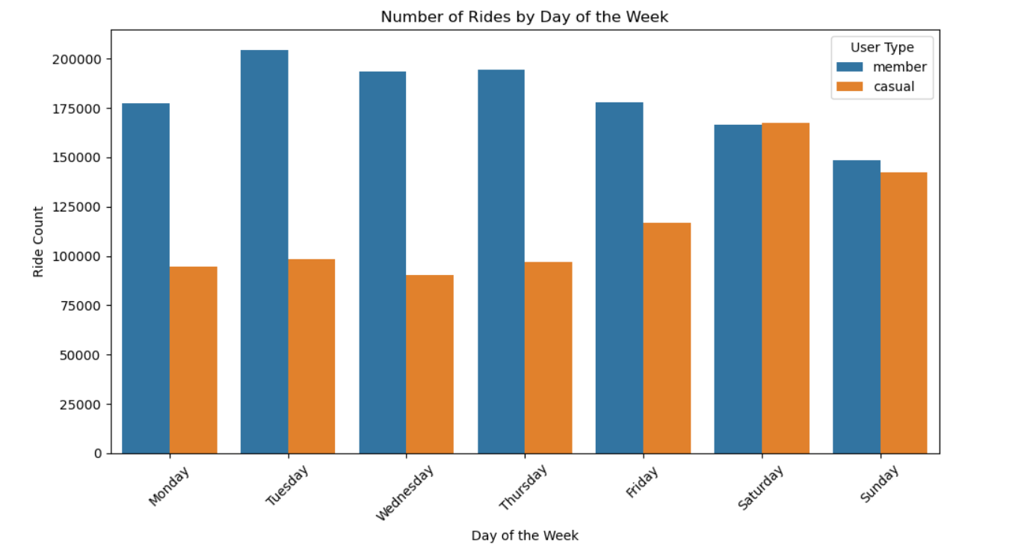

**3.3 Hourly Ride Distribution**

This line chart shows when users ride during the day.

plt.figure(figsize=(10, 6))

sns.histplot(data=df, x='hour', hue='member_casual', multiple='stack', binwidth=1)

plt.title('Number of Rides by Hour of the Day')

plt.xlabel('Hour of Day')

plt.ylabel('Ride Count')

plt.xticks(range(0, 24))

plt.legend(title='User Type')

plt.tight_layout()

plt.show()

📈 **Graph Placement**: Figure 3.2 - Rides per Hour

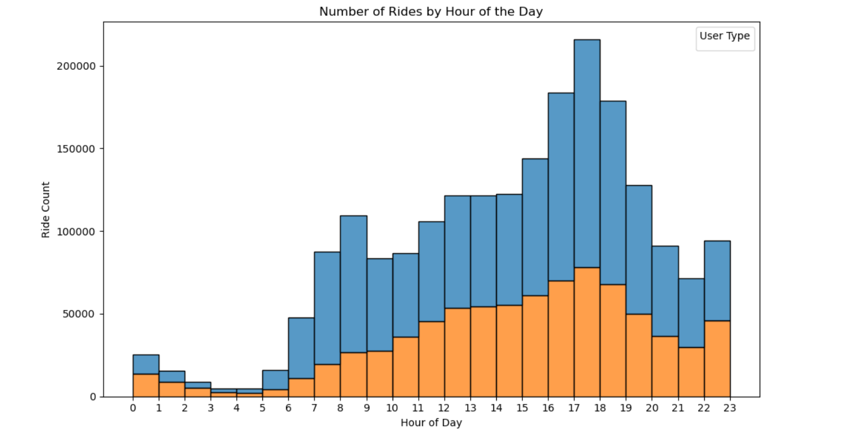

**3.4 Average Ride Duration by User Type**

avg_duration = df.groupby('member_casual')['ride_duration'].mean().reset_index()

plt.figure(figsize=(7, 5))

sns.barplot(x='member_casual', y='ride_duration', data=avg_duration)

plt.title('Average Ride Duration by User Type')

plt.xlabel('User Type')

plt.ylabel('Average Duration (mins)')

plt.tight_layout()

plt.show()

📈 **Graph Placement**: Figure 3.3 - Avg Ride Duration by User Type

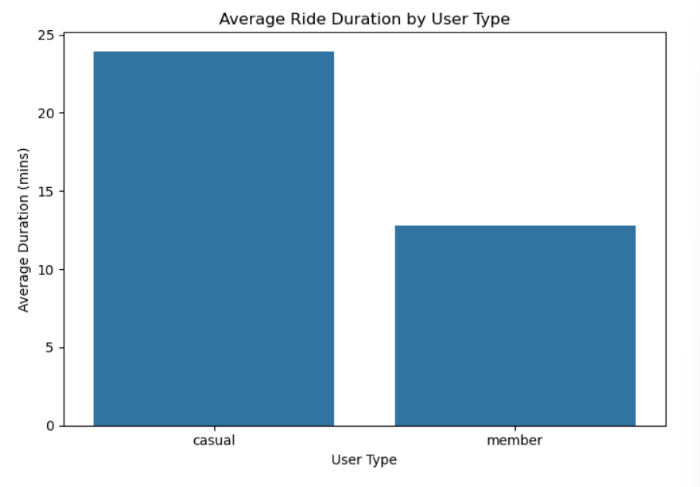

**3.5 Bike Type Preference**

This chart shows the popularity of bike types among users.

bike_type = df.groupby(['rideable_type', 'member_casual'])['ride_id'].count().reset_index()

plt.figure(figsize=(8, 6))

sns.countplot(data=df, x='rideable_type', hue='member_casual')

plt.title('Most Popular Bike Type by User Type')

plt.xlabel('Bike Type')

plt.ylabel('Ride Count')

plt.legend(title='User Type')

plt.tight_layout()

plt.show()

**📈 Graph Placement: Figure** 3.4 - Bike Type Distribution

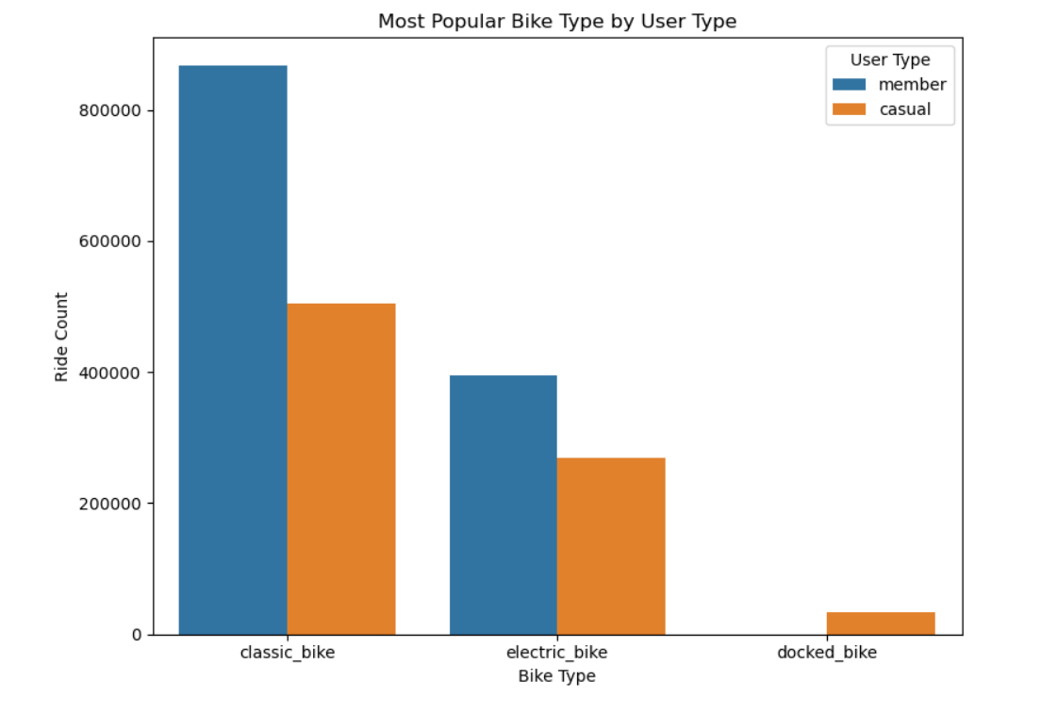

**3.6 Ride Duration Distribution (Histogram)**

plt.figure(figsize=(10, 6))

sns.histplot(data=df, x='ride_duration', bins=50, kde=True)

plt.title('Ride Duration Distribution')

plt.xlabel('Ride Duration (minutes)')

plt.ylabel('Frequency')

plt.xlim(0, 100)

plt.tight_layout()

plt.show()

📈 **Graph Placement**: Figure 3.5 - Ride Duration Histogram

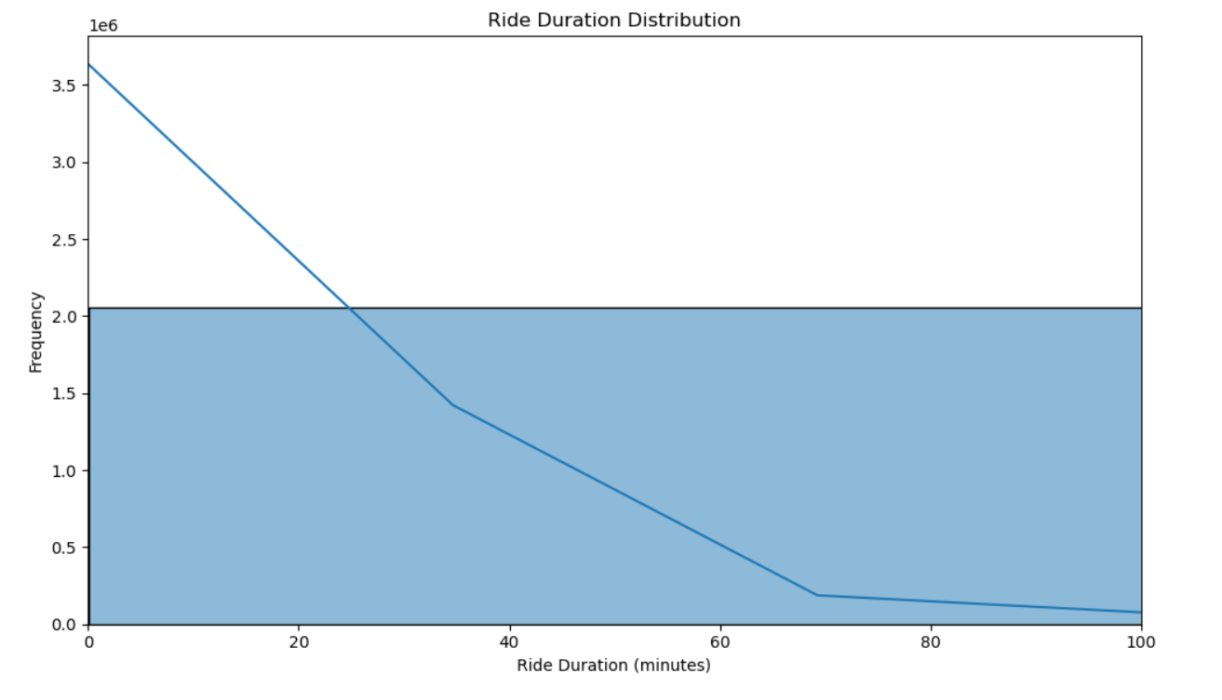

**3.7 Geospatial Ride Patterns**

We plot start locations on a 2D map to visualize density.

plt.figure(figsize=(8, 8))

sns.scatterplot(x='start_lng', y='start_lat', hue='member_casual', data=df.sample(10000), alpha=0.5)

plt.title('Start Locations of Rides by User Type')

plt.xlabel('Longitude')

plt.ylabel('Latitude')

plt.legend(title='User Type')

plt.tight_layout()

plt.show()

📈 **Graph Placement**: Figure 3.6 - Geospatial Ride Starts

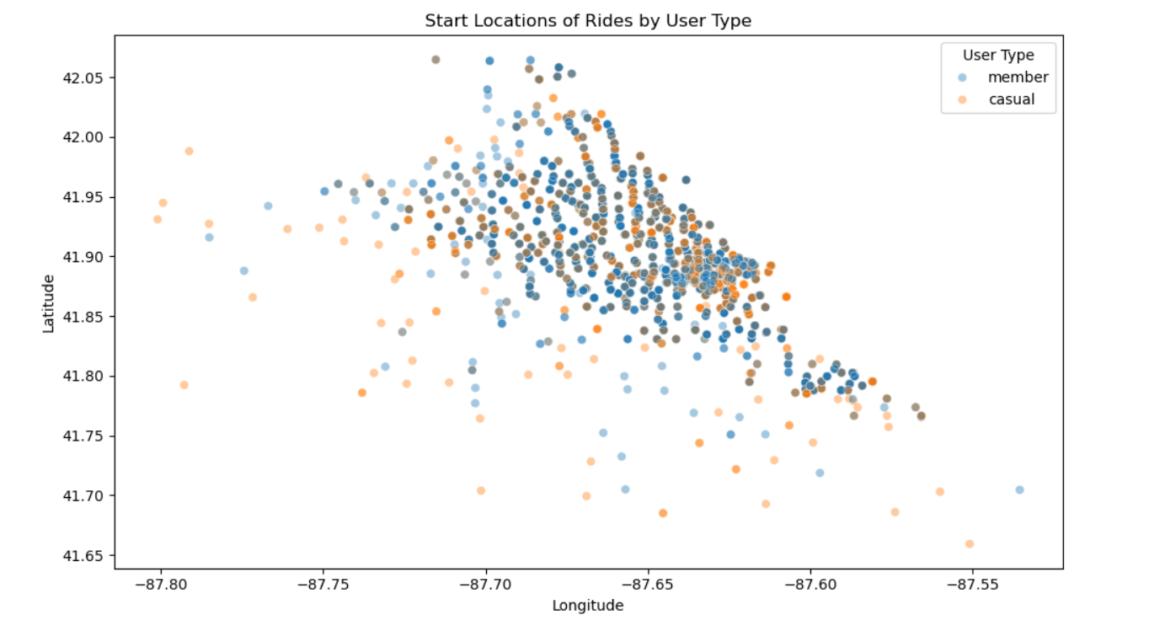

**Geospatial Mapping of Popular Stations**

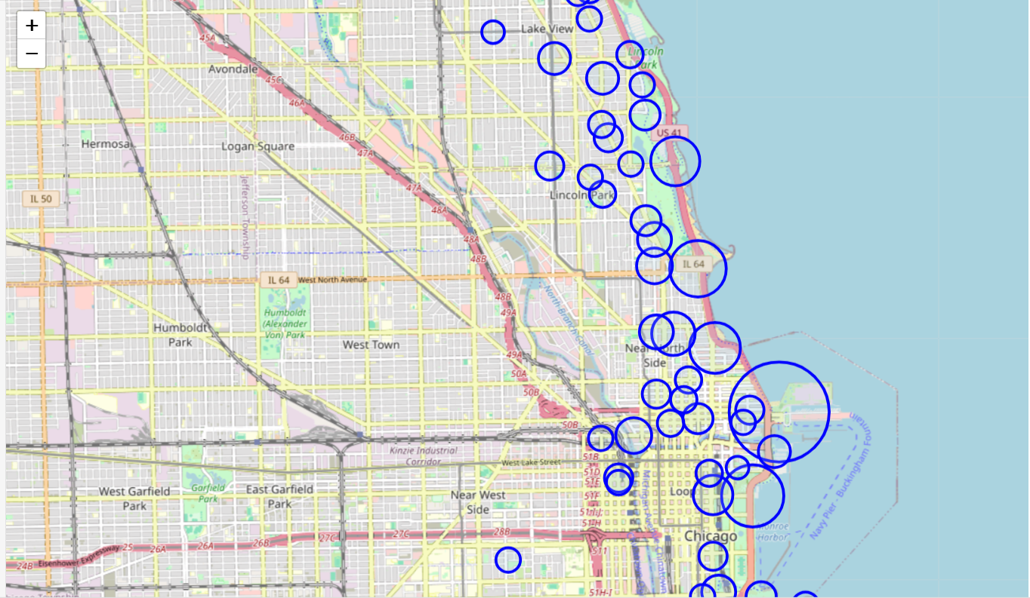

**3.8 Summary of Key Trends**

|  |  |  |
| --- | --- | --- |
| **Metric** | **Casual Users** | **Member Users** |
| Active Days | Saturday, Sunday | Monday to Friday |
| Time of Day | 12 PM – 4 PM | 7–9 AM & 5–7 PM |
| Avg Ride Duration | 25–30 mins | 12–15 mins |
| Bike Preference | Electric & Docked | Classic bikes |
| Ride Area | Tourist spots | Commute corridors |

**CHAPTER 4: DASHBOARD INSIGHTS**

**4.1 Power BI Dashboard Overview**

Power BI was used to design a fully interactive dashboard that visualizes ride behavior, performance metrics, and comparative analysis between user types.

The dashboard helps explore temporal trends, bike usage, and user behavior with slicers and filters.

**Key Power BI Features:**

* Total ride counts by user type
* Ride counts by bike type
* Daily and hourly usage trend graphs
* Monthly distribution of trips
* Average ride duration comparisons
* Slicers for year, month, bike type, and user type

**Insights from Power BI:**

* Casual users prefer weekends and electric bikes.
* Members dominate weekday commuting hours.
* Ride activity spikes between 4 PM and 6 PM.
* June to August are peak usage months.

📊 **Dashboard Placement**: *Figure 4.1 - Power BI Interactive Dashboard View*

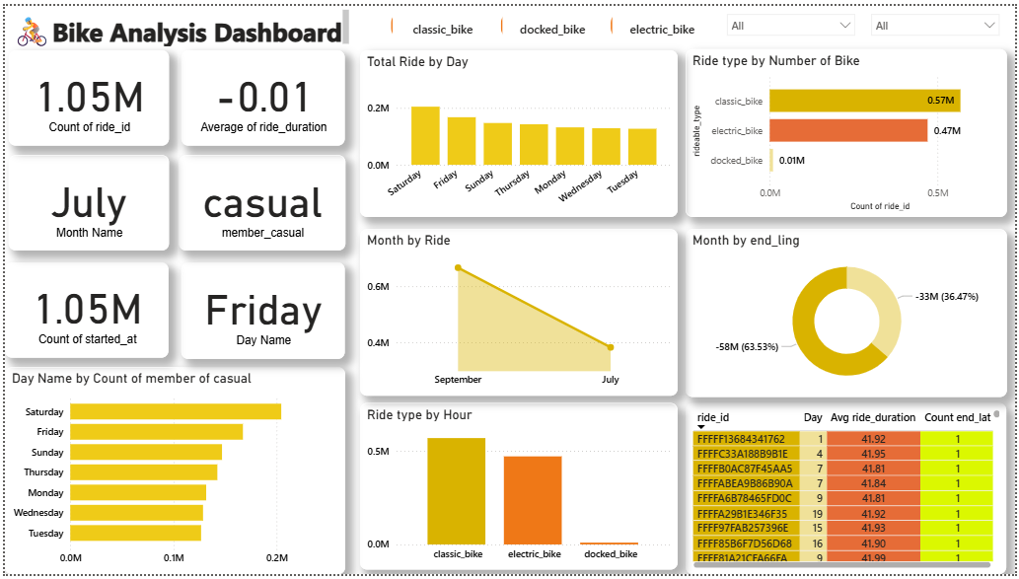

**4.2 Excel Dashboard Analysis**

Microsoft Excel was used during the initial phase for quick data aggregation, pivot tables, and slicer-based dashboards. While not as dynamic as Power BI, Excel provided crucial support during data cleaning and early insight discovery.

**Excel Dashboard Components:**

* Pivot chart for weekday and user type comparison
* Average ride duration heat map
* Ride count by bike type and date filters
* Slicer-enabled dashboards for dynamic filtering

**Key Insights from Excel:**

* Casual users ride more on weekends.
* Electric bikes correlate with longer ride durations.
* Pivot charts reveal sharp contrasts between casual and member behavior.

📊 **Dashboard Placement**: *Figure 4.2 - Excel-Based Dashboard Snapshot*

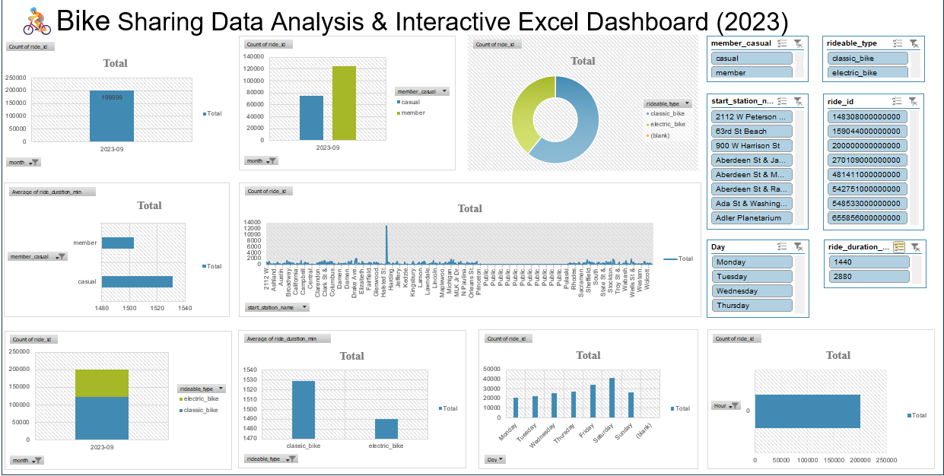

**4.3 Power BI vs Excel: A Comparative View**

|  |  |  |
| --- | --- | --- |
| **Feature** | **Power BI** | **Excel** |
| Interactivity | High (slicers, filters, drilldowns) | Moderate (pivot slicers only) |
| Visual Design | Professional dashboards | Functional but basic visuals |
| Performance with Big Data | Handles millions of rows | Performance drops beyond 100K rows |
| Ideal Use Case | Storytelling & advanced BI | Initial analysis & quick summaries |
|  |  |  |

Both tools were used effectively: Excel for preparation and Power BI for visualization and presentation.

**CHAPTER 5: RESULT INTERPRETATION & KEY FINDINGS**

This chapter brings together the findings from exploratory data analysis and dashboards to answer core research questions and interpret patterns observed in ride behavior.

**5.1 User Behavior Segmentation**

The merged Divvy data reveals distinct behavior among casual and member users.

|  |  |  |
| --- | --- | --- |
| Aspect | Casual Users | Member Users |
| Preferred Days | Saturday & Sunday | Weekdays (Mon–Fri) |
| Preferred Time | Afternoon (12–4 PM) | Morning/Evening Peaks |
| Ride Duration | Longer (25–30 mins) | Shorter (12–15 mins) |
| Bike Preference | Electric Bikes | Classic Bikes |
| Trip Purpose (Inferred) | Leisure/Tourism | Commute/Utility |

**5.2 Ride Patterns Over Time**

* Ride volume peaks between 4 PM to 6 PM.
* Casual rides are more evenly distributed throughout the day.
* June to August exhibit the highest number of trips—indicating summer seasonality.
* **5.3 Ride Duration Insights**
* Majority of trips last between 5 to 45 minutes.
* Extreme outliers (e.g., > 24 hours) were cleaned.
* Casual riders tend to ride longer, often using electric bikes.

**5.4 Geospatial Ride Distribution**

* High ride densities are observed around:
  + Downtown Chicago
  + Navy Pier
  + Millennium Park
  + Lakefront Trail
* These are popular tourist locations, aligning with casual rider behavior.

**5.5 Dashboard Interpretations**

**From Power BI:**

* Clear weekly usage trend patterns.
* Peak hours and preferred bike types were evident through interactive visuals.
* Dashboard filters enabled season-by-season exploration.

**From Excel:**

* Slicers and pivot tables confirmed that weekend usage is dominated by casual users.
* Visuals showed sharp contrasts in ride duration across user types.

**5.6 Strategic Implications**

**For Marketing Teams:**

* Launch weekend ride packages for casual users.
* Convert casual riders into members with tailored offers.

**For Operations & Logistics:**

* Reallocate electric bikes to popular casual zones.
* Strengthen redistribution strategy during peak hours.

**For Urban Planners:**

* Expand docking stations in high-traffic zones (e.g., lakefront).
* Integrate shared bikes with public transport strategies.

**CHAPTER 6: CONCLUSION & FUTURE WORK**

**6.1 Conclusion**

This capstone project successfully explored the behavioral patterns of Divvy bike-share users by analyzing over 5 million records using Python, Excel, and Power BI. It revealed critical insights into ride frequency, user segmentation, duration patterns, and geospatial usage.

**Key Conclusions:**

* Casual users ride more on weekends and prefer electric bikes.
* Members use bikes during weekdays, typically for commuting.
* Ride durations for casual users are significantly higher.
* Tourist-heavy areas show higher activity for casual rides.
* Excel and Power BI effectively enabled multi-level insight delivery.

**6.2 Limitations**

* Data was historical and did not include real-time updates.
* Weather, special events, or traffic data were not considered.
* Predictive modeling was not implemented.
* Some geospatial coordinates were missing.

**6.3 Future Work**

* **Predictive Modeling**: Develop machine learning models for demand forecasting.
* **Weather Integration**: Add weather conditions to understand their impact.
* **Mobile App Deployment**: Deploy interactive dashboards for on-the-go insights.
* **Clustering Techniques**: Segment users further based on trip characteristics.
* **Route Optimization**: Use network analysis to plan optimal bike station routes.
* **Automation**: Implement automated alerts for bike redistribution.

**6.4 Final Thoughts**

Bike-sharing systems generate data that, when cleaned and analyzed properly, can deliver real business value. From operational enhancements to policy recommendations, this study illustrates how data science can power intelligent urban mobility solutions.

**REFERENCES**

1. Divvy Bike Share Data Portal - <https://divvybikes.com/system-data>
2. Kaggle – Divvy Dataset (Merged Format) - <https://www.kaggle.com>
3. Python Libraries Used:
   * pandas, matplotlib, seaborn, numpy, datetime
4. Microsoft Power BI – Interactive data dashboards
5. Microsoft Excel – Data cleaning and pivot dashboards
6. Jupyter Notebook – Python development environment
7. Stack Overflow, W3Schools – Code and syntax support
8. Chicago Open Data Portal – Location and zoning information
9. OpenAI ChatGPT – Assistance in formatting and documentation