FOG COMPUTING

A project submitted to the Bharathidasan University
In partial fulfillment of the requirements
For the award of the Degree of

MASTER OF SCIENCE IN COMPUTER SCIENCE

Submitted by

K.RAJKUMAR

Register Number: 4CS123207

Under the guidance of
Ms. PERSIS JESSINTHA, MCA, M.Phil.,
Assistant Professor



PG DEPARTMENT OF COMPUTER SCIENCE (S.F)
BISHOP HEBER COLLEGE (AUTONOMOUS)
(Nationally Reaccredited at the A⁺ Level by NAAC)
(Recognized by UGC as ‘College with Potential for Excellence’)
TIRUCHIRAPPALLI-620017

APRIL – 2014

DECLARATION

I hereby declare that the project work presented is originally done by me under the
guidance of Mrs. PERSIS JESSINTHA, MCA, M.Phil., PG Department of Computer Science (S.F), Bishop Heber College (Autonomous), Tiruchirappalli-620 017,
and has not been included in any other thesis/project submitted for any other degree.

Name of the Candidate : K.RAJKUMAR

Register Number : 4CS123207

Batch : 2012-2014

Signature of the Candidate

Mrs. PERSIS JESSINTHA, MCA, M.Phil.,
Assistant Professor,
PG Department of Computer Science (S.F),
Bishop Heber College (Autonomous),
Tiruchirappalli – 620017.

Date:

CERTIFICATE

This is to certify that the project work entitled “FOG COMPUTING” is a bonafide record work done by K.RAJKUMAR, Register Number: 4CS123207 in partial fulfillment of the requirements for the award of the degree of MASTER OF SCIENCE IN COMPUTER SCIENCE during the period 2012 - 2014.

Place: Signature of the Guide

PG DEPARTMENT OF COMPUTER SCIENCE (S.F),
BISHOP HEBER COLLEGE (AUTONOMOUS),
(Nationally Reaccredited at the A⁺ Level by NAAC),
(Recognized by UGC as ‘College with Potential for Excellence’),
TIRUCHIRAPPALLI - 620 017

Date:

Course Title: Project Course Code: P11CS4PJ

CERTIFICATE

The Viva-Voce examination for the candidate K.RAJKUMAR
Register Number: 4CS123207 was held on _________________.

Signature of the HOD Signature of the Guide

Examiners:
1.

2.
ACKNOWLEDGEMENT

I would like to express my gratitude to all those who gave me the possibility
to complete this project.

My sincere thanks are to Dr. D. PAUL DHAYABARAN, M.Sc., M.Phil., PGDCSA., Ph.D., Principal, Bishop Heber College, Tiruchirapalli for permitting me to do this project.

I wish to place on record my gratitude to Prof G. SOBERS SMILES DAVID, MCA, M.Phil., Assistant Professor & Head, Department of Computer Science, Bishop Heber College, Tiruchirapalli for his support during this project work.

I express my deep sense of gratitude Mrs.J.PERSIS JESSINTHA, MCA, M.Phil., Assistant Professor, Department of Computer Science, Bishop Heber College, Tiruchirapalli, who has offered invaluable guidance and constant encouragement throughout this work.

I thank my friends for their help and innovative ideas during my project work. I also thank my parents for extending help in all aspects during the course of this project.

SYNOPSIS

Cloud computing is a phrase used to describe a variety of computing concepts that involve a large number of computers connected through a communication network such as the Internet. It is very similar to the concept of utility computing. In science, cloud computing is a synonym for distributed computing over a network, and means the ability to run a program or application on many connected computers at the same time. The phrase is often used in reference to network-based services, which appear to be provided by real server hardware, and are in fact served up by virtual hardware, simulated by software running on one or more real machines. Such virtual servers do not physically exist and can therefore be moved around and scaled up or down on the fly without affecting the end user, somewhat like a cloud becoming larger or smaller without being a physical object.

Cloud computing promises to significantly change the way, I was use computers and access and store our personal and business information. With these new computing and communications paradigms arise new data security challenges. Existing data protection mechanisms such as encryption have failed in preventing data theft attacks, especially those perpetrated by an insider to the cloud provider. It Propose a different approach for securing data in the cloud using offensive decoy technology. It Monitor data access in the cloud and detect abnormal data access patterns. When unauthorized access is suspected and then verified using challenge questions, it launches a disinformation attack by returning large amounts of decoy information to the attacker. This protects against the misuse of the user’s real data. Experiments conducted in a local file setting provide evidence that this approach may provide unprecedented levels of user data security in a Cloud environment.
CONTENTS

CHAPTER NO. | INDEX | PAGE NO
1 | PROJECT DESRIPTION  - Introduction  - Existing System  - Proposed System
2 | PROBLEM SURVEY
3 | LOGICAL DEVELOPMENT  3.1 DFD’s  3.2 Architectural Design
4 | DATABASE DESIGN  4.1 Data Dictionary
5 | PROGRAM DESIGN
6 | TESTING
7 | CONCLUSION
8 | REFRENCES
9 | APPENDIX  9.1 Source Code  9.2 Output Screenshot

PROJECT DESRIPTION

- PROJECT DESCRIPTION

1.1 INTRODUCTION

In computer networking, cloud computing is a phrase used to describe a variety of computing concepts that involve a large number of computers connected through a communication network such as the Internet. It is very similar to the concept of utility computing. In science, cloud computing is a synonym for distributed computing over a network, and means the ability to run a program or application on many connected computers at the same time.
The phrase is often used in reference to network-based services, which appear to be provided by real server hardware, and are in fact served up by virtual hardware, simulated by software running on one or more real machines. Such virtual servers do not physically exist and can therefore be moved around and scaled up or down on the fly without affecting the end user, somewhat like a cloud becoming larger or smaller without being a physical object.
In common usage, the term "the cloud" is essentially a metaphor for the Internet. Marketers have further popularized the phrase "in the cloud" to refer to software, platforms and infrastructure that are sold "as a service", i.e. remotely through the Internet. Typically, the seller has actual energy-consuming servers which host products and services from a remote location, so end-users don't have to; they can simply log on to the network without installing anything. The major models of cloud computing service are known as software as a service, platform as a service, and infrastructure as a service. These cloud services may be offered in a public, private or hybrid network. Google, Amazon, Oracle Cloud, Salesforce, Zoho and Microsoft Azure are some well-known cloud vendors.
Cloud computing relies on sharing of resources to achieve coherence and economies of scale, similar to a utility (like the electricity grid) over a network. At the foundation of cloud computing is the broader concept of converged infrastructure and shared services.
The cloud also focuses on maximizing the effectiveness of the shared resources. Cloud resources are usually not only shared by multiple users but are also dynamically reallocated per
demand. This can work for allocating resources to users. For example, a cloud computer facility that serves European users during European business hours with a specific application (e.g., email) may reallocate the same resources to serve North American users during North
America's business hours with a different application (e.g., a web server). This approach should maximize the use of computing powers thus reducing environmental damage as well since less power, air conditioning, rackspace, etc. is required for a variety of functions. With cloud computing, multiple users can access a single server to retrieve and update their data without purchasing licenses for different applications.
The term "moving to cloud" also refers to an organization moving away from a traditional CAPEX model (buy the dedicated hardware and depreciate it over a period of time) to the OPEX model (use a shared cloud infrastructure and pay as one uses it).
Proponents claim that cloud computing allows companies to avoid upfront infrastructure costs, and focus on projects that differentiate their businesses instead of infrastructure. Proponents also claim that cloud computing allows enterprises to get their applications up and running faster, with improved manageability and less maintenance, and enables IT to more rapidly adjust resources to meet fluctuating and unpredictable business demand. Cloud providers typically use a "pay as you go model." This can lead to unexpectedly high charges if administrators do not adapt to the cloud pricing model.

1.2 EXISTING SYSTEM

Data theft attacks are amplified if the attacker is a malicious insider. This is considered as one of the top threats to cloud computing by the Cloud Security Alliance. While most Cloud computing customers are well-aware of this threat, they are left only with trusting the service provider when it comes to protecting their data. The lack of transparency into, let alone control over, the Cloud provider’s authentication, authorization, and audit controls only exacerbates this threat.

1.3 PROPOSED SYSTEM

I propose a completely different approach to securing the cloud using decoy information technology, that we have come to call Fog computing. I use this technology to launch disinformation attacks against malicious insiders, preventing them from distinguishing the real sensitive customer data from fake worthless data. In this paper, I propose two ways of using Fog computing to prevent attacks such as the Twitter attack, by deploying decoy information within the Cloud by the Cloud service customer and within personal online social networking profiles by individual users.

PROBLEM SURVEY
2. PROBLEM SURVEY

Businesses, especially startups, small and medium businesses (SMBs), are increasingly opting for outsourcing data and computation to the Cloud. This obviously supports better operational efficiency, but comes with greater risks, perhaps the most serious of which are data theft attacks. Data theft attacks are amplified if the attacker is a malicious insider. This is considered as one of the top threats to cloud computing by the Cloud Security Alliance. While most Cloud computing customers are well-aware of this threat, they are left only with trusting the service provider when it comes to protecting their data. The lack of transparency into, let alone control over, the Cloud provider’s authentication, authorization, and audit controls only exacerbates this threat.

The Twitter incident is one example of a data theft attack from the Cloud. Several Twitter corporate and personal documents were ex-filtrated to technological website TechCrunch, and customers’ accounts, including the account of U.S. President Barack Obama, were illegally accessed. The attacker used a Twitter administrator’s password to gain access to Twitter’s corporate documents, hosted on Google’s infrastructure as Google Docs. The damage was significant both for Twitter and for its customers. While this particular attack was launched by an outsider, stealing a customer’s admin passwords is much easier if perpetrated by a malicious insider. Rocha and Correia outline how easy passwords may be stolen by a malicious insider of the Cloud service provider. The authors also demonstrated how Cloud customers’ private keys might be stolen, and how their confidential data might be extracted from a hard disk.

After stealing a customer’s password and private key, the malicious insider get access to all customer data, while the customer has no means of detecting this unauthorized access. Much research in Cloud computing security has focused on ways of preventing unauthorized and illegitimate access to data by developing sophisticated access control and encryption mechanisms. However these mechanisms have not been able to prevent data compromise. Van Dijk and Juels have shown that fully homomorphic encryption, often acclaimed as the solution to such threats, is not a sufficient data protection mechanism when used alone.

LogicaL DevelopmeNt
3. Logical Development

3.1 DFD

LEVEL 0

LOGIN
DATABASE
USER

USER HOME

LOGIN
DATABASE
ADMIN

ADMIN HOME

LEVEL 1
FILE UPLOAD

DATABASE
VIEW FILES
USER HOME

DOWNLOAD FILES

USER DETAILS
DATABASE
ADMIN HOME

DOWNLOAD DETAILS

LEVEL 2

LOGIN

USER
ADMIN

VIEW FILES
DOWNLOAD FILES
DOWNLOAD DETAILS
FILEUPLOAD
USERDETAILS

DATABASE

3.2 Architectural Design

LOGIN

USER
ADMIN

VIEW FILES
FILE UPLOAD
DOWNLOAD FILES
USER DETAILS
DOWNLOAD DETAILS

CLOUD

DATABASE DESIGN
4. DATABASE DESIGN

4.1 DATA DICTIONARY

TABLE NAME: REG
FIELD NAME | DESCRIPTION
Id | User id
Username | Username
Email | Email address
Password | Password
Cpwd | Confirm password
Phone | Phone
Address | Address
Secques | Security Question
Secans | Security Answer

TABLE NAME: upload

FIELD NAME | DESCRIPTION
File Id | File id
Filename | Filename
Date | Uploaded date
Time | Uploaded time
Username | Username
Userview | Userview
Hackerview | Hacker view

TABLE NAME: DOWNload

FIELD NAME | DESCRIPTION
File Id | File id
Filename | Filename
Username | Username
Userview | User view
Hackerview | Hacker view

4.2 TABLE DESIGN

TABLE NAME: REG

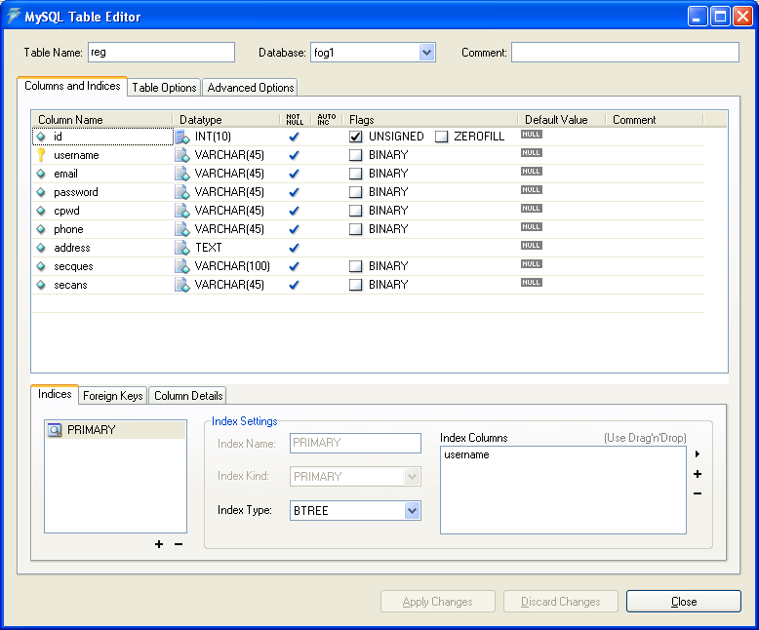

TABLE NAME: UPLOAD

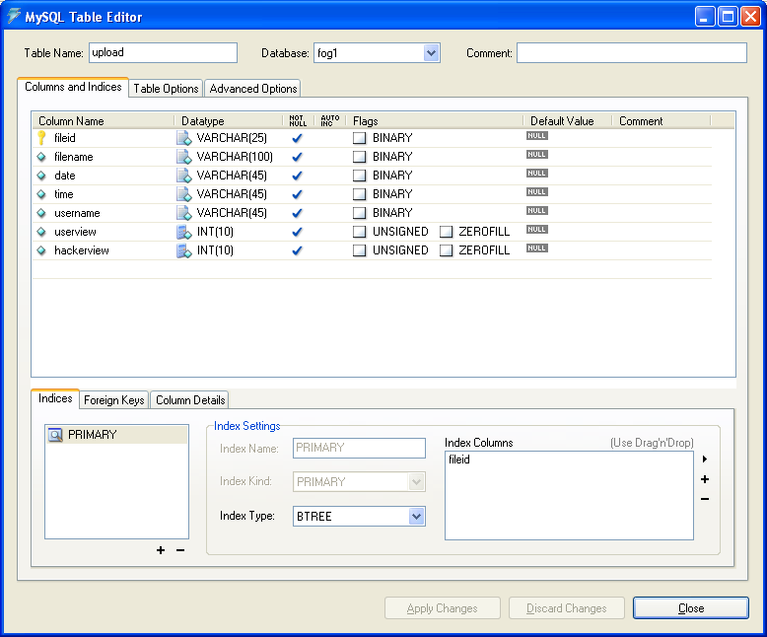

TABLE NAME: DOWNLOAD

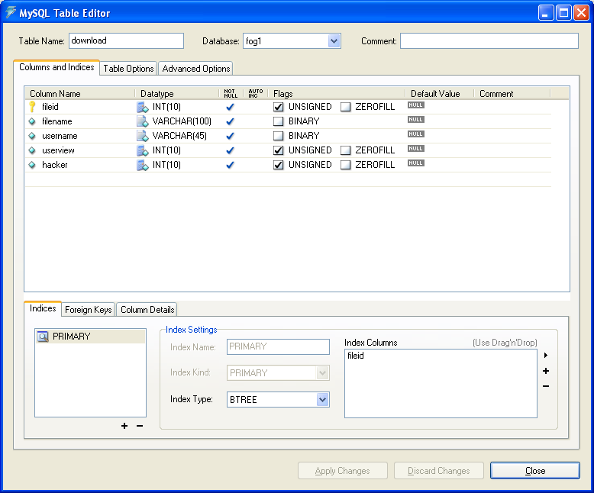

PROGRAM DESIGN
5. PROGRAM DESIGN

5.1 MODULES

- ADMIN
  - USER DETAILS
  - DOWNLOAD DETAILS

- USER
  - FILE UPLOAD
  - USER VIEW
  - HACKER VIEW
  - DOWNLOAD FILE
- USER BEHAVIOUR PROFILING

MODULES DESCRIPTION

- ADMIN
A service provider that offers customers storage or software services available via a private (private cloud) or public network (cloud). Usually, it means the storage and software is available for access via the Internet. Cloud computing providers offer their services according to several fundamental models: Infrastructure as a service (IaaS), platform as a service (PaaS), and software as a service (SaaS) where IaaS is the most basic and each higher model abstracts from the details of the lower models.

- USER
Cloud computing relies on sharing of resources to achieve coherence and economies of scale, similar to a utility (like the electricity grid) over a network. At the foundation of cloud computing is the broader concept of converged infrastructure and shared services. The cloud also focuses on maximizing the effectiveness of the shared resources. Cloud resources are usually not only shared by multiple users but are also dynamically reallocated per demand. This can work for allocating resources to users.
- User Behavior Profiling

It is expected that access to a user’s information in the Cloud will exhibit a normal means of access. User profiling is a well known technique that can be applied here to model how, when, and how much a user accesses their information in the Cloud. Such ‘normal user’ behavior can be continuously checked to determine whether abnormal access to a user’s information is occurring. This method of behavior-based security is commonly used in fraud detection applications. Such profiles would naturally include volumetric information, how many documents are typically read and how often. These simple user specific features can serve to detect abnormal Cloud access based partially upon the scale and scope of data transferred.

TESTING

6. TESTING

When a system is developed, it is expected that it performs properly. In practice, however, some errors always occur. The main purpose of testing an information system is to find the errors and correct them. A successful test is one, which find an error. The main objectives of the system testing are
- To ensure during the operation that the system will perform as per specified in the design phase.
- To make sure that the system meets user requirements during operations.
- To verify that the controls incorporated in the system functions as intended.
- To see that if correct inputs are fed into the system, it provides perfect output.
- To verify that during operation incorrect input processing and output will be deleted.

Software testing is a critical element of software quality assurance and represents the ultimate review of specification, design and coding. If the testing conducted successfully, it will uncover errors in the software. As a secondary benefit, testing demonstrates that the software function appears to be working according to specification and that performance requirements appear to have been made.

The scope of the system test should include both manual operations and computer operations system testing is comprehensive evaluation of the programs, manual procedures, computer operations and controls.

System testing is the process of checking if the developed system is working according to the original objectives and requirements. All testing needs to be conducted in accordance to the test conditions specifies earlier.

This will ensure that the test coverage meets the requirement and that testing is done in sysmantic manner. System testing accounts for the largest percentage of technical effort in the siftware development phase.

There are three aspects of system testing:

- Unit testing
- Validation testing

UNIT TESTING
The application is tested in small units like functions so as to check that the function achieves the desired functionality when correct input is supplied.

VALIDATION TESTING
The application is tested to check how it responds to various kinds of input given. The user should be intimated of any kind of exceptions in a more understandable manner so that debugging becomes easier.

At the culmination of the black box testing, software is completely assembled as a package; interfacing errors have been uncovered and corrected. Next stage is the validation testing and it can be defined in many ways, but a simple definition is that the validation succeeds when the software functions in the manner that can be reasonably expected by the user. When an user enters incorrect inputs it should not display error messages, instead it should display helpful messages enabling user to use the tool properly. The tool is tested with test data as well as live data and has been found to work properly in the networked environment.

CONCLUSION

7. CONCLUSION

Data theft attacks are amplified if the attacker is a malicious insider. This is considered as one of the top threats to cloud computing by the Cloud Security Alliance. While most Cloud computing customers are well-aware of this threat, they are left only with trusting the service provider when it comes to protecting their data. The lack of transparency into, let alone control over, the Cloud provider’s authentication, authorization, and audit controls only exacerbates this threat.

Much research in Cloud computing security has focused on ways of preventing unauthorized and illegitimate access to data by developing sophisticated access control and encryption mechanisms. However these mechanisms have not been able to prevent data compromise.

This project proposes monitoring data access patterns by profiling user behavior to determine if and when a malicious insider illegitimately accesses someone’s documents in a Cloud service. Decoy documents stored in the Cloud alongside the user’s real data also serve as sensors to detect illegitimate access. Once unauthorized data access or exposure is suspected, and later verified, with challenge questions for instance, we inundate the malicious insider with bogus information in order to dilute the user’s real data. Such preventive attacks that rely on disinformation technology could provide unprecedented levels of security in the Cloud and in social networks.

REFERENCES
8. REFERENCES

Book References

- E.Balagurusamy, “PROGRAMMING WITH JAVA 3e”, “Tata McGraw-Hill Publishing Company Limited, New Delhi, 2004”

- Herbert Schildt, “THE COMPLETE REFERENCE Java 2”, Fifth Edition, “Tata McGraw-Hill Publishing Company Limited, New Delhi, 2004”

- Jim Keogh, “THE COMPLETE REFERENCE J2EE”, “Tata McGraw-Hill Publishing Company Limited, New Delhi, 2004”

- Pressman .R.S, “SOFTWARE ENGINEERING - A PRACTITIONER’S APPROACH ”, Sixth Edition, “Tata McGraw-Hill Publishing Company Limited, New Delhi, 2004”

Web References

- http://java.sun.com/products/jsp
- http://www.jsptut.com/introduction.html
- http://www.roseindia.net/jsp/jsp.html
- http://www.theresumebuilder.com
- http://www.easyjob.net
- http://en.wikipedia.org/wiki/NetBeans

APPENDIX
9. APPENDIX

9.1 Source code

log.jsp

<%@page contentType="text/html" pageEncoding="UTF-8"%>
<!DOCTYPE HTML PUBLIC "-//W3C//DTD HTML 4.01 Transitional//EN"
"http://www.w3.org/TR/html4/loose.dtd">
<%@ include file="dbcon.jsp" %>
<html>
<head>
<meta http-equiv="Content-Type" content="text/html; charset=UTF-8">
<title>JSP Page</title>
</head>
<body>
<%

String un=request.getParameter("username");
String pass=request.getParameter("password");

String qry ="select * from reg where username='"+ un +"' and password='"+ pass +"'";

ResultSet rs=st.executeQuery(qry);
if (rs.next())
{

session.setAttribute("un", rs.getString("username"));

response.sendRedirect("userhome.jsp");

}
else if(un.equals("admin")&& pass.equals("admin") )
{
session.setAttribute("un", un);
response.sendRedirect("admin.jsp");
}

else
{

response.sendRedirect("index.jsp");
}
%>
</body>
</html>

Reg.jsp

<%@page contentType="text/html" pageEncoding="UTF-8"%>
<!DOCTYPE HTML PUBLIC "-//W3C//DTD HTML 4.01 Transitional//EN"
"http://www.w3.org/TR/html4/loose.dtd">
<%@ include file="dbcon.jsp" %>
<html>
<head>
<meta http-equiv="Content-Type" content="text/html; charset=UTF-8">
<title>JSP Page</title>
</head>
<body>
<%

String un=request.getParameter("username");
String pass=request.getParameter("password");

String qry ="select * from reg where username='"+ un +"' and password='"+ pass +"'";

ResultSet rs=st.executeQuery(qry);
if (rs.next())
{

session.setAttribute("un", rs.getString("username"));

response.sendRedirect("userhome.jsp");

}
else if(un.equals("admin")&& pass.equals("admin") )
{
session.setAttribute("un", un);
response.sendRedirect("admin.jsp");
}

else
{

response.sendRedirect("index.jsp");
}
%>
</body>
</html>
Userhome.jsp

<%@page contentType="text/html" pageEncoding="UTF-8" import="java.sql.*" import="java.text.*"%>
<!DOCTYPE HTML PUBLIC "-//W3C//DTD HTML 4.01 Transitional//EN" "http://www.w3.org/TR/html4/loose.dtd">

<%@ page import="java.io.*,java.util.*,javax.servlet.*" %>
<%@ page import="javax.servlet.http.*" %>
<%@ page import="org.apache.commons.fileupload.*" %>
<%@ page import="org.apache.commons.fileupload.disk.*" %>
<%@ page import="org.apache.commons.fileupload.servlet.*" %>
<%@ page import="org.apache.commons.io.output.*" %>
<%@ include file="dbcon.jsp" %>
<html>
<head>
<meta http-equiv="Content-Type" content="text/html; charset=UTF-8">
<title>JSP Page</title>
</head>
<body>
<%

//String filename=request.getParameter("filename");
//String file=request.getParameter("file");
//String fileid123=request.getParameter("fileid");
String fileid123= session.getAttribute("fileid").toString();
String uname=(String)session.getAttribute("un");

String saveFile="";

String contentType = request.getContentType();
if ((contentType != null) && (contentType.indexOf("multipart/form-data") >= 0)) {
DataInputStream in = new DataInputStream(request.getInputStream());
int formDataLength = request.getContentLength();
byte dataBytes[] = new byte[formDataLength];
int byteRead = 0;
int totalBytesRead = 0;
while (totalBytesRead < formDataLength) {
byteRead = in.read(dataBytes, totalBytesRead,formDataLength);
totalBytesRead += byteRead;
}
String file = new String(dataBytes);
saveFile = file.substring(file.indexOf("filename=\"") + 10);
saveFile = saveFile.substring(0, saveFile.indexOf("\n"));
saveFile = saveFile.substring(saveFile.lastIndexOf("\\") + 1,saveFile.indexOf("\""));
int lastIndex = contentType.lastIndexOf("=");
String boundary = contentType.substring(lastIndex + 1,contentType.length());
int pos;
pos = file.indexOf("filename=\"");
pos = file.indexOf("\n", pos) + 1;
pos = file.indexOf("\n", pos) + 1;
pos = file.indexOf("\n", pos) + 1;
int boundaryLocation = file.indexOf(boundary, pos) - 4;
int startPos = ((file.substring(0, pos)).getBytes()).length;
int endPos = ((file.substring(0, boundaryLocation)).getBytes()).length;

int id1=0;
String filename=saveFile;
DateFormat formatter = new SimpleDateFormat("dd-MMM-yy");
String date1 = formatter.format(new java.util.Date());

SimpleDateFormat sdfTime = new SimpleDateFormat("HH:mm:ss");
java.util.Date now = new java.util.Date();

java.util.Date date123= new java.util.Date();
String a=new Timestamp(date123.getTime()).toString();

String strTime = sdfTime.format(now);
java.io.File folder = new File("C:/Users/selva/Documents/CloudMe/"+uname);
if(!folder.exists())
{
folder.mkdirs();
saveFile="C:/Users/selva/Documents/CloudMe/"+ uname+"/"+saveFile;
File f = new File(saveFile);
FileOutputStream fileOut = new FileOutputStream(f);
fileOut.write(dataBytes, startPos, (endPos - startPos));
fileOut.flush();
fileOut.close();

String qry="insert into upload values('"+ fileid123 +"','"+filename+"','"+ date1 +"','"+ strTime +"','"+ uname +"',0,0)";
st.executeUpdate(qry);
out.println("File Uploaded ......");
// response.sendRedirect("userhome.jsp");

}
else
{

saveFile="C:/Users/selva/Documents/CloudMe/"+ uname+"/"+saveFile;
File f = new File(saveFile);
FileOutputStream fileOut = new FileOutputStream(f);
fileOut.write(dataBytes, startPos, (endPos - startPos));
fileOut.flush();
fileOut.close();

String qry="insert into upload values('"+ fileid123 +"','"+filename+"','"+ date1 +"','"+ strTime +"','"+ uname +"',0,0)";
st.executeUpdate(qry);
out.println("File Uploaded ......");

}

%>
<b>You have successfully upload the file by the name of:</b>
<%
out.println(saveFile);
}

%>
</body>
</html>
Alert.jsp

<%@ include file="dbcon.jsp" %>

<!DOCTYPE html PUBLIC "-//W3C//DTD XHTML 1.0 Transitional//EN" "http://www.w3.org/TR/xhtml1/DTD/xhtml1-transitional.dtd">
<html xmlns="http://www.w3.org/1999/xhtml">
<head>
<meta http-equiv="Content-Type" content="text/html; charset=iso-8859-1" />
<title>Untitled Document</title>
<style type="text/css">
<!--
body {
background-image: url(images/bg6.jpg);
}
.style1 {
color: #000000;
font-weight: bold;
}
-->
</style></head>

<body>
<table width="781" border="1" align="center">
<tr>
<td colspan="5"><img src="images/banner.gif" width="773" height="90" /></td>
</tr>
<tr bgcolor="#CCCCCC">
<td width="118"><div align="center" class="style1"><a href="userhome.jsp">Upload Files</a> </div></td>
<td width="122"><div align="center" class="style1"><a href="files.jsp">MyFiles</a></div></td>
<td width="156"><div align="center" class="style1"><a href="password.jsp">Change Password</a> </div></td>
<td width="157"><div align="center" class="style1"><a href="alert.jsp">View Alert </a></div></td>
<td width="194"><div align="center" class="style1"><a href="index.jsp">Signout</a></div></td>
</tr>
<tr>
<td colspan="5"><p>
<%

String uname=(String)session.getAttribute("un");
String query ="select * from upload where username='"+uname+"'" ;
st.executeQuery(query);
ResultSet rs=st.executeQuery(query);
out.println("<table border=1 align=center bgcolor=white>");
out.println("<tr bgcolor=#CCCCCC><th>File ID</th><th>FileName</th><th>UserView</th><th>Hacker View</th></tr>");
while(rs.next())
{

out.println("<tr><td>"+rs.getString("fileid")+"</td>");
out.println("<td>"+rs.getString("filename")+"</td>");
out.println("<td>"+rs.getString("userview")+"</td>");
out.println("<td>"+rs.getString("hackerview")+"</td>");

//out.println("<td>"+"<a href=sec.jsp?id="+ rs.getString("fileid")+">"+"Download File"+"</a></td><tr>");

}

out.println("</table>");
%>
</p>
</td>
</tr>
</table>
</body>
</html>
Sec1.jsp

<%@page contentType="text/html" pageEncoding="UTF-8"%>
<!DOCTYPE HTML PUBLIC "-//W3C//DTD HTML 4.01 Transitional//EN"
"http://www.w3.org/TR/html4/loose.dtd">

<html>
<head>
<meta http-equiv="Content-Type" content="text/html; charset=UTF-8">
<title>JSP Page</title>
</head>
<body>
<%@ include file="dbcon.jsp" %><%@page import="java.io.*,java.net.*"%>

<%!
public static String getMimeType(String fileUrl)
throws java.io.IOException, MalformedURLException
{
String type = null;
URL u = new URL(fileUrl);
URLConnection uc = null;
uc = u.openConnection();
type = uc.getContentType();
return type;
}

%>
<%
String uname=(String)session.getAttribute("un");

int id= Integer.parseInt(session.getAttribute("fileid").toString());

String query ="select secans from reg where username='"+uname+"'" ;
st.executeQuery(query);
ResultSet rs=st.executeQuery(query);
String ques="";
if(rs.next())
{
ques=rs.getString("secans");

}
int fileid=Integer.parseInt(session.getAttribute("fileid").toString());
//out.println(ques);

String ans=request.getParameter("secans");
if (ans.equals(ques))
{
out.println("Original File");
String query1 ="select filename,username from upload where fileid="+ fileid +"" ;
st.executeQuery(query1);
ResultSet rs1=st.executeQuery(query1);
if (rs1.next())
{

//String file=request.getParameter("f");
String file1=rs1.getString("filename");

String file="C:/Users/selva/Documents/CloudMe/"+uname+"/"+file1;
out.println("FILE NAME"+ file);

File f = new File (file);
String filename=f.getName();
String type=getMimeType("file:"+file);

out.println("FILE NAME"+ filename +"" +file);
response.setContentType (type);
response.setHeader ("Content-Disposition", "attachment; filename=\""+filename+"\"");

String name = f.getName().substring(f.getName().lastIndexOf("/") + 1,f.getName().length());
InputStream in = new FileInputStream(f);
ServletOutputStream outs = response.getOutputStream();

int bit = 256;
int i = 0;
try {
while ((bit) >= 0) {
bit = in.read();
outs.write(bit);
}
} catch (IOException ioe) {
ioe.printStackTrace(System.out);
}
outs.flush();
outs.close();
in.close();

String q12="select userview from upload where username='"+uname+"'";
st.executeQuery(q12);
ResultSet rs2=st.executeQuery(q12);
int userview=0,uv=0;
if (rs2.next())
{
userview=rs2.getInt("userview");
}
uv=userview+1;

String q1="update upload set userview="+ uv +" where fileid="+id+"";
st.executeUpdate(q1);

}
else
{
out.println("Error .................. ");
}

}
else
{
out.println("Duplicate File");

String q12="select hackerview from upload where username='"+uname+"'";
st.executeQuery(q12);
ResultSet rs2=st.executeQuery(q12);
int userview=0,uv=0;
if (rs2.next())
{
userview=rs2.getInt("hackerview");
}
uv=userview+1;

String q1="update upload set hackerview="+ uv +" where fileid="+id+"";
st.executeUpdate(q1);

}

%>
</body>
</html>

Admin.jsp

<%@page contentType="text/html" pageEncoding="UTF-8"%>
<!DOCTYPE HTML PUBLIC "-//W3C//DTD HTML 4.01 Transitional//EN"
"http://www.w3.org/TR/html4/loose.dtd">

<html>
<head>
<meta http-equiv="Content-Type" content="text/html; charset=UTF-8">
<title>JSP Page</title>
<style type="text/css">
<!--
.style1 { font-size: xx-large;
font-weight: bold;
}
.style2 {color: #FF0000}
.style3 { color: #000000;
font-weight: bold;
}
-->
</style>
</head>

<%@ include file="dbcon.jsp" %>
<body>
<table width="799" height="375" border="1" align="center">
<tr>
<td height="42" colspan="4"><div align="center" class="style1"><img src="images/banner.gif" width="788" height="90" /></div></td>
</tr>
<tr bgcolor="#CCCCCC">
<td width="239" bgcolor="#CCCCCC"><div align="center"><strong><a href="admin.jsp">UserDetail</a></strong></div></td>
<td width="295" bgcolor="#CCCCCC"><div align="center"><strong><a href="afile.jsp">Upload Details </a></strong></div></td>
<td width="243" bgcolor="#CCCCCC"><div align="center"><strong><a href="index.jsp">Logout</a></strong></div></td>
</tr>
<tr>
<td height="233" colspan="4">

<%

String uname=(String)session.getAttribute("un");
String query ="select * from reg" ;
st.executeQuery(query);
ResultSet rs=st.executeQuery(query);
out.println("<table border=1 align=center bgcolor=white>");
out.println("<tr bgcolor=#CCCCCC><th>UserName</th><th>Email</th><th>Phone</th><th>Address</th></tr>");
while(rs.next())
{

out.println("<tr><td>"+rs.getString("username")+"</td>");
out.println("<td>"+rs.getString("email")+"</td>");
out.println("<td>"+rs.getString("phone")+"</td>");
out.println("<td>"+rs.getString("address")+"</td></tr>");

//out.println("<td>"+"<a href=sec.jsp?id="+ rs.getString("fileid")+">"+"Download File"+"</a></td><tr>");

}

out.println("</tab>”)
%>

</td>
</tr>
</table>
<h2>&nbsp;</h2>
</body>
</html>

Afile.jsp

<%@page contentType="text/html" pageEncoding="UTF-8"%>
<!DOCTYPE HTML PUBLIC "-//W3C//DTD HTML 4.01 Transitional//EN"
"http://www.w3.org/TR/html4/loose.dtd">

<html>
<head>
<meta http-equiv="Content-Type" content="text/html; charset=UTF-8">
<title>JSP Page</title>
<style type="text/css">
<!--
.style1 { font-size: xx-large;
font-weight: bold;
}
.style2 {color: #FF0000}
.style3 { color: #000000;
font-weight: bold;
}
-->
</style>
</head>
<%@ include file="dbcon.jsp" %>
<body>
<table width="799" height="375" border="1" align="center">
<tr>
<td height="42" colspan="4"><div align="center" class="style1"><img src="images/banner.gif" width="788" height="90" /></div></td>
</tr>
<tr bgcolor="#CCCCCC">
<td width="239" bgcolor="#CCCCCC"><div align="center"><strong><a href="admin.jsp">UserDetail</a></strong></div></td>
<td width="295" bgcolor="#CCCCCC"><div align="center"><strong><a href="afile.jsp">Upload Details </a></strong></div></td>
<td width="243" bgcolor="#CCCCCC"><div align="center"><strong><a href="index.jsp">Logout</a></strong></div></td>
</tr>
<tr>
<td height="233" colspan="4"><p align="justify">&nbsp;</p>
<%

String uname=(String)session.getAttribute("un");
String query ="select * from upload " ;
st.executeQuery(query);
ResultSet rs=st.executeQuery(query);
out.println("<table border=1 align=center bgcolor=white>");
out.println("<tr bgcolor=#CCCCCC><th>File ID</th><th>FileName</th><th>Date</th><th>Time</th><th>UserName</th></tr>");
while(rs.next())
{

out.println("<tr><td>"+rs.getString("fileid")+"</td>");
out.println("<td>"+rs.getString("filename")+"</td>");
out.println("<td>"+rs.getString("date")+"</td>");
out.println("<td>"+rs.getString("time")+"</td>");
out.println("<td>"+rs.getString("username")+"</td>");
//out.println("<td>"+"<a href=sec.jsp?id="+ rs.getString("fileid")+">"+"Download File"+"</a></td><tr>");

}

out.println("</table>");

%>
</tr>
</table>
<h2>&nbsp;</h2>
</body>
</html>

9.2 OUTPUT SCREEN SHOT

Login.jsp

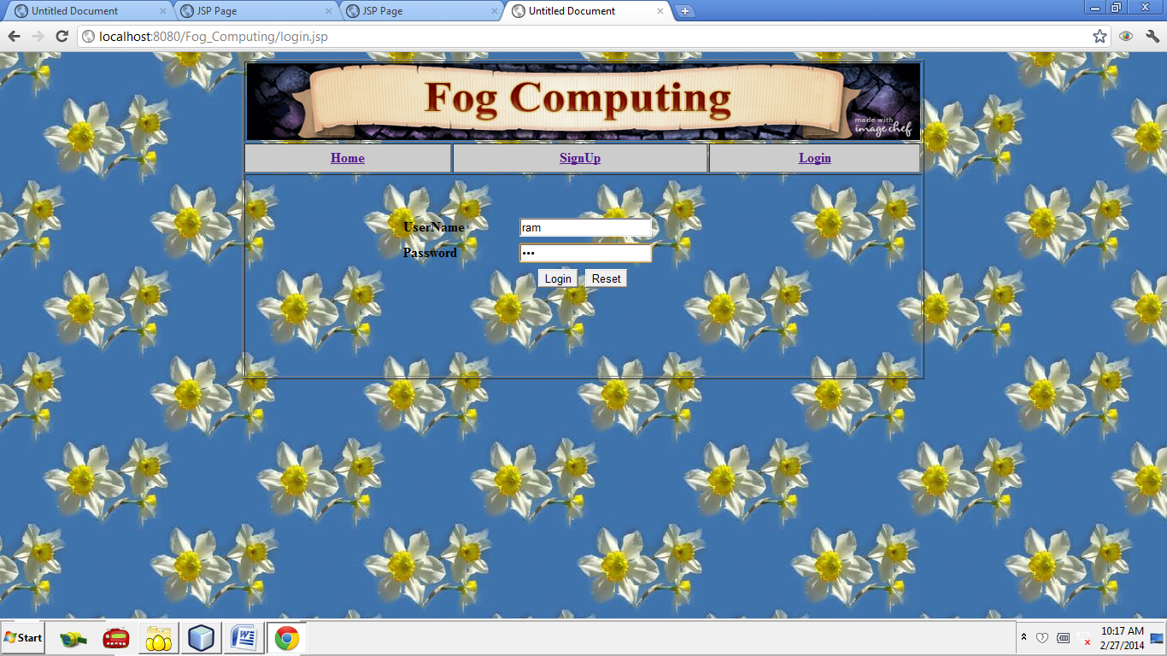
Reg.jsp

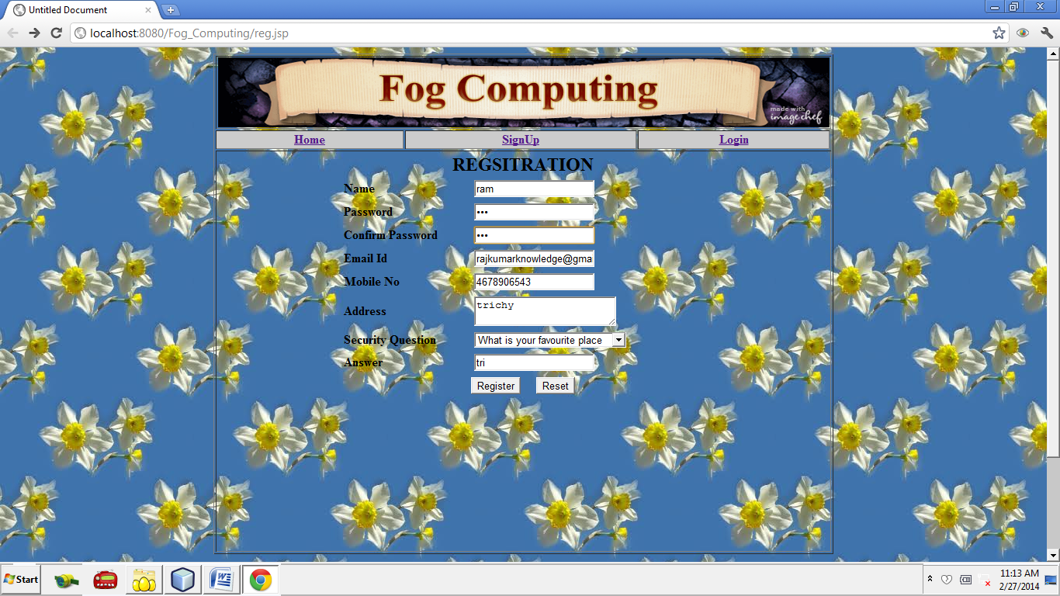
Userhome.jsp

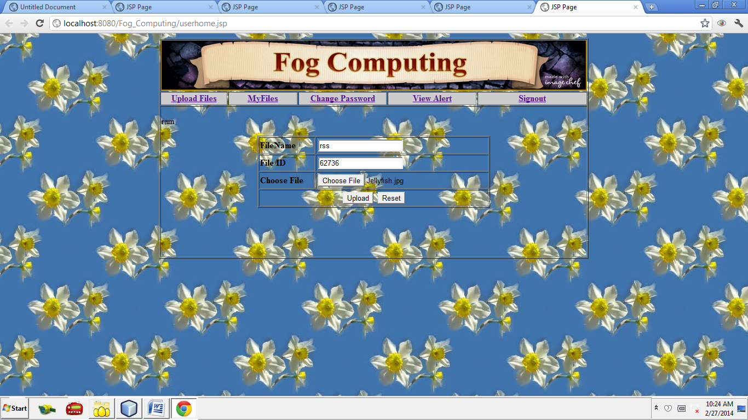
file.jsp

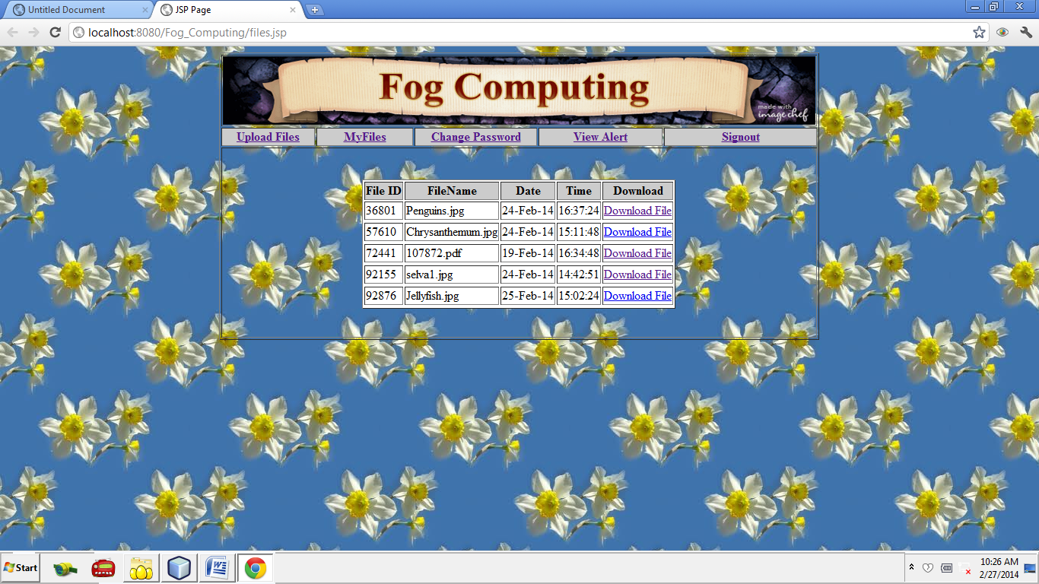
Sec.jsp

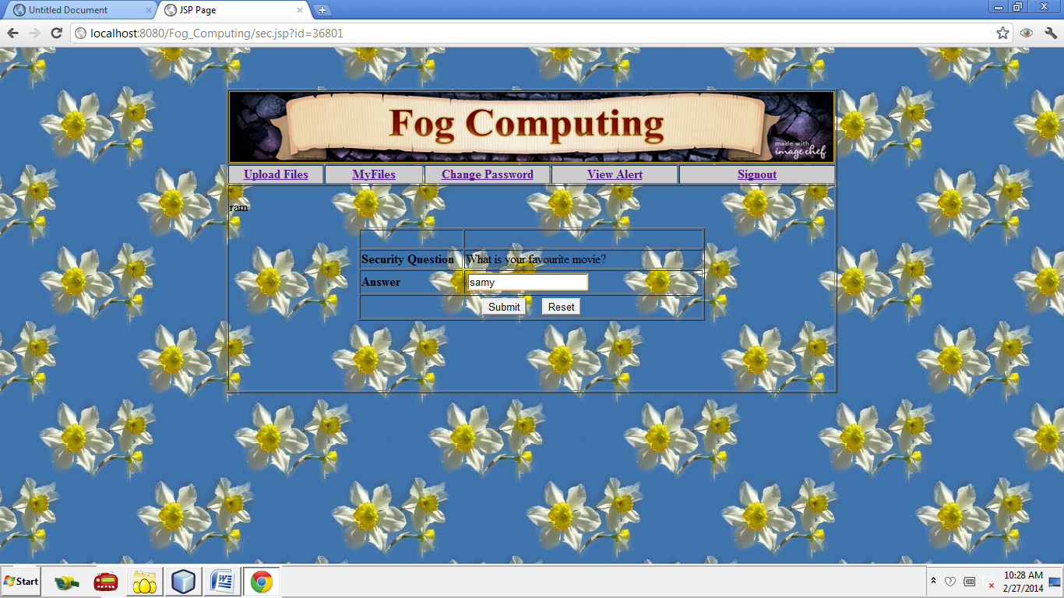
Alert.jsp

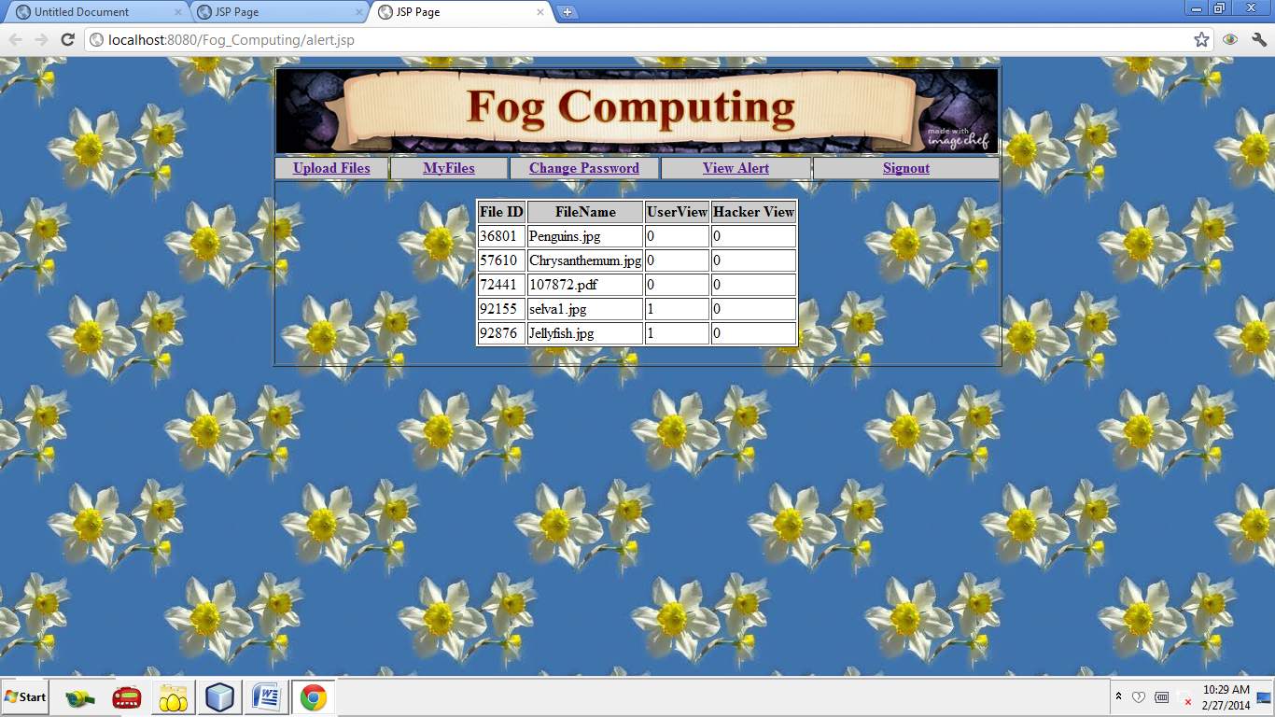
Admin.jsp

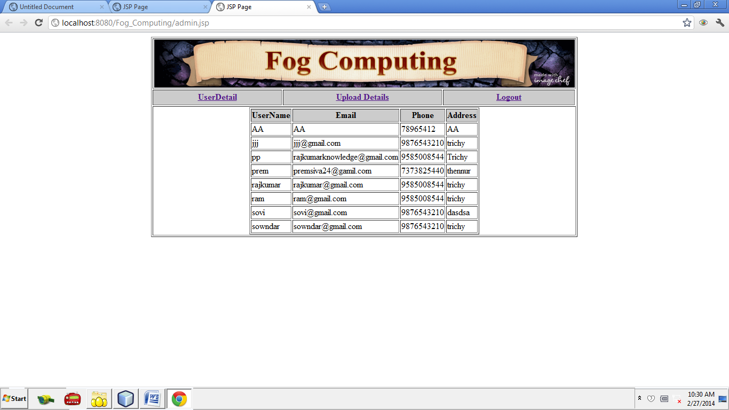
Afile.jsp

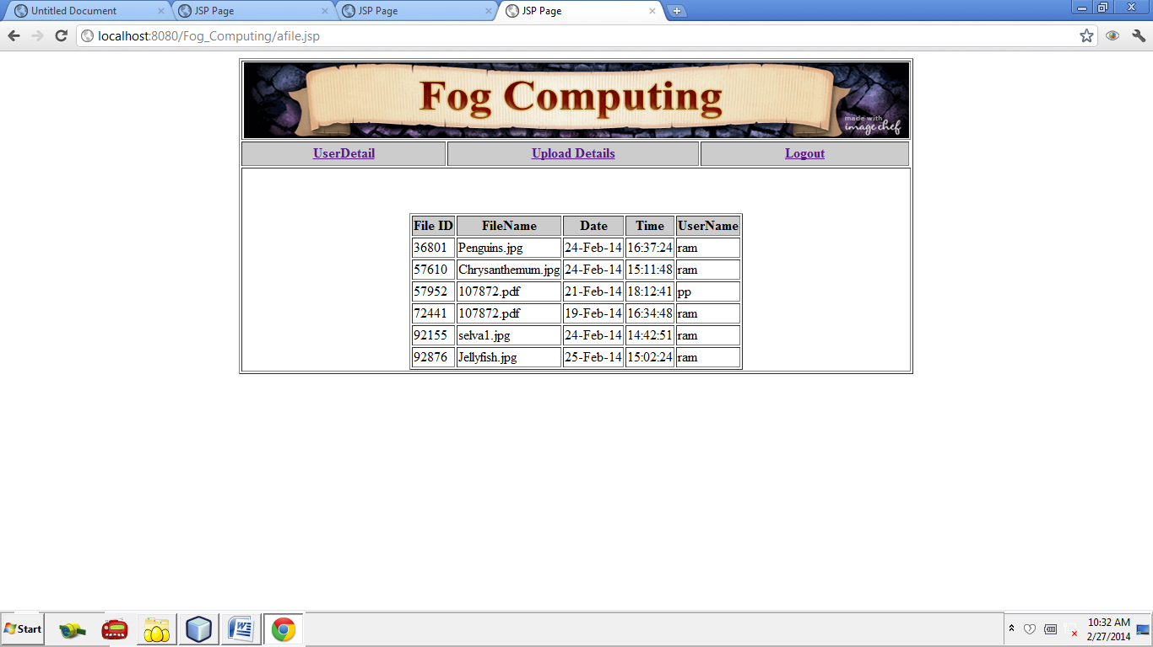

Cloudme loginpage

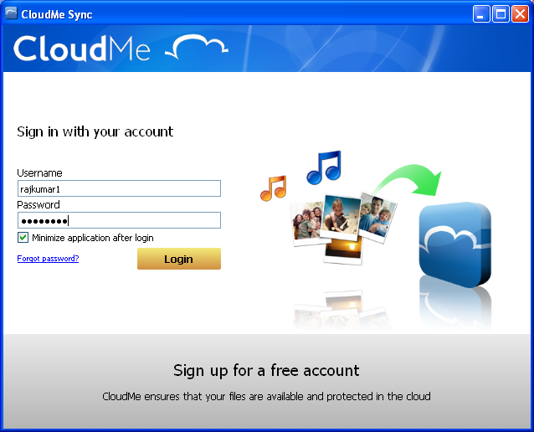
Cloudme uploadpage

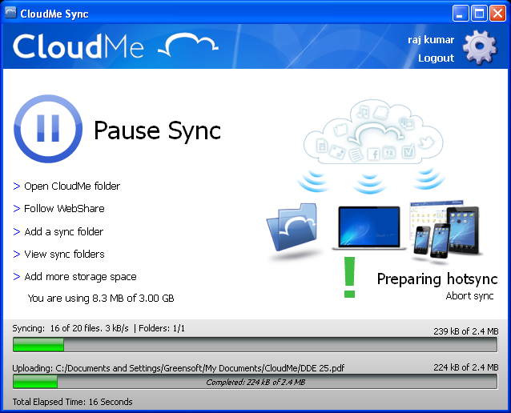
Uploaded files in Cloud Me

