REPORT
ASSIGNMENT-5

Working statement:
A job application tracker helps users manage and organize their job search activities efficiently. Instead of manually remembering which companies they have applied to, application dates, interview schedules, and statuses, this system records and updates all information in a structured way. It automates reminders, maintains application history, and reduces confusion during the job-search process. This system enhances productivity and ensures that no opportunities are missed due to poor tracking or lack of reminders.

ALGORITHM:

START

1. Initialize an empty list named Job Applications.

2. Display menu:
1. Add New Job Application
2. Update Application Status
3. View All Applications
4. Search Application by Company Name
5. Exit

- INPUT userChoice

4. IF userChoice = 1 THEN
INPUT CompanyName
INPUT JobRole
INPUT DateApplied
INPUT ApplicationStatus
Create a new record with above fields
Append record to JobApplications
DISPLAY "Application Added Successfully"

5. ELSE IF userChoice = 2 THEN
INPUT CompanyName
SEARCH JobApplications for matching CompanyName
IF found THEN
INPUT newStatus
UPDATE application status
DISPLAY "Status Updated"
ELSE
DISPLAY "Company Not Found"

6. ELSE IF userChoice = 3 THEN
DISPLAY all records in JobApplications

7. ELSE IF userChoice = 4 THEN
INPUT searchName
SEARCH for application with searchName
IF found DISPLAY record
ELSE DISPLAY "No record found"

8. ELSE IF userChoice = 5 THEN
DISPLAY "Exiting System"
9. ELSE
DISPLAY "Invalid Choice"

10. REPEAT menu loop until user exits.

END

FLOWCHART: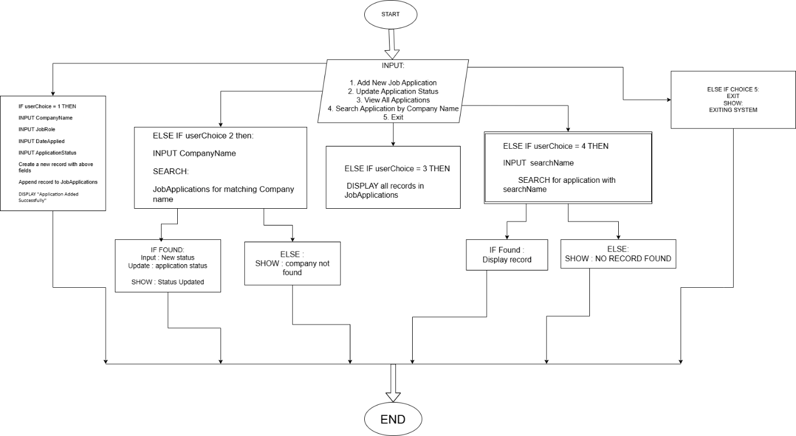

INFOGRAPHIC : 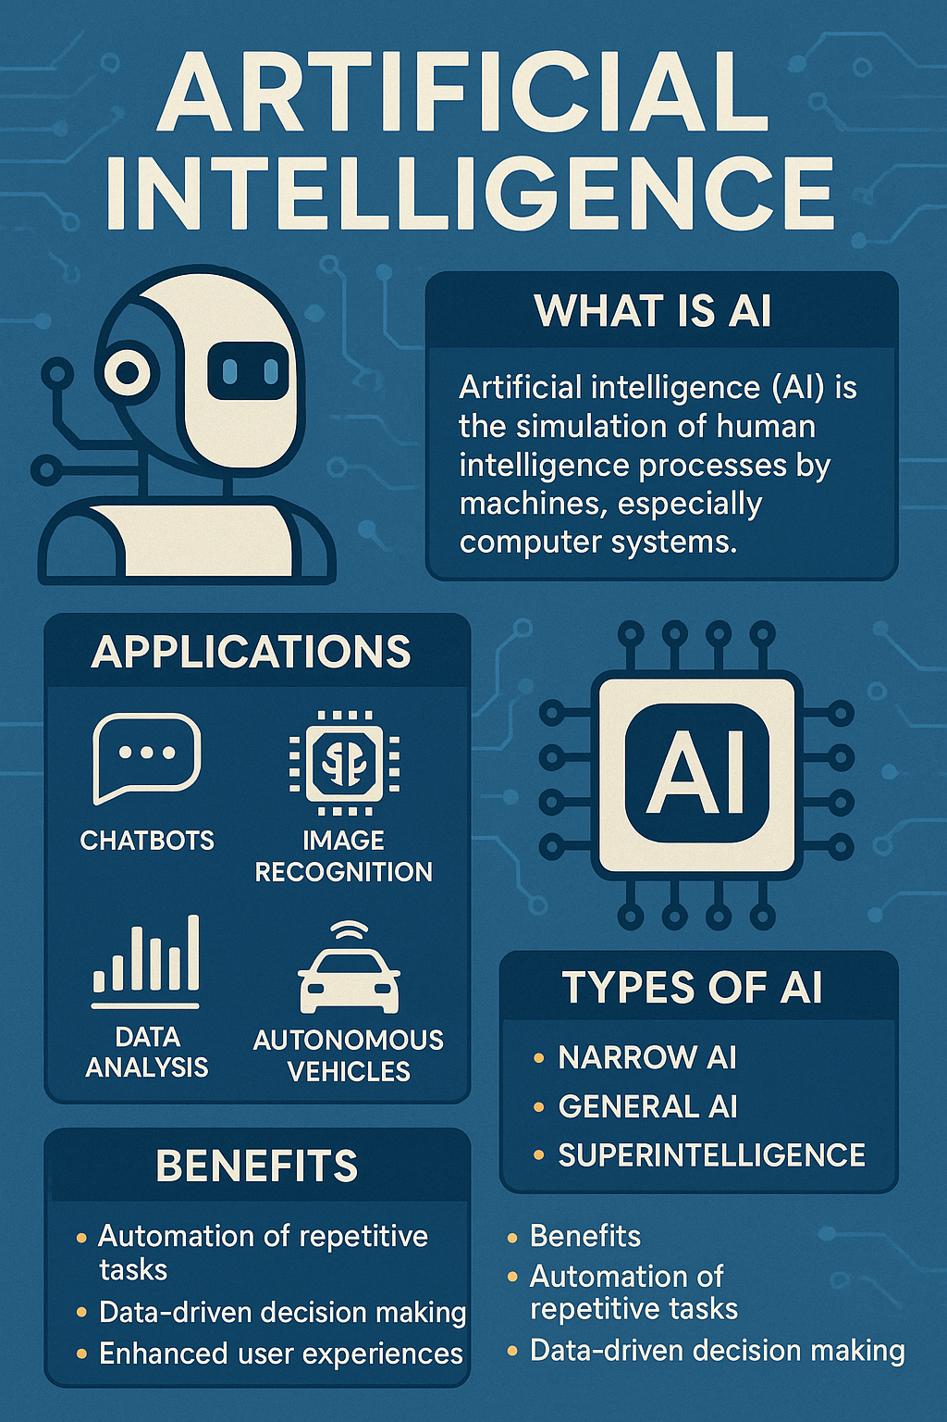

Linux & Automation Practice: SCREENSHOTS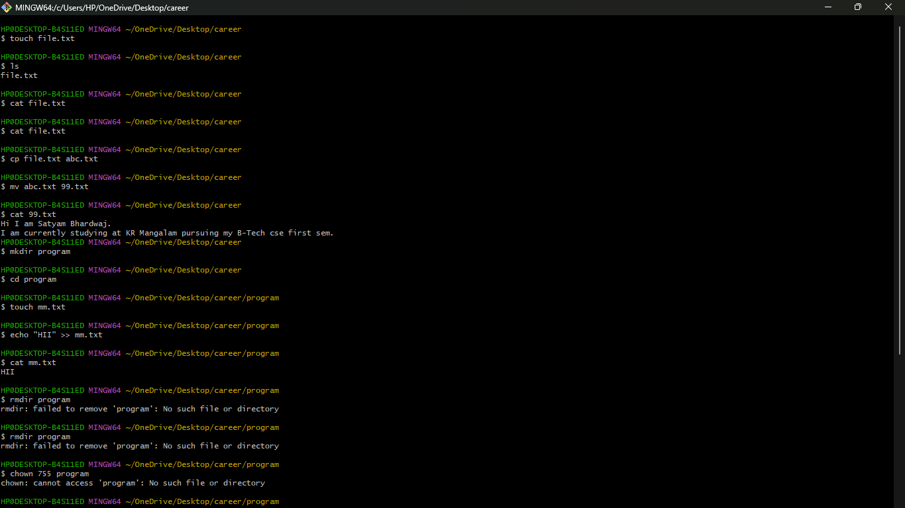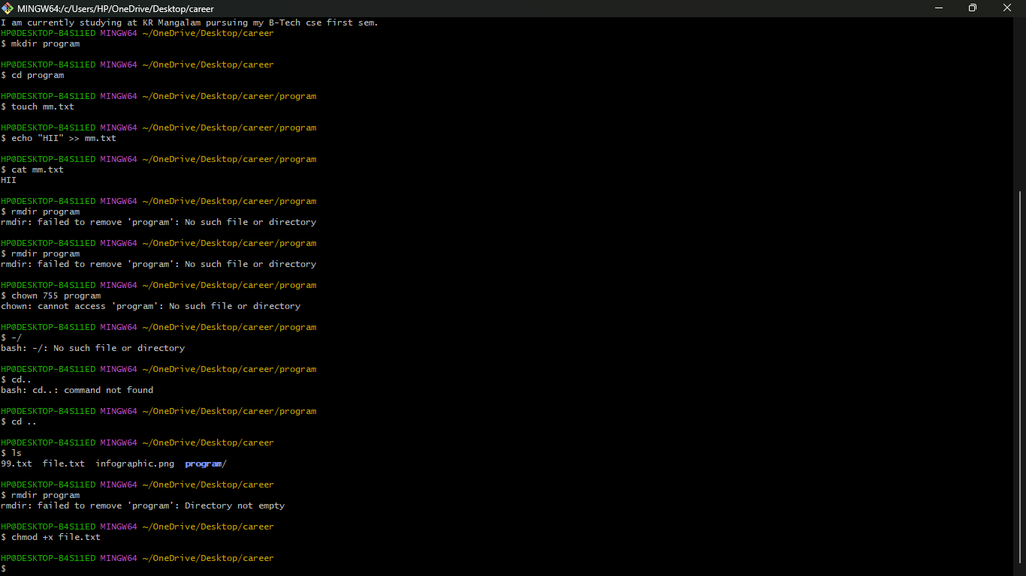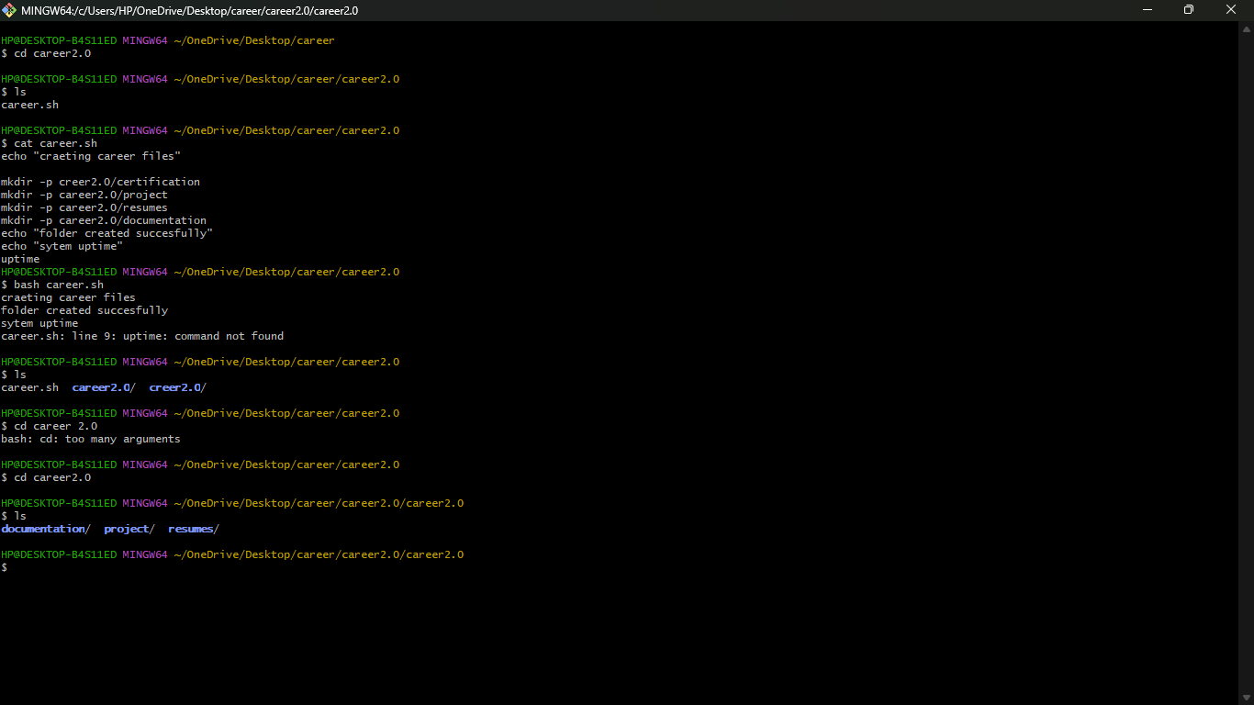

Career Planning & Professional Readiness

- SMART GOALS:

Short-Term SMART Goal (0–6 months)
I will learn the basics of Python, Linux, and AI concepts and complete at least two beginner-level projects (such as a chat-bot or data classifier) by consistently studying 1 hour daily for the next 6 months.

Medium-Term SMART Goal (6–18 months)
I will complete two industry-recognized certifications such as “Coursera Machine Learning” and “AWS AI Practitioner” within 18 months and publish 3 projects on GitHub to build a strong technical portfolio.

Long-Term SMART Goal (2–4 years)
I will secure a paid internship or entry-level role as a Machine Learning/AI Engineer by building advanced skills, completing specialized certifications, and gaining hands-on experience through hackathons and open-source contributions.

- CERTIFICATION RESEARCH:
Certification 1: Machine Learning (Coursera – Andrew Ng)
Provider: Stanford University / Coursera
Duration: 8–12 weeks
Cost: Free (audit mode) / ₹3,500 for certificate
Skills Covered:
- Supervised learning
- Regression & classification
- Neural networks
- Model evaluation
- Alignment with SMART Goal:
This certification builds strong foundational knowledge in machine learning, supporting the short-term and medium-term goals of learning core AI concepts and completing technical projects.
Certification 2: AWS Certified AI Practitioner
Provider: Amazon Web Services
Duration: 1–2 months
Cost: Around ₹7,000–₹10,000
Skills Covered:
- AWS cloud AI tools
- Machine learning workflow
- AI deployment & automation
- Alignment with SMART Goal:
This certification aligns with the medium and long-term goals by providing cloud-ready AI skills, increasing employability, and preparing the student for AI/ML internships.

- Hackathon / Contest / Open-Source Plan
Hackathon Plan
Event Name: Smart India Hackathon (SIH)
Date: varies (next upcoming cycle)
Preparation Steps:
- Learn basics of AI, Python, and project development
- Form a team or join an existing team
- Practice problem-solving on platforms like HackerRank, Kaggle
- Prepare a mini-project as a portfolio
- Attend pre-hackathon workshops

- CAREER ROADMAP
My long-term goal is to become a skilled Artificial Intelligence and Robotics Engineer capable of building intelligent systems that solve real-world problems. To reach this goal, I plan to follow a structured, year-wise development roadmap that includes skill-building, certifications, hands-on projects, and professional experience.

Year 1: Foundation Building
In the first year of my B-Tech program, my focus will be on understanding fundamental concepts such as Python programming, C programming, computational thinking, Linux commands, and problem-solving. I will also work on basic projects like a chat-bot, a calculator, or a simple machine learning model. This will give me confidence in programming and prepare me for more advanced work. In addition, I will build a strong online presence by creating a LinkedIn profile and GitHub repository, ensuring that my work is publicly visible.

Year 2: Exploring AI & Machine Learning
During the second year, I will start diving deeper into artificial intelligence, machine learning, and data science. I plan to complete at least two major certifications—Machine Learning by Andrew Ng and AWS AI Practitioner. These will help me strengthen my concepts while understanding how AI models work in real-world scenarios. I also aim to participate in hackathons and coding competitions to gain hands-on experience and teamwork skills. I will work on intermediate-level projects such as image classification, speech recognition, and data visualization dashboards.

Year 3: Advanced Learning & Internships
In the third year, I will focus on advanced AI topics such as deep learning, computer vision, NLP (Natural Language Processing), and robotics systems. I plan to take part in specialized certification programs such as Tensor Flow Developer Certificate or IBM AI Engineering. Along with learning, I will work on larger projects like autonomous navigation, object detection, or real-time AI automation. During this year, my goal is to secure one or two internships in AI or robotics companies. This practical exposure will help me apply my knowledge and understand industry expectations.

Year 4: Specialization & Career Preparation
The final year of my degree will be dedicated to specialization and career preparation. I will work on a final-year AI-based project, preferably using machine learning, robotics, or automation. I also plan to contribute to open-source AI projects to strengthen my resume. Additionally, I will prepare for placement interviews by practicing coding problems, building a portfolio website, updating my LinkedIn profile, and networking with professionals in the industry.

Throughout this journey, I will continuously update my GitHub with projects, maintain my resume, and stay active in the AI community. By following this roadmap, I will be fully prepared to start my career as an AI Engineer or Robotics Developer, equipped with technical skills, certifications, projects, and industry experience.

REFLECTION
Completing this assignment was a valuable learning experience that strengthened my understanding of both technical and career development concepts. I faced some challenges while working with Linux commands and bash scripting, as these were new areas for me, but practicing them helped me understand how automation and system-level tasks work. Creating the infographic and flowchart also improved my documentation and presentation skills.
Researching AI domains, job roles, and certifications gave me clarity about the industry and helped me understand the skills required to build a successful career. Setting SMART goals allowed me to plan my academic journey more effectively, while updating my LinkedIn profile and preparing for hackathons encouraged me to build a stronger professional identity.
Overall, this assignment helped me combine computer science fundamentals with real-world career planning. It has motivated me to stay consistent with my learning and build practical projects that will support my long-term goal of becoming an AI and Robotics Engineer.

NAME: Satyam Bhardwaj
ROLL NO: 2501730293
COURSE: B-TECH-CSE-AI/ML

