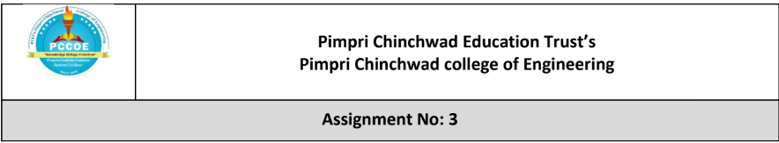

Problem Statement: Emergency Relief Supply Distribution

A devastating flood has hit multiple villages in a remote area, and the government, along with NGOs, is organizing an emergency relief operation. A rescue team has a limited-capacity boat that can carry a maximum weight of W kilograms. The boat must transport critical supplies, including food, medicine, and drinking water, from a relief center to the affected villages.

Each type of relief item has:

A weight (wi) in kilograms.

Utility value (vi) indicating its importance (e.g., medicine has higher value than food).

Some items can be divided into smaller portions (e.g., food and water), while others must be taken as a whole (e.g., medical kits).

Goals:

Implement the Fractional Knapsack algorithm to maximize the total utility value of the supplies transported.

Prioritize high-value items while considering weight constraints.

Allow partial selection of divisible items (e.g., carrying a fraction of food packets).

Ensure that the boat carries the most critical supplies given its weight limit W.
Course Objectives:
- To know the basics of computational complexity of various algorithms.
- To select appropriate algorithm design strategies to solve real-world problems.

Course Outcomes: After learning the course, students will be able to:
- Analyze the asymptotic performance of algorithms.
- Solve computational problems by applying suitable paradigms such as Divide and Conquer or Greedy methodologies.

Theory:
The Fractional Knapsack Problem is a classic optimization problem: given a set of items—each with weight wᵢ and value vᵢ—and a maximum capacity W, the objective is to maximize total value by selecting items (or fractions of them) up to capacity.
Unlike the 0/1 Knapsack, the fractional version allows partial selection, making it solvable optimally in polynomial time.
Algorithm (Greedy Strategy):
- Compute the value-to-weight ratio vᵢ / wᵢ for each item.
- Sort items in descending order of this ratio.
- Fill the knapsack:
  - Take items fully if they fit.
  - If capacity runs out, take the exact fraction needed of the current item (only if divisible).
  - Skip indivisible items that do not fit.
Working of Greedy:
- Greedy-choice property: Choosing the highest ratio item at each step is always part of an optimal solution.
- Optimal substructure: Once part of the knapsack is filled, the remaining capacity forms a smaller instance of the same problem.
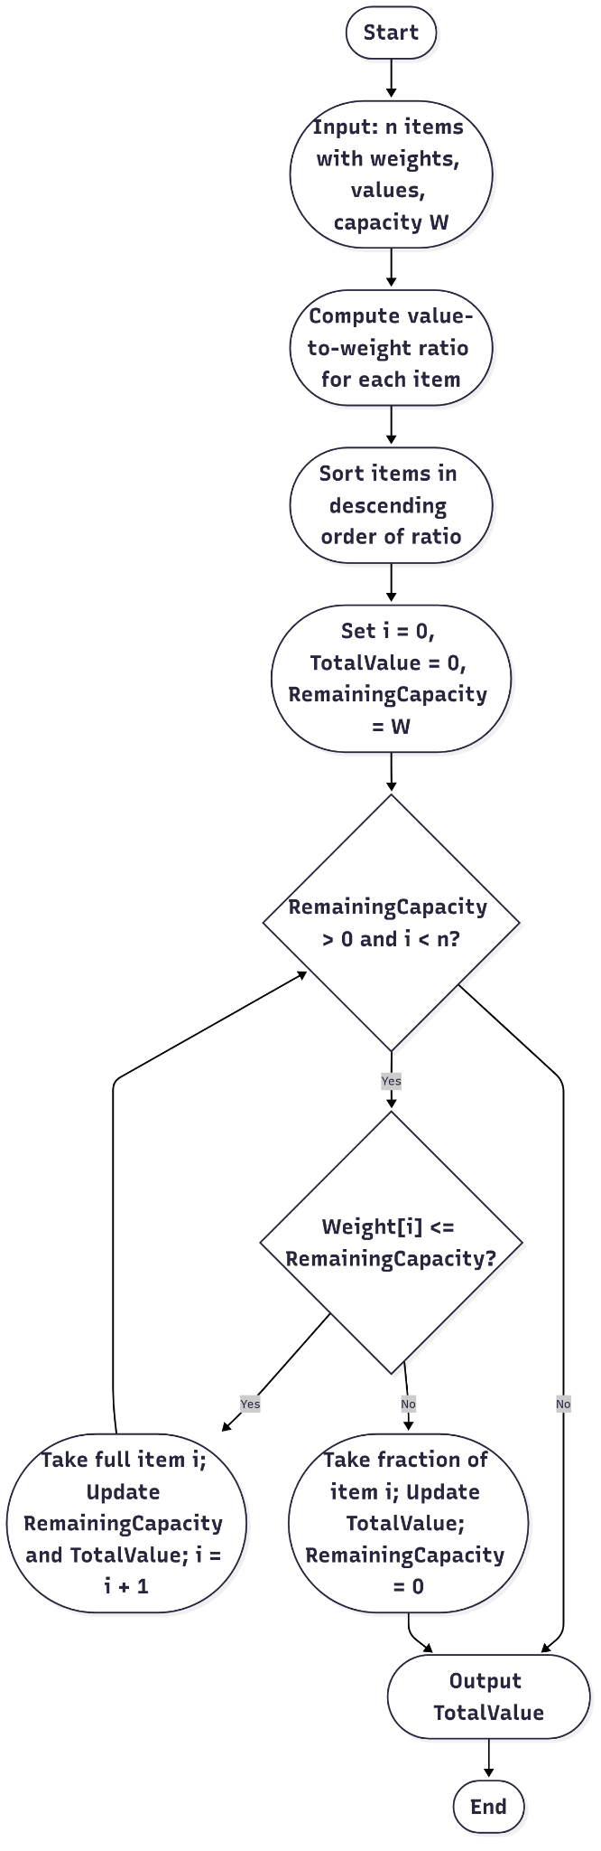
Time Complexity:
- Ratio computation: O(n)
- Sorting: O(n log n)
- Selection: O(n)
- Total: O(n log n)

Implementation (Pseudocode)
function MaxUtilFractional(items, W):
Input: items = list of (weight w, value v, isDivisible), capacity W
Output: maximum total utility value

Compute ratio r[i] = v[i] / w[i] for each item
Sort items by descending r[i]

totalValue = 0
remainingCapacity = W

for each item in sorted items:
if remainingCapacity == 0:
break
if item.weight <= remainingCapacity:
totalValue += item.value
remainingCapacity -= item.weight
else if item.isDivisible:
fraction = remainingCapacity / item.weight
totalValue += fraction * item.value
remainingCapacity = 0
// else if indivisible and can't fit, skip
return totalValue

Output:
Sample Example:
Item | Weight (kg) | Utility | Divisible | Taken | Value Obtained
Medicine | 5 | 50 | No | Full | 50
Food | 10 | 30 | Yes | Full | 30
Water | 20 | 20 | Yes | Partial (if needed) | up to 20
Maximum Utility = 100 (if all fit in given W).
Boat capacity: 17 kg

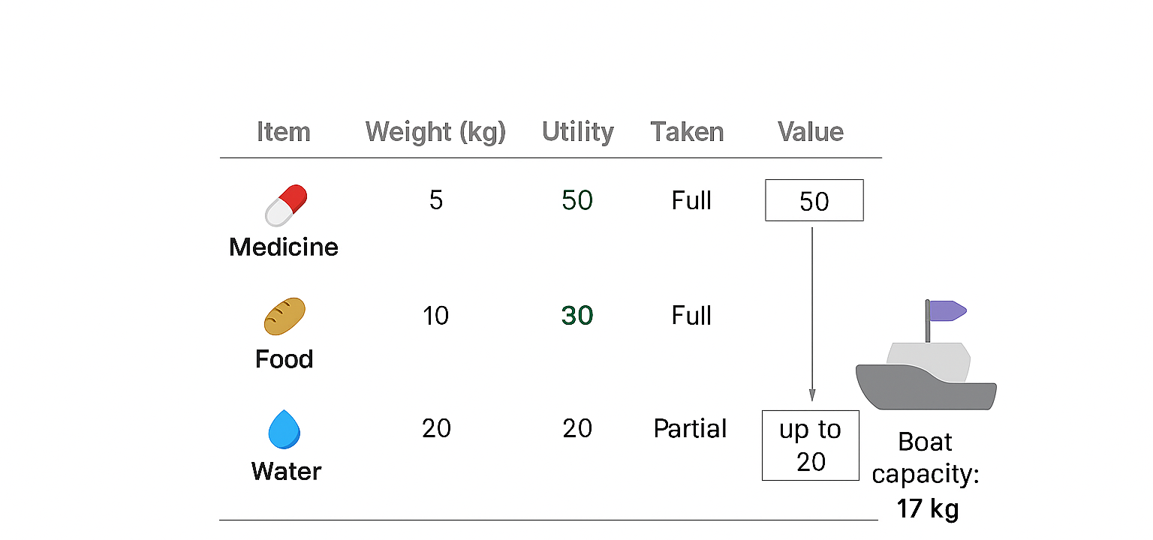

Step 1: Calculate utility per kg
- Medicine: 50 / 5 = 10
- Food: 30 / 10 = 3
- Water: 20 / 20 = 1
Preference order: Medicine → Food → Water

Step 2: Fill the boat
- Take Medicine fully:
  - Weight used = 5 kg
  - Utility = 50
  - Remaining capacity = 17 - 5 = 12 kg

- Take Food fully (weight 10 kg, divisible):
  - Fits completely
  - Utility = 30
  - Remaining capacity = 12 - 10 = 2 kg
- Take Water partially (weight 20 kg, divisible):
  - Only 2 kg fits
  - Utility = 20 × (2/20) = 2

Step 3: Total Utility
- Medicine: 50
- Food: 30
- Water (partial): 2
Total Utility = 82

Code:
#include <iostream>
#include <vector>
#include <algorithm>
#include <chrono>

using namespace std;
using namespace chrono;

struct Item {
string name;
double weight;
double value;
bool divisible;
int priority;

Item(string n, double w, double v, bool d, int p)
: name(n), weight(w), value(v), divisible(d), priority(p) {}

double valuePerWeight() const {
return value / weight;
}
};

bool compare(const Item& a, const Item& b) {
if (a.priority == b.priority)
return a.valuePerWeight() > b.valuePerWeight();
return a.priority < b.priority;
}

double fractionalKnapsack(vector<Item>& items, double capacity, double& totalWeight) {
sort(items.begin(), items.end(), compare);
double totalValue = 0;
totalWeight = 0;

cout << "\nItems selected for transport:\n";
for (const auto& item : items) {
if (capacity <= 0) break;

if (item.divisible) {
double take = min(item.weight, capacity);
double itemValue = take * item.valuePerWeight();
totalValue += itemValue;
totalWeight += take;
capacity -= take;

cout << item.name << " (Divisible): " << take << " kg, Utility = "
<< itemValue << "\n";
} else if (item.weight <= capacity) {
totalValue += item.value;
totalWeight += item.weight;
capacity -= item.weight;

cout << item.name << " (Indivisible): " << item.weight << " kg, Utility = "
<< item.value << "\n";
}
}

return totalValue;
}

int main() {
auto start = high_resolution_clock::now();

int n;
cout << "Enter number of relief items: ";
cin >> n;

vector<Item> items;
cin.ignore(); // Clear newline before getline

for (int i = 0; i < n; ++i) {
string name;
double weight, value;
int divisibleInt, priority;

cout << "\nItem #" << (i + 1) << " Name: ";
getline(cin, name);

cout << "Weight (kg): ";
cin >> weight;

cout << "Utility Value: ";
cin >> value;

cout << "Divisible? (1 = Yes, 0 = No): ";
cin >> divisibleInt;

cout << "Priority (1=High, 2=Medium, 3=Low): ";
cin >> priority;

cin.ignore(); // Prepare for next getline
items.emplace_back(name, weight, value, divisibleInt == 1, priority);
}

double capacity;
cout << "\nEnter maximum weight capacity of the boat (kg): ";
cin >> capacity;

double totalWeight;
double maxValue = fractionalKnapsack(items, capacity, totalWeight);

cout << "\n===== Final Report =====\n";
cout << "Total weight carried: " << totalWeight << " kg\n";
cout << "Total utility value carried: " << maxValue << "\n";

auto end = high_resolution_clock::now();
auto duration = duration_cast<milliseconds>(end - start);
cout << "Program execution time: " << duration.count() << " ms\n";

return 0;
}

Output:
Enter number of relief items: 4
Item #1 Name: Rice Bags
Weight (kg): 10
Utility Value: 60
Divisible? (1 = Yes, 0 = No): 1
Priority (1=High,2=Medium,3=Low): 2
Item #2 Name: Medicine Box
Weight (kg): 5
Utility Value: 100
Divisible? (1 = Yes, 0 = No): 0
Priority (1=High,2=Medium,3=Low): 1
Item #3 Name: Water Bottles
Weight (kg): 8
Utility Value: 70
Divisible? (1 = Yes, 0 = No): 1
Priority (1=High,2=Medium,3=Low): 2
Item #4 Name: Blankets
Weight (kg): 12
Utility Value: 90
Divisible? (1 = Yes, 0 = No): 0
Priority (1=High,2=Medium,3=Low): 3

1
0

Enter maximum weight capacity of the boat (kg): 20
Items selected for transport:
Medicine Box (Indivisible): 5 kg, Utility = 100
Rice Bags (Divisible): 10 kg, Utility = 60
Water Bottles (Divisible): 5 kg, Utility = 43.75
===== Final Report =====
Total weight carried: 20 kg
Total utility value carried: 203.75
Program execution time: 1 ms

Conclusion:

The Fractional Knapsack Algorithm maximizes utility by prioritizing items with the highest value-to-weight ratio. In emergency relief logistics, this ensures that life-saving items like medicine kits are transported first, followed by food and water as space allows.
The greedy algorithm is both efficient (O(n log n)) and optimal for fractional cases, making it highly effective in disaster management where quick, resource-optimized decisions are critical.

