Spring
- Spring is a Dependency Injection Framework used to make Java application loosely coupled.
- It makes the development of JavaEE applications easy.
- Developed by Rod Johnson in 2003

--Dependency Injection
- Dependency is when a class depends on the object of another class to do its work.
- Now, spring comes into action and it takes the control of creating the object and injecting it to the other class during runtime. This is called Inversion of Controll. There is an IOC container that is responsible for this process.
- To configure the Dependency Injection, we can either use XML or annotations.
--Why Dependency Injection?
- Let’s say, we are using the new keyword to use the object of the PrductDao class so that we can access the data at the Service Level. Now this makes the application highly coupled, because if we change anything at the Data Access Layer, we also need to make changes at the Service Layer as well as UI Layer. This is not recommended for developing big Enterprise Applications
- All these processes of creating and injecting objects into classes is managed by spring.
UI Layer
Data Access layer
Busines/Service Layer
ProductController

ProductService

ProductDao

Database

--Ways of Dependency Injection
- Using Setter Injection: Simply uses setter methods to set the values in the dependencies and then injects the objects.
- Using Constructor Injection: Uses constructor to set the values in the dependencies and then injects the objects
--Configuration File: It is the XML file where we declare beans(these are the classes that we provide to the IoC container) and its dependencies.
--Dependency Injection of which data-types are supported by the IoC:
- Primitive DataTypes: byte, short, char, int, float, double, long, boolean.
- Collection Type: List, Set, Map and Properties
- Reference Type (user defined): Other class Object

--Spring Features
- Spring MVC
UI Layer
- Strut/ JSF

- Security
Business/ Service Layer
- Transaction Management
Data Access Layer
- Spring JDBC
- Spring ORM

--Spring Modules
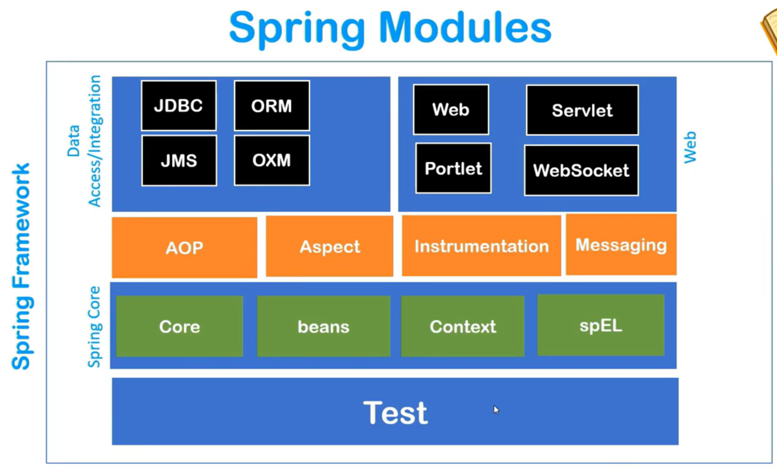

-- Spring IoC Container: It is component or pre-defined program of spring that is responsible for
- Creating the Objects
- Holding the objects in the memory Basically maintains the
- Injecting the objects into other objects lifecycle of an object
--Pre-requisites for IoC Container
- Configure which beans have to be managed by the IoC Container
- XML Configuration (Which object is dependent on which)

--ApplicationContext
- It is an interface that extends the spring IoC Container
- It has all the properties of the IoC container and has its own properties as well
- Since it is an interface, we can’t instantiate it. We need to create objects of its sub classes.
--Implementations of ApplicationContext Interface
- ClasspathXMLApplicationContext: It is used to search the XML configuration in the java class path.
- AnnotationConfigApplicationContext: It searches those beans for which we used the Annotation.
- FileSystemXMLApplicationContext: It seaches the config file from the file system.

--Creating first Spring project
- Create maven project: [Note: select quickstart option]
- Add spring core maven dependency code of any version to the pom.xml file: [Search maven spring core on google and choose any version (eg: 5.2.3)]
- Add spring context maven dependency code in pom.xml: [Note: Same version as the spring core]
- Update project
- Configure build: a) Remove JRE System lib J2SE 1.5
b) Add JRE System lib JDK
- Create a config.xml file in the package of src/main/java
- Copy paste the required code from the spring framework documentation:
<beans xmlns="http://www.springframework.org/schema/beans"
xmlns:xsi="http://www.w3.org/2001/XMLSchema-instance" xmlns:context="http://www.springframework.org/schema/context"
xmlns:p="http://www.springframework.org/schema/p"
xsi:schemaLocation="http://www.springframework.org/schema/beans
http://www.springframework.org/schema/beans/spring-beans.xsd
http://www.springframework.org/schema/context
http://www.springframework.org/schema/context/spring-context.xsd">
</beans>
- Add beans to the config.xml

--Ways to put values in the beans
1.
<bean class="com.springcore.springcore.Student" name="student1">

<property name="studentId">
<value>101</value>
</property>

<property name="studentName">
<value>Satyam Deb</value>
</property>

<property name="studentAddress">
<value>Tripura</value>
</property>
</bean>
2.
<bean class="com.springcore.springcore.Student" name="student2">

<property name="studentId" value="102"/>

<property name="studentName" value="Alan Walker"/>

<property name="studentAddress" value="Atlantis"/>
</bean>

3.
<bean class="com.springcore.springcore.Student" name="student3"
p:studentId="103" p:studentName="Adelle" p:studentAddress="Callifornia"/>

