PingPal – A Random Chat & Private Messaging Application

Project Report

Submitted by: Your Name(s)  
Roll Number(s): XXXXX  
Institution: Your College/University  
Date: September 2025

# Abstract

PingPal is a real-time chat application that enables users to engage in random conversations as well as private one-to-one chats. The system is designed to encourage social interactions by placing users in random chat rooms with suggested topics and allowing them to transition into private conversations. With features such as dynamic avatars, usernames, and OTP-based authentication, PingPal combines fun with security to create a lightweight, user-friendly chatting experience.

# Introduction & Objectives

The objective of PingPal is to create a platform where strangers can interact in a safe and engaging manner. Many online chat systems lack spontaneity or meaningful conversation starters. PingPal solves this by offering random chat rooms with limited participants and built-in topic suggestions. The project also enables users to build meaningful connections by continuing their conversations through private messaging.

# System Features

* Random Chat Rooms – up to 10 users per room with auto-suggested topics.
* Private Messaging – secure one-to-one chat with friends made in rooms.
* User Experience – random avatars, usernames, message pop-ups, and chat hold support.
* Authentication – OTP-based signup and login for security.
* Lightweight UI – clean, simple, and responsive design.

# System Design & Architecture

PingPal follows a client-server model with real-time communication facilitated by Socket.IO. The frontend is built using HTML, CSS, and JavaScript, while the backend uses Node.js and Express.js. MongoDB stores user information, session data, and messages. Authentication is handled via OTP sent to user emails.

# Implementation Details

Frontend: HTML, CSS, JavaScript (for chat UI and interactions).  
Backend: Node.js with Express.js for handling routes and logic.  
Database: MongoDB for storing users, messages, and sessions.  
Realtime Communication: Socket.IO for live chat.  
Authentication: OTP verification system for secure login.

# Testing & Results

The application was tested with multiple users joining random chat rooms simultaneously. Each room successfully handled up to 10 participants without major latency issues. Private messaging was verified to ensure secure communication. Future testing may focus on scalability and deployment in a cloud environment.

# Conclusion & Future Work

PingPal successfully demonstrates the concept of a random chat and private messaging system. It provides a secure and engaging way for users to meet new people online. Future work will focus on adding mobile-friendly interfaces, user profile customization, enhanced moderation tools, and multilingual support.

# References

- Node.js Documentation (https://nodejs.org)  
- Express.js Documentation (https://expressjs.com)  
- MongoDB Documentation (https://www.mongodb.com/docs/)  
- Socket.IO Documentation (https://socket.io/docs/)

# Application Screenshots & Explanations

## Homepage - Introduction to PingPal

This section shows the 'Homepage - Introduction to PingPal'. It provides a detailed look into how PingPal enhances user experience at different stages of interaction. Below is the screenshot:



Figure: Homepage - Introduction to PingPal

## Random Chat Room - Connecting with Strangers

This section shows the 'Random Chat Room - Connecting with Strangers'. It provides a detailed look into how PingPal enhances user experience at different stages of interaction. Below is the screenshot:

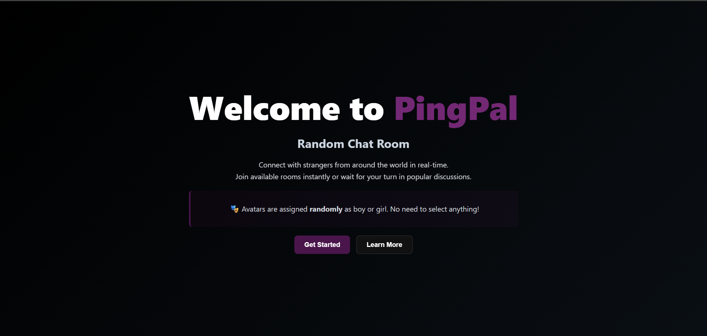

Figure: Random Chat Room - Connecting with Strangers

## Live Chat Example - User Interaction in Rooms

This section shows the 'Live Chat Example - User Interaction in Rooms'. It provides a detailed look into how PingPal enhances user experience at different stages of interaction. Below is the screenshot:

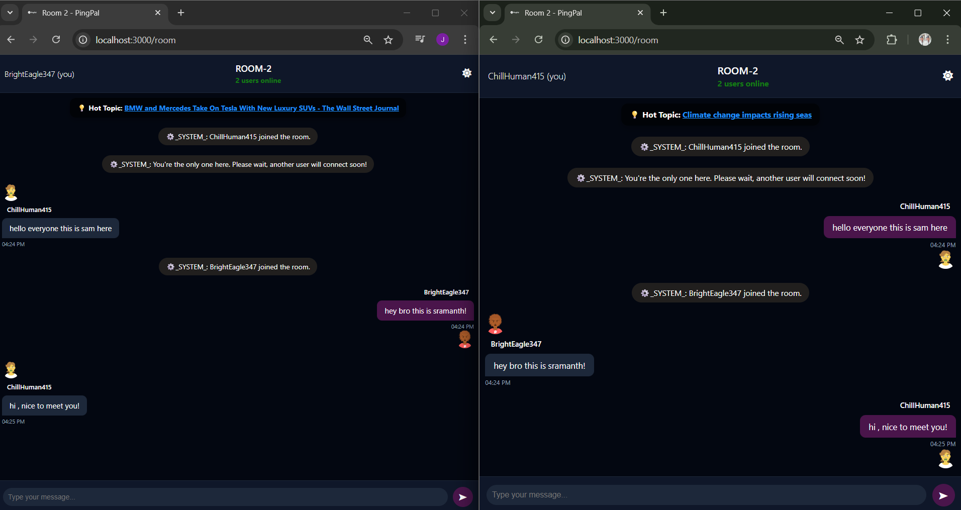

Figure: Live Chat Example - User Interaction in Rooms

## Login Page - Secure Sign In

This section shows the 'Login Page - Secure Sign In'. It provides a detailed look into how PingPal enhances user experience at different stages of interaction. Below is the screenshot:

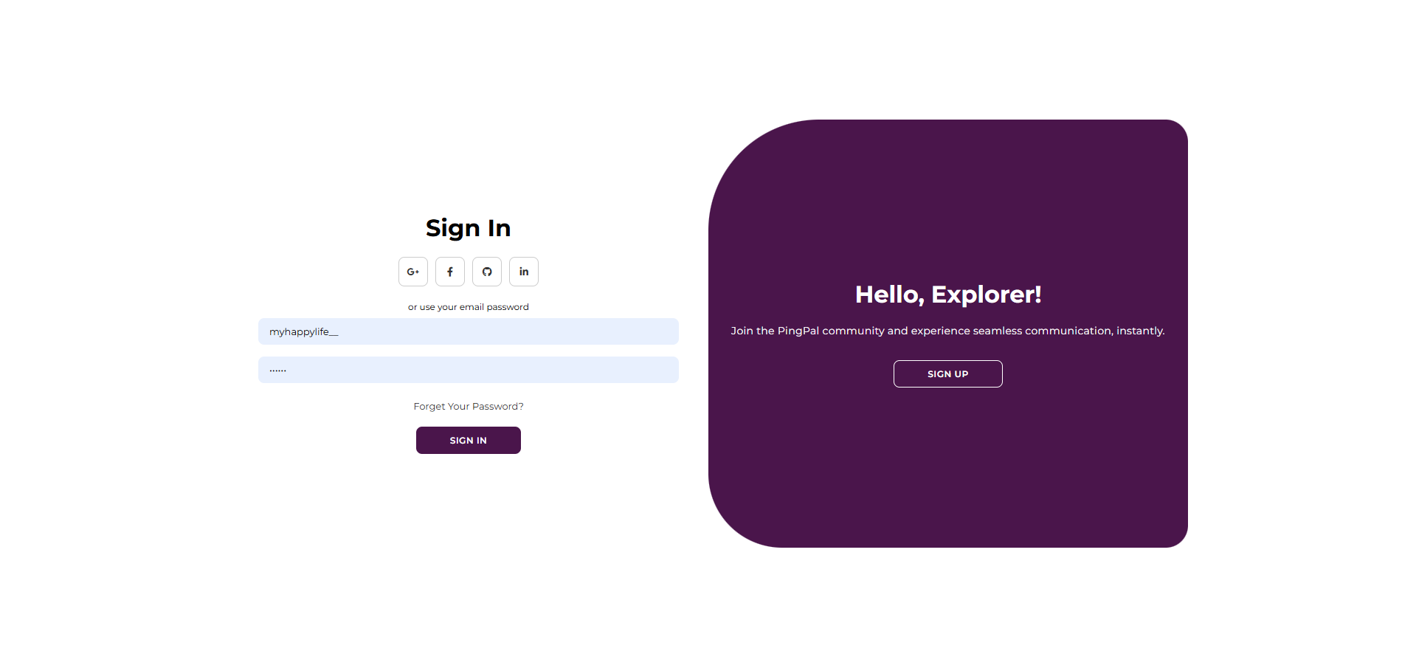

Figure: Login Page - Secure Sign In

## Sign Up Page - Account Creation with Email & Password

This section shows the 'Sign Up Page - Account Creation with Email & Password'. It provides a detailed look into how PingPal enhances user experience at different stages of interaction. Below is the screenshot:

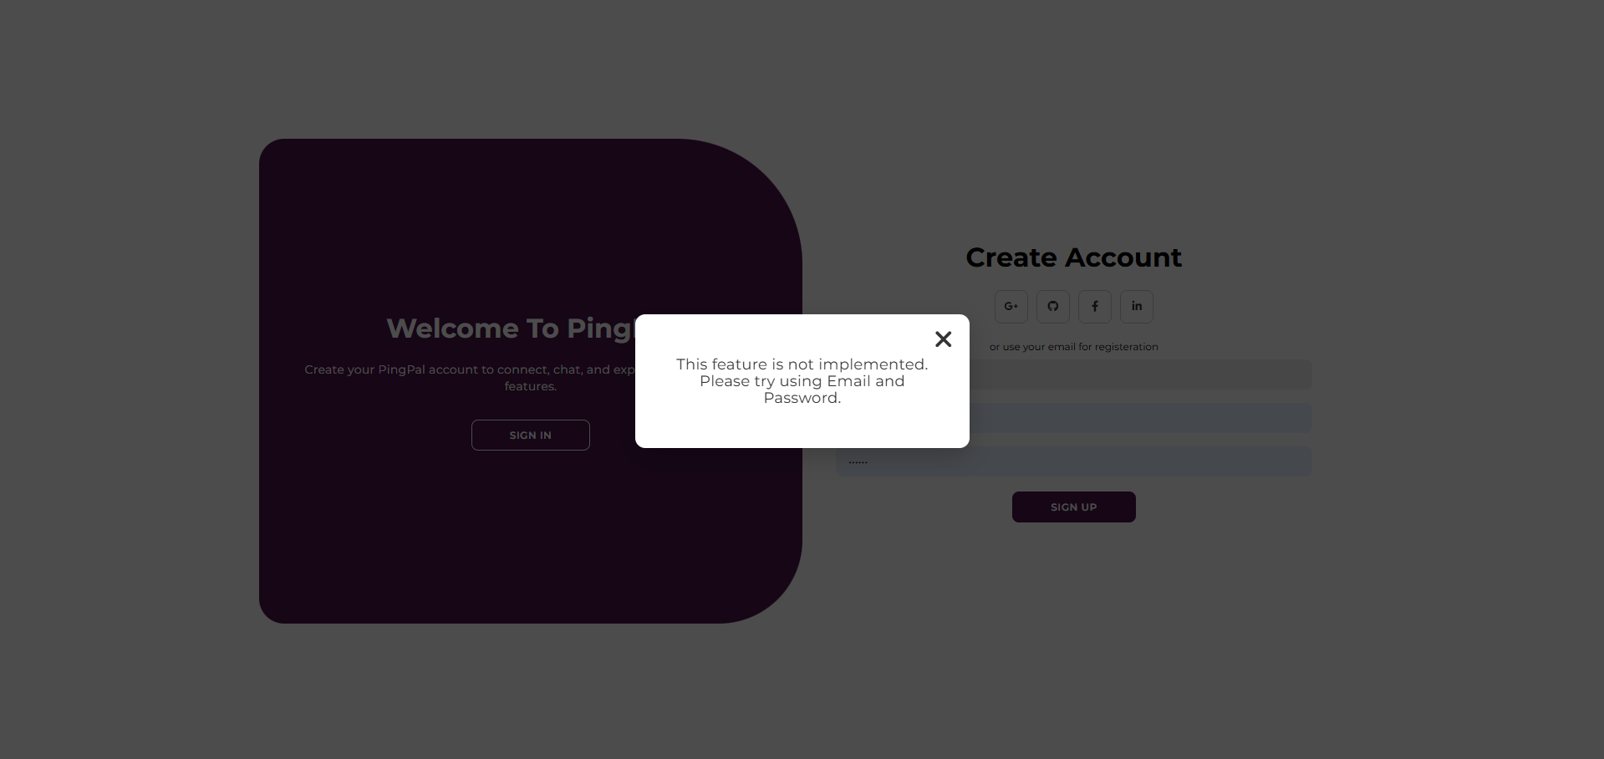

Figure: Sign Up Page - Account Creation with Email & Password