**Product Dissection for Quora**

# **Company Overview:-**

Quora, founded in 2009 by Adam D'Angelo and Charlie Cheever, is a prominent online knowledge-sharing platform with a mission to connect people with information and expertise. Through its user-friendly question-and-answer format, Quora enables users to pose queries, receive responses, and engage in discussions on diverse topics. The platform boasts an engaged and active community, comprising experts and enthusiasts across a wide spectrum of fields. Users can create profiles, follow topics, and showcase their expertise. Quora has introduced monetization options for advertisers and has attracted funding from notable investors. With millions of monthly active users and a global presence, Quora remains a leading hub for the exchange of knowledge and ideas.

### **Product Dissection and Real-World Problems Solved by Quora:-**

Quora, a question-and-answer platform, plays a pivotal role in addressing real-world problems through its user-generated questions, answers, and a sophisticated voting system that ensures the most accurate and valuable content surfaces at the top. With users spanning the globe, Quora has evolved into a rich source of knowledge and problem-solving, catering to an extensive array of subjects and issues. Students and learners turn to Quora for educational support, seeking explanations and clarifications across diverse subjects, making it an invaluable educational resource. Job seekers and professionals find Quora a treasure trove of career advice, industry insights, and interview tips, enabling them to make informed career choices and progress in their chosen fields.

Quora's role in health and wellness is evident as it hosts discussions on health, fitness, and overall well-being, provides answers to medical questions, offers tips for maintaining a healthy lifestyle, and extends support for mental health issues. Travel enthusiasts uncover travel recommendations, plan itineraries, and explore hidden gems through the shared experiences of fellow travelers on the platform. For aspiring entrepreneurs and business professionals, Quora presents a wealth of insights on entrepreneurship, marketing strategies, and business management, supporting them in starting and growing successful ventures. The technology and innovation discussions on Quora address complex tech-related issues, keep users updated on the latest developments and enable the sharing of knowledge about emerging technologies.

Furthermore, the platform fosters open and honest discussions on cultural and social issues, promoting understanding, and empathy, and offering potential solutions to societal challenges. Users seeking personal development can access advice on self-improvement, life coaching, and goal achievement, assisting them in overcoming challenges and progressing towards their aspirations.

Additionally, Quora serves as a valuable source for product and service recommendations, allowing consumers to make informed purchasing decisions by asking for suggestions and reading reviews. In summary, Quora, with its global community and user-generated content, has grown into a versatile resource for addressing an extensive range of real-world issues, promoting learning, problem-solving, and the sharing of expertise across a vast spectrum of topics.

## **Case Study: Real-World Problems and Quora Innovative Solutions:-**

Quora has emerged as a unique platform where individuals can ask questions, share knowledge, and engage in meaningful conversations. Over the years, Quora has not only become a hub for curious minds but has also tackled various real-world problems with innovative solutions. This case study explores some of the challenges Quora has faced and the creative solutions it has implemented.

**Problem 1: Combating Misinformation**

In the era of fake news and disinformation, Quora was not immune to the spread of inaccurate information. Users were posting answers based on false data or personal biases, affecting the quality of knowledge shared on the platform.

**Solution:**

Quora implemented a robust moderation system, combining human reviewers and machine learning algorithms. This system automatically flagged potentially misleading or harmful content and assigned it for review. Human moderators then assessed these flagged items, ensuring the community guidelines were followed. Additionally, Quora encouraged users to provide credible sources for their answers and started highlighting verified experts in various fields.

**Result:**

This approach significantly reduced the prevalence of misinformation on the platform. Users began to trust Quora as a reliable source of information, and the quality of discussions improved.

**Problem 2: Addressing Toxicity and Harassment**

Like many online platforms, Quora faced challenges related to toxic behavior, harassment, and cyberbullying. Users were discouraged from participating due to negative interactions.

**Solution:**

Quora introduced a combination of community-driven reporting tools and machine-learning algorithms to detect and address toxic content. Users were empowered to report harmful behavior, and algorithms could identify patterns of harassment. Quora also introduced stricter content policies and enforced consequences for those who violated them.

**Result:**

The online environment on Quora has become more welcoming and inclusive. Users felt safer and more encouraged to participate in discussions, leading to a more vibrant and diverse community.

**Problem 3: Enhancing User Engagement**

Quora wanted to keep users engaged and active on the platform, especially with increasing competition from other social media platforms.

**Solution:**

To boost user engagement, Quora introduced several innovative features. These included the Quora Spaces feature, allowing users to create topic-based communities, and the "Quora Digest" email, which delivered personalized content to users' inboxes. Quora also improved its mobile app and user interface to enhance the user experience.

**Result:**

User engagement on Quora increased, and the platform retained existing users while attracting new ones. The introduction of Spaces and personalized content recommendations made Quora a more interactive and dynamic platform.

**Problem 4: Monetization and Sustainability**

Quora needed to find a sustainable way to support its platform, ensure its long-term viability, and continue providing valuable content.

**Solution:**

Quora introduced the Quora Partner Program, allowing writers to earn money through their content by sharing in the revenue generated by ads placed on their answers. This provided an incentive for high-quality contributions and attracted more writers to the platform. Quora also experimented with paid subscription models, offering exclusive features to premium users.

**Result:**

The Quora Partner Program provided a win-win solution: writers were rewarded for their expertise, and Quora generated revenue to support the platform's operations and growth. The subscription model added an additional revenue stream while offering premium users extra benefits.

**Conclusion:-**

Quora's journey in addressing real-world problems through innovative solutions showcases the platform's commitment to fostering a positive online community.

By tackling issues such as misinformation, toxicity, user engagement, and monetization, Quora has not only maintained its position as a valuable source of knowledge but has also set a precedent for other online platforms to follow. Through a combination of technology, user empowerment, and creative thinking, Quora continues to evolve and thrive in the ever-changing digital landscape.

## **Top Features of Quora:-**

Quora, a popular question-and-answer platform, offers several key features:

**1. User-Generated Content:** Users ask and answer questions, providing a wealth of information.

**2. Personalized Feed:** Tailored content based on your interests and activity.

**3. Voting System:** Upvotes and downvotes determine answer visibility and quality.

**4. Expertise Recognition:** Users can earn credentials as top writers in specific topics.

**5. Community Guidelines:** Ensures a respectful and informative environment.

**6. User Profiles:** Customize profiles with expertise, interests, and links.

**7. Notifications:** Stay updated on questions, answers, and comments.

**8. Follow Topics:** Track subjects you care about for regular updates.

**9. Anonymous Posting:** Ask sensitive questions without revealing your identity.

**10. Mobile Apps:** Access Quora on the go with iOS and Android apps.

**11. Ads and Monetization:** Businesses can advertise and users can earn through the Quora Partner Program.

**12. Rich Media Support:** Embed images, videos, and links in answers.

**13. Language Support:** Available in multiple languages for a global user base.

## **Schema Description:-**

Quora's database schema is complex and not publicly disclosed, but I can provide a simplified representation of what the schema might include in a question-and-answer platform like Quora. Keep in mind that the actual schema would be much more detailed and sophisticated.

**Users Table:**

UserID (Primary Key)

Username

Email

Password

Profile Information (e.g., Name, Bio, Location)

User Reputation/Stats

Profile Picture

**Questions Table:**

QuestionID (Primary Key)

Title

Description

Timestamp

UserID (Foreign Key to Users)

Topic/Category (Foreign Key to Topics)

**Answers Table:**

AnswerID (Primary Key)

Content

Timestamp

UserID (Foreign Key to Users)

QuestionID (Foreign Key to Questions)

Upvotes/Downvotes Count

**Comments Table:**

CommentID (Primary Key)

Content

Timestamp

UserID (Foreign Key to Users)

AnswerID (Foreign Key to Answers)

**Topics Table:**

TopicID (Primary Key)

Topic Name

Parent Topic (for subtopics)

Description

**Follows Table:**

UserID (Foreign Key to Users)

FollowedTopicID (Foreign Key to Topics)

**Notifications Table:**

NotificationID (Primary Key)

UserID (Foreign Key to Users)

Notification Type

Content

Timestamp

Status (Read/Unread)

This is a simplified schema, and in reality, the database structure would be more intricate, with additional tables and relationships to handle user interactions, moderation, ads, and various other features. The specific schema and database design for a platform like Quora would require careful planning and optimization to ensure efficient performance and data integrity.

## **ER-Diagram:-**

An Entity-Relationship (ER) diagram for a simplified representation of Quora might look like this:

Entities and Relationships:

**1. User**

Attributes: UserID (Primary Key), Username, Email, Password, Name, Bio, Location, Reputation, Profile Picture

Relationships:

Asks (one-to-many with Question)

Answers (one-to-many with Answer)

Follows (many-to-many with Topic)

Comments (one-to-many with Comment)

Receives (one-to-many with Notification)

**2.Question**

Attributes: QuestionID (Primary Key), Title, Description, Timestamp

Relationships:

AskedBy (many-to-one with User)

BelongsTo (many-to-many with Topic)

HasAnswers (one-to-many with Answer)

**3.Answer**

Attributes: AnswerID (Primary Key), Content, Timestamp, Upvotes/Downvotes Count

Relationships:

AnsweredTo (many-to-one with User)

InResponseTo (many-to-one with Question)

HasComments (one-to-many with Comment)

**4.Comment**

Attributes: CommentID (Primary Key), Content, Timestamp

Relationships:

CommentedBy (many-to-one with User)

CommentOn (many-to-one with Answer)

**5.Topic**

Attributes: TopicID (Primary Key), Topic Name, Description

Relationships:

Includes (many-to-many with User)

BelongsTo (many-to-one with Topic for hierarchical organization)

**6.Notification**

Attributes: NotificationID (Primary Key), Notification Type, Content, Timestamp, Status (Read/Unread)

Relationships:

SentTo (many-to-one with User)

**Cardinalities:**

One User can Ask multiple Questions (one-to-many).

One User can Answer multiple Questions (one-to-many).

One User can Follow multiple Topics (many-to-many).

One User can Comment multiple times (one-to-many).

One User can receive multiple Notifications (one-to-many).

One Question can have multiple Answers (one-to-many).

One Question can belong to multiple Topics (many-to-many).

One Answer can have multiple Comments (one-to-many).

One Comment is associated with one Answer (many-to-one).

One Comment is made by one User (many-to-one).

One Topic can include multiple Users (many-to-many).

Topics can be organized hierarchically (many-to-one for parent topics).

One Notification is sent to one User (many-to-one).

This simplified ER diagram captures the core entities and relationships within a platform like Quora. In reality, a production-level ER diagram for such a platform would be more complex, considering additional entities and attributes to handle features like ads, moderation, user roles, and more.

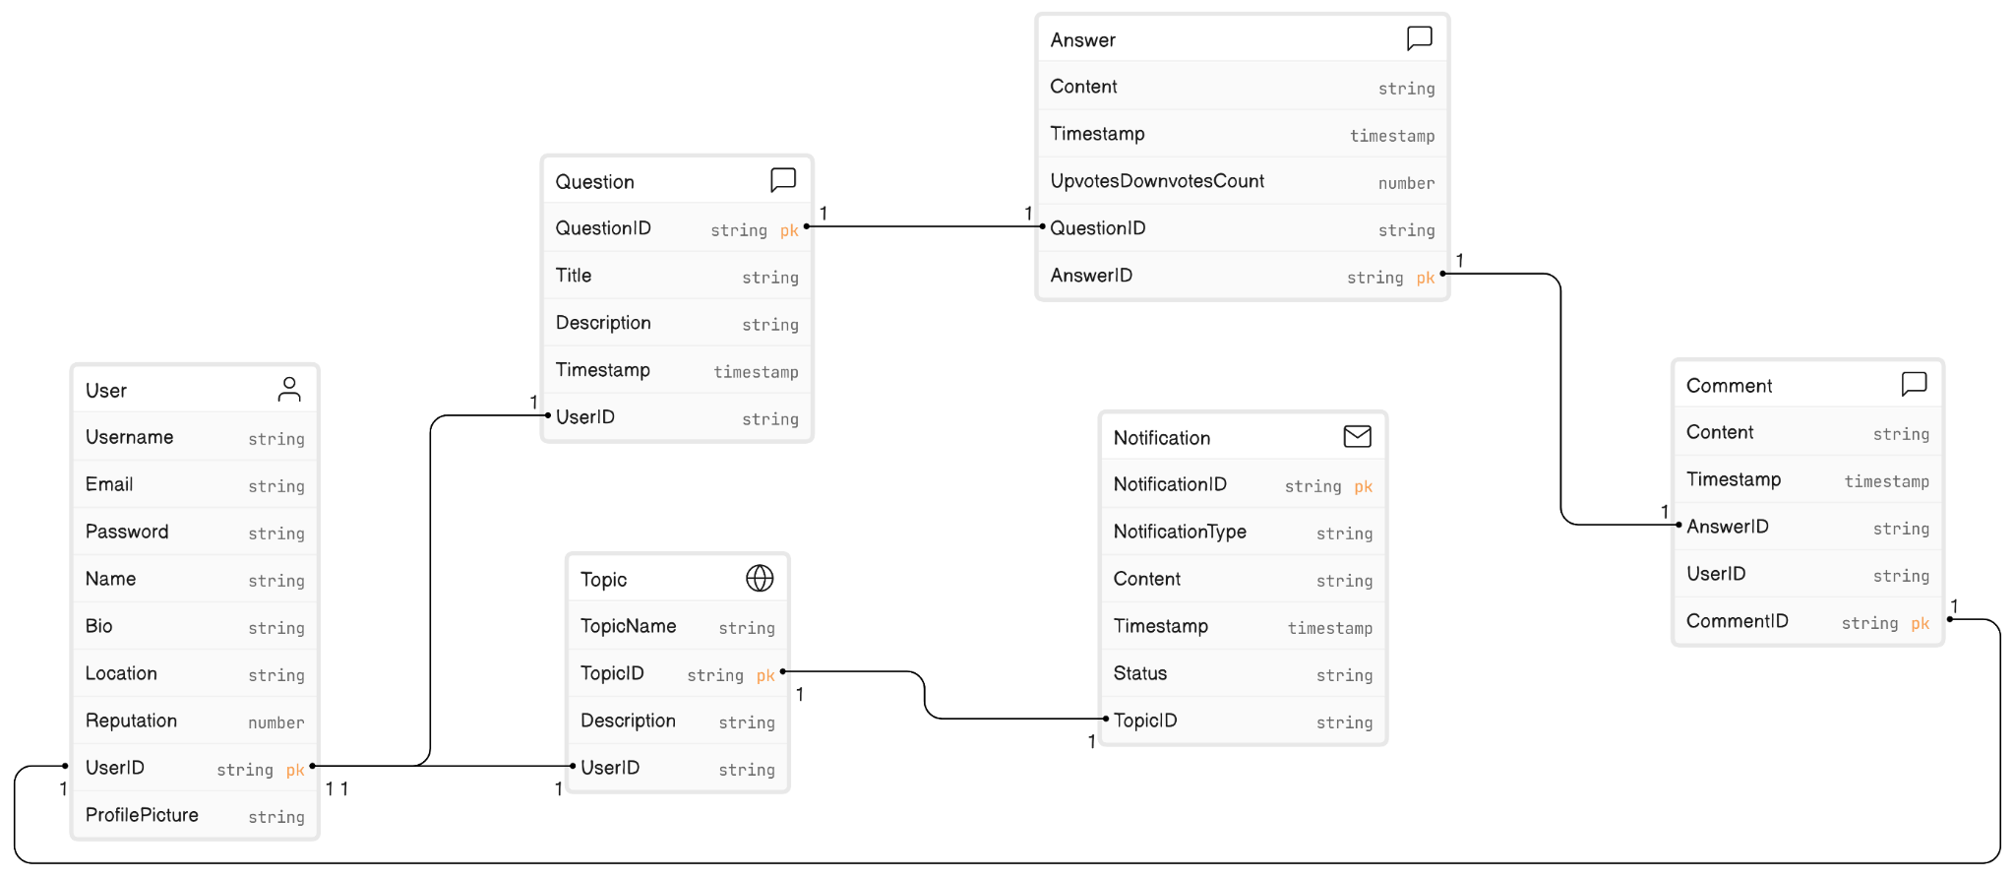

## **Conclusion:-**

Quora, a renowned online knowledge-sharing platform, has effectively tackled real-world issues and nurtured a positive online community through innovative approaches. It combats misinformation by employing a robust moderation system and emphasizes credibility by validating experts, establishing itself as a reliable source of information. Quora has also taken significant steps to combat toxicity and harassment by empowering users with reporting tools and enforcing strict content policies, thus creating a safer and more inclusive environment. The introduction of features like Spaces and personalized content recommendations has enhanced user engagement, rendering it a dynamic and interactive platform. Monetization and sustainability are achieved through the Quora Partner Program, benefiting content creators and ensuring long-term viability.