**Problem Description:**

An undeloyed portlets from Liferay portal webapp context only removes the portlet of visibility in the “Add Application” so that permission users can’t add that portlet to a page. But portlets instance information was not removed from layout and its preferences (user and layout level) and permissions. Still there is a mapping existed in tables from liferay schema.

**Proposed Solution:** As Liferay provides cool feature of hooks which users can customize Liferay Portal source. We can use this hook to identify the undeployed portltes and clean the unwanted data.

**Steps to reproduce the problem**

**Step: 1** - Download Liferay Instance

**Step: 2** - Download photolibraryportlet (this only for example, you can deploy and underplay any custom portlet)

**Step: 3** - Create 2 Liferay Pages and add calendar portlet,

**Step: 4 -** Configure Portlet Preferences

**Step-5** - Setup Portlet Permissions

**Page1**

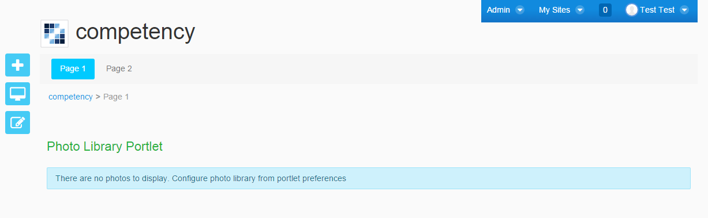

**Page2**

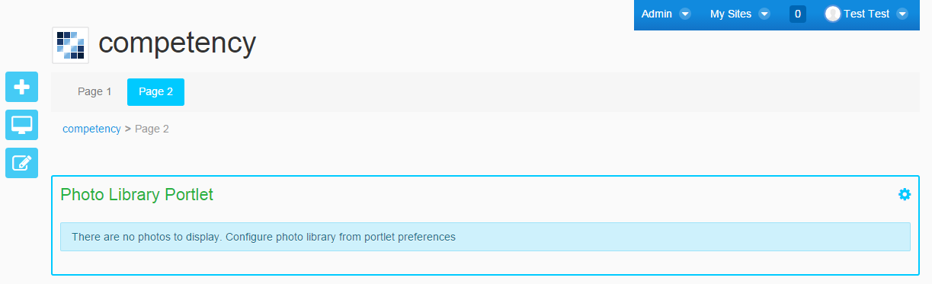

**Page/Layout Level Porlet Related Data**

SELECT * FROM portletpreferences WHERE portletId LIKE '%photolibraryportlet%';



SELECT * FROM resourcepermission WHERE NAME LIKE '%photolibraryportlet%';

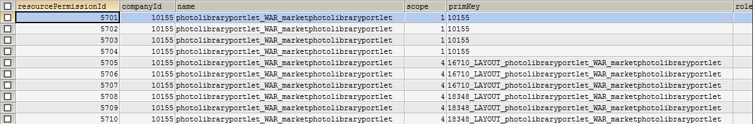

**Step-6:** Undeploy the photolibraryportlet portlet

1. Remove the removelibraryportlet webapp context from portal

cd %LIFE_HOME%\tomcat-7.0.42\webapps\market-photolibrary-portlet

rm –rf market-photolibrary-portlet

**Step-7:** Access Page1 and Page2 where you have render the portlet through admin

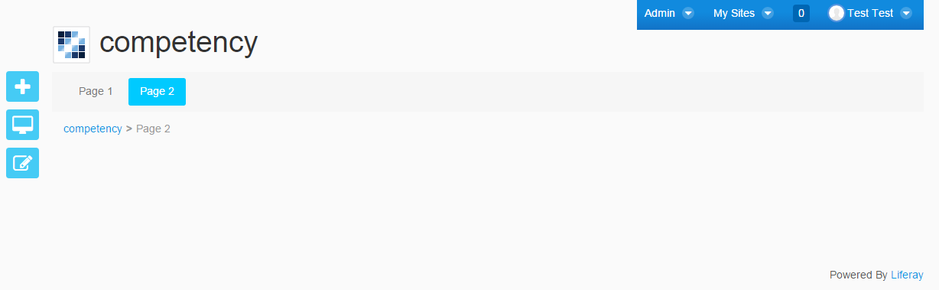

Admin can’t add the portlet from UI as it’s undeployed – working as expected

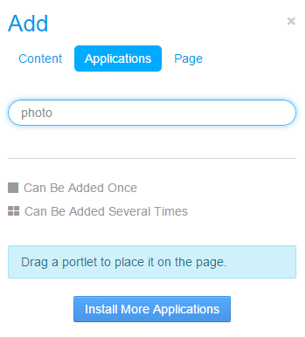

**Validation:** Even though portlet was undeployed still its information existed in liferay tables

SELECT * FROM **portletpreferences** WHERE portletId LIKE '%photolibraryportlet%';

SELECT * FROM **resourcepermission** WHERE NAME LIKE '%photolibraryportlet%';

**Summary of API for this hook plugin:**

1. Get Group Layouts(public and private)

**List<Layout> layouts= LayoutLocalServiceUtil.getLayouts(groupId, privateLayout)**

1. Iterate Layouts and identify the undeployed portlets

**List<Portlet> allPortlets = layoutTypePortlet.getPortlets()**

**if(pagePortlet.isUndeployedPortlet())**

1. Remove Porlet from Layout and update Layout

**layoutTypePortlet.removePortletId(userId, pagePortlet.getPortletId())**

**Steps to clean undeployed portlets entries from database tables.**

* **Step0: Deploy ‘clean-db-tables-of-undeployed-portlets-1.0.0-SNAPSHOT.war’ into liferay instance.**
* **Step1: Goto control panel**

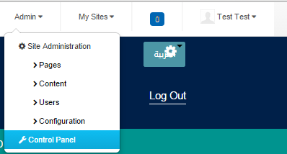

* **Step2: click ‘server administration’ option**

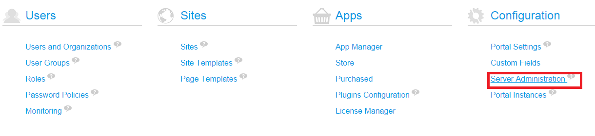

* **Step3: click ‘Execute’ button 🡪 to clean Database tables entries of undeployed portlets.**

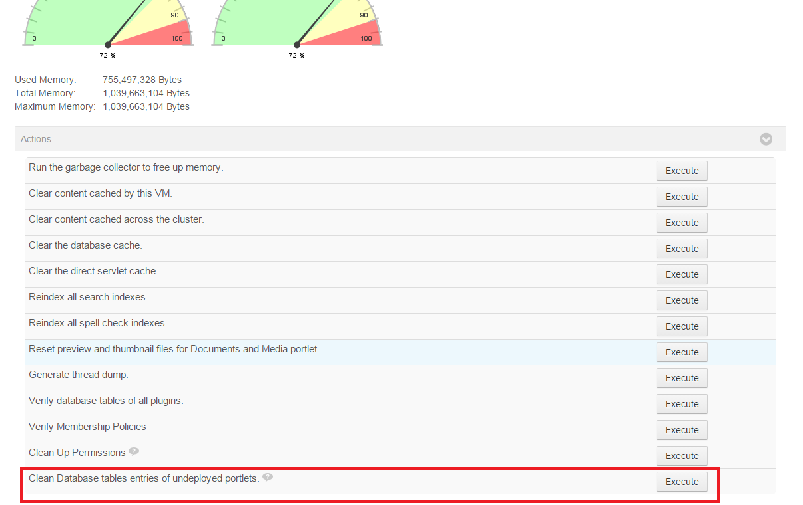

* **Step4: After successful execution we will get success message.**

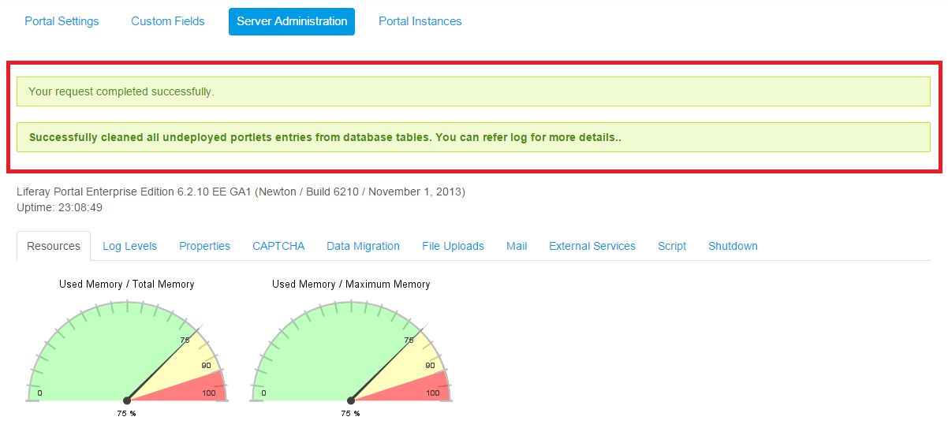

* **On the log file, you can find** 
  + **1. total number sites are available in the current instance**
  + **2. total number of applied layouts are 4 for the respective site**
  + **3. total number of added portlets for the respective page**
  + **4. cleaned undeployed xxx-portlet portlet entries from database table**

**Final validations :**

* **DB Validation (No Data related to page level)**
  + SELECT * FROM **portletpreferences** WHERE portletId LIKE '%photolibraryportlet%';
  + SELECT * FROM **resourcepermission** WHERE NAME LIKE '%photolibraryportlet %';