**QA Test Deployment and Automation**

This repository provides the instructions and resources for deploying and verifying a frontend and backend service integration using Kubernetes and automated testing with Java and TestNG.

**Project Overview**

This project demonstrates how to deploy a frontend and backend service to a local Kubernetes cluster, verify their communication, and automate testing to ensure correct integration.

## **Prerequisites**

Before you begin, ensure you have the following tools installed:

* Docker
* Minikube
* Java
* Test NG
* IDE (Eclipse, IntelliJ)
* Maven (for managing Java dependencies)

## **Instructions**

## **Deployment**

1. **Clone the Repository**

git clone https://github.com/Vengatesh-m/qa-test

cd qa-test

1. **Start Minikube**

minikube start

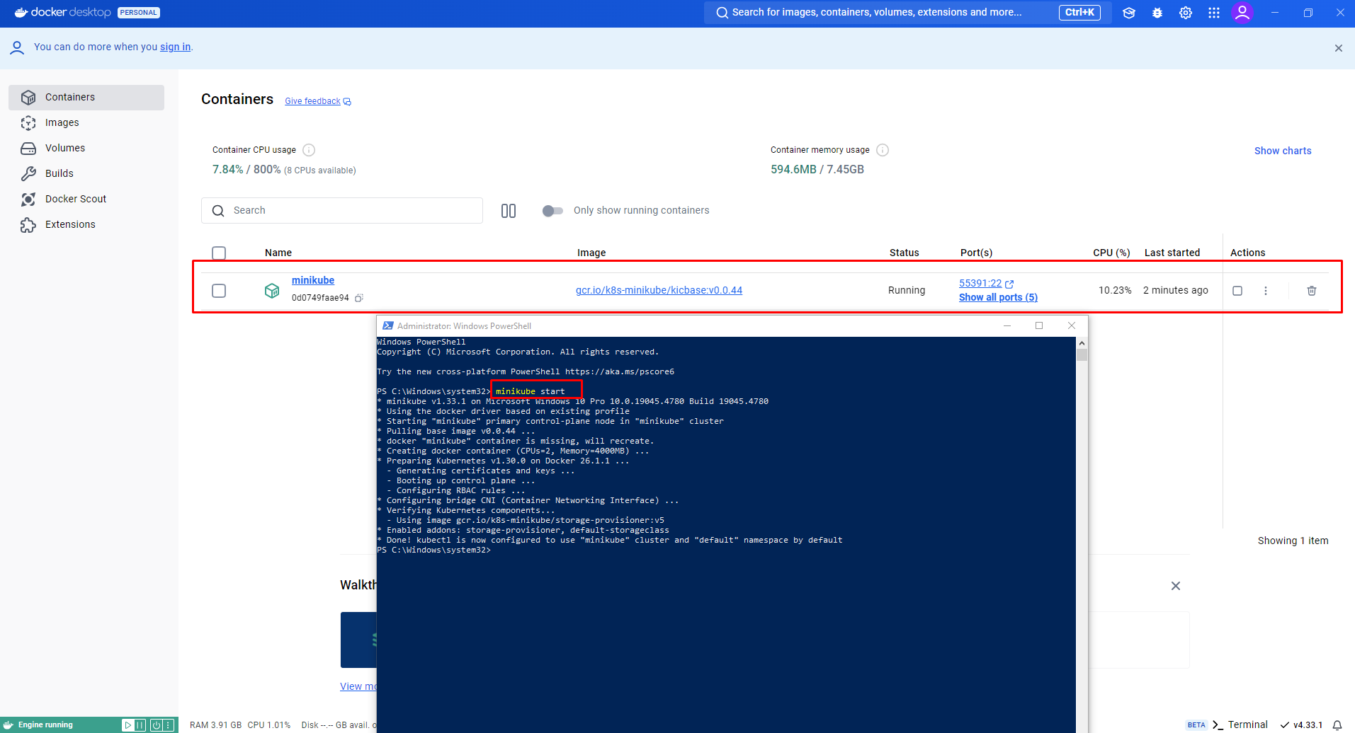

1. **Deploy Services to Kubernetes**

Apply the Kubernetes YAML files to deploy the frontend and backend services:

kubectl apply -f backend-deployment.yaml

kubectl apply -f frontend-deployment.yaml

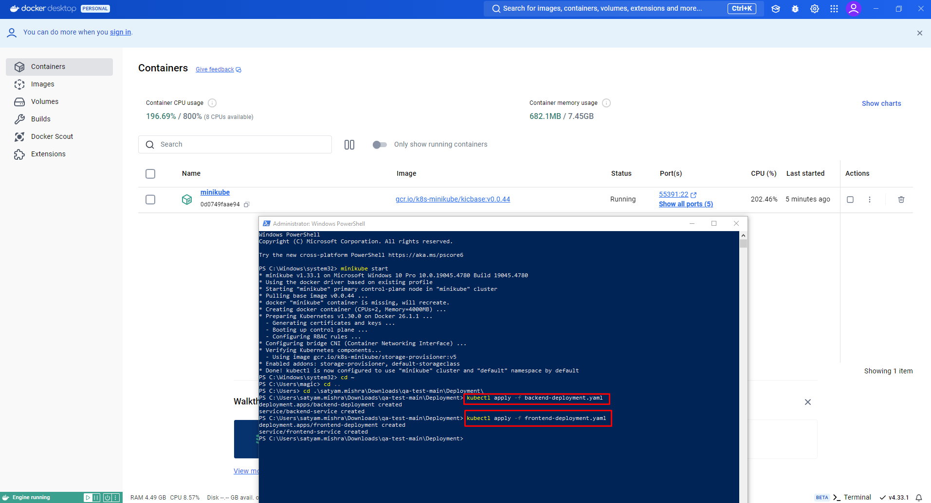

## **Verification**

1. **Verify Frontend-Backend Communication**

Get the service URL for the frontend:

minikube service frontend-service --url

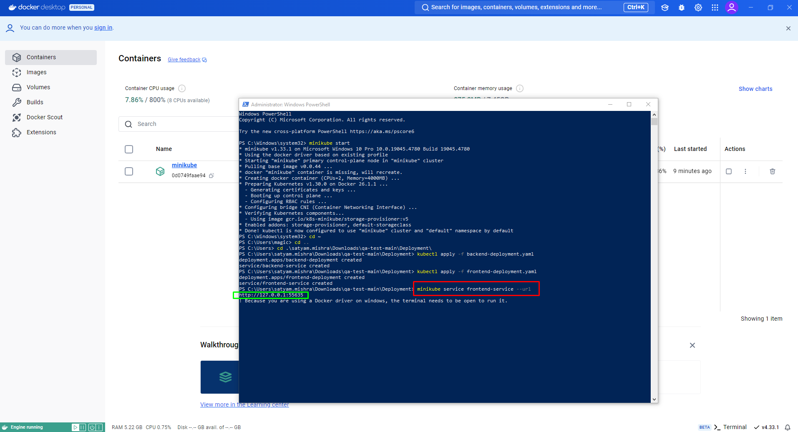

1. **Access the frontend URL in your browser to check if the greeting message is displayed.**

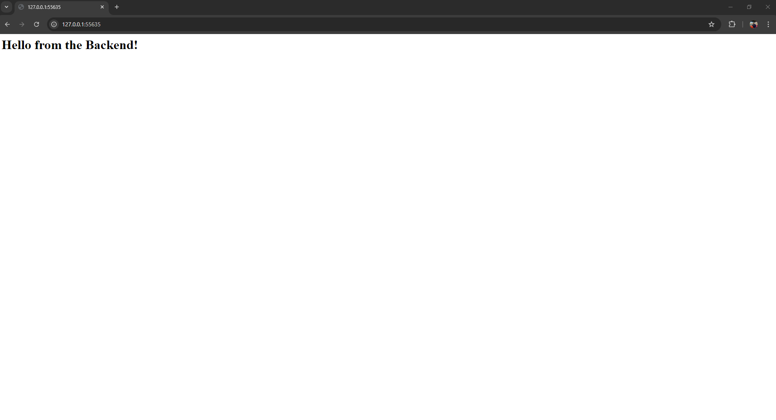

## **Automation Testing**

1. **Set Up Java Project**

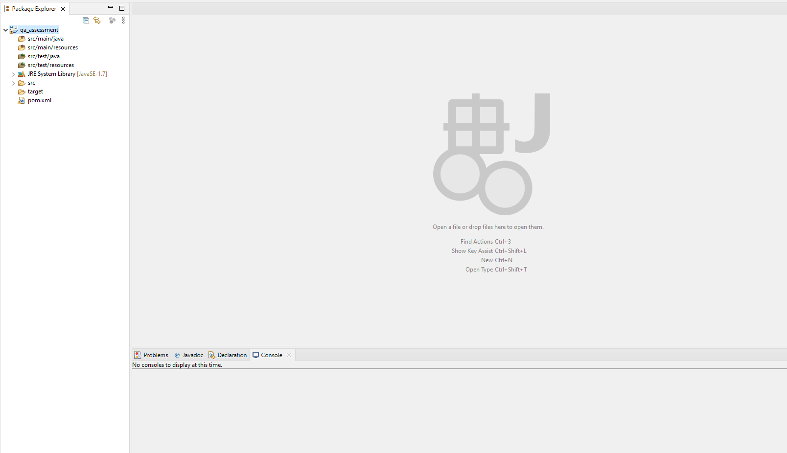

1. **Install Dependencies**

Navigate to the test directory and add TestNG and other dependencies to your pom.xml:

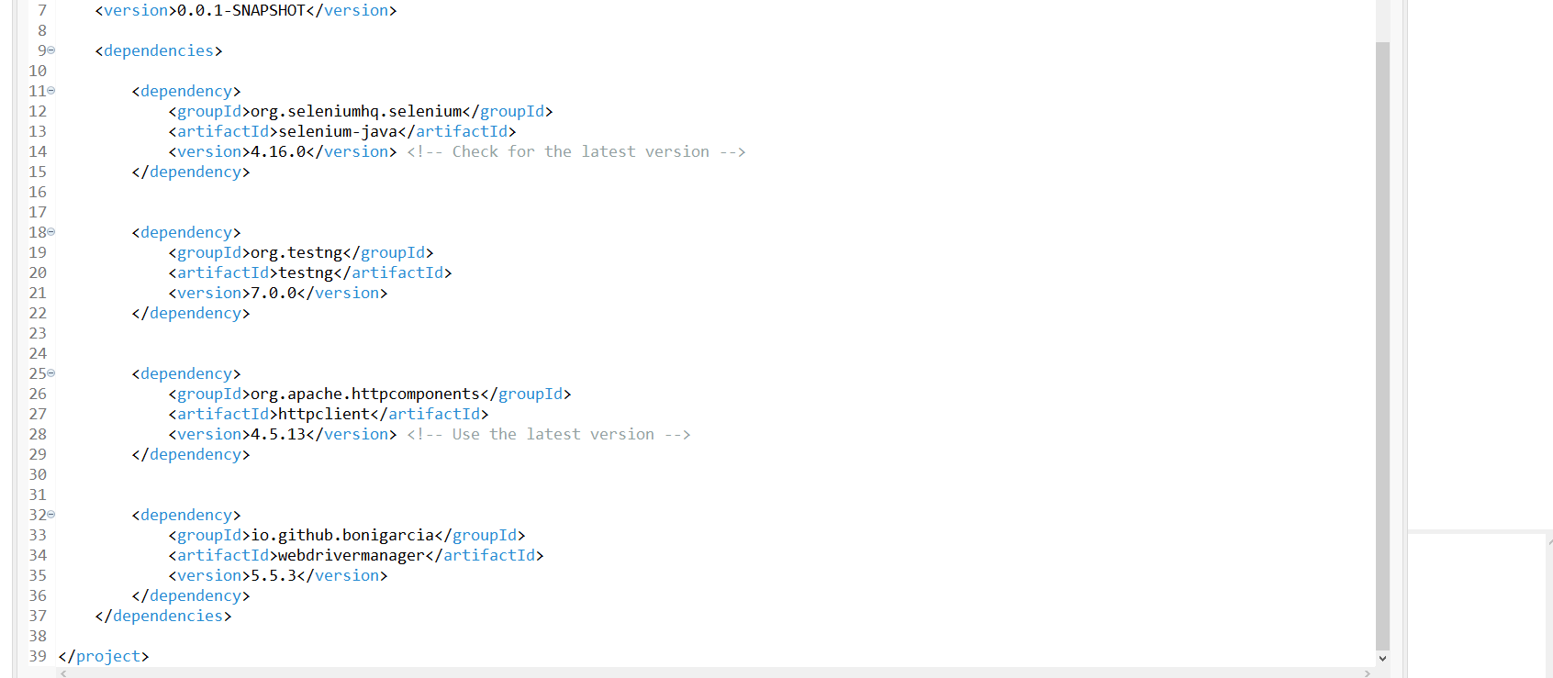

1. **Compile and Run Tests**

The TestNG test script, located in src/test/java, performs the following checks:

* Sends an HTTP request to the frontend service.
* Verifies that the response contains the expected greeting message from the backend service**.**

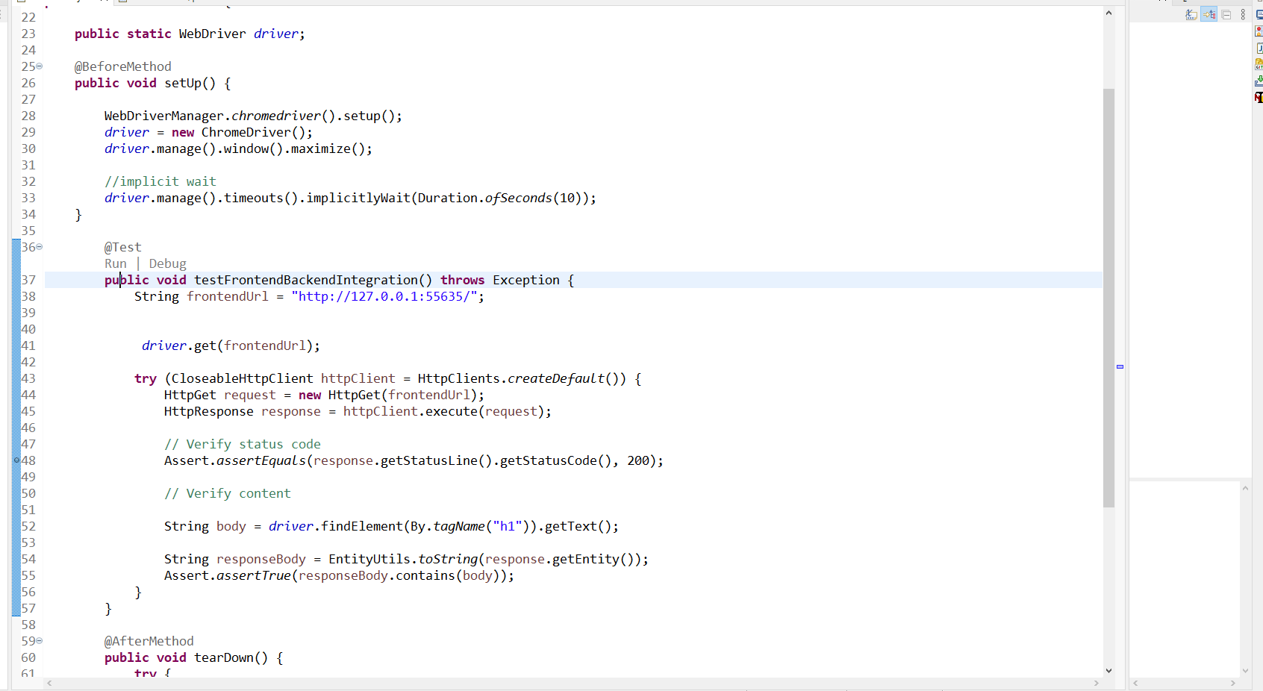

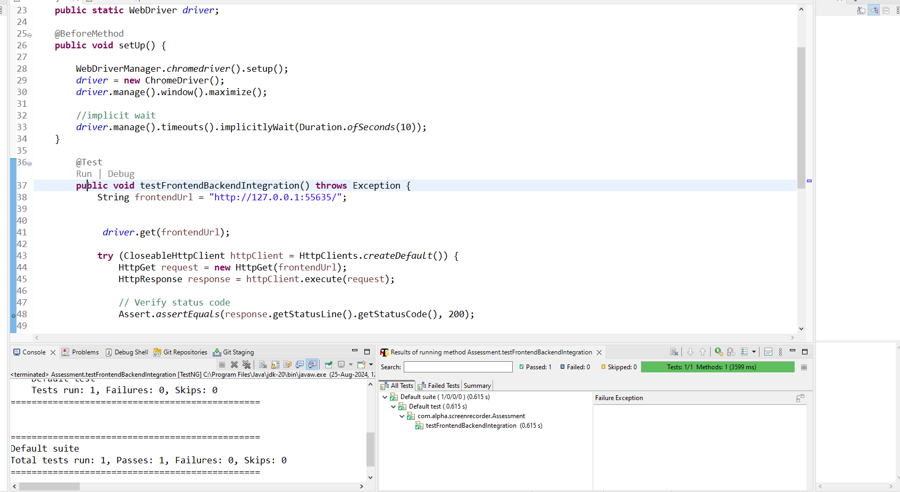

## **Troubleshooting**

* If you encounter issues, check the Kubernetes pod logs:

kubectl logs <pod-name>

* Ensure all services are running and reachable within the cluster.