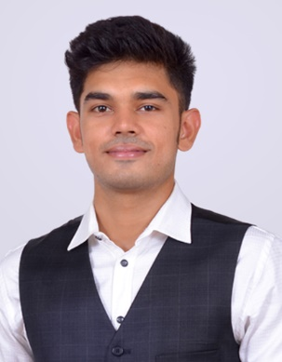

**Satyam Puniya**

♦

♦

♦

♦

+91 - 9566187787

SRM institute of technology

B.Tech – Information Technology

My name is Satyam Puniya ,and I’m currently pursuing a bachelor degree in Information Technology. I am an upbeat, self-motivated team player with excellent communication skills. I also play basketball and have won many accolades for it.

My main motive is to work on a challenging job profile which provides an opportunity to enhance my technical skills and knowledge, this could provide me an insight into new aspects so that it would be helpful for my career. I can assure you that my dedication will make me an asset for your company.

PROFESSIONAL DEVELOPMENT



Indian Institute Of Technology (IIT - Kanpur)

**Information Retrieval and Data Mining**

June - 2018

Massachusetts Institute of Technology (MITX)

June - 2018

Omkar Deshpande (Data Scientist at Walmart labs)

University Of Michigan

**Introduction to Data Science Using Python**

June - 2017

SKILLS

EDUCATION

Delhi Public School, Noida

Junior High School – 10th (CBSE)

https://www.linkedin.com/in/thisissatyam-2897

**Information Retrieval and Mining massive Datasets**

**Introduction to CS and Programming Using Python**

satyampuniya@live.com

Regent B901 , Grand Omaxe Sector 93B, Noida - 201304

CONTACTS

May - 2018

C++

Python

Java

Selenium

SQL

Mongo DB

C

Marketing

2012 - 2013

Brain storming with members, creating marketing strategies and how to implement them.

Deciding ways in which we can create awareness about our product.

I was taught both the practical and conceptual skills that build the foundation for understanding basic Testing through software like Selenium,Postman etc.

The focus of the training was on learning the fundamentals of Website Testing and Automation.

AIESEC in Chennai

**Marketing Manager**

2016 - 2017

2014 - 2015

2015 - 2019

Delhi Public School, Noida

High School – 12th (CBSE)

One Mobikwik Pvt.Ltd

**Technical Intern**

June - 2017

WORK EXPERIENCE

ABOUT ME