PS – 1647 Requirements: -

There should be 2 panels:

1. Government employees panel
2. User panel

In Government panel there should be: -

1. Daily prices of certain vegetables categorized by Date.

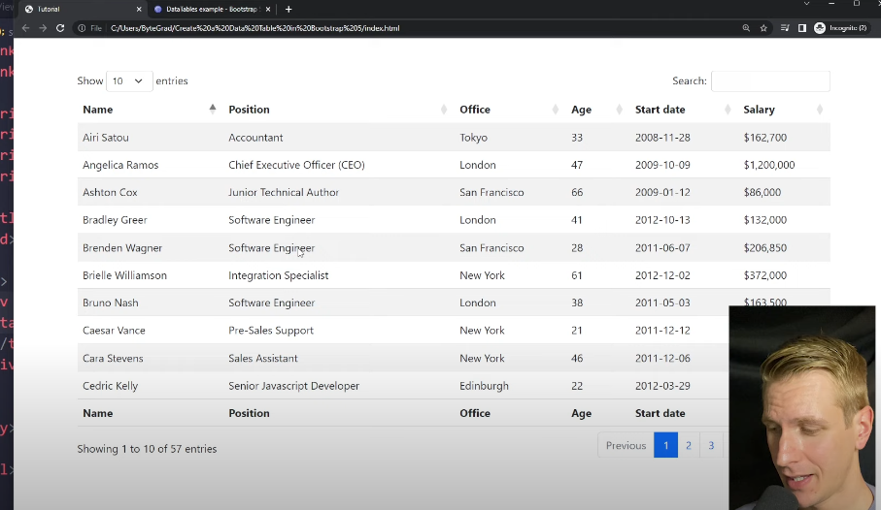

1. Realtime Data Analysis of Buffer stock by government.

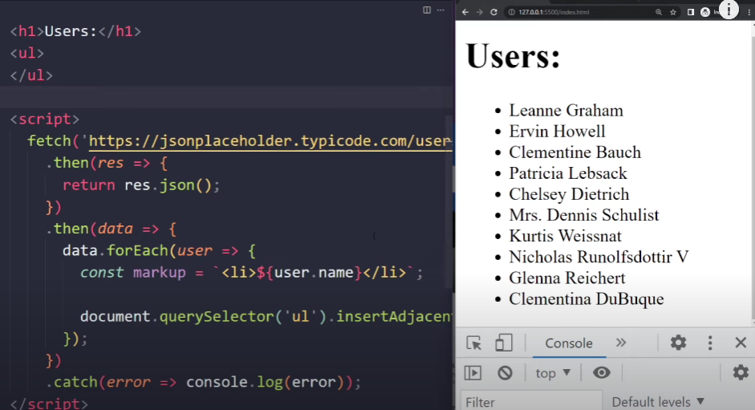

* There should be Notification sender option, through which government employees can send a message to FCI (food corporation of India ) about how much buffer stock is to release. All the previous release records will be saved here.
* The ML model which will predict, how much buffer stock is to be released and when. This will be on this panel.
* There should be 550 government users who will daily upload the price of Agri-horticulture food commodities in an excel sheet. The excel sheet will be connected to our portal for Realtime price.

User Panel: -

There is major 4 features of this panel:

1. They can watch daily prices of food commodities.
2. They can check upcoming weather for their farming activities. ( Api)
3. People can achieve best time to stock food commodities for their home.
4. For users there will be no login system, it will be easily accessible.

Example of price (UI Will look like this)-

Mumbai

Goa

Varanasi

Delhi

Rice

Potato

Grains

Pulses

Language