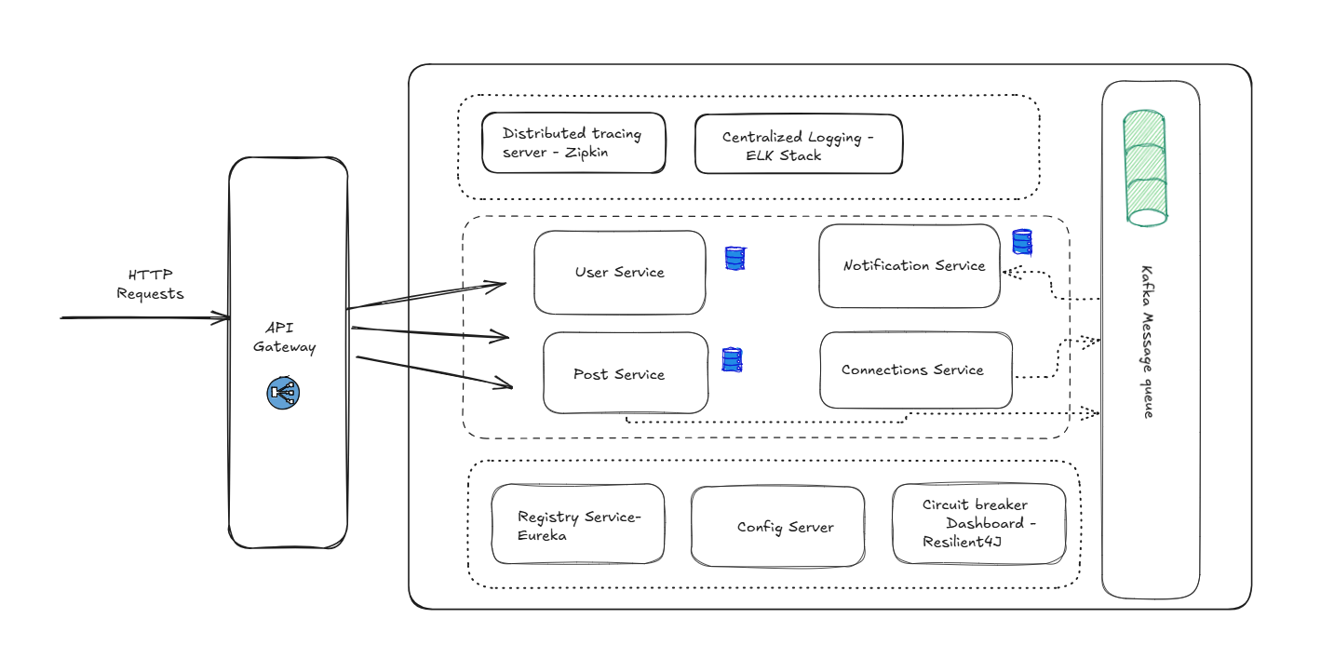

User Service :

POST /auth/signup

POST /auth/login

GET /profile/{userId}

PUT /profile/{userId}

Post Service:

POST /posts

GET /posts/{postId}