Student Performance Prediction System
Project Report — Satyam
Version 1.0.0

Table of Contents
1. Introduction
2. Dataset & Preprocessing
3. Exploratory Data Analysis
4. Statistical Analysis
5. Model Development & Evaluation
6. Explainability (SHAP)
7. Counterfactual Explanations
8. Fairness Audit
9. Cohort Simulator
10. Dashboard & API
11. Deployment
12. Conclusion

1. Introduction
This project builds a machine learning system that predicts student academic performance (High / Medium / Low) from behavioural engagement data collected through a learning management system. The system goes beyond simple prediction to provide:
• SHAP-based explanations of why each prediction was made
• Counterfactual suggestions for how to improve outcomes
• A fairness audit across gender and nationality
• A Monte Carlo cohort simulator for policy-level decisions
We deliberately avoided deep learning — with a dataset of 478 students, tree ensembles generalize better, stay interpretable, and are appropriate for a decision-support tool in an educational setting.

2. Dataset & Preprocessing
Dataset: xAPI-Edu-Data (Amrieh, Hamtini & Aljarah, 2016)
• Rows (original): 480
• Rows (after cleaning): 478
• Duplicates removed: 2
• Target: Class (L/M/H — Low/Medium/High performance)
Preprocessing steps: whitespace trimming, duplicate removal, missing value imputation (median for numeric, mode for categorical), numeric range validation and clipping.

3. Exploratory Data Analysis
See reports/figures/ for the complete set of EDA visualisations. Key findings: high-performing students consistently show higher engagement across all four behavioural metrics (hands raised, resources visited, announcements read, discussion posts). Attendance (StudentAbsenceDays) shows the clearest separation between performance bands.
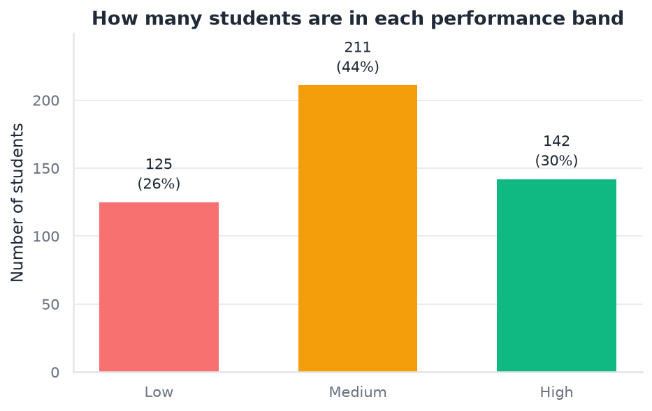
01 Class Distribution
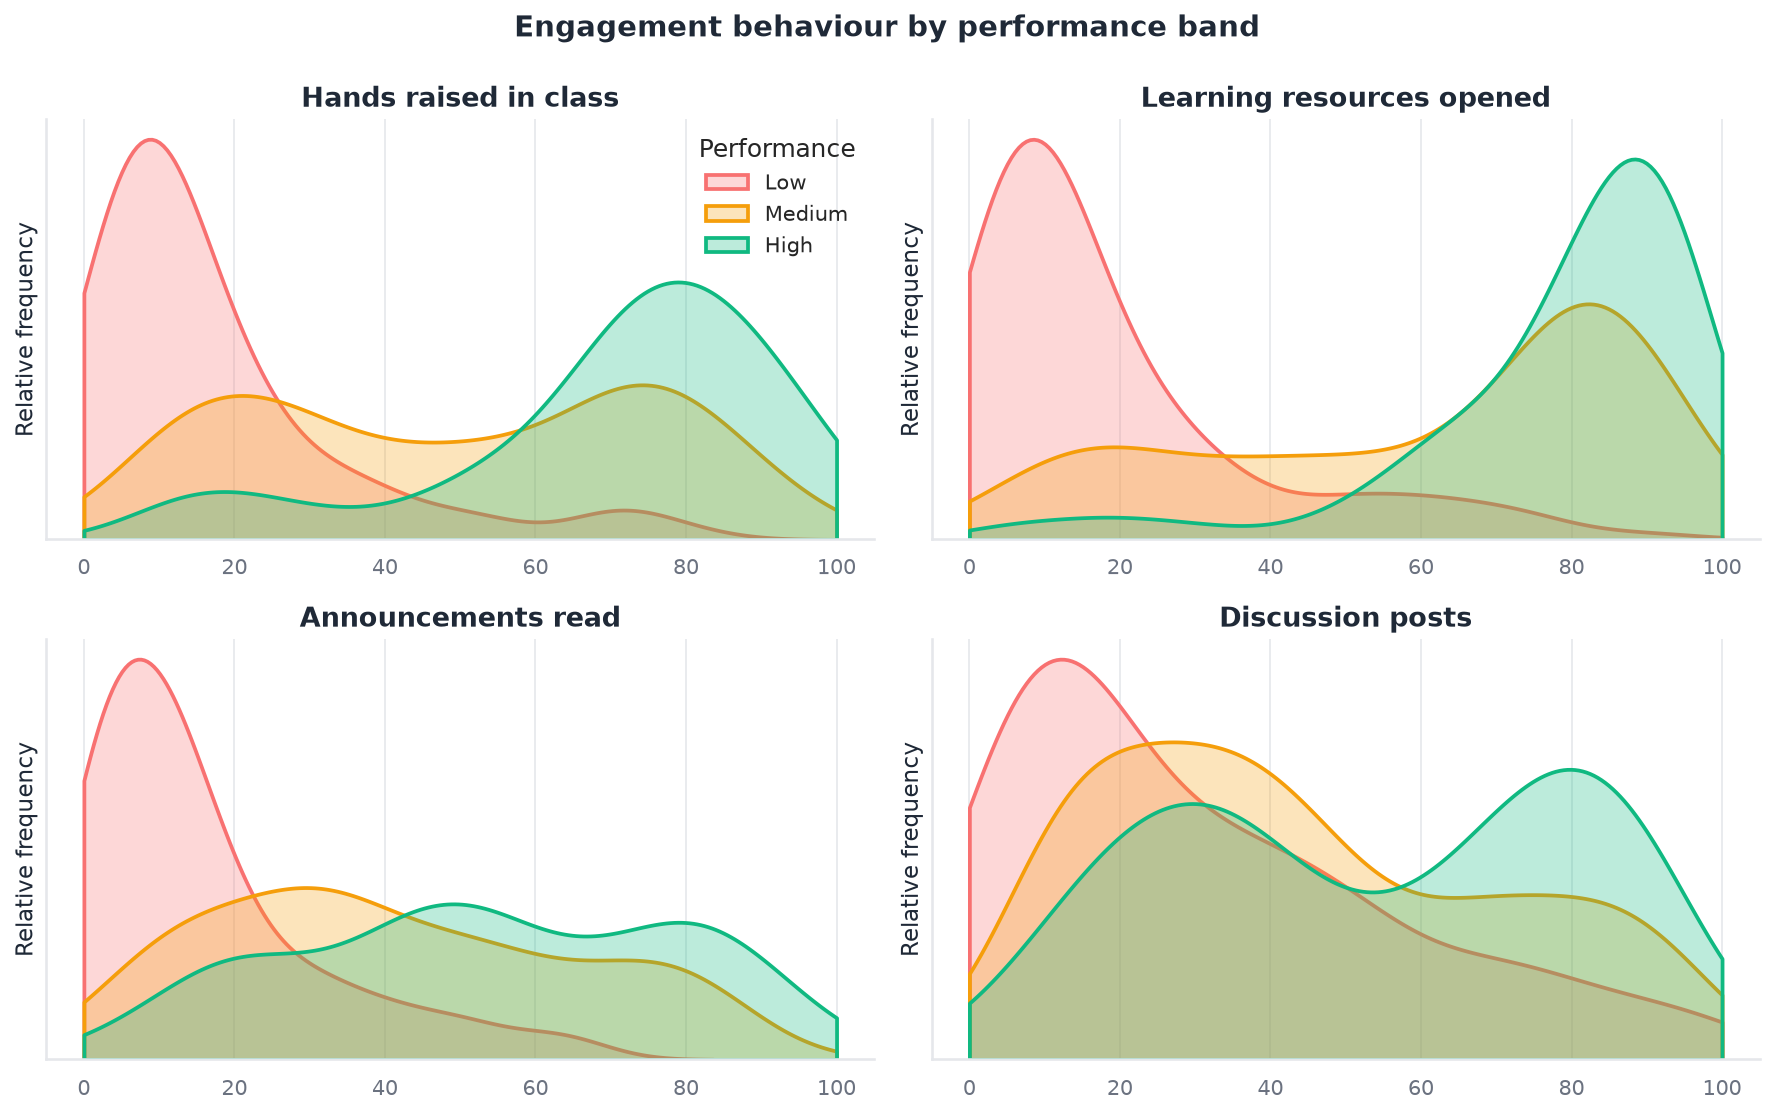
02 Numeric Distributions
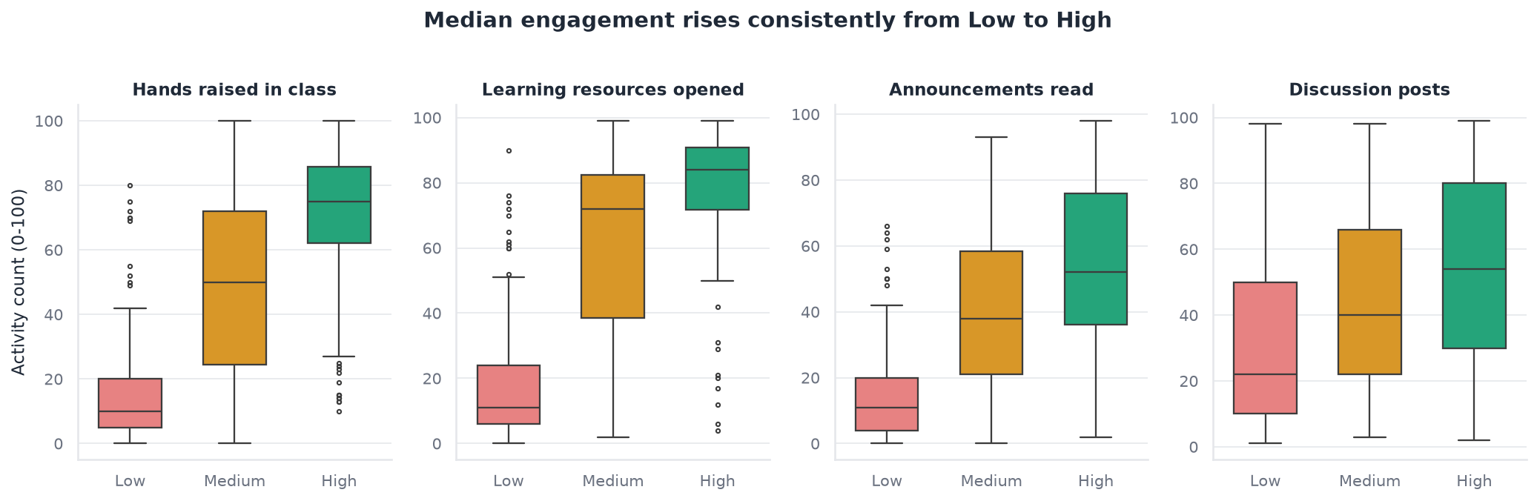
03 Boxplots By Class
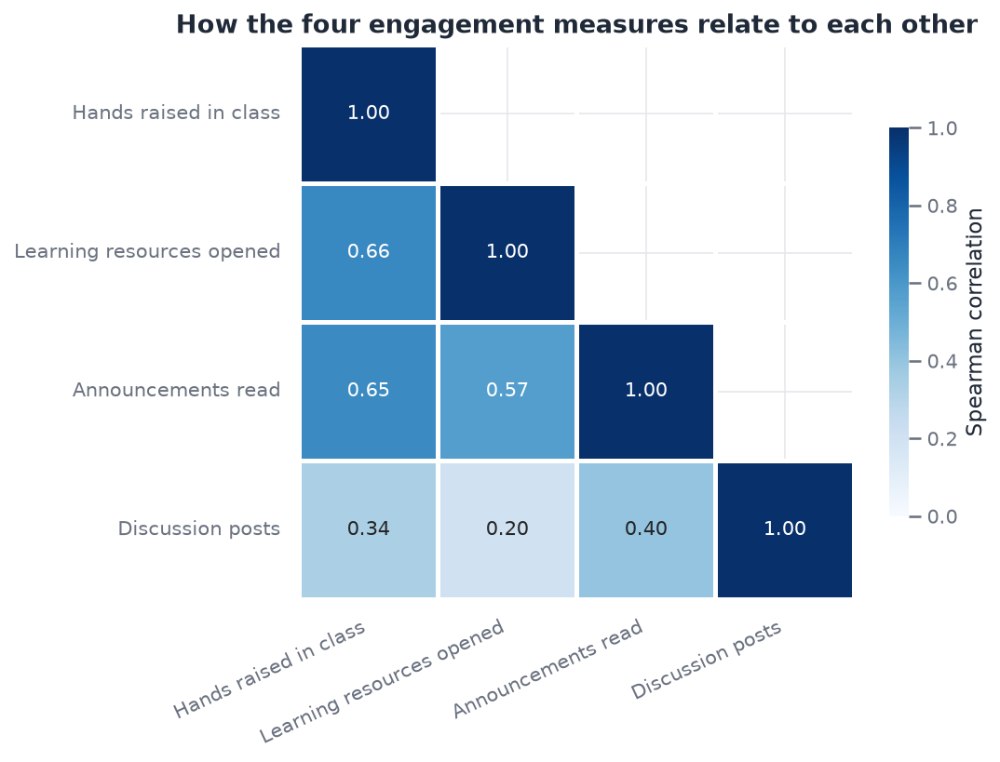
04 Correlation Heatmap
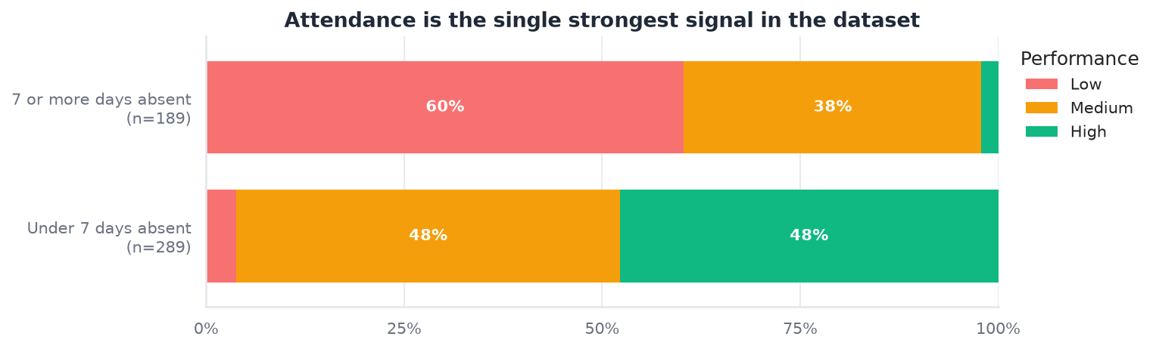
05 Absence Vs Class
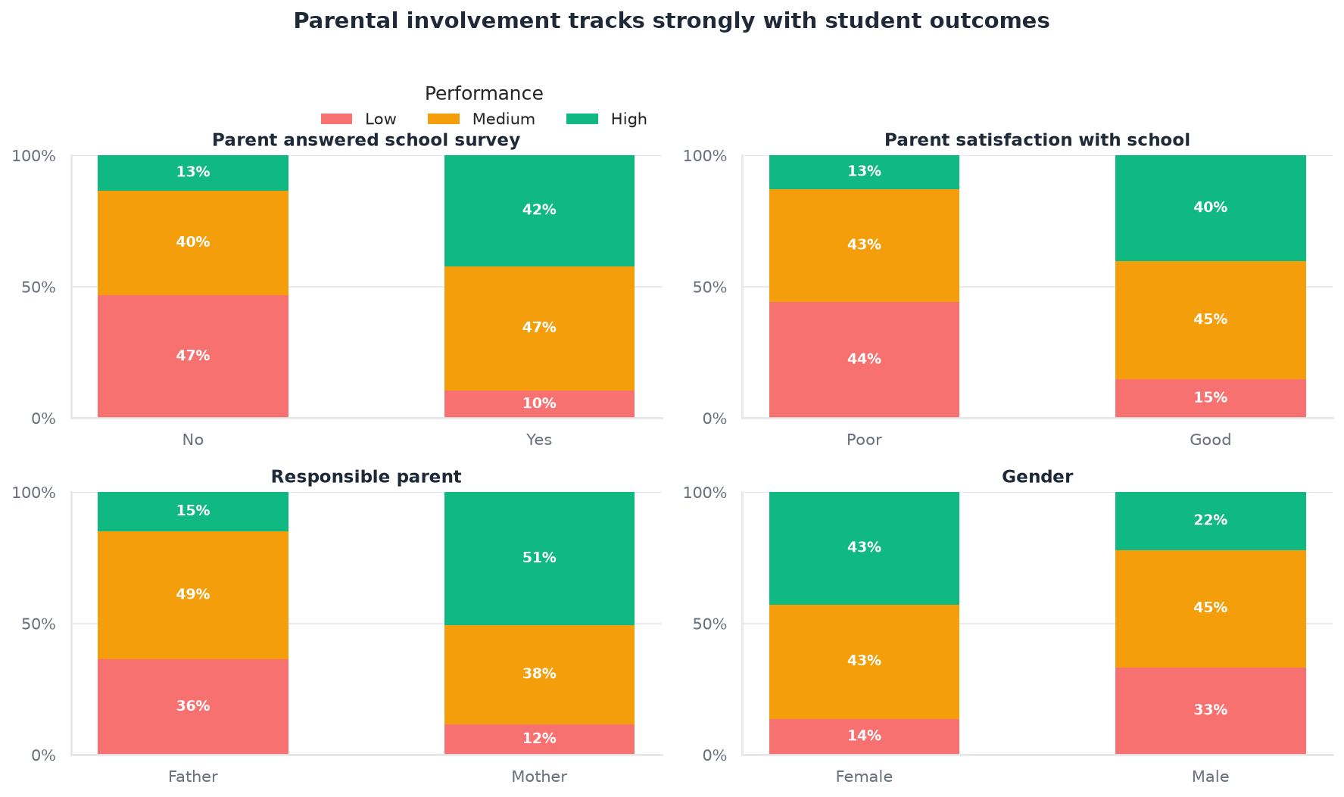
06 Categorical Panel
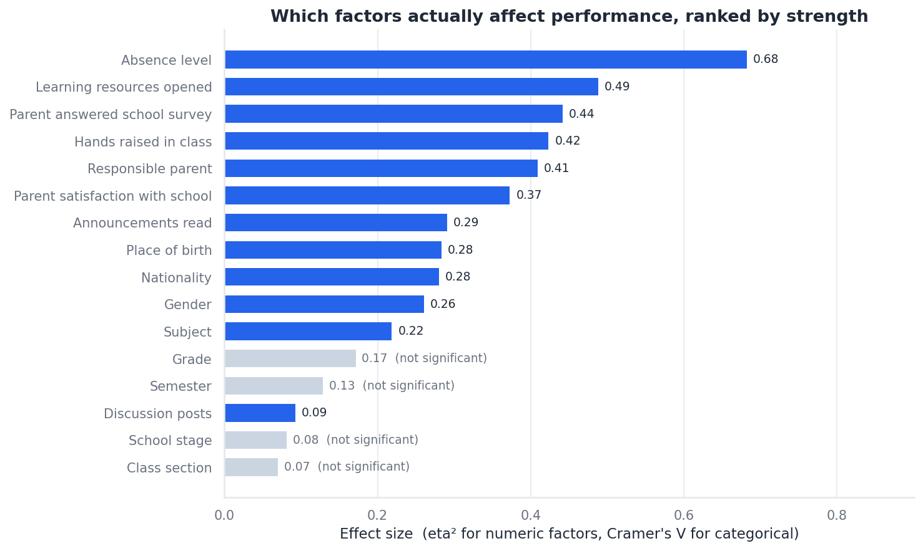
07 Effect Size Ranking
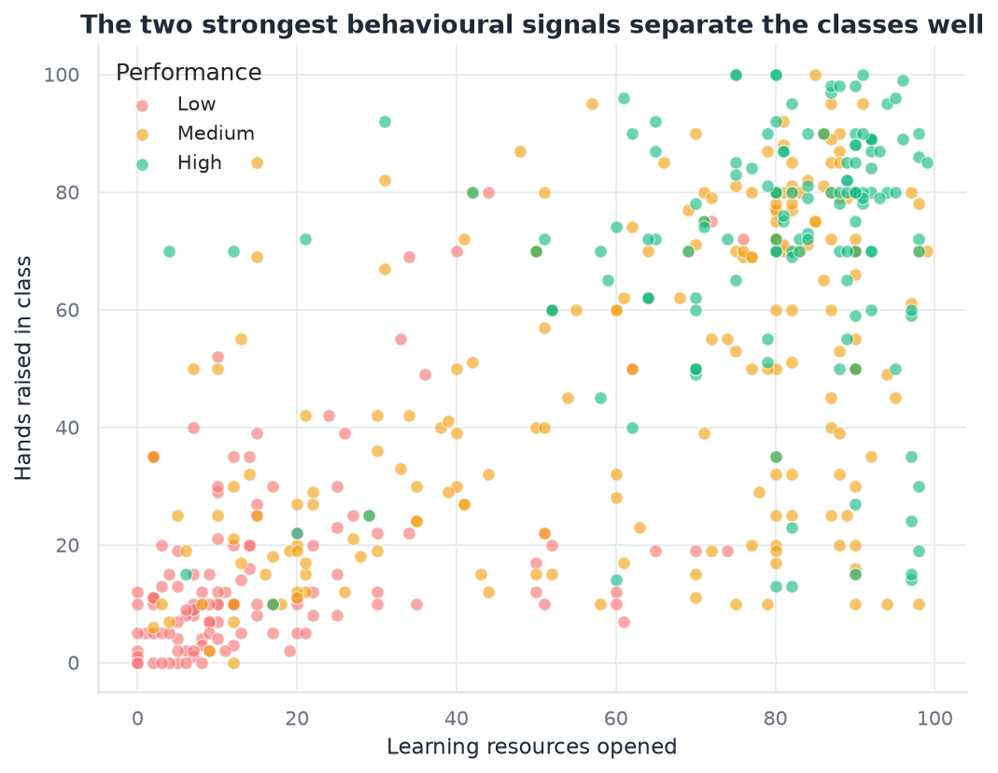
08 Engagement Scatter
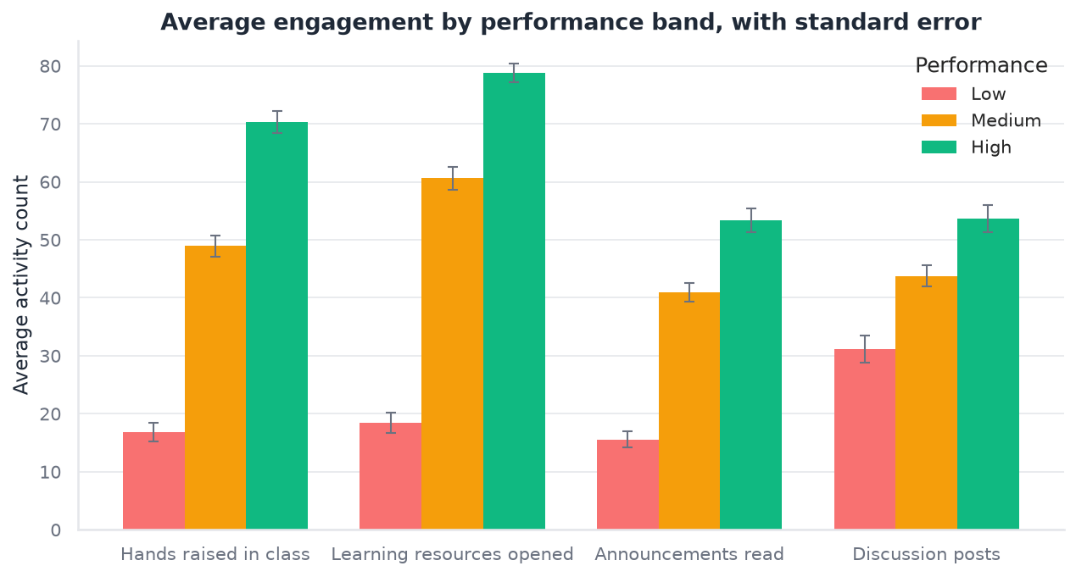
09 Group Means
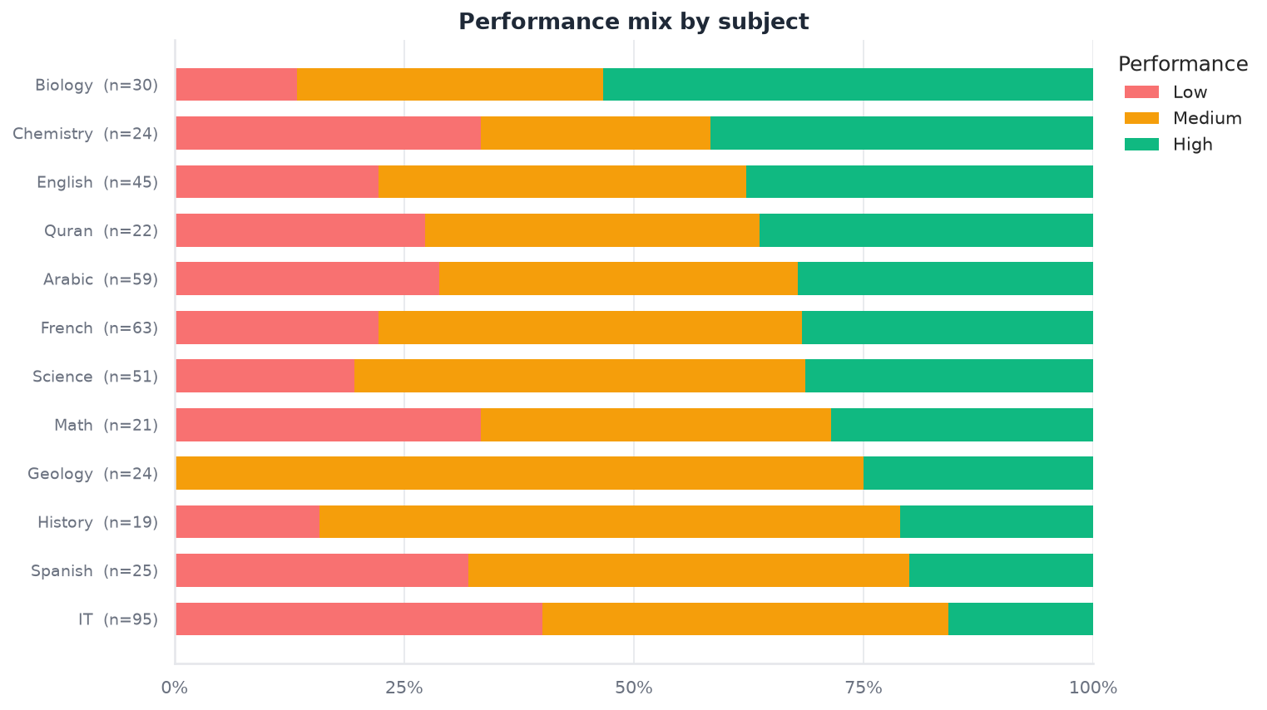
10 Topic Breakdown
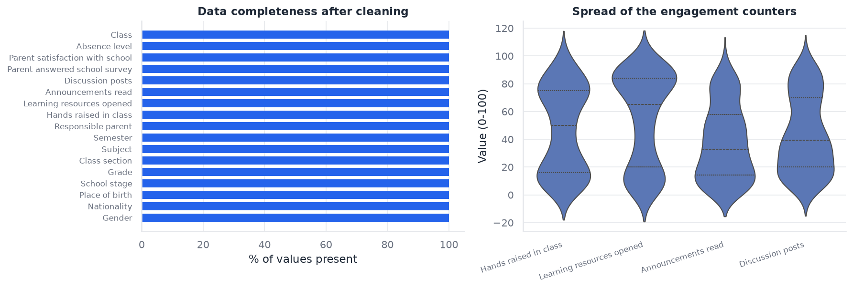
11 Data Quality
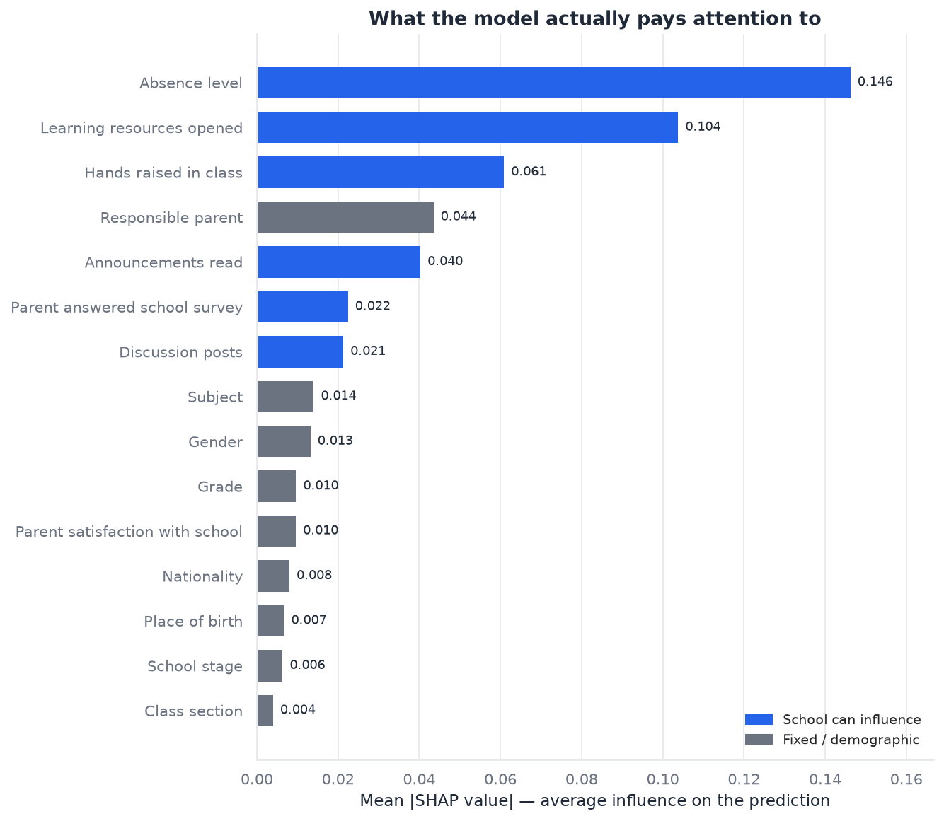
12 Shap Global Importance
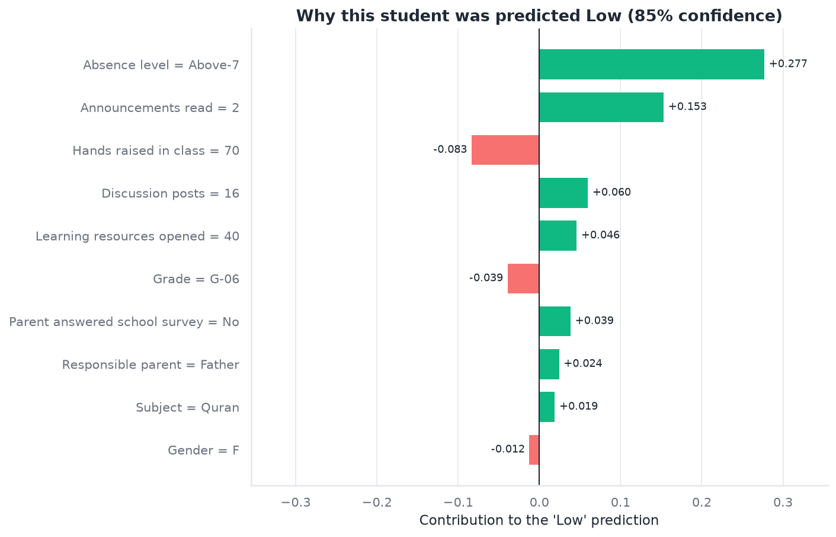
13 Shap Local Example

4. Statistical Analysis
We ran ANOVA for continuous features and chi-square tests for categorical features, with Holm-Bonferroni correction for multiple testing. 12 features showed statistically significant association with performance class.
Feature | Test | p-value | Effect Size
StudentAbsenceDays | Chi-Square | 4.35e-49 | 0.683
VisITedResources | ANOVA | 8.64e-70 | 0.488
ParentAnsweringSurvey | Chi-Square | 5.50e-21 | 0.442
raisedhands | ANOVA | 1.52e-57 | 0.423
Relation | Chi-Square | 3.96e-18 | 0.409
ParentschoolSatisfaction | Chi-Square | 3.66e-15 | 0.373
AnnouncementsView | ANOVA | 3.87e-36 | 0.291
PlaceofBirth | Chi-Square | 6.03e-07 | 0.284
NationalITy | Chi-Square | 1.21e-06 | 0.280
gender | Chi-Square | 9.08e-08 | 0.261

5. Model Development & Evaluation
Models trained: Logistic Regression, Decision Tree, Random Forest, Gradient Boosting (XGBoost).
Best model: random_forest
• Test accuracy: 0.8229
• Test macro-F1: 0.8282
Selection was validated with bootstrapped confidence intervals (2000 resamples) and McNemar's test to confirm the winning model is statistically distinguishable from the runner-up.

6. Explainability (SHAP)
SHAP values provide both global feature importance and per-student local explanations.
See reports/artifacts/ for full results.

7. Counterfactual Explanations
For students predicted Medium or Low, the dice-ml engine identifies the minimal realistic changes that would move them to a higher band.
See reports/artifacts/ for full results.

8. Fairness Audit
Demographic parity and equalized odds were checked across gender and nationality using fairlearn.
See reports/artifacts/ for full results.

9. Cohort Simulator
Monte Carlo simulation models the effect of class-wide interventions on the L/M/H distribution.
See reports/artifacts/ for full results.

10. Dashboard & API
The Streamlit dashboard provides four pages: Overview, Individual Predictor, What-If Simulator, and Cohort Simulator. A FastAPI REST endpoint serves the same model via POST /predict.

11. Deployment
Dashboard: Streamlit Community Cloud
API: Render
CI: GitHub Actions (pytest on every push)

12. Conclusion
This system demonstrates that a rigorous classical ML approach — without deep learning — can deliver a production-quality prediction tool with explainability, fairness auditing, and actionable recommendations. The key differentiators are statistical rigor (bootstrapped CIs, McNemar's test), counterfactual explanations, and the cohort simulator for policy-level decisions.

