Algorithm Trading

MINI PROJECT - 1

SYNOPSIS



Department of Computer Science & Application

**Institute of Engineering & Technology**

SUBMITTED TO: - SUBMITTED BY:-

Ruchi Talwar Akshat Maan Singh

Satyam Singh

Supra Vyas

Akhil jaiswal

Acknowledgement

It gives us a great sense of pleasure to present the synopsis of the B.Tech mini project undertaken during B.Tech III Year. This project is going to be an acknowledgement to the inspiration, drive and technical assistance will be contributed to it by many individuals. We owe special debt of gratitude to Mrs. Ruchi Talwar, Technical Trainer , for providing us with an encouraging platform to develop this project, which thus helped us in shaping our abilities towards a constructive goal and for his constant support and guidance to our work.

His sincerity, thoroughness and perseverance has been a constant source of inspiration for us. We believe that he will shower us with all his extensively experienced ideas and insightful comments at different stages of the project & also taught us about the latest industry-oriented technologies. We also do not like to miss the opportunity to acknowledge the contribution of all faculty members of the department for their kind guidance and co-operation.

Akshat Maan Singh

Satyam Singh

Supra Vyas

Akhil Jaiswal

Abstract

In Stock Market Prediction, the aim is to predict the future value of the financial stocks of a company. The recent trend in stock market prediction technologies is the use of machine learning which makes predictions based on the values of current stock market indices by training on their previous values. Machine learning itself employs different models to make prediction easier and authentic. The project focuses on the use of Regression and LSTM based Machine learning to predict stock values. Factors considered are open, close, low, high and volume.

Contents

Acknowledgement

Abstract

Declaration

1. Introduction

1.1 Objective

1.2 Motivation

1.3 Problem Statement

2. Software Requirement

2.1 Hardware Requirement

2.2 Software Requirement

3. Project Description

4. Working

5. Implementation

6. References

INTRODUCTION

Technology and investment are the most interesting domains for people across the world. Everyone wants to get a degree in the technical domain and get a job as well as earn side income. Trading is one of the best ways to earn a lot of money even without investing much time and money. Nowadays, trading is one of the most competitive domains, and with machine learning algorithms, it has become a new wonder weapon for everything across the globe. ***Machine learning has a crucial role in trading as it extracts signals from financial and alternative data to design and backtest systematic strategies.*** In this topic, we will discuss various key aspects related to trading and how Machine learning can be used for trading, along with the advantages of using ML for Trading.

SOFTWARE AND HARDWARE REQUIREMENTS

* Intel i3 core processor
* 4GB RAM
* 20 GB disk(ssd preferable)
* Windows 10
* Python and its libraries

PROJECT DESCRIPTION

The purpose of this project is to make the traders work easier to determine the next prediction of trading. There are many algorithms in machine learning which helps to determine the prediction. Machine Learning algorithms can spot patterns in large volumes of data.They are used to find associations in historical data that can be applied to algorithmic trading strategies.

We will implement this by using the language python. We use python for this because python is easy to read and understand. Less coding compared to other languages because of comprehensive libraries . So less coding, more trading.It’s an interpreted language that executes the code statements, constructing a comprehensive debugging. Besides, the single error execution speeds up the entire construction process.It also

has incredible computing power to subsidise your portfolio and scalability. Asides, fixing a new module in Python and making it extensive is more straightforward than any other language.It has an extensive support library consisting of the most popular programming language tasks within them in a simplistic method.

In this project we will use some machine learning algorithms to implement this project like LSTM etc.

This will helpful for the:-

* Traders:-This will help them to analyse the result of the upcoming traders , like the graph will go up or down. It also helps for the stock prediction to predict the future price of the particular company stock as it takes the past database of the company and take some features form the features, through that features it helps to determine the future prediction of the stock or trade

Working

In this we have used some libraries to implement algorithmic trading. We have used the library Metatrade5, matplotlib, numpy, and pandas . Then we take the dataset from the yahoo finance of a particular company and then the dataset will be of 10-15 years . Here we have created and backtested an SMA(Simple Moving Average)Trading strategy. It is an average price for a particular time. We have used linear regression, LSMA etc models to implement my project.

We will first import the dataset which is in the form of a csv file through the read function. Then will import the date time, pandas, numpy ,MetaTrade5 etc libraries to implement the model. Then we will calculate SMA and there will be a condition that if short period > long period then we will buy the stock otherwise if short period is less than long period then we will sell it.Then we will get the output of our project through which we could get that we should buy or sell it.

Implementation

We have used the language python as it is easy to read and understand.In this less coding is required and the comprehensive libraries are there which helps to implement the python and make it easy to code and saves time. We have used the libraries pandas , numpy, matplotlib and some more libraries. We also use the SMA to calculate the stocks and LSMA model , linear regression, KNN model etc to implement the Algorithmic Trading project.We have taken the dataset of any particular company of 10-15 years and through that dataset we will predict the algorithmic trading. The dataset will be in a csv file . We have used 5-6 algorithms to implement algorithmic trading.

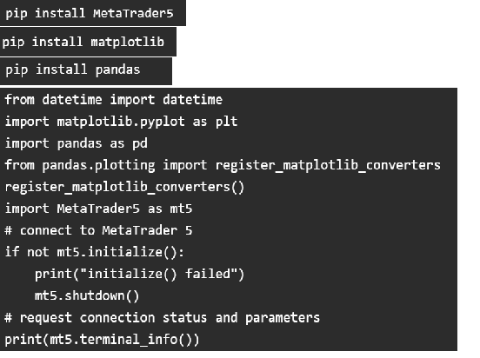

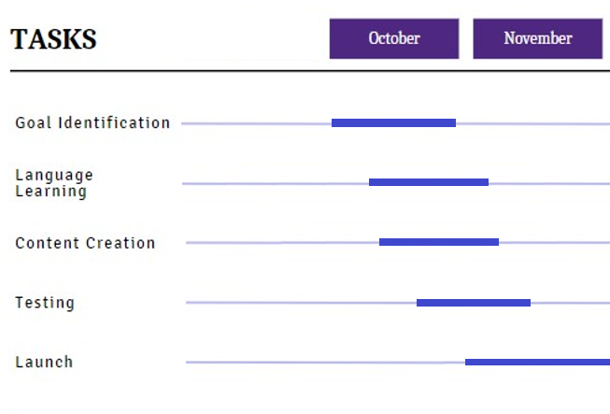

References

Books:

* Python

Python Crash Course:A Hands-On

* Machine Learning

Hands-On ML with Scikit -Learn, Keras & TensorFlow

Lluís A. Belanche Muñoz

Websites:

* [www.kaggle.com](http://www.kaggle.com)
* [www.w3school.com](http://www.w3school.com)
* [www.google.com](http://www.google.com)
* [www.projectdeveloper.com](http://www.projectdeveloper.com)
* [www.finance.yahoo.com](http://www.finance.yahoo.com)

Faculty Guidelines:

Mrs. Ruchi Talwar(Technical Trainer in GLA University)

Github Repository Link:

* <https://github.com/Akshatm312/Mini-Project.git>
* <https://github.com/satyamsingh831792222222222222/Mini-project.git>
* <https://github.com/SupraVyas/mini-project.git>