Experiment: Implementation of NOT, AND, OR Gates using NAND Gates
HDL Simulation Record

1. Aim
To implement the basic logic gates NOT, AND, and OR using only 2-input NAND gates in a Hardware Description Language (HDL), to draw the equivalent logic (schematic) diagram for each derived gate, to write the corresponding Boolean expression, and to verify functional correctness by running a test-bench script and capturing the simulation output.

2. Schematic Diagram
Every gate below is built exclusively from 2-input NAND gates (NAND being a universal gate). The diagrams were drawn as logic schematics in the style of Lucidchart, showing gate symbols, signal names, and interconnecting wires.
2.1 NOT Gate from NAND
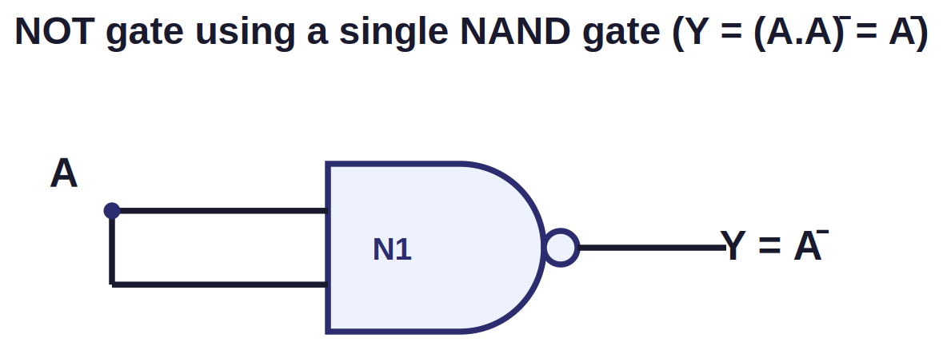
Fig. 1 — NOT gate realised using a single NAND gate (inputs shorted together)
Boolean Expression: Y = (A . A)' = A'

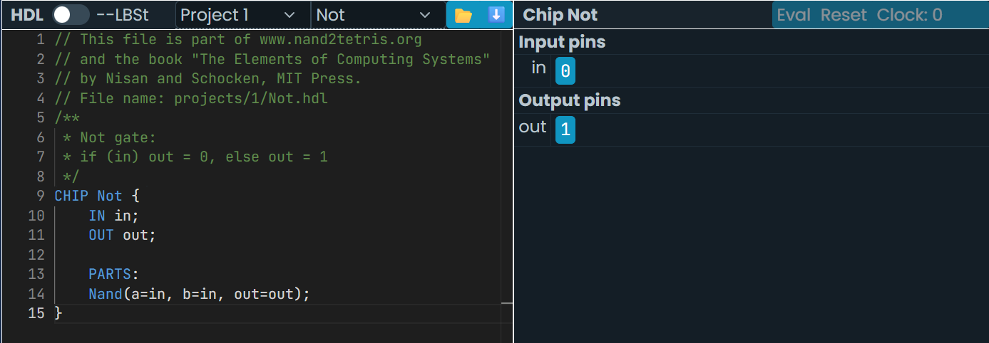

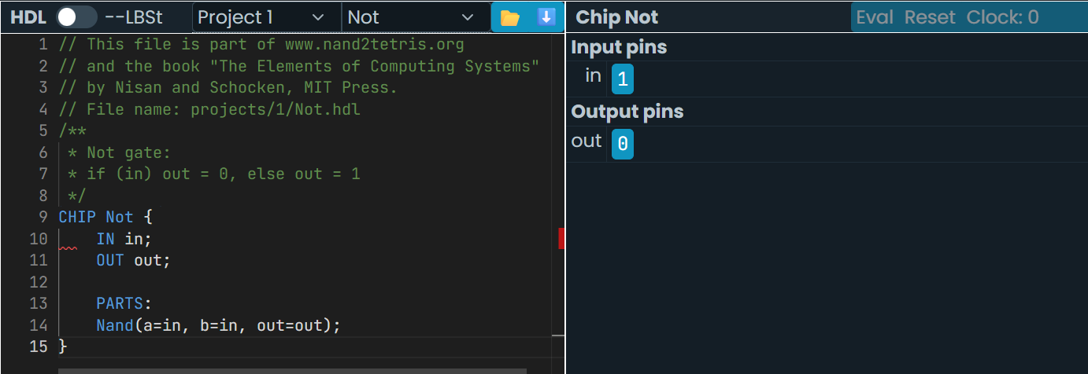
2.2 AND Gate from NAND
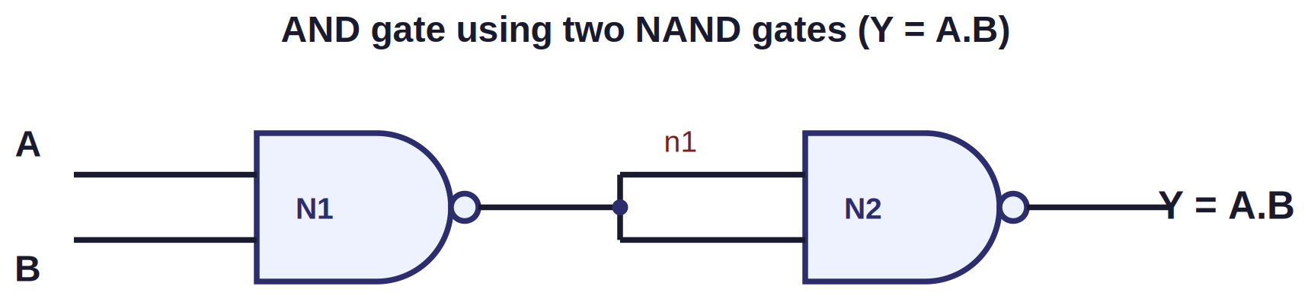
Fig. 2 — AND gate realised using two NAND gates (2nd NAND used as inverter)
Boolean Expression: n1 = (A.B)' , Y = (n1 . n1)' = A.B

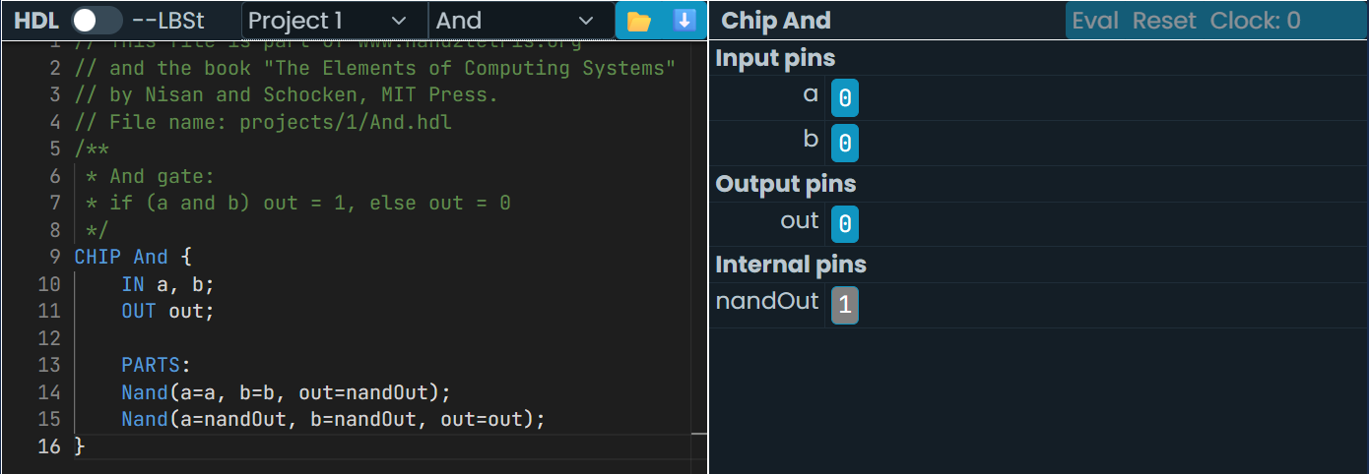

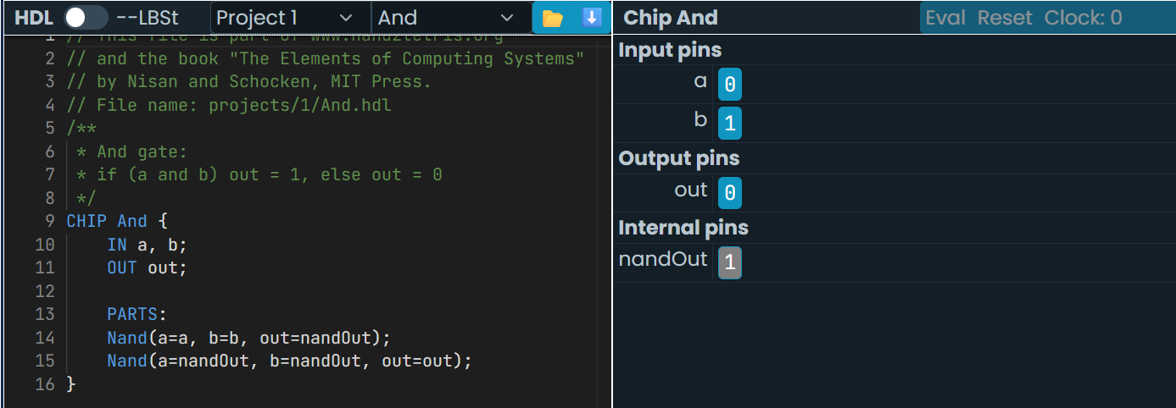

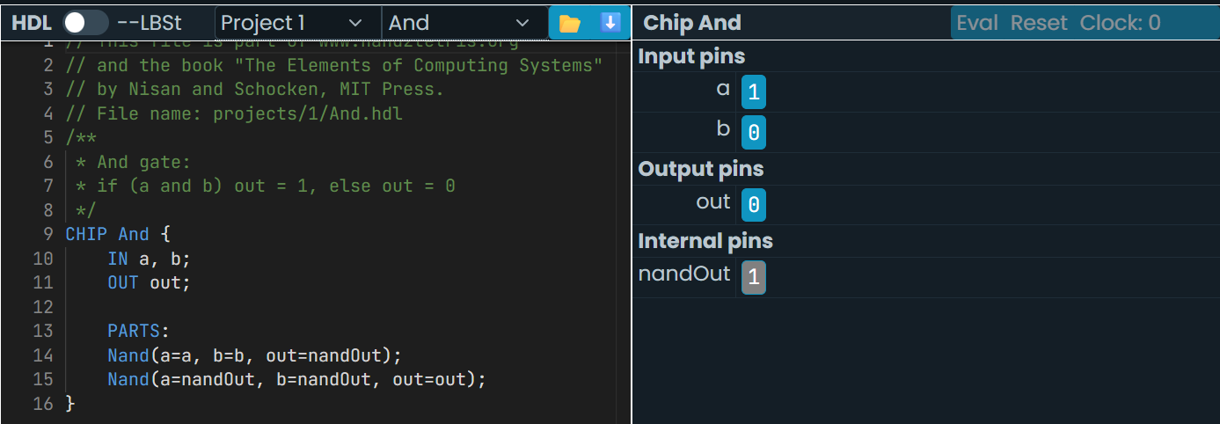

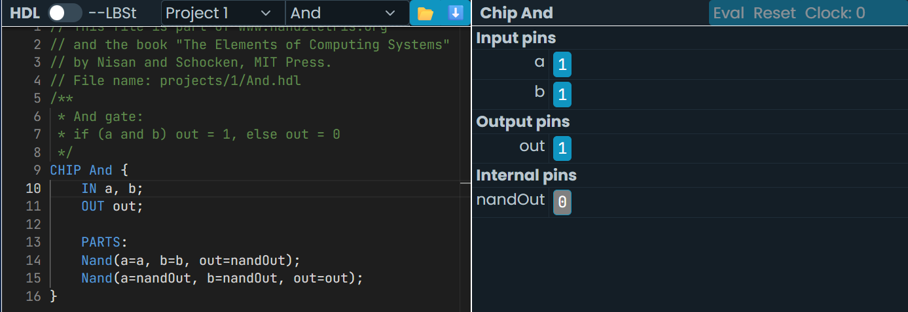

2.3 OR Gate from NAND

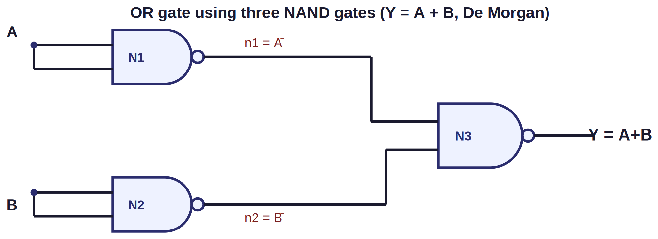
Fig. 3 — OR gate realised using three NAND gates (De Morgan's theorem)
Boolean Expression: n1 = A' , n2 = B' , Y = (n1 . n2)' = (A'.B')' = A + B

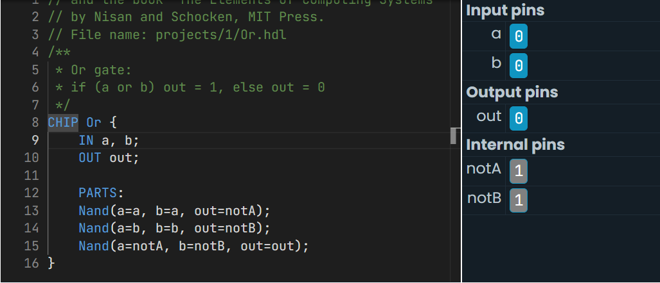

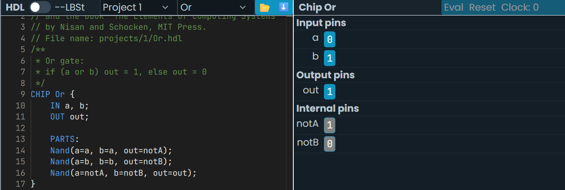

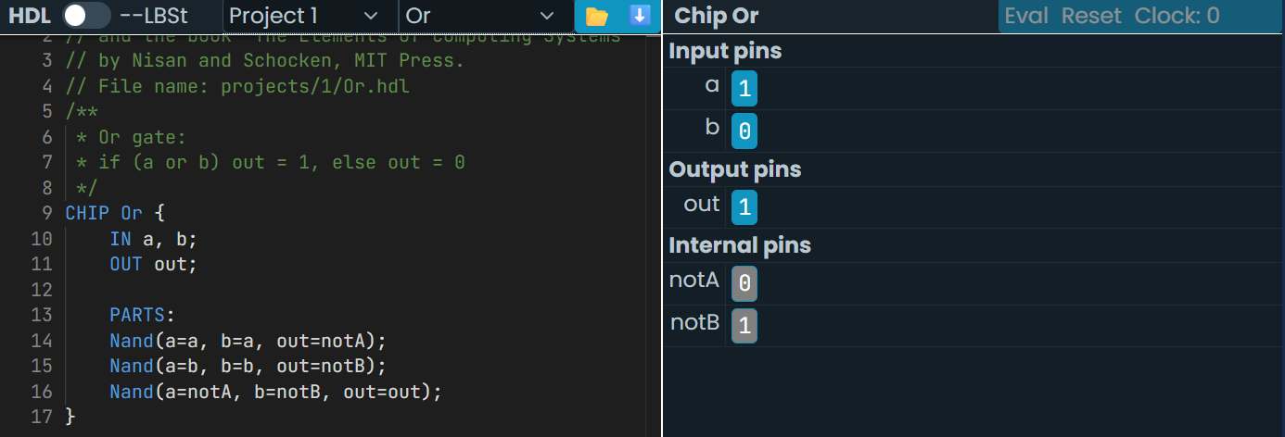

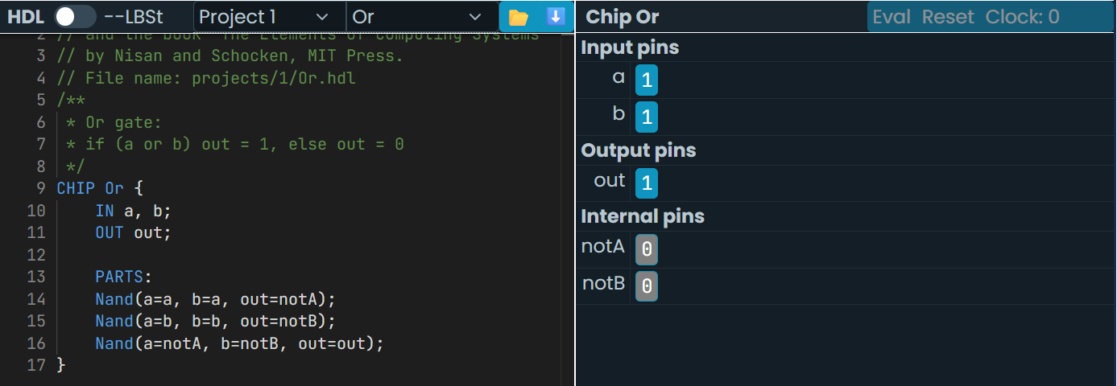

4.2 Truth Tables
NOT gate:
A | Y = A'
0 | 1
1 | 0

AND gate:
A | B | Y = A.B
0 | 0 | 0
0 | 1 | 0
1 | 0 | 0
1 | 1 | 1

OR gate:
A | B | Y = A+B
0 | 0 | 0
0 | 1 | 1
1 | 0 | 1
1 | 1 | 1

Result
The NOT, AND, and OR gates were successfully implemented in HDL using only NAND gates. The simulation output obtained matches the expected truth table of each gate, thereby verifying that the NAND gate is a universal gate capable of realising all basic logic functions.

