Name: Satyam Tiwari

RegNo:22BCE1921

Collage: VIT Chennai

Project Name: Grocery Delivery App (Backend)

Checking Login credential for Delivery Partner using email and password:

Method:POST

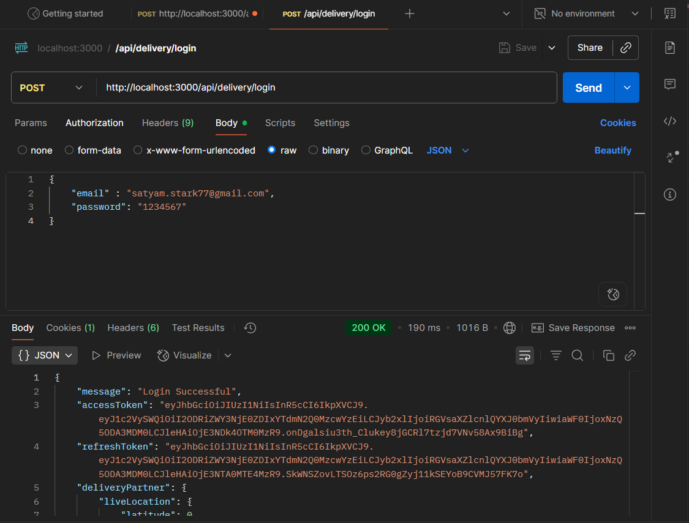

Checking the credential for the Customer using there phone Number and then allowing them to login:

Method:POST

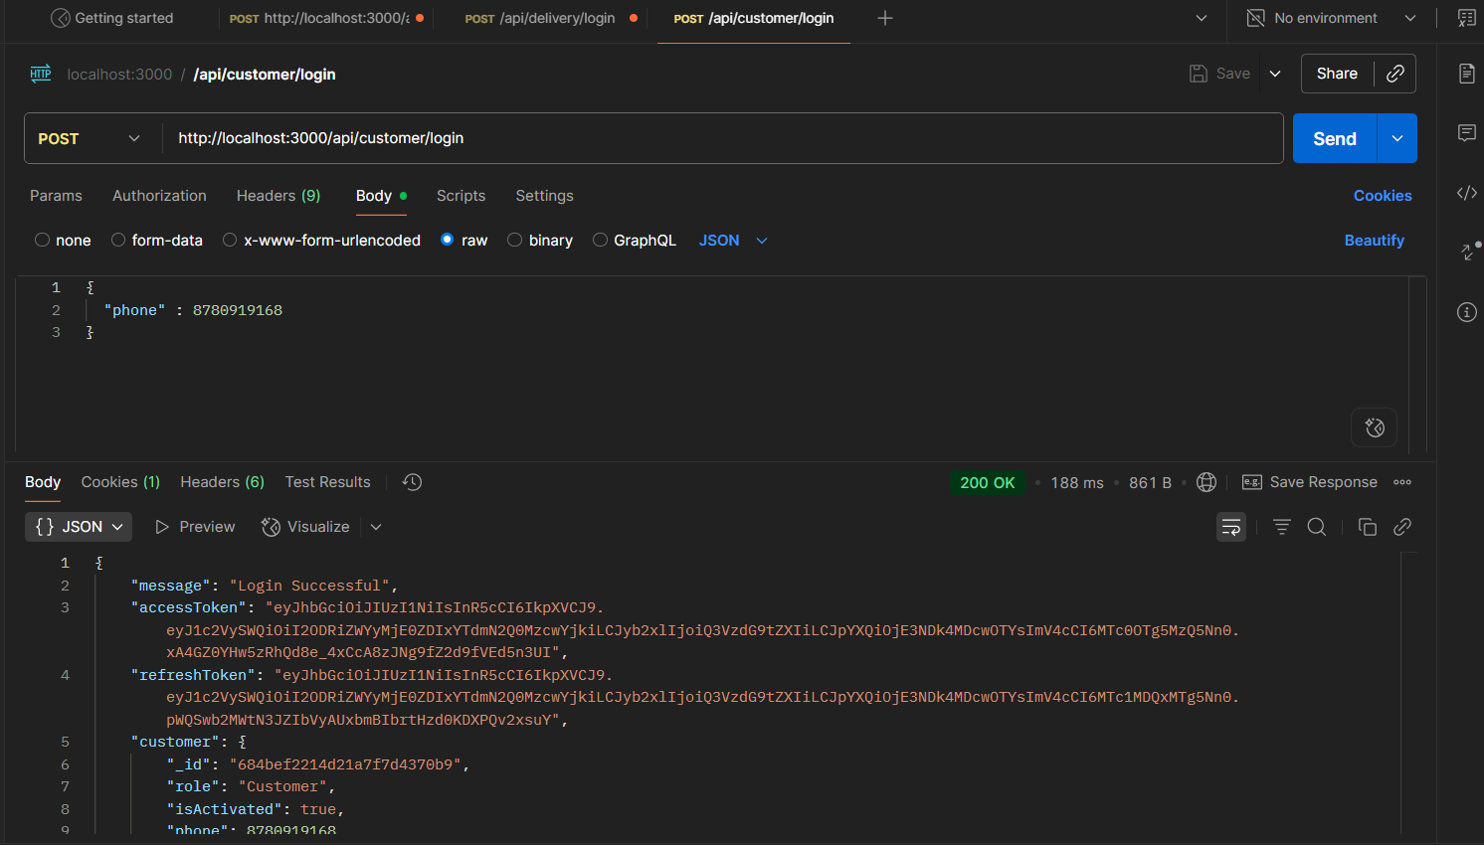

Fetching the Category Information:

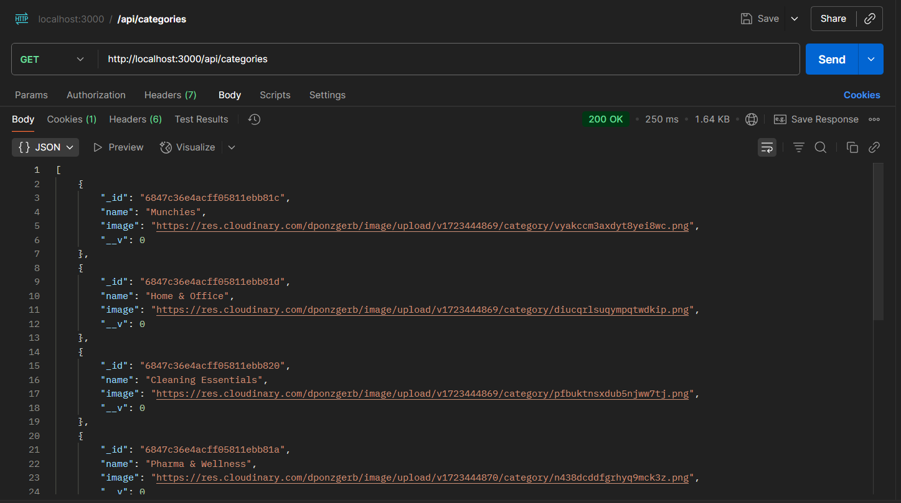

Fetching User Information by providing user_Id , role, and also the access Token because there is the middleware:

Method:GET

1. Fetching Delivery Partner Info

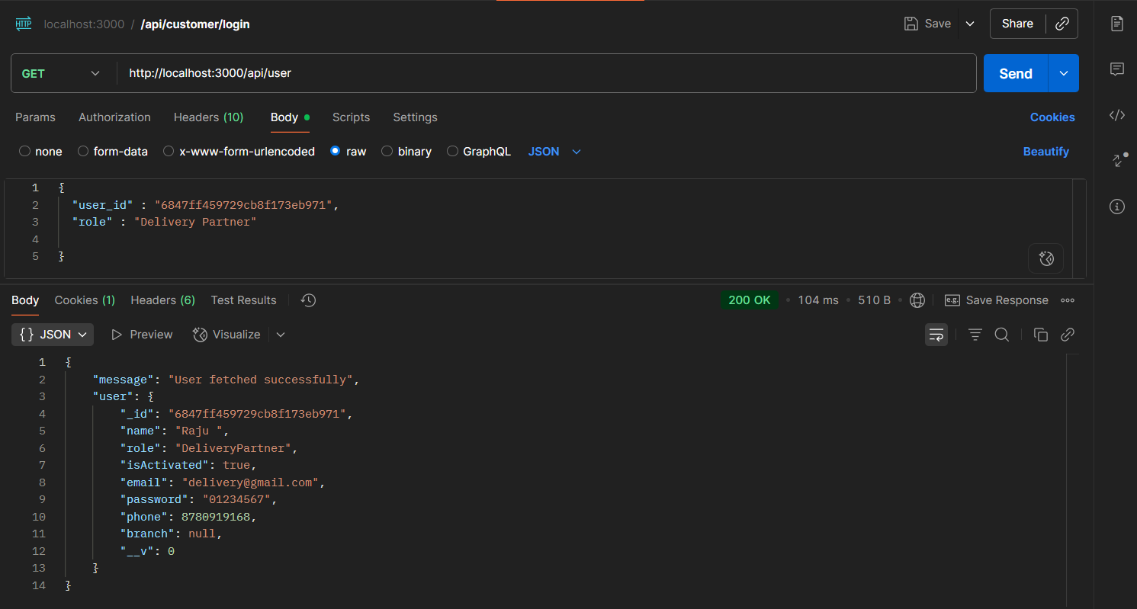

1. 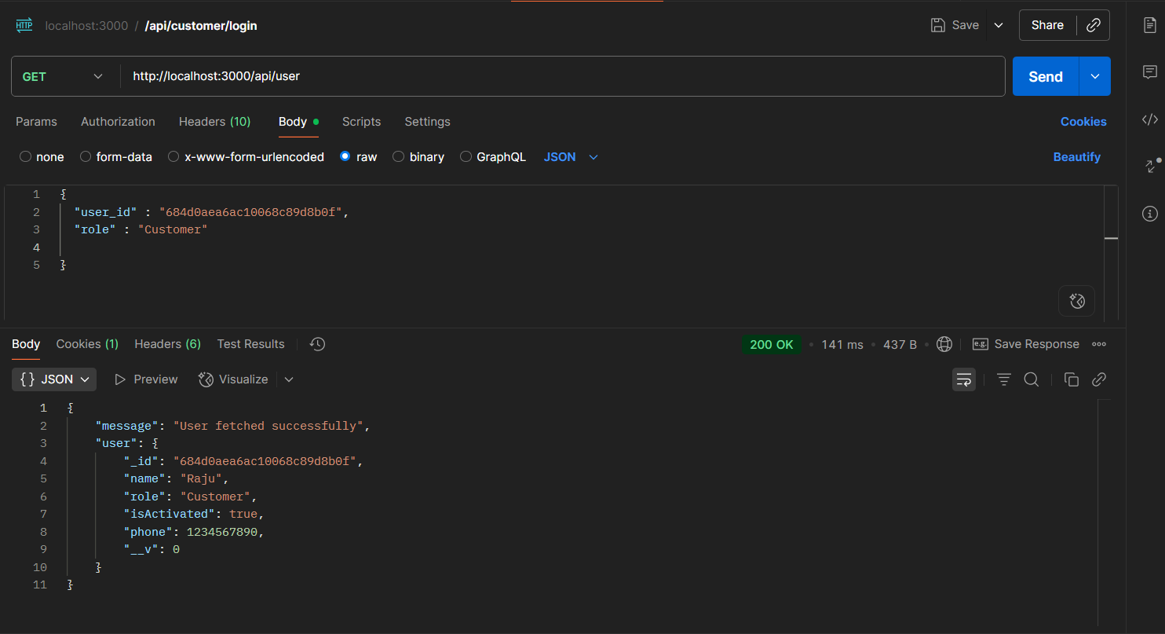Fetching the user info

Update the User:  
Method: PATCH

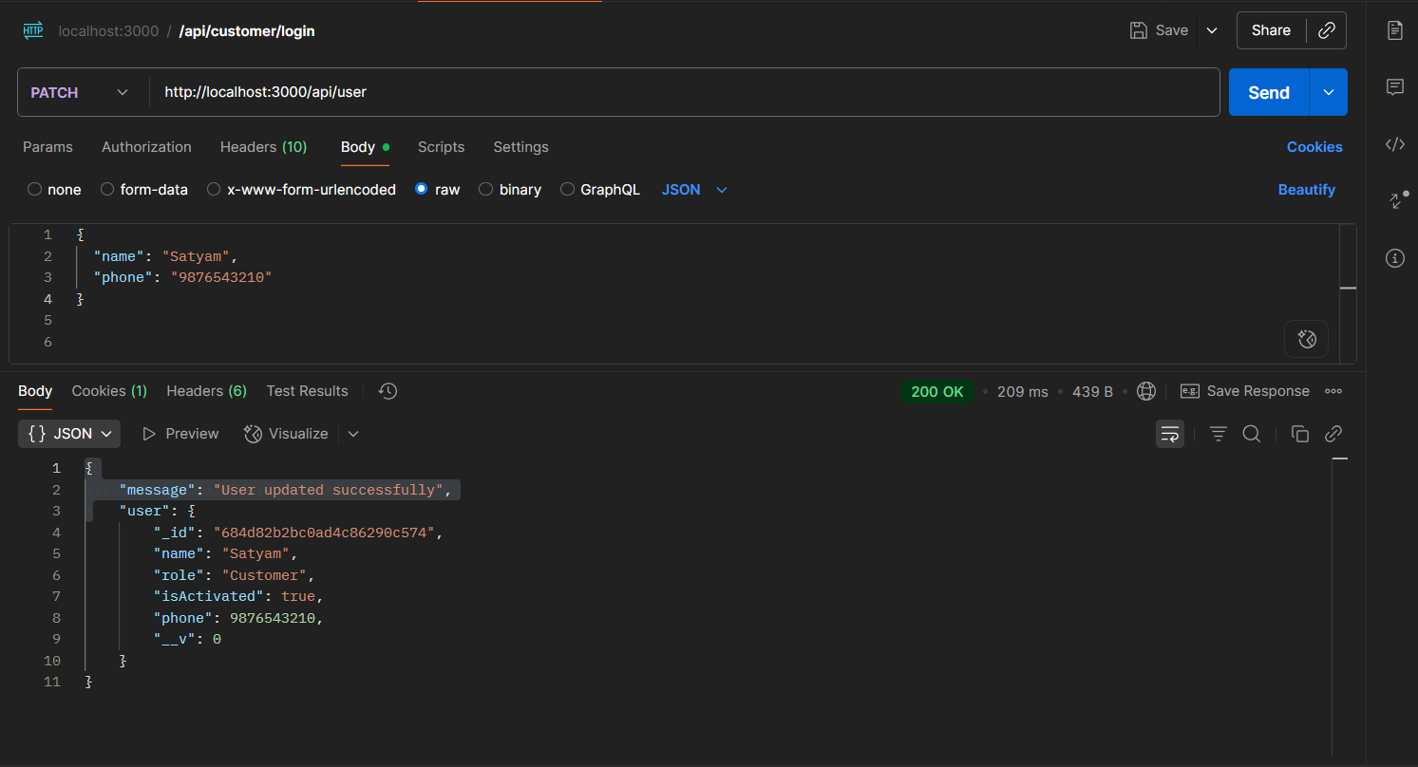

MongoDB Atlas:

Customer Collections:

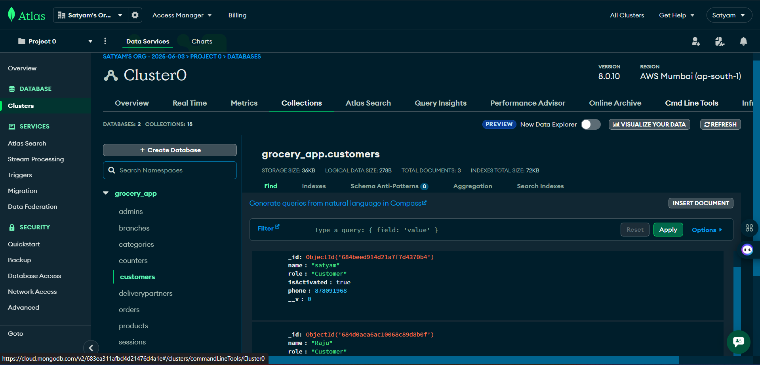

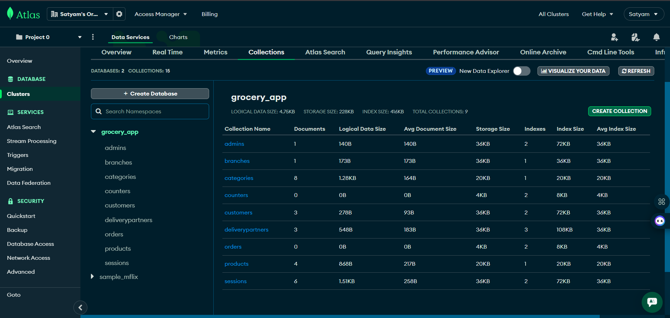

DeliveryPartner Collections:

