Voice-Based Stress Detection from Paralinguistic Features

A Project Report

Submitted by

Satyanarayan Baral – 240301130374

Dinesh Kumar Pandab - 240301120376

Indrajit Majhi – 240301120402

Abhijit Behera – 240301120469



1. Introduction
Human speech carries two layers of information: the words that are said, and the way they are said. The second layer, known as the paralinguistic layer, includes pitch, loudness, speaking rate and voice quality. When a person is tense or anxious, this layer changes even if the words stay the same.
This project builds a deep learning system that classifies a voice clip as Calm or Stressed using only paralinguistic acoustic features. The spoken words are never transcribed or used. The work completed so far covers the full pipeline, from preparing the dataset to a working demo model with a web interface, and this report describes that workflow.

2. Problem Statement
To design and implement a deep learning model that classifies a speaker's state as Calm or Stressed using only paralinguistic voice features (MFCCs, pitch and energy), without using the spoken content, and to compare how different neural network architectures perform on this task.

3. Objectives
- To label a speech dataset into two classes, Calm and Stressed.
- To extract paralinguistic features from raw audio using the librosa library.
- To build and train three deep learning models: a Dense network, an LSTM and a CNN with pooling layers.
- To train the models using gradient descent (Adam optimizer) with activation functions, and to visualise the learning process.
- To compare the models using accuracy, precision, recall, F1-score and confusion matrices on unseen speakers.
- To build a web application where a user can record or upload speech and view the predicted stress level.

4. Dataset
The project uses the RAVDESS speech audio dataset (Ryerson Audio-Visual Database of Emotional Speech and Song). The audio is stored in folders named Actor_01 to Actor_24, one folder per professional actor. Each filename encodes the recording details in seven numbers, for example 03-01-06-01-02-01-12.wav.
Position | Meaning | Codes used in this project
1 | Modality | 03 = audio only
2 | Vocal channel | 01 = speech (songs are excluded)
3 | Emotion | 01 neutral, 02 calm, 05 angry, 06 fearful
4 | Intensity | 01 normal, 02 strong
5 | Statement | 01 or 02
6 | Repetition | 01 or 02
7 | Actor | 01 to 24

The emotions were grouped into the two project classes as follows: Calm consists of neutral and calm clips, and Stressed consists of angry and fearful clips. The remaining emotions (happy, sad, disgust and surprised) were left out to keep a clean two-class problem. This gives 288 Calm clips and 384 Stressed clips, so the classes are slightly imbalanced and class weights are used during training.

5. Overall Workflow
The project follows the pipeline below. Each stage takes the output of the previous one.
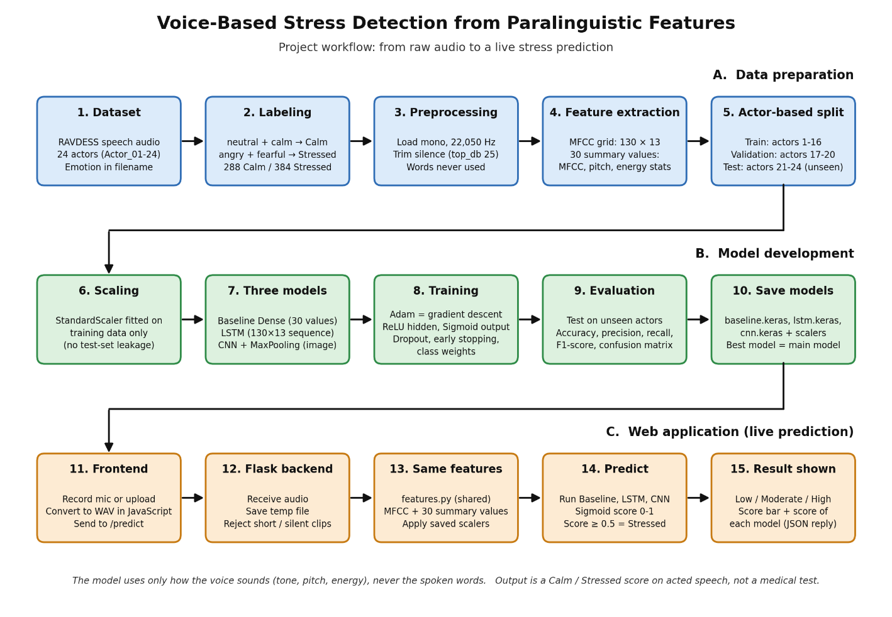
Stage | Process | Output
1. Data labeling | Read filenames, map emotion codes to Calm or Stressed | labels.csv
2. Feature extraction | Trim silence, extract MFCC, pitch and energy | Feature arrays (.npy)
3. Data splitting | Split by actor into train, validation and test; scale features | dataset.npz, scalers
4. Model training | Train Dense, LSTM and CNN models with Adam | Saved models
5. Evaluation | Compute metrics and confusion matrices on test actors | Results table, plots
6. Demo model | Flask backend and web frontend for recording and prediction | Working web app

6. Phase-wise Description

6.1 Data labeling
A script walks through all actor folders, reads each filename, extracts the emotion code and speech channel, and maps the code to the Calm or Stressed label. The actor number is also stored, because it is needed later for the split. The output is a table (labels.csv) with the file path, actor, emotion and label of every clip.

6.2 Feature extraction
Each clip is loaded at a 22,050 Hz sampling rate and leading and trailing silence is removed. Two kinds of features are then computed with librosa:
- Sequence features: 13 MFCCs (Mel-Frequency Cepstral Coefficients) over 130 time frames, giving a 130 by 13 grid. Shorter clips are zero-padded and longer clips are cut. This grid is used by the LSTM and the CNN.
- Aggregated features: summary statistics per clip, namely the mean and standard deviation of each MFCC, the mean and variation of pitch (fundamental frequency) and the mean and variation of energy (RMS). This vector is used by the baseline Dense network.
The same feature extraction code is shared by the training scripts and the web application, so that a clip is prepared identically during training and during prediction. At no stage is the audio converted to text.

6.3 Train, validation and test split
The data is split by actor instead of randomly. Actors 1 to 16 are used for training, actors 17 to 20 for validation and actors 21 to 24 for testing. A random split would place different clips of the same actor in both training and test sets, and the model could then score well by recognising the actor's voice. Splitting by actor means the test voices are completely unseen, so the reported accuracy is more honest. Feature scalers are fitted on the training data only, so no information from the test set leaks into training.

6.4 Model development
Three models were built so that their performance could be compared.
Model | Input | Architecture | Purpose
Baseline | 30 aggregated features | Dense layers with ReLU and Dropout, Sigmoid output | Reference model without time information
LSTM | 130 x 13 MFCC sequence | Two LSTM layers, Dropout, Dense with ReLU, Sigmoid output | Tracks how the voice changes over time
CNN | 130 x 13 x 1 MFCC image | Two Conv2D layers with ReLU, each followed by MaxPooling2D, then Dense layers | Detects local time-frequency patterns

Activation functions. ReLU (Rectified Linear Unit) is used in the hidden layers. It passes positive values and outputs zero for negative values, which adds the non-linearity that lets the network learn complex patterns. Sigmoid is used in the output layer. It squashes the result into a value between 0 and 1, which is read as the probability that the clip is Stressed.
Gradient descent. All models are trained with the Adam optimizer, an improved form of gradient descent. In each step the model predicts, the binary cross-entropy loss measures how wrong the prediction was, the gradients show which direction reduces the error, and the weights are adjusted slightly in that direction. This repeats over many batches and epochs. The falling loss curve and rising accuracy curve produced during training are the visual evidence of this process. Early stopping halts training when the validation loss stops improving, and class weights compensate for the imbalance between Calm and Stressed.
Pooling. In the CNN, the MFCC grid is treated as a grayscale image. Convolution layers slide small filters over it to find local patterns, and MaxPooling layers then shrink the image by keeping only the strongest value in each small region. This reduces computation and keeps the most important information.

6.5 Evaluation
All three models are evaluated on the test actors, whose voices were never seen in training. The metrics used are accuracy, precision, recall, F1-score and the confusion matrix. Because the classes are unequal, F1-score is used together with accuracy to judge which model performs best.
Results obtained on the test set (fill in from the notebook output):
Model | Accuracy | Precision | Recall | F1-score
Baseline (Dense)
LSTM
CNN with pooling

The best performing model on this table is used as the main model in the demo.

6.6 Demo model and web application
A demo application was built so that the trained models can be used interactively. It has two parts.
- Backend: a Flask server loads the saved models and scalers once at startup. When it receives an audio clip, it extracts features using the shared feature code, runs the models and returns a stress score, a stress level (Low, Moderate or High) and the score from each model.
- Frontend: a web page that lets the user record speech from the microphone or upload an audio file, play it back, and press Analyze. The page converts the recording to WAV format in the browser, sends it to the server and displays the stress level, a score bar and the score of each model.
For presentation, demo clips taken only from the test actors are included, so the audience can see the model's prediction next to the true label. A command-line demo script is also available for quick testing.

7. Tools and Technologies
Category | Tools
Language | Python
Audio processing | librosa, numpy, soundfile
Deep learning | TensorFlow and Keras
Data handling and metrics | pandas, scikit-learn
Visualisation | matplotlib, seaborn
Web application | Flask, HTML, CSS, JavaScript
Development environment | Jupyter Notebook, Antigravity IDE

8. Work Completed So Far
- Dataset organised and labeled into Calm and Stressed.
- Paralinguistic features extracted without using the spoken words.
- Actor-based split created with scalers fitted on training data only.
- Baseline, LSTM and CNN models built and trained using activation functions and gradient descent.
- Training curves plotted and the three models compared on unseen actors.
- Working demo model with a record-and-upload web interface.

9. Limitations
- RAVDESS contains acted emotional speech recorded in a studio. The Stressed class means acted anger or fear, not real psychological stress, so the output should be read as "sounds like angry or fearful speech" and not as a medical or diagnostic result.
- The dataset has only 24 actors, so the model may not generalise to all voices, accents and languages.
- Laptop microphones and noisy rooms differ from studio recordings, so accuracy on a live voice can be lower than on the test set.
- The dataset is small, which makes overfitting a risk. Dropout, early stopping and the actor-based split are used to reduce it.

10. Next Steps
- Record calm and tense clips of our own voices and test the models on them, reporting where they fail.
- Add data augmentation (pitch shift, time stretch and light noise) on the training set only and check whether it improves the results.
- Extend the aggregated features with jitter and shimmer if they can be computed reliably.
- Identify which features (pitch, energy, MFCCs) matter most using feature importance.
- Complete the final report and presentation, including the model comparison and the limitations.

11. Conclusion
The initial workflow of the project is complete. A labeled dataset, a shared feature extraction pipeline, three trained deep learning models and a working demo application are in place. The comparison of the Dense, LSTM and CNN models on unseen actors shows which architecture is best suited to detecting stress-like patterns in voice, and the demo makes this result easy to show. The remaining work focuses on testing with our own voices, improving the features and completing the final documentation.

