# **Normalization**

## **Problem Statement**

A hospital tracks patient details, their appointments, and doctor information in a single table. This leads to redundancy and data anomalies.

### **Initial Table: Violated Table Structure**

CREATE TABLE HospitalRecords (

PatientID INT,

PatientName VARCHAR(50),

ContactNumbers VARCHAR(100),

AppointmentDetails TEXT,

DoctorName VARCHAR(50),

DoctorSpecialization VARCHAR(50),

DoctorContact VARCHAR(50),

RoomDetails VARCHAR(50)

);

INSERT INTO HospitalRecords VALUES

(1, 'Satya', '123-456, 789-012', '2024-11-13:10:00AM, 2024-11-14:11:00AM', 'Dr. Naga', 'Cardiology', '555-111', 'Room 101'),

(2, 'Swaroop', '456-789', '2024-11-14:09:30AM', 'Dr. Sai', 'Orthopedics', '555-222', 'Room 102'),

(3, 'Sai', '123-123', '2024-11-15:12:00PM', 'Dr. Murari', 'Dermatology', '555-333', 'Room 103'),

(1, 'Satya', '123-456, 789-012', '2024-11-15:01:00PM', 'Dr. Manish', 'Neurology', '555-444', 'Room 104');

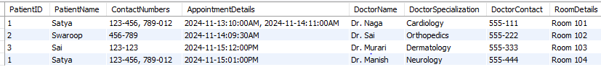

### **Violations**

#### **1NF Violation**

The original table HospitalRecords has the following issues:

* **Repeating group s:** Multiple ContactNumbers are stored in a single column as a comma-separated list.
* **Multi-valued attributes:** AppointmentDetails stores multiple appointments in a single row, also separated by commas.

This violates **1NF (First Normal Form)**, which requires:

1. Each column to hold atomic values.
2. No repeating groups or multi-valued attributes.

#### **Step 1: Convert to 1NF**

Break the multi-valued fields into atomic values by creating separate rows for each combination.

CREATE TABLE HospitalRecords_1NF (

PatientID INT,

PatientName VARCHAR(50),

ContactNumber VARCHAR(50),

AppointmentDateTime DATETIME,

DoctorName VARCHAR(50),

DoctorSpecialization VARCHAR(50),

DoctorContact VARCHAR(50),

RoomDetails VARCHAR(50)

);

INSERT INTO HospitalRecords_1NF VALUES

(1, 'Satya', '123-456', '2024-11-13 10:00:00', 'Dr. Naga', 'Cardiology', '555-111', 'Room 101'),

(1, 'Satya', '789-012', '2024-11-14 11:00:00', 'Dr. Naga', 'Cardiology', '555-111', 'Room 101'),

(2, 'Swaroop', '456-789', '2024-11-14 09:30:00', 'Dr. Sai', 'Orthopedics', '555-222', 'Room 102'),

(3, 'Sai', '123-123', '2024-11-15 12:00:00', 'Dr. Murari', 'Dermatology', '555-333', 'Room 103'),

(1, 'Satya', '123-456', '2024-11-15 01:00:00', 'Dr. Manish', 'Neurology', '555-444', 'Room 104');

**Issues Resolved:**

* Each field now contains atomic values, removing multi-valued attributes.

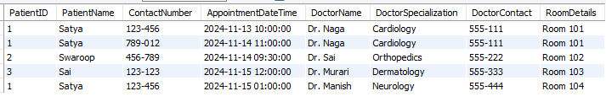

#### **2NF Violation:**

#### **2NF Requirements:**

1. The table must be in 1NF.
2. All non-prime attributes must depend entirely on the primary key (no partial dependency).

**Issues in 1NF Table:**

* The composite primary key would likely be (PatientID, ContactNumber, AppointmentDateTime), but attributes like DoctorSpecialization, DoctorContact, and RoomDetails depend only on DoctorName, not the full primary key.

#### **Resolving 2NF Violations:**

1. Decompose the table into smaller tables to remove partial dependencies.
2. Create separate tables for Patients, Doctors, and Appointments.

CREATE TABLE Patients (

PatientID INT,

PatientName VARCHAR(50),

ContactNumber VARCHAR(50),

PRIMARY KEY (PatientID, ContactNumber)

);

INSERT INTO Patients VALUES

(1, 'Satya', '123-456'),

(1, 'Satya', '789-012'),

(2, 'Swaroop', '456-789'),

(3, 'Sai', '123-123');

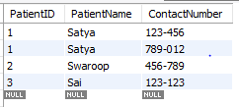

CREATE TABLE Doctors (

DoctorID INT AUTO_INCREMENT PRIMARY KEY,

DoctorName VARCHAR(50),

DoctorSpecialization VARCHAR(50),

DoctorContact VARCHAR(50),

RoomDetails VARCHAR(50)

);

INSERT INTO Doctors VALUES

(1, 'Dr. Naga', 'Cardiology', '555-111', 'Room 101'),

(2, 'Dr. Sai', 'Orthopedics', '555-222', 'Room 102'),

(3, 'Dr. Murari', 'Dermatology', '555-333', 'Room 103'),

(4, 'Dr. Manish', 'Neurology', '555-444', 'Room 104');

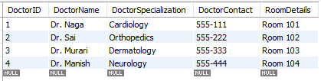

CREATE TABLE Appointments (

AppointmentID INT AUTO_INCREMENT PRIMARY KEY,

PatientID INT,

AppointmentDateTime DATETIME,

DoctorID INT,

FOREIGN KEY (PatientID) REFERENCES Patients(PatientID),

FOREIGN KEY (DoctorID) REFERENCES Doctors(DoctorID)

);

INSERT INTO Appointments VALUES

(1, 1, '2024-11-13 10:00:00', 1),

(2, 1, '2024-11-14 11:00:00', 1),

(3, 2, '2024-11-14 09:30:00', 2),

(4, 3, '2024-11-15 12:00:00', 3),

(5, 1, '2024-11-15 01:00:00', 4);

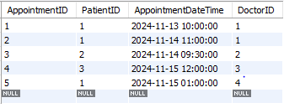

#### **3NF Violation:**

#### **3NF Requirements:**

1. The table must be in 2NF.
2. There should be no transitive dependency (non-prime attributes should not depend on other non-prime attributes).

**Issues in 2NF Tables:**

* In the Doctors table, DoctorSpecialization is dependent on DoctorID, but it can be further normalized to eliminate redundancy.

#### **Resolving 3NF Violations:**

1. Create a separate table for Specializations.

**Normalized Tables for 3NF:**

CREATE TABLE Specializations (

SpecializationID INT AUTO_INCREMENT PRIMARY KEY,

DoctorID INT,

Specialization VARCHAR(50),

FOREIGN KEY (DoctorID) REFERENCES Doctors(DoctorID)

);

INSERT INTO Specializations VALUES

(1, 1, 'Cardiology'),

(2, 2, 'Orthopedics'),

(3, 3, 'Dermatology'),

(4, 4, 'Neurology');

