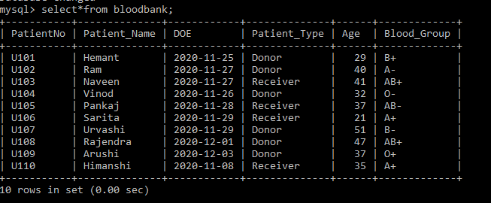

Code:-

**import mysql.connector as mys**

**mycon = mys.connect(host='localhost',user='root',**

**passwd='password',**

**database='project')**

**if mycon.is_connected():   
    print('MySQL is successfully connected')**

**cursor = mycon.cursor()   
    
def start():   
 print("******************************************"*2,**

**"\n")   
 print("\t\t\t**********ST MARY'S CONVENT S.S..SCHOOL**

**,UJJAIN **********\n")   
 print("\t\t\t\t**********BLOOD BANK**

**INFORMATION SYSTEM**********\n")   
 print("Designed and Maintained By:\n")   
 print("SATYANSH MITTAL - CLASS XII SCIENCE –**

**ROLL NO - 19   [２０20- 21]")   
 print("*ATIRATH KAPOOR - CLASS XII SCIENCE –**

**ROLL NO - 7    [２０20-21]\n")   
 print("\*\*\*\*\*\*\*\*\*\*\*\*\*\*\*\*\*\*\*\*\*\*\*\*\*\*\*\*\*\*\*\*\*\*\*\*\*\*\*\***

**\*\*"*2,"\n")   
 input("press any key to continue")   
 print()   
    
#INTRODUCTION OF PROJECT   
def pintro():   
 print("-This is a python program which can help you to**

**MANAGE BLOOD BANK DATABASE")   
 print("-This can help you to view, analyze and modify**

**BLOOD BANK DATABASE")   
 print("-You can do analysis of each and**

**every blood transaction")**

**print("-Hope this project work can make your**

**work easier :)")   
 input("press any key to continue")   
    
#START OF THE PROGRAM   
ch = 0    
start()   
pintro()**

**while ch !=7:   
    #MENU OF PROGRAM   
    print("\tMAIN MENU")   
    print("\t1.SHOW ALL PATIENT DETAILS")   
    print("\t2.SEARCH A PATIENT BY NAME")   
    print("\t3.SEARCH A PATIENT BY BLOOD GROUP")   
    print("\t4.ADD NEW PATIENT")   
    print("\t5.UPDATE PATIENT DATA")   
    print("\t6.REMOVE PATIENT DATA")   
    print("\t7.EXIT")   
    print()   
    print("\tSelect Your Option (1-7) ")   
    ch = int(input("enter = "))**

**#DEFINING FUNCTIONS OF CHOICES  
    if ch==1:   
        cursor.execute("select*from bloodbank")   
        data = cursor.fetchall()   
        for row in data :   
            print(row,'\n')**

**elif ch==2:   
        name = input("Enter name to search = ")   
        print()   
        cursor.execute("select* from bloodbank where**

**Patient_Name='{}'".format(name))   
        data=cursor.fetchall()   
        if data :   
            print('DATA FOUND\n')   
            print(data,"\n")   
        else:   
            print('INVALID NAME! PLEASE SEARCH BY A**

**RECORDED NAME')**

**elif ch==3:   
        bg = input("Enter blood group of patients**

**you want to search = ")   
        print()**

**cursor.execute("select * from bloodbank**

**where Blood_Group='{}'".format(bg))**

**data = cursor.fetchall()   
        if data:   
            print('DATA FOUND\n')   
            for row in data:   
                print(row,"\n")   
        else:   
            print('BLOOD GROUP NOT FOUND!')**

**elif ch==4:   
        a = input('Enter patient code = ')   
        b = input("Enter patient's name = ")   
        c = input("Enter patient's date of entry = ")   
        d = input("Enter patient type(donor/receiver) = ")   
        e = int(input('Enter age = '))   
        f = input('Enter blood group = ')   
        print()**

**qry="insert into bloodbank values ('{}','{}',**

**'{}','{}', '{}','{}')".format(a,b,c,d,e,f)**

**cursor.execute(qry)   
        final = input('Save records(y/n) = ')   
        if final=='y':   
            mycon.commit()       
            print('\n RECORDS SAVED\n')   
        else:   
            print("OK!")**

**elif ch==5:   
        a = input("Which patient number's data do you**

**want to update ? = " )   
        b = input("Enter the new patient number = ")   
        c = input("Enter the new patient's name =")   
        d = input('Enter date of entry(yyyy-mm-dd) = ')   
        e = input('Enter the new**

**patient type(donor/receiver) = ')   
        f = int(input("Enter new age = "))   
        g = input("Enter the patient's new blood group = ")**

**qry = "update bloodbank set PatientNo='{}',**

**Patient_Name='{}',DOE='{}',**

**Patient_Type='{}',Age='{}',Blood_Group='{}'**

**where PatientNo='{}'".format(b,c,d,e,f,g,a)**

**cursor.execute(qry)   
        mycon.commit()   
        print('SUCCESSFULLY UPDATED!')**

**elif ch==6:   
        ask = input('By which patient number you want to**

**delete data? = ')   
        cursor.execute("delete from bloodbank where**

**PatientNo='{}' ".format(ask))   
        mycon.commit()   
        print('\nSUCCESSFULLY DELETED\n')**

**elif ch==7:   
        print('\nTHANKS FOR USING\n')**

**print("********************END\*\*\*\*\*\*\*\*\*\*\*\*\*\*\*\*\*\*\***

**\*\*","\n")   
    else:   
        print('\nINVALID CHOICE! PLEASE TRY AGAIN.\n')   
        continue**