FieldOps Revamp — Action Plan for Final Submission
Oct 27, 2026 · @CSE10

Goal and guiding principles
By final submission, FieldOps runs as Flutter and Next.js clients → Node.js REST API → repository layer → a plain SQL schema that ports to Oracle 12c. Every attendance rule from the v4 plan is enforced in the backend, and all 19 SMKC deliverables are handed over.
Six rules every task in this plan has to pass:
- Clients never touch the database. No supabase-js or supabase_flutter for data, storage, auth or realtime. Every read and write goes through the REST API.
- The backend is the only authority. Server time, geofence checks, hierarchy rules, face matching and liveness challenges are decided in Node, never on the phone or in the browser.
- The database only stores. Tables, keys, constraints, indexes, transactions and CRUD. No triggers, stored functions, row-level security, PostGIS, pgvector or pg_cron.
- SQL stays portable. Types that map cleanly to Oracle: VARCHAR, DECIMAL, TIMESTAMP stored in UTC, CLOB/TEXT. No JSONB, arrays or Postgres-only syntax. Anything unavoidable goes on the database-specific-features list (deliverable 17).
- Self-hostable and free. Everything must run on SMKC's own server. No paid or public-cloud service holds staff selfies, face data or GPS trails. Maps use OpenStreetMap.
- Core first. Attendance, hierarchy, geofencing, live map and route history ship before any extras.
- Built for 4,000 field users, one way. One modular monolith with the same four layers in every module, generated API clients, one error format and retry-safe writes. Full detail: FieldOps Architecture Guidelines — Robust and Simple by Design.

Target architecture and stack
The new piece is a Node.js backend that sits between the apps and the database. Supabase leaves the project entirely. Development uses a local PostgreSQL, and the same schema must run on Oracle 12c.
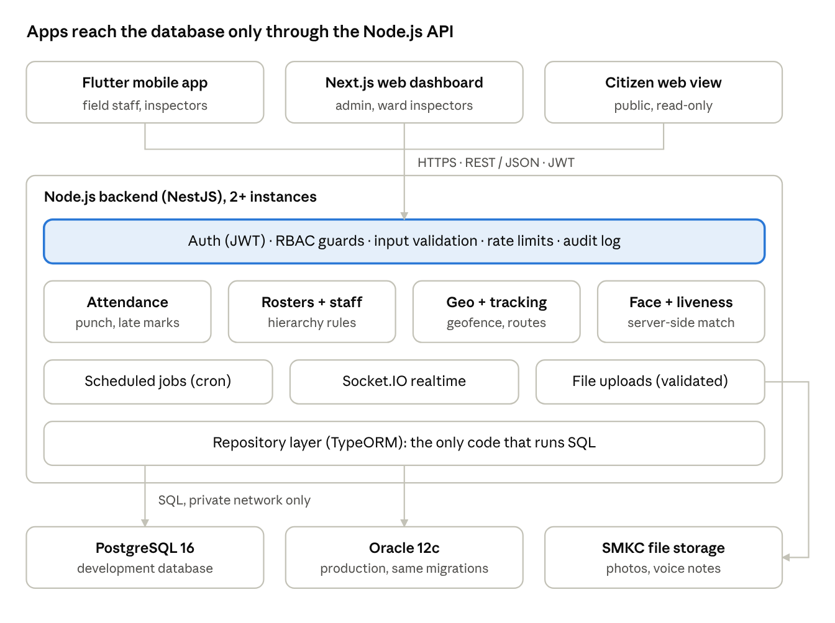
target architecture · apps, API layers, data stores
Every request passes the auth, RBAC, validation and audit layer first. Only the repository layer talks to the database, so the same code moves from PostgreSQL to Oracle.
Component | SMKC requires | Our choice | Notes
Web frontend | Next.js preferred; equivalent modern framework allowed | Next.js (App Router) + Tailwind, TanStack Query for client-side server data | Matches SMKC's preferred option (D1). Frontend only: all data through the NestJS API
Mobile app | React Native / Flutter | Keep Flutter + GetX | Repositories wrap a generated Dart client; one Drift outbox for offline writes
Backend | Node.js / .NET | Node.js LTS + NestJS, one modular monolith | Same four layers per module: controller, service, policy, repository (D2)
API | REST | REST + JSON, OpenAPI 3 via @nestjs/swagger | Versioned under /api/v1. Swagger is deliverable 09
API clients | — | Generated from openapi.json (TypeScript and Dart) | No hand-written request code; CI fails if clients are out of date
Dev database | MySQL / PostgreSQL / SQL Server / Oracle | PostgreSQL 16, local or Docker | Replaces Supabase
Data access | Repository / DAL / ORM | TypeORM repositories + migrations | Supports Postgres and Oracle. Avoid Prisma (no Oracle support)
Authentication | Backend auth + RBAC + JWT + CORS | Backend-issued JWT (short access token + refresh), RBAC guards, CORS allowlist | OTP for field staff, bcrypt passwords for web users. Test login without OTP in dev/test only; device binding after delivery (D3)
Face and liveness | Python / OpenCV / TensorFlow / PyTorch or suitable | On-device ML Kit liveness; AuraFace-v1 embeddings (Apache-2.0) via ONNX Runtime in the backend, YuNet detection, MiniFASNet anti-spoofing; SFace fallback | Server-issued one-time liveness challenge per punch; face crops never stored (D4)
GIS | OpenStreetMap | OSM + Leaflet (web) and flutter_map (mobile) | Geofence = point-in-polygon in Node (Turf.js). Boundaries stored as GeoJSON text. Offline tile pack built from OSM data and served by our backend (D5)
Realtime | — | One Socket.IO gateway for the web dashboard | Mobile uses REST + FCM push; events only trigger a REST refetch
Errors and logging | — | problem+json errors with one code list; pino JSON logs with a request ID end to end | One request ID traces a failure from phone to database
File storage | No public AI/cloud for SMKC data | Backend upload endpoint → disk or MinIO on SMKC server | Type and size validated; private links
Scheduled jobs | — | @nestjs/schedule, run once via a database lock | Auto-checkout, roll-ups, spot checks, retention purge
Notifications | — | FCM push (data-only) + in-app inbox with polling fallback; SMS / WhatsApp adapters switched off by default | SMKC enables a provider by configuration, no code change (D5, working assumptions)
Source control | Git / GitHub / GitLab | Git + GitHub | CI for lint, tests, migrations and client generation
Hosting | Existing SMKC server | PM2 cluster (2+ API instances) + Next.js server behind IIS with HTTPS | Assumed Windows Server 2012; code runs on Node 18.18+ (risk R1)

Engineering standards
Every feature is built the same way, so the code stays small and failures are easy to trace:
- Module template. Controller → service (one transaction) → pure policy → repository. Modules talk only through exported services.
- Pure policies. Hierarchy, late mark, geofence and face-match rules have no database, clock or network access, and are tested with tables of cases.
- Shared kit. Injected Clock (UTC), app-generated UUIDs, AppError + error-code enum, request-ID middleware, audit interceptor, validated config that fails fast at startup.
- Retry-safe writes. Every punch, ping and offline write carries a client UUID with a unique constraint; optimistic locking (version) on rosters and staff.
- Explicit demo mode. Allowed only in development; the server refuses to start with it in production.
- Not building: microservices, Redis/Kafka, GraphQL, Kubernetes, stored procedures or a separate Python service.

Scale target: 4,000 mobile users
Estimates use the 10-minute ping interval and a 06:00 shift start; confirm both with SMKC.
Load | Estimate | Design target
Location pings | ≈ 7 requests/s steady; about 190,000 rows per 8-hour day | Batch endpoint with bulk insert; p95 under 300 ms
Morning check-in burst | 4,000 punches, mostly 05:45–06:30 | Sustain 50 punches/s in load tests; p95 under 500 ms; zero duplicates
Stored pings | About 5.8 million rows a month; about 17 million at 90-day retention | Index on (staff, time); nightly roll-up into daily summaries, then purge (avoids paid Oracle Partitioning)
Face data | 4,000 × 512 numbers ≈ 8 MB per enrolment photo | In-memory matching; 1-to-N only within one ward team
Web dashboards | A few hundred supervisors | One realtime gateway; dashboards read summary tables

Gap list: today vs SMKC requirement
The review found 15 gaps. The first six are architecture-level and account for most of the work.
# | Area | Today | SMKC requires | Action
1 | Backend | None; Supabase is the backend | Node.js / .NET | Build a NestJS API in a new backend/ folder
2 | Data access from apps | About 30 web and mobile files call Supabase tables, storage and realtime directly | Apps must never access the database | Replace every call with REST endpoints; remove the Supabase SDKs
3 | Data access layer | None | Repository / DAL / ORM | TypeORM entities + one repository per aggregate
4 | Business logic location | Split between the clients (geofence, late rule, payroll rates) and plpgsql (9 functions, 4 triggers) | Backend handles logic; database stores | Move all of it into backend services
5 | Database portability | PostGIS, pgvector, uuid-ossp, 32 RLS policies tied to auth.uid(), JSONB, arrays | Migratable to Oracle 12c | Rewrite the schema as portable TypeORM migrations
6 | Authentication and RBAC | Supabase OTP; route guard checks login only; demo OTP 123456, one-click demo login, auto-login as supervisor | Backend auth + RBAC + JWT + CORS | Backend JWT + role guards on every endpoint; delete every demo bypass
7 | Secrets | Supabase URL and key hardcoded in main.dart | No keys in source code | Config from environment / --dart-define only
8 | Environments | One .env | Separate Dev / Test / Prod config | .env.development, .env.test, .env.production + config validation
9 | Upload validation | Only a non-empty check; content type hardcoded | File and image validation | Validate type, size and image header server-side
10 | Audit trail | Tamper and photo logs only | Audit trail for important transactions | Generic audit_log table written by a backend interceptor
11 | API documentation | None | Swagger / OpenAPI preferred | Generated from NestJS decorators
12 | Hosting and data residency | Supabase cloud holds selfies, embeddings and GPS | SMKC server; no unauthorized cloud | Everything self-hosted; push payloads carry no personal data
13 | Face matching | ML Kit with 0.40 threshold; lets users through if it fails | Proper API authentication and security | Real embeddings, server-side match, no fail-open
14 | Unused / risky code | pg in web deps; simulatePosition() in mobile | — | Remove
15 | Deliverables | Schema, seed and some tests exist | 19 mandatory deliverables | Tracked in the deliverables section below

Changes to the v4 implementation plan
The v4 plan keeps all of its features. What changes is where each rule runs: from Supabase SQL into the Node backend. Several bugs and contradictions also get fixed.

Keep as designed
- Role hierarchy ADMIN → WARD_INSPECTOR → INSPECTOR → WORKER, plus OFFICE_STAFF reporting to ADMIN
- Standing rosters as the default, with daily reassignments as approved exceptions
- Higher rank marks lower rank, same ward, same team for that day
- Ward-wide geofencing with no checkpoint pins; 100 m office geofence
- 15-minute grace period, server-side timestamps, 3-late-marks flag
- Removal of payroll and QR checkpoint attendance
- Chat with soft deletes and permanent history; hierarchy-based messaging rules
- Cold-start GPS settling, tamper watchdog, offline ping buffer
- Ward 4 pilot and phased rollout

Rework: same feature, new home
v4 plan uses | Replace with
record_attendance_punch() plpgsql | AttendanceService.punch() inside a database transaction
enforce_attendance_hierarchy trigger | HierarchyPolicy called by the attendance service
PostGIS ST_Within / ST_DWithin / ST_Buffer | Turf.js booleanPointInPolygon + buffer, computed in Node; polygons stored as GeoJSON text
pgvector <=> and match_worker_face_in_ward() | Cosine similarity in the backend over that ward's 512-D AuraFace embeddings (a few dozen per ward)
Row-level security policies | RBAC guards + scoped repository queries (e.g. a ward inspector only gets their ward)
pg_cron auto_checkout_unclosed_shifts() | @nestjs/schedule job every 30 minutes
get_staff_route_summary() RPC | GET /api/v1/staff/:id/route?date= with role checks; distance computed in Node
Supabase Storage (voice-notes, attendance-photos) | Backend upload endpoint + SMKC-hosted storage; signed, expiring download links
Supabase Realtime | Socket.IO rooms per ward / conversation
Supabase webhook to SMS/WhatsApp | Backend notification service → FCM, NIC/DLT SMS fallback
gen_random_uuid(), TIMESTAMPTZ, JSONB | UUIDs generated in Node, stored as VARCHAR(36); TIMESTAMP in UTC; plain columns or CLOB text

Fix: bugs and contradictions
- The punch must prove the face. The punch endpoint takes a one-time liveness challenge ID and the face crop. The backend checks the challenge, computes the embedding and matches it before writing anything. Mock-location and accuracy flags stay as warnings, not security.
- Timestamps. Store real UTC times; convert to IST only for the shift date and display. This removes the 5h30 shift in all 24 defaults.
- Office check-in. Accept accuracy up to 100 m for office staff, matching the office buffer. Field staff stay at 25 m.
- Approvals. Self-join and self-pick assignments start unapproved; a punch checks is_approved.
- One ward per inspector per day. Enforce it in the roster service; the current unique constraint doesn't cover inspector rows.
- Route and face-match access. Every endpoint checks the caller's role and scope; workers see only their own route for today.
- Pick one value each: AuraFace-v1 512-D on the backend (drop the 36-D vector and on-device matching); 90-day voice-note retention; spot checks use the safer version (polite chime, 10-minute window, one snooze); geofence = point-in-polygon with a 25 m edge allowance.
- Spot-check scheduling falls back to default shift times when there is no shift row.
- Claims. Drop "DPDP-compliant 90 days" and "collusion is mathematically impossible". State the retention period as SMKC policy.

Extras now in scope (decision D5)
- WhatsApp and SMS confirmations as pluggable adapters, switched off by default; FCM push and the in-app inbox are the primary channels, and SMKC can enable a provider by configuration
- Offline map tiles from a tile pack we build for the SMKMC area from OpenStreetMap data and serve from our own backend (OSM's public servers forbid bulk download)
- BLE / rolling-QR co-presence for inspector proxy punches
- Full-screen spot-check alert, using Android's alarm or call permissions where the Play policy allows, with a high-priority notification as the fallback on Android 14+, plus in-app polling when push is unavailable

Phased work plan
Six phases over about seven weeks, each ending in a gate that must pass before the next phase starts. Week numbers are relative because the submission date isn't confirmed yet (see decisions). Phases 2 and 3 can overlap once the punch API is stable.
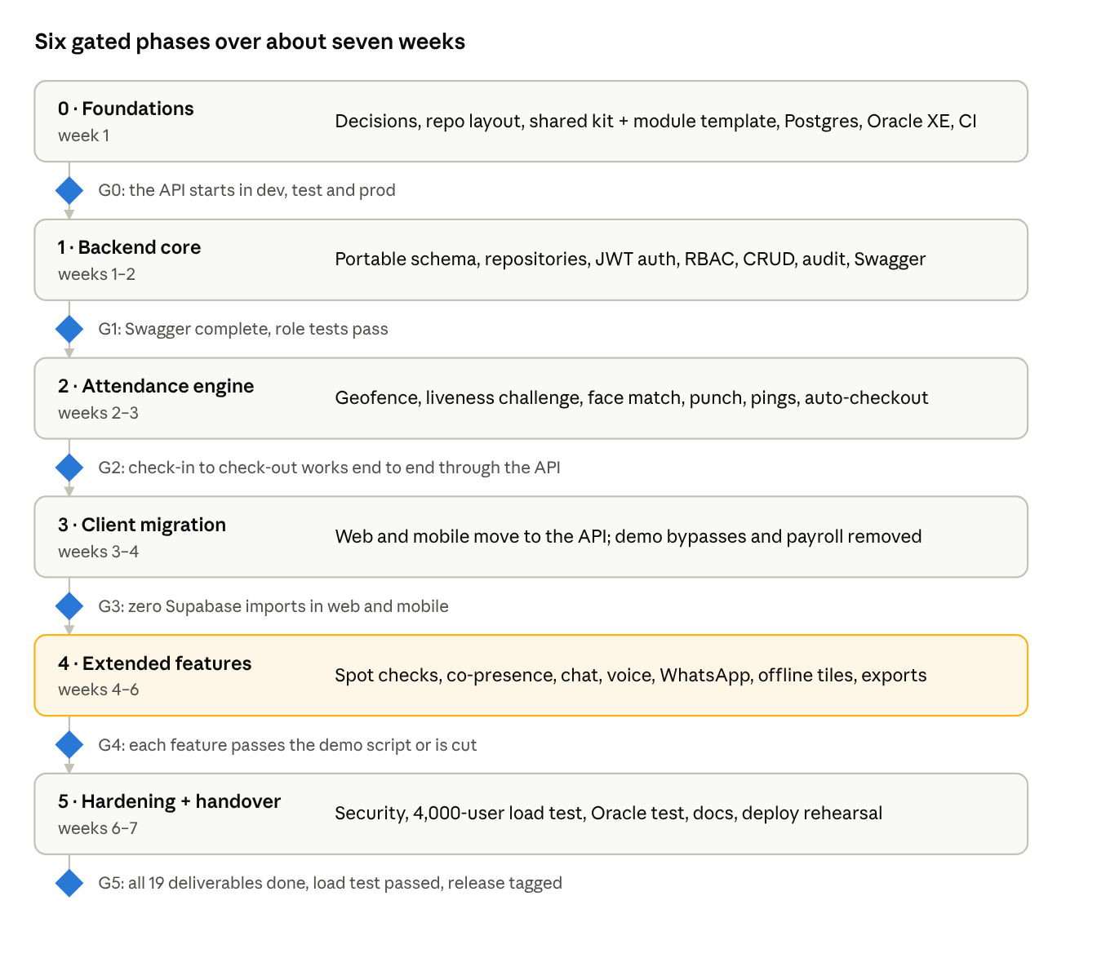
revamp roadmap · 6 phases, 6 gates
Phases 0–3 and 5 carry the SMKC requirements. Phase 4 holds all the v4 extras (D5); if the deadline gets tight, its items drop in the order given in risk R5.

Phase 0 — Foundations (week 1)
- ☒ Confirm decisions D1–D6 (done 28 Oct; submission date still open)
- ☒ Restructure the repo: backend/, web/fieldops-next/, database/, openapi/, scripts/ added; legacy web/fieldops-web/ and data/ kept until Phase 3
- ☒ Scaffold NestJS with config for dev / test / prod and validated env vars (fails fast at startup)
- ☒ Build the shared kit: Clock, UUID generator, AppError + error-code enum + problem+json filter, request-ID middleware, pino logging, /health and /ready
- ☒ Build the reference module (wards) end to end with all four layers, portable migration, unit and e2e tests
- ☒ Scaffold the Next.js app (App Router, Tailwind, TanStack Query, typed API client) beside the current Vite app
- ☒ Test-login switch for dev/test (config flag), refused at startup in production; the login endpoint itself comes in Phase 1
- ☐ Face-model selection (D4): AuraFace-v1 chosen, SFace fallback, licences recorded; the speed and accuracy benchmark runs at the start of Phase 2 (needs pilot photos)
- ☒ Local PostgreSQL 16 via Docker Compose; Oracle XE profile for portability checks
- ☒ CI workflow: lint, unit tests, migrations, e2e, OpenAPI export, web and Dart client generation (file in scripts/ci/; move it to .github/workflows/)
- ☒ Record hosting assumptions instead of asking SMKC (no contact possible; see Working assumptions)
- ☐ Run Gate G0 on your machine: npm install, npm test, npm run test:e2e, start in dev, test and prod (code was written in a session without npm access)
Gate G0: the backend starts in all three environments and /api/v1/health answers.

Phase 1 — Backend core (weeks 1–2)
- ☒ Portable schema as TypeORM migrations: wards, offices, staff, standing rosters, daily assignments, shifts, attendance, location pings, tamper logs, tasks, complaints, leave, holidays, alerts, conversations, messages, spot checks, audit log
- ☒ Drop payroll and checkpoint tables; add audit_log
- ☒ Idempotency key column + unique constraint on punches, pings and every offline write
- ☒ version column for optimistic locking on staff, rosters and assignments
- ☒ Indexes for every list filter, including location pings on (staff, time)
- ☒ Repositories for each aggregate; no raw SQL in services
- ☒ Auth module: OTP request / verify, bcrypt passwords for web users, JWT access + refresh, logout and session revoke
- ☒ RBAC guard with roles ADMIN, WARD_INSPECTOR, INSPECTOR, WORKER, OFFICE_STAFF, CITIZEN, plus ward / team scope checks
- ☒ Staff, ward, office and roster CRUD with the v4 assignment rules
- ☐ Audit interceptor writing inside the same transaction; global validation pipe; per-user and per-device rate limits; CORS allowlist
- ☒ /health and /ready endpoints; Swagger at /api/docs
- ☒ New seed script that loads through the repositories (no PostGIS)
Gate G1: Swagger lists all core endpoints and role tests pass (e.g. a worker gets 403 on another worker's data).

Phase 2 — Attendance engine (weeks 2–3)
- ☒ Write HierarchyPolicy, LateMarkPolicy, GeofencePolicy and FaceMatchPolicy as pure functions with table-driven tests, before the service code
- ☒ Geo service: point-in-polygon for wards and buffered offices, distance, route length
- ☒ Liveness challenge endpoint: one-time challenge ID with a short expiry
- ☐ Face benchmark first (model selection doc), then the local face engine behind the existing FaceVerifier interface (Aadhaar adapter already built; switch with FACE_PROVIDER=aadhaar): YuNet + MiniFASNet + AuraFace through ONNX Runtime in a worker pool; enrol 3–5 photos per person (admin), 1-to-1 match, 1-to-N within a team, in memory
- ☒ POST /attendance/punches: server time, geofence, hierarchy and team checks, approval check, face and challenge check, idempotency, late-mark calculation, one transaction, audit entry
- ☒ Batch ping endpoint with bulk insert (handles the offline buffer); out-of-zone alerts
- ☒ Tamper events and silent-gap detection
- ☒ Jobs (run once via database lock): auto-checkout, nightly roll-up of pings into daily route summaries, daily attendance summary per ward, retention purge
- ☒ Route history endpoint reading summaries plus the day's raw points
- ☒ Unit tests for the 15-minute grace boundary, IST date rollover, proxy rules and geofence edges, using a frozen Clock
Gate G2: a full check-in and check-out works end to end through the API, including a proxy punch by an inspector.

Phase 3 — Client migration (weeks 3–4)
- ☒ Web: rebuild each page in Next.js (App Router) on the generated client + TanStack Query; retire the Vite app when every page is ported
- ☒ Web: route protection in Next.js middleware and layouts from one role table; tokens in httpOnly cookies; no demo login, auto-login or pg dependency
- ☐ Web: Socket.IO events only invalidate queries; live map, hierarchy tree view, route playback, attendance and late-mark reports reading summary tables; no payroll pages
- ☒ Citizen view as server-rendered Next.js pages over read-only, rate-limited public endpoints
- ☒ Mobile: repositories over the generated Dart client with secure token storage; replace every supabase_flutter call
- ☒ Mobile: one Drift outbox for every offline write (punch, ping, task update, tamper event) with idempotency UUIDs and backoff
- ☒ Mobile: ML Kit active liveness and face-crop upload with the challenge ID (D4); liveness UI (blinks, smile, progress ring); self and inspector dual-mode attendance
- ☒ Mobile: GPS settling and check-in lock; tamper watchdog; config via --dart-define
- ☒ Mobile: minimum-version check that forces updates; remote logout (device binding comes after delivery, D3)
- ☒ Mobile: delete demo OTP, simulatePosition(), fail-open face match and hardcoded keys; remove payroll and QR screens
- ☒ Both apps: one error-code message table (Marathi / English) and the request ID on error screens
Gate G3: a search finds zero Supabase imports in web/ and mobile/, and both apps work against the API only.

Phase 4 — Extended features (weeks 4–6)
- ☐ Random spot-check engine: scheduler, FCM wake-up, full-screen alert where allowed, 10-minute window with one snooze, escalation, senior manual trigger
- ☒ BLE / rolling-QR co-presence check for inspector proxy punches
- ☒ Hierarchy-based chat channels and archived squads
- ☒ Voice notes through the upload endpoint, with the retention job
- ☒ One notification interface: FCM push, in-app inbox and polling fallback, plus WhatsApp and SMS adapters switched off by default
- ☐ Offline tile pack for the SMKMC area (built from OSM data, served by the backend) + pre-caching in the mobile app
- ☒ Muster-roll export (CSV / PDF) and leave / holiday / regularization flows
Gate G4: the extended features pass a demo script; anything unfinished is cut, not left half-built.

Phase 5 — Hardening and handover (weeks 6–7)
- ☐ Walk through the security checklist below and close every item
- ☐ Run all migrations and the test suite against Oracle XE; record what differs
- ☐ k6 load test simulating 4,000 users: steady pings plus the 06:00 check-in burst; tune the connection pool and indexes until the scale targets pass
- ☐ Deploy rehearsal on a Windows Server VM matching SMKC's server: PM2 cluster with 2+ instances behind IIS, HTTPS, jobs running once
- ☐ Nightly database and file-storage backups; one restore drill; recovery targets documented in the administrator manual
- ☐ Write the documents in the deliverables tracker
- ☐ Freeze the code, tag the release, record the demo
Gate G5: all 19 deliverables are done, the 4,000-user load test passes, and the release is tagged.

Security checklist (SMKC section 6)
All 12 items are mandatory. None are fully met today, so every row starts as not started.
SMKC requirement | How we meet it | Status
HTTPS for API communication | TLS at IIS / reverse proxy; HTTP redirected; mobile rejects cleartext | Not started
Role-based access control | RBAC guard on every endpoint + ward/team scope checks; roles in the JWT, re-checked against the database for sensitive actions | Not started
Passwords securely hashed | bcrypt (cost 12) for web users; OTP codes hashed with expiry and attempt limits | Not started
No database passwords or API keys in source | Env files outside git; --dart-define for mobile; secret scan in CI | Not started
Input validation and parameterized queries | DTO validation pipe on every request; TypeORM query builder only, no string-built SQL | Not started
File / image upload validation | MIME and magic-byte check, size cap, image re-encode, random file names, private storage | Not started
Audit trail for important transactions | audit_log: actor, action, entity, before/after, IP, time — for punches, proxy punches, roster changes, staff CRUD, logins | Not started
Login / session security | Short-lived access token, rotating refresh token, device binding for field staff, lockout after failed attempts, logout revokes | Not started
Proper API authentication | JWT on all non-public routes; public citizen endpoints read-only and rate-limited | Not started
Production Oracle not exposed to the Internet | Database reachable only from the API host; documented in the deployment guide | Not started
No SMKC data to unauthorized AI / cloud | Face matching on device + own server; no Supabase; push and SMS carry no personal data | Not started
Separate Dev / Test / Prod configuration | Three env files + config schema; different databases and keys per environment | Not started

Deliverables tracker (SMKC section 7)
SMKC wants the complete project, not just a demo. Six items are partly done; the backend source and every document are still to come.
No. | Deliverable | What we hand over | Phase | Status
01 | Complete source code | Tagged Git release of the whole repo | 5 | In progress
02 | Frontend source code | web/ (React + Vite) | 3 | In progress
03 | Backend / API source code | backend/ (NestJS) | 1–2 | Not started
04 | Mobile app source code | mobile/ (Flutter) + signed APK | 3 | In progress
05 | AI source code and trained model / weights | MobileFaceNet .tflite, liveness logic, matching code, inference steps | 2–3 | Not started
06 | Complete database schema and SQL scripts | TypeORM migrations + exported DDL for PostgreSQL and Oracle | 1 | In progress
07 | Sample / test database | Seed script + SQL dump | 1 | In progress
08 | ER diagram | Generated from the final schema | 5 | Not started
09 | API documentation | Swagger / OpenAPI 3 + exported openapi.json | 1–5 | Not started
10 | Dependency list with versions | From lock files: npm, pub, backend | 5 | Not started
11 | Installation and deployment guide | Windows Server + IIS + Node service + Oracle steps | 5 | Not started
12 | User manual | Field worker, inspector, ward inspector, office staff, citizen (English + Marathi) | 5 | Not started
13 | Administrator manual | Staff / ward / roster management, reports, backups | 5 | Not started
14 | Source-code build instructions | Backend, web, mobile; env setup per environment | 5 | Not started
15 | Third-party API / library details and licences | Licence report from dependencies; OSM attribution | 5 | Not started
16 | Paid services / APIs / subscriptions | Expected: none; SMS gateway cost if SMKC uses one | 5 | Not started
17 | Database-specific features used | List of anything non-portable, with reasons | 5 | Not started
18 | Test credentials and sample data | One account per role + seed description | 5 | Not started
19 | Final working demonstration | Scripted demo + recording | 5 | Not started

Decisions, risks and next steps

Decisions (confirmed 28 Oct 2026)
# | Decision | Outcome | What it changes
D1 | Web framework | Move to Next.js (App Router) | The web app is rebuilt in Next.js as a pure frontend over the NestJS API. No Next.js API routes or server code touch the database. The citizen view is server-rendered
D2 | Backend framework | NestJS (recorded from "nxt js"; confirm) | Unchanged: NestJS modular monolith
D3 | Field-staff login | OTP only for now; device binding after delivery to SMKC | A test login (fixed test accounts, no OTP) works only in the development and test environments for full pre-delivery testing. The server refuses to start with it enabled in production
D4 | Face recognition | Highest-accuracy model that also meets SMKC rules (licence allows government use, runs on SMKC's server, no cloud) | Chosen 31 Oct: AuraFace-v1 (Apache-2.0) on the backend, OpenCV SFace as fallback (see the face model selection doc). Embeddings are computed on the backend: the phone sends a liveness-checked face crop over HTTPS (never stored), so a larger model can run. Liveness stays on the device
D5 | v4 extras in scope | All in scope | Adds WhatsApp confirmations, offline map tiles, BLE / rolling-QR co-presence and full-screen spot-check alerts to phase 4, which grows by a week
D6 | Ownership | You and Claude own every track | One combined backlog; docs written alongside each phase

Working assumptions (no contact with SMKC before submission)
We cannot reach SMKC, so every unknown about their environment is decided by the safest assumption and the build is made to work either way. Each assumption is written into the installation guide (deliverable 11) so SMKC IT can see what to check.
Unknown | Assumption we build for | How the design copes either way
Server OS and Node version | Windows Server 2012 / 2012 R2, as the SMKC document states | Code targets Node 18.18+ (NestJS 10, Next.js 15), so it runs on the newest Node the server accepts. The guide covers both a current LTS and the fallback, and notes that Node 18 no longer gets security updates
Process manager / web server | IIS available; nothing else installed | API and Next.js run as Windows services (PM2 or NSSM) behind IIS reverse proxy with HTTPS; step-by-step guide plus scripts
Oracle version | 12c Release 1 (the strictest) | Schema rules already target 12.1: 30-character names, no BOOLEAN/JSON types, no PL/SQL. Migrations tested on Oracle XE 21 with those limits
Server capacity | Modest: 4 vCPU, 8–16 GB RAM | Load test runs on a VM of that size; the guide states minimum and recommended hardware
Internet access from the server | May be restricted | Nothing core needs the internet. Push (FCM) is best-effort; the app also polls while on duty, so spot checks and alerts still arrive
SMS / WhatsApp gateway | None approved | Notification adapters ship switched off; FCM push and in-app inbox are the default. SMKC enables a provider by configuration, no code change (listed in deliverable 16)
Map tiles for offline use | No SMKC tile server | We build an offline tile pack for the SMKMC area from OpenStreetMap data and serve it from our own backend, with OSM attribution; no public tile server is bulk-downloaded
Backups | No known policy | Backup and restore scripts plus a documented schedule are part of the administrator manual
TLS certificate | Provided by SMKC at deployment | Guide covers installing their certificate in IIS; we test with a self-signed one
Ward boundaries | SMKMC supplies official prabhag boundaries (GeoJSON or shapefile) before the pilot | The seed uses synthetic squares until then; real boundaries load through PATCH /wards/:id with no code change
Citizen accounts | None needed: citizens file and track complaints with a tracking ID | Public portal with no sign-in, a stricter per-IP rate limit and no personal data in responses; a citizen login can be added later without schema changes
Location history retention | Raw GPS pings kept 90 days, then purged nightly | PING_RETENTION_DAYS sets SMKC's period (7–365 days) without code changes; daily route summaries hold no coordinates, so the purge really ends the location history
Forgotten check-out | Closed automatically 60 minutes after the shift end | Field staff at the time their phone was last seen during the shift, office staff at the scheduled end; audited as a system action and corrected through regularization if wrong
Silent phone | 30 minutes without a ping during a field shift is a gap | A server-side tamper event and a supervisor alert; it closes when pings resume (late offline uploads count) or at check-out. The threshold is one constant to tune after the pilot
Web sign-in | Dashboard for ADMIN, WARD_INSPECTOR and OFFICE_STAFF with a password | Inspectors and workers use the mobile app with OTP; no demo or test login on the web. Tokens stay in httpOnly cookies behind a Next.js session layer; in development the seed sets SEED_WEB_PASSWORD for these roles
Web language | Marathi by default, English one click away | The choice is remembered per browser; API errors are shown from one shared Marathi / English code table with the request ID
Punches need the network | Punches are online; pings, tamper events and task updates are queued | The liveness challenge lives 2 minutes, so punches are not queued offline: a network failure retries twice with the same clientUuid. Pings, tamper events and task updates (with their photo) go through the phone's SQLite outbox: backoff 30 s doubling to 30 min with 20% jitter, kept rows capped per kind (5,000 pings), 4xx answers dropped, 5xx / 429 / no network retried
When the phone pings | Only during a checked-in field shift | Only while a field shift is checked in: every 10 min in the foreground, every 15 min in the background (Workmanager). Tamper events for GPS-off spans, a revoked location permission and the first mocked fix. Office staff send no pings
Phone GPS gate | 25 m field / 100 m office, up to 45 s | Before a punch the phone waits up to 45 s for 25 m (field) / 100 m (office) accuracy; the server still decides
Aadhaar face on the phone | Not in this build | With FACE_PROVIDER=aadhaar the app shows "not in this build": FaceRD capture is not implemented (decision D4 keeps it ready on the server only)
Random spot checks | 30% of field staff per shift, unpredictable, decided once | SPOT_CHECK_DAILY_RATE (default 0.3) of checked-in field staff get one random check per shift, at a time between half an hour after check-in and half an hour before the end; whether and when is decided once from a keyed hash of the shift, so staff cannot predict it and re-runs do not change it. 10 minutes to answer, one 10-minute snooze; a face mismatch may be retried until the deadline, an answer from outside the ward is escalated
Push and SMS | Inbox always; push without personal data; SMS only when urgent | Every message lands in the in-app inbox, which the app polls; FCM push carries only ids and kinds (no names, places or photos reach Google); SMS / WhatsApp through SMKC's gateway only for HIGH priority (spot checks, high alerts) and only when configured
Co-presence | Rolling QR, optional for the pilot | Rolling QR instead of BLE (BLE is first to drop, risk R5): the worker's phone shows a 6-digit TOTP code from a per-person key; proxy punches check it when sent and require it when COPRESENCE_REQUIRED=true (off for the pilot)
Chat | Channels follow the hierarchy and the day | Channels follow the day's placement (squad = inspector + workers placed under them that day; ward and city broadcasts are one-way); direct messages only along reporting lines or between ranks in the same ward; history is never deleted, voice notes after 90 days
Offline map tiles | Served from our server, built offline from OSM | The backend serves a pack of OSM tiles (z/x/y.png + manifest.json) from TILE_DIR; the pack is built offline from OSM data for the SMKMC area (never by bulk-downloading openstreetmap.org tiles)
Muster roll | Per ward and month, CSV and PDF | Per ward and month; codes P / L / H / A / LV / HO / R; the PDF prints English names (built-in PDF fonts have no Devanagari), the CSV keeps Marathi
Photo storage | Task photos stay on the SMKC server's disk | UPLOAD_DIR (backed up with the database), JPEG or PNG only, 2 MB by default; visible only to the uploader and the people who review their work
Mobile updates | The app checks a minimum version at start-up | Builds below MOBILE_MIN_VERSION_CODE must update first, from the Play Store or the download page set in MOBILE_UPDATE_URL
Live map refresh | Polling every 30 seconds; push events later | Phones send a position about every 10 minutes, so push adds little now; Socket.IO events that only invalidate queries follow. Reports cover yesterday and earlier, at most 92 days per request
Citizen transparency | Public ward pages show daily counts only | Placed, present and on-leave counts for the last week; never staff names, photos or locations
Office weekly off | Office staff are off on Sundays and on listed holidays | Field staff work whenever they hold an approved placement (sanitation runs every day); their weekly offs are requested as WEEKLY_OFF leave. The day-close job marks office Sundays and holidays HOLIDAY_OFF
Proxies and server instances | IIS, Next.js and the API run on one SMKC server | TRUST_PROXY=loopback trusts forwarded client addresses only from local proxies; Next.js runs as one instance bound to 127.0.0.1, the API scales under PM2 with per-instance rate limits
Web map tiles | The public OpenStreetMap tile server until our offline tile pack ships | With OSM attribution; NEXT_PUBLIC_TILE_URL switches to the offline SMKMC pack (Phase 4) without code changes. Only tile requests leave the network, never staff data

Risks
- R1 — Windows Server 2012 host. We can't confirm which Node version SMKC allows. Mitigation: code runs on Node 18.18+, the guide covers a current LTS and the fallback, and we rehearse on a Windows Server VM. Node 18 gets no security updates, which the guide states plainly.
- R2 — Oracle 12c differences. No access to SMKC's Oracle. Mitigation: build to 12.1 limits (30-character names, no BOOLEAN/JSON), test every migration on Oracle XE from phase 1, and list any database-specific feature (deliverable 17).
- R3 — Client rewrite size. About 30 files call Supabase directly, and the web app also moves to Next.js. Port one page at a time onto the generated client; finish web before mobile.
- R4 — Face accuracy. Thresholds need tuning on real staff photos. Measure false rejects in the Ward 4 pilot before tightening.
- R5 — Schedule. All extras are in scope, so there is little slack and the submission date isn't confirmed. If time runs short, drop in this order: BLE co-presence, WhatsApp, offline tiles.
- R6 — 06:00 check-in burst at 4,000 users. Most punches land in about 45 minutes, and the server size is unknown. Mitigate with the load test on a modest VM (4 vCPU, 8–16 GB), idempotent retries with backoff in the app, and documented minimum hardware.
- R7 — Ping table growth. About 17 million rows at 90 days. The nightly roll-up and purge job must ship in phase 2, not at the end.
- R8 — Face model licence. Many top face models allow research use only. The benchmark must check the weights' licence, not just the code's, and record it for deliverable 15.
- R9 — Unknown SMKC integrations. No confirmed SMS/WhatsApp gateway, internet access or tile server. Mitigation: nothing core depends on them; adapters ship switched off, push has an in-app polling fallback, and we serve our own offline tile pack.

Next steps
- ☐ Confirm the final submission date and re-date the phases
- ☒ Agree D1–D6 (28 Oct)
- ☒ Replace SMKC IT questions with documented working assumptions (31 Oct; no contact possible)
- ☒ Create the backend/ NestJS scaffold and Docker Compose for Postgres
- ☐ Run Gate G0 locally and share any errors
- ☐ Freeze new Supabase work: no new features on the old stack

