FieldOps Architecture Guidelines — Robust and Simple by Design
Oct 27, 2026 · @CSE10

Five rules that keep the code simple
We stay robust by doing fewer things, one way, everywhere, not by adding infrastructure. One backend, one API contract, one way to handle errors, time, IDs and offline writes. Every new feature then follows a template instead of a new design.
- One deployable backend, split into feature modules. A modular monolith, not microservices.
- The API contract is the source of truth. Web and mobile clients are generated from it, never hand-written.
- Business rules are pure functions. No database, clock or HTTP inside a rule, so each one is tested in milliseconds and reused by endpoints and jobs.
- Every failure looks the same. One error format, one error-code list, one log format with a request ID that runs from the phone to the database.
- Every write is safe to retry. Client-generated IDs and idempotency keys, so offline sync and flaky networks never create duplicates.

Backend shape: a modular monolith
One NestJS app, one process, one database, deployed as one Windows service. It runs on a single SMKC server and is debugged with one log file. Inside, each feature is a module with the same four layers, so every feature is built and debugged the same way.
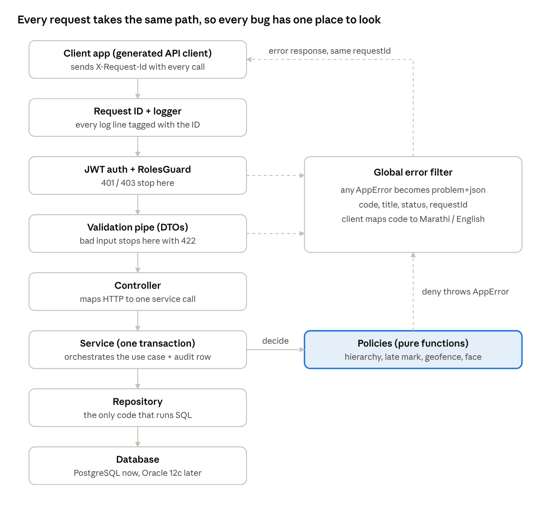
request lifecycle · main path and error path
Rules sit in one place (policies), SQL in one place (repositories), and every failure leaves through one filter carrying the request ID.

Module anatomy
Layer | Does | Never does
Controller | Maps HTTP to a service call; declares roles, DTOs and Swagger docs | Business logic, SQL
Service | Orchestrates one use case inside one transaction; calls policies and repositories | Read HTTP headers, write raw SQL
Policy | Pure rule: inputs in, decision out (canMarkAttendance, lateMinutes, isInsideWard) | Touch the database, clock or network
Repository | The only place with queries; returns entities | Make decisions

Module boundaries
- A module calls another module only through its exported service, never its repository or entities.
- The shared/ folder holds cross-cutting pieces only: clock, ID generator, errors, auth guard, audit, logger, config.
- Circular imports between modules are a design smell; fix them by moving the shared rule into a policy.

Folder layout
backend/src/
main.ts bootstrap: config check, logger, global pipes and filters
shared/
clock/ Clock service (UTC now, IST date helpers), mockable
ids/ UUID generator
errors/ AppError, ErrorCode enum, problem+json filter
auth/ JWT strategy, RolesGuard, ScopeGuard, @CurrentUser
audit/ AuditInterceptor + audit repository
logging/ pino setup, request-ID middleware
config/ typed config + validation schema (dev / test / prod)
modules/
auth/ staff/ wards/ rosters/ attendance/ tracking/
face/ tasks/ chat/ spot-checks/ reports/ files/ notifications/
<module>.module.ts
<module>.controller.ts
<module>.service.ts
<module>.policy.ts pure rules + their unit tests beside them
<module>.repository.ts
dto/ entities/
jobs/ scheduled jobs; each calls a module service
database/migrations/ portable migrations (run in CI on Postgres and Oracle XE)
A new feature is: copy the module template, write the policy and its tests, then the service, repository and controller. No new patterns.

One API contract, generated clients
The NestJS DTOs produce openapi.json. That one file generates the typed web client and the Dart client. A renamed field then breaks the build in all three places at once, instead of failing silently in the field.
- Backend DTOs + @nestjs/swagger decorators → openapi.json, exported on every build (also deliverable 09).
- Web: openapi-typescript + openapi-fetch (or Orval) generates the typed client into web/src/api/generated/.
- Mobile: openapi-generator (dart-dio) generates the client into mobile/lib/core/api/generated/.
- CI regenerates both clients and fails if the committed files differ, so nobody forgets.
Rules for the contract:
- Version under /api/v1. Additive changes only within a version.
- Plural nouns and standard verbs: GET /staff/:id, POST /attendance/punches, GET /staff/:id/route?date=.
- List endpoints share one pagination shape: ?page=&pageSize= returning { items, page, pageSize, total }.
- Times are ISO 8601 UTC strings in and out (2026-10-27T00:42:00Z); the client shows IST.
- IDs are UUID strings. Enums are UPPER_SNAKE strings, the same in DTOs, database and clients.

Robustness patterns
Ten patterns, each built once in shared/ or the module template. Together they cover the failures FieldOps will actually hit: flaky rural networks, offline phones, retries, wrong clocks and bad input.
Pattern | Prevents | How, in one line
Idempotent writes | Duplicate punches and pings when the phone retries or syncs offline | Client sends a UUID per punch / ping; unique constraint on it; a repeat returns the first result
One transaction per use case | Half-written attendance (log saved, audit missing) | Service method runs inside one TypeORM transaction; the audit row is written in the same transaction
Injected Clock | Timezone bugs and untestable grace-period logic | All time comes from Clock.now() in UTC; tests freeze it at 06:15:59 and 06:16:00
App-generated UUIDs | Postgres/Oracle ID differences; offline records needing IDs | ids.new() in Node; stored as VARCHAR(36)
Validation at the edge | Bad input reaching services or SQL | Global ValidationPipe with whitelist; DTOs define every field, unknown fields rejected
Fail-fast config | Starting in production with a missing secret or the dev database | Config schema checked at boot; process exits with a clear message
Policies as pure functions | Rules duplicated in the controller, job and client | One function per rule, used everywhere; clients show the server's decision, never recompute it
Optimistic locking | Two supervisors overwriting the same roster | version column on editable entities; a stale update returns 409
Safe background jobs | Auto-checkout running twice or skipping a day | Each job is idempotent and records its last run; a database row lock stops a second instance
Explicit demo mode | Demo shortcuts leaking into production | DEMO_MODE allowed only when NODE_ENV=development; boot fails otherwise

One error format
Every error leaves the API as RFC 7807 application/problem+json with a stable code from one enum:
{
"type": "https://fieldops.smkc/errors/OUTSIDE_WARD",
"code": "OUTSIDE_WARD",
"title": "Location is outside your assigned ward",
"status": 422,
"requestId": "7f3c2a1e-9b4d-4e1a-8c2f-1d5e6a7b8c90",
"details": { "distanceMeters": 140 }
}
Services throw AppError(ErrorCode.OUTSIDE_WARD, details); one global filter turns it into this shape. Clients map code to Marathi and English messages from a single table. No screen-specific error parsing.

Debugging and observability
Any bug report should be traceable from one ID. When a worker says "my check-in failed", the app shows a short request ID. One search of the log file then gives the full story: who, which endpoint, which rule said no, and how long each step took.
- Request ID end to end. The client sends X-Request-Id (a UUID it creates). The backend uses it in every log line and audit row and returns it in errors. The app shows the last 8 characters on error screens.
- Structured logs. pino writes JSON lines with requestId, staffId, role, route, status, durationMs. On Windows they go to daily rotating files. Never log OTPs, tokens, face embeddings or exact home locations.
- Decision logging in policies. When a rule denies something, the service logs the rule name and inputs (e.g. HierarchyPolicy: INSPECTOR cannot mark WARD_INSPECTOR). This answers "why was I rejected?" without a debugger.
- Audit log is not the debug log. The audit table records who changed what, for SMKC. The log file records how the system behaved, for us. Both carry the request ID.
- Health endpoints. /health (process up) and /ready (database reachable, migrations current), used by the deploy script and the demo checklist.
- Reproducible data. One seed command builds the same 34-account dataset every time. test environment resets it before each end-to-end run.
- Time travel for tests. Because time comes from the Clock service, a test can run "06:16 on a Monday" or "auto-checkout at 15:05" without waiting.
Optional if time allows: self-hosted GlitchTip (Sentry-compatible) for crash reports from web and mobile. It runs on SMKC's server, so no data leaves.

Web and mobile client structure
Both clients become thin: they display server data, collect input and call the generated client. Rules live in the backend, so client bugs are display bugs, not data bugs.

Web (React + Vite)
- TanStack Query for all server data: caching, retries, loading and error states in one place. No useEffect fetch code in pages.
- One API wrapper around the generated client: adds the token, refreshes it on 401, attaches X-Request-Id, converts problem+json into a typed error.
- One route table with the roles allowed per route; the menu and the guard both read it. Hiding a menu item is cosmetic — the API still enforces access.
- Realtime as a hint. A Socket.IO event like attendance.changed only invalidates the matching query; data is always fetched over REST. One data path, so no live-map vs. table mismatches.
- Folders: src/api/, src/features/<feature>/ (pages, components, hooks), src/shared/ (layout, error banner, map).

Mobile (Flutter + GetX)
- Feature-first folders (already in place): features/<feature>/{controllers,screens,repository}.
- Repositories wrap the generated Dart client. Controllers never call dio directly, so mocking for tests is one line.
- One generic outbox (Drift table) for every offline write: punch, ping, task update, tamper event. Each row carries its idempotency UUID and is retried with backoff. One sync engine instead of one per feature.
- Device signals are sent, not judged. The app sends accuracy, mock-location flag, battery and capture time; the backend decides. The app only blocks obviously bad input (e.g. accuracy above 25 m) for better UX.
- Config from --dart-define per environment; no defaults with real URLs or keys in code.
- One error widget that maps error code to a Marathi/English message and shows the request ID.

What we deliberately don't build
Each item below adds moving parts that a small team can't debug before the deadline. At 4,000 mobile users FieldOps' load is modest for one well-built backend (see the next section), so none of them is needed.
Not building | Why not | Use instead
Microservices | Network calls, distributed debugging, several deploys on one Windows server | Modules inside one NestJS app
Redis / Kafka / message queues | Another server to run and monitor | In-process scheduler + database outbox
GraphQL | Second API style; SMKC asks for REST | REST + OpenAPI
CQRS / event sourcing | Large conceptual overhead | Plain services and tables, plus the audit log
Kubernetes / Docker in production | Not available on Windows Server 2012 | Windows service + IIS; Docker only for local development
Custom auth or crypto | Easy to get subtly wrong | Passport JWT, bcrypt, standard libraries
Database stored procedures and triggers | Break Oracle portability and hide logic | Backend services and policies
A separate Python AI service (for now) | Second runtime to deploy | On-device embeddings + matching in Node; revisit only if accuracy needs server-side inference

Scale and enterprise readiness: 4,000 mobile users
The same modular monolith serves 4,000 field users from SMKC's server. Scale comes from a stateless API, the right indexes, summary tables and a second instance, not from new infrastructure. The figures below are estimates from the plan's 10-minute ping interval and a 06:00 shift start; confirm them with SMKC.
Load | Estimate | Design target
Location pings | 4,000 users × 1 per 10 min ≈ 7 requests/s steady; about 190,000 rows per 8-hour day | Batch endpoint with bulk insert; p95 under 300 ms
Morning check-in burst | 4,000 punches, mostly 05:45–06:30 | Sustain 50 punches/s in load tests; p95 under 500 ms; zero duplicates
Stored pings | About 5.8 million rows a month; about 17 million at 90-day retention | Index on (staff, time); nightly roll-up into daily route summaries, then purge
Face data | 4,000 × 128 numbers ≈ 2 MB | Matching runs in memory; 1-to-N only within one ward team
Web dashboards | A few hundred supervisors on the live map | One realtime gateway; dashboards read summary tables

What makes it enterprise grade
- Two or more API instances. PM2 cluster mode on Windows behind IIS. JWT keeps the API stateless, so any instance serves any request; scheduled jobs run once through a database lock.
- Realtime only where it's needed. Mobile uses REST plus FCM push; Socket.IO serves only the web dashboard from one gateway process, so no Redis adapter is required.
- Summary tables for reporting. Jobs maintain daily attendance per ward and daily route summaries. Dashboards and exports never aggregate millions of raw rows live.
- Retention instead of partitioning. The roll-up-and-purge job keeps tables small. This avoids Oracle Partitioning, which is a paid option.
- Database discipline. Sized connection pool (start at 20–40 and tune under load), query timeouts, slow-query log, an index for every list filter.
- Rate limits and size limits per user and per device, plus upload size caps.
- Mobile fleet control. A minimum-version endpoint that forces updates, staged APK rollout, device binding and remote logout for lost phones.
- Backup and restore. Nightly database and file-storage backups, with recovery targets agreed with SMKC IT and one restore drill before handover.
- Load test as a gate. A k6 script simulating 4,000 users (steady pings plus the 06:00 burst) must pass in phase 5.
- Security testing by SMKC IT, as their deployment approval requires.

Fit with SMKC requirements
Everything here stays inside the SMKC stack: Node.js backend, REST + JSON, repository layer over SQL, OpenStreetMap, RBAC + JWT + CORS, hosting on SMKC's own server and no paid services. Running two instances and backups are hosting choices SMKC IT should confirm, not new technology.

What this adds to the revamp action plan
Most of this is one-time setup in phases 0 and 1. It costs about two to three extra days and pays back on every feature after that.
Phase 0 — Foundations
- ☐ Create the shared/ kit: Clock, IDs, AppError + ErrorCode enum + problem+json filter, request-ID middleware, pino logging, config schema with fail-fast boot
- ☐ Build one reference module (wards) end to end with all four layers and tests; it becomes the template
- ☐ CI step that exports openapi.json and regenerates the web and Dart clients
Phase 1 — Backend core
- ☐ Idempotency key column + unique constraint on punches, pings and other offline writes
- ☐ version column for optimistic locking on staff, rosters and assignments
- ☐ Audit interceptor writing inside the same transaction
- ☐ /health and /ready endpoints
Phase 2 — Attendance engine
- ☐ Write HierarchyPolicy, LateMarkPolicy, GeofencePolicy and FaceMatchPolicy as pure functions with table-driven tests before the service code
Phase 3 — Client migration
- ☐ Web: TanStack Query + API wrapper + role route table
- ☐ Mobile: repositories over the generated client + one Drift outbox for all offline writes
- ☐ Shared error-code message table (Marathi / English) in both apps

