ENGINEERING SOURCE REFERENCE
PredictiveEdge Login Module
Frontend and Backend - As-Built Design, Architecture, Classes, Methods and Runtime Flows
Document control | Value
Document version | v0.1
Status | Review - pre-commit baseline
Implementation date | 16 July 2026
Runtime scope | Registration, dual OTP verification, login, profile and logout
Delivery decision | Amazon SES email; mock mobile SMS
Broker boundary | Broker integration intentionally excluded from this release

Implementation baseline: This document is generated from the source currently present in the workspace. It describes implemented behavior and identifies known constraints; it does not claim that production hardening items are complete.

PredictiveEdge separates identity verification from broker authorization.

Contents
- 1. Purpose and implemented scope
- 2. Technology stack
- 3. Module and technical architecture
- 4. Backend source-code catalog
- 5. Frontend source-code catalog
- 6. REST API contract
- 7. Registration and OTP workflows
- 8. Login, authentication and logout
- 9. Data architecture
- 10. Security architecture
- 11. Configuration and deployment
- 12. Testing and verified behavior
- 13. Known constraints and production backlog
- Appendix A. Source file inventory

1. Purpose and implemented scope
This reference captures the login module as implemented immediately before the first source commit. It is intended for engineering review, handoff, future broker integration planning and regression analysis.
Capability | Implemented behavior | Current adapter
Registration | Collects display name, email, E.164 mobile and 12+ character password; creates a pending account. | React UI + REST
Email verification | Generates a six-digit OTP, stores only an HMAC digest and delivers the code synchronously. | Amazon SES v2
Mobile verification | Generates and verifies a separate six-digit OTP; returns it to the development UI. | MockSmsOtpSender
Activation | Changes the account to ACTIVE only after both verification timestamps exist. | PostgreSQL transaction
Login | Validates normalized email and Argon2 password, requires ACTIVE, creates a server-side session and signs a bearer token. | IdentityService
Authenticated access | Bearer filter verifies token and active server-side session before /me or logout. | Spring Security
Logout | Revokes the persisted session; subsequent bearer authentication fails. | JDBC update

Out of scope: Broker authorization, trading credentials, production SMS/DLT routing, refresh tokens, password reset and social login are intentionally excluded.

Design principles
- Ports isolate delivery, persistence, password, OTP and token mechanisms from orchestration.
- Plain OTPs and passwords are never stored; OTP hashes are bound to verification session and channel.
- Account activation is a database invariant driven by both verified timestamps.
- REST error responses use stable identity error codes and correlation identifiers.
- Development mock SMS is rejected when the Spring prod profile is active.

2. Technology stack
Layer | Technology | Use in login module
Frontend | React 19.2.7, TypeScript 7.0.2, Vite 8.1 | Screen state, forms, REST client and production bundle
Edge | Nginx 1.27 Alpine | Static hosting and /api reverse proxy
Backend | Java 21, Spring Boot 3.5.16 | REST, dependency injection, validation, configuration and actuator
Security | Spring Security, Argon2, HMAC-SHA256 | Stateless endpoint policy, password hashing, OTP digest and bearer token
Persistence | PostgreSQL 16, JdbcTemplate, Flyway | Identity schema, sessions, OTP lifecycle and migrations
Email | AWS SDK for Java v2 SES 2.32.10 | Synchronous email OTP delivery
Mobile | MockSmsOtpSender | Development-only mobile OTP exposure
Build/test | Maven 3.9.11, npm, Vitest 4.1 | Reactor build, frontend build and focused unit tests
Runtime | Docker Compose | Web, platform-core, PostgreSQL and Redis containers

Redis is provisioned by the platform stack but is not currently used by the login implementation.

3. Module and technical architecture
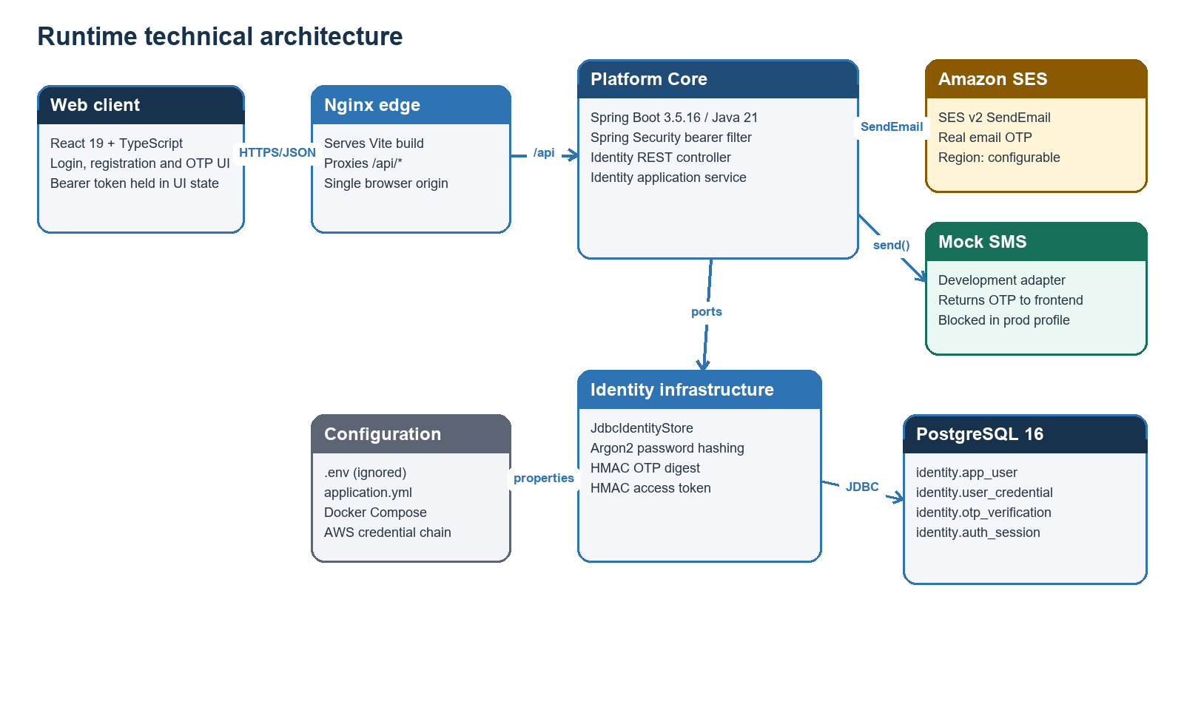
Figure 1. Runtime architecture and external dependencies.

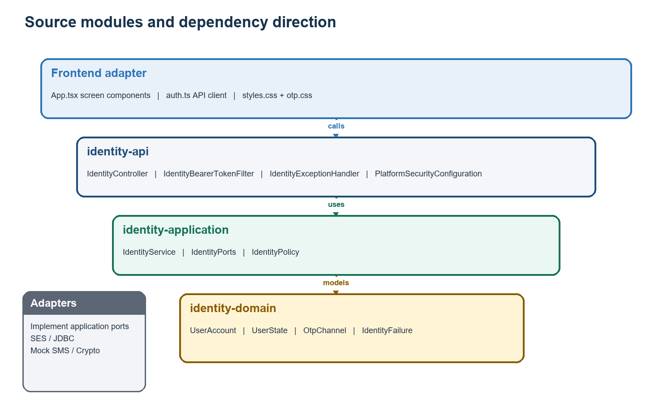
Figure 2. Source modules and inward dependency direction.
Module | Owns | Depends on
identity-domain | Account model, states, OTP channel and domain failure codes | Java only
identity-application | Use cases, policies, ports, commands and results | identity-domain; Spring @Service
identity-infrastructure | JDBC store, SES/mock adapters, Argon2/HMAC codecs, properties | identity-application
identity-api | REST endpoints, request validation, bearer filter, error mapping | identity-application
platform-core-app | Composition root, configuration and Flyway migrations | identity-api + identity-infrastructure
predictiveedge-web | User-facing screens and typed API adapter | HTTP contract only

4. Backend source-code catalog

4.1 Domain module
Class / type | Implemented methods or values | Responsibility
UserAccount | emailVerified(); mobileVerified() | Immutable user projection and verification helpers.
UserState | PENDING_VERIFICATION; ACTIVE; LOCKED; SUSPENDED; CLOSED | Account lifecycle vocabulary.
OtpChannel | EMAIL; MOBILE | Selects independent OTP challenge path.
IdentityFailure | IdentityFailure(Code,String); code() | Stable domain exception; codes cover credentials, account, OTP, token and dependency failures.

4.2 Application module
Class / interface | Method signature | Implemented behavior
IdentityService | register(RegisterCommand) | Normalizes input; generates identifiers and two OTPs; persists hashes; invokes SES and SMS ports; returns masked contacts and warnings.
IdentityService | resendOtp(UUID, OtpChannel) | Supersedes the active challenge, persists a new hash and redelivers through the selected channel.
IdentityService | verifyOtp(UUID, OtpChannel, String) | Hashes submitted OTP and converts store outcomes to stable IdentityFailure codes.
IdentityService | login(LoginCommand) | Uses constant-work password matching, requires ACTIVE, creates session and issues bearer token.
IdentityService | authenticate(String) | Verifies signed token and requires a non-revoked, non-expired persisted session.
IdentityService | logout(AuthenticatedIdentity) | Revokes the persisted session.
IdentityPolicy | IdentityPolicy(Duration,int,Duration) | Validates OTP lifetime, attempt limit and access-token lifetime.
IdentityPorts.Store | createRegistration; verifyOtp; reissueOtp; findLoginByEmail; createSession; findActiveSessionUser; revokeSession | Persistence boundary used by the application service.
IdentityPorts.PasswordHasher | hash; matches | Password-crypto abstraction.
IdentityPorts.OtpCodec | generate; hash | OTP generation and digest abstraction.
IdentityPorts.AccessTokenCodec | issue; verify | Bearer-token abstraction.
IdentityPorts.EmailOtpSender | send | Email delivery boundary.
IdentityPorts.SmsOtpSender | send | SMS delivery boundary returning a development receipt when applicable.

4.3 API module
Class | Method | Responsibility
IdentityController | register; verifyEmail; verifyMobile; resend; login; me; logout | Maps validated REST requests to application commands and maps results to HTTP responses.
IdentityBearerTokenFilter | doFilterInternal | Extracts Bearer token, authenticates it and populates Spring Security context.
IdentityExceptionHandler | validation; identityFailure; error | Maps validation/domain failures to JSON error contracts with correlation IDs.
PlatformSecurityConfiguration | platformSecurityFilterChain | Permits public auth endpoints, protects /me and logout, denies all other requests and enforces stateless security.

4.4 Infrastructure module
Class | Method(s) | Responsibility
JdbcIdentityStore | createRegistration; insertOtp | Creates user, credential and both OTP records in one transaction; suppresses duplicate disclosure.
JdbcIdentityStore | verifyOtp | Locks latest challenge, enforces expiry/attempts, consumes valid challenge and activates fully verified account.
JdbcIdentityStore | reissueOtp | Supersedes the latest active challenge and inserts a replacement.
JdbcIdentityStore | findLoginByEmail; createSession; findActiveSessionUser; revokeSession | Supports login and server-side session validation/revocation.
ArgonPasswordHasher | hash; matches | Spring Security Argon2 password encoder adapter.
HmacOtpCodec | generate; hash; hmac | SecureRandom six-digit OTP and HMAC-SHA256 digest bound to session/channel.
HmacAccessTokenCodec | issue; verify; sign | HS256-style compact token containing user ID, session ID and expiry; validates signature and expiry.
SesEmailOtpSender | send; close | Builds an HTML OTP email and calls SES v2 SendEmail.
MockSmsOtpSender | send | Returns provider ID plus plaintext OTP to the development caller.
IdentityProperties | getters/setters; Email; Sms | Binds predictiveedge.identity configuration.
IdentityInfrastructureConfiguration | identityClock; identityPolicy; identityPasswordHasher; identityOtpCodec; identityAccessTokenCodec; rejectMockSmsInProduction | Composition and production-profile guardrail.

5. Frontend source-code catalog
File / component | Method or state | Implemented behavior
App.tsx / App | screen; registration; session | Routes between login, registration, verification and authenticated workspace using component state.
LoginForm | submit | Calls login, displays errors and returns AuthSession to App.
RegisterForm | update; submit | Validates password confirmation, normalizes Indian mobile input and submits registration.
VerifyForm | verify; resend | Tracks each channel, displays delivery warning, clearly exposes latest mock OTP and enables completion after both UI verifications.
Workspace | signOut | Displays verified identity and revokes the bearer-backed session.
auth.ts | request<T> | Central JSON fetch wrapper; converts API errors and supports 204 responses.
auth.ts | register; verifyOtp; resendVerificationOtp; login; logout | Typed identity API operations.
auth.ts | toIndianE164 | Normalizes ten-digit Indian numbers to +91 E.164 form.
main.tsx | createRoot(...).render | Bootstraps React StrictMode and imports global/OTP styles.
auth.test.ts | two toIndianE164 tests | Covers spaced national input and an existing +91 country code.

Frontend token handling: The bearer token currently lives only in React component memory. This reduces persistent-browser storage exposure but signs the user out on reload and does not provide refresh-token behavior.

6. REST API contract
Method and path | Access | Success | Purpose
POST /api/identity/v1/auth/register | Public | 202 + RegistrationResponse | Create pending identity and deliver both challenges.
POST /api/identity/v1/auth/verify-email | Public | 204 | Verify email OTP.
POST /api/identity/v1/auth/verify-mobile | Public | 204 | Verify mobile OTP.
POST /api/identity/v1/auth/verification/otp/resend | Public | 202 + ResendResponse | Reissue EMAIL or MOBILE challenge.
POST /api/identity/v1/auth/login | Public | 200 no-store + AuthResponse | Authenticate active account and issue bearer token.
GET /api/identity/v1/me | Bearer | 200 + UserResponse | Return current active session user.
POST /api/identity/v1/auth/logout | Bearer | 204 | Revoke current session.

Validation contract
Field | Rule
displayName | Required; maximum 120 characters.
email | Required; syntactically valid; maximum 320 characters.
mobileNumber | Required E.164: + followed by 8-15 total digits.
password | Required; 12-1024 characters for registration.
otp | Exactly six numeric digits.
verificationSessionId | Required UUID.
channel | EMAIL or MOBILE.

Error mapping
Identity code | HTTP | Meaning
AUTH_VALIDATION_FAILED | 400 | One or more request fields failed validation.
AUTH_INVALID_CREDENTIALS | 401 | Email or password mismatch; response does not disclose which.
AUTH_ACCESS_TOKEN_INVALID | 401 | Token malformed, expired, invalidly signed or session unavailable.
AUTH_ACCOUNT_UNAVAILABLE | 403 | Account has not reached ACTIVE or is otherwise unavailable.
AUTH_OTP_INVALID | 400 | Challenge or code invalid.
AUTH_OTP_EXPIRED | 410 | Challenge expired.
AUTH_OTP_ATTEMPTS_EXCEEDED | 429 | Configured attempt ceiling reached.
AUTH_DEPENDENCY_UNAVAILABLE | 503 | OTP delivery dependency failed during resend.

7. Registration and OTP workflows
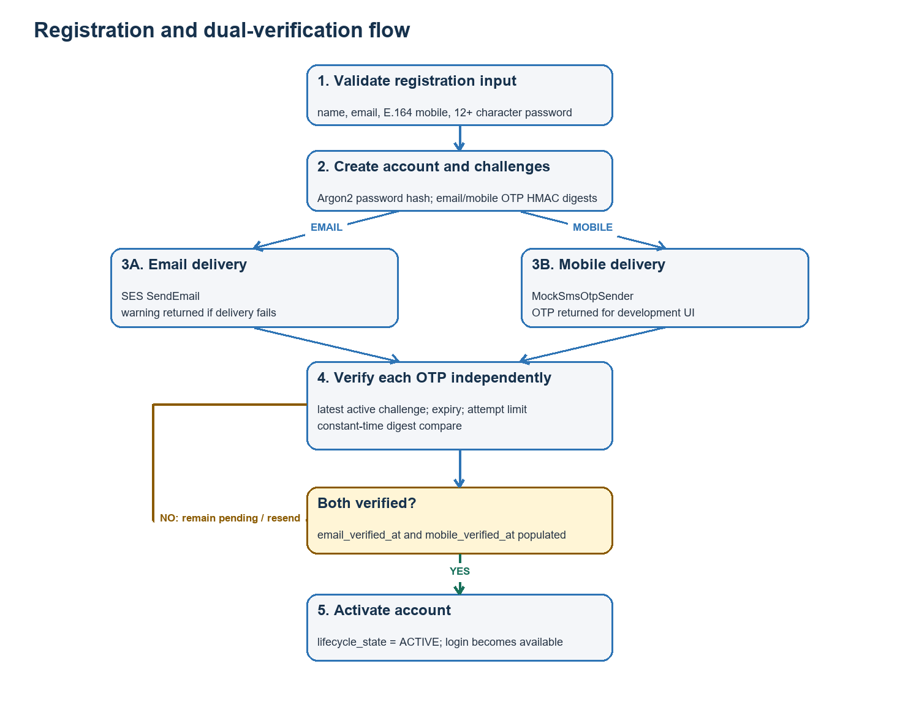
Figure 3. Registration, independent verification and activation flow.

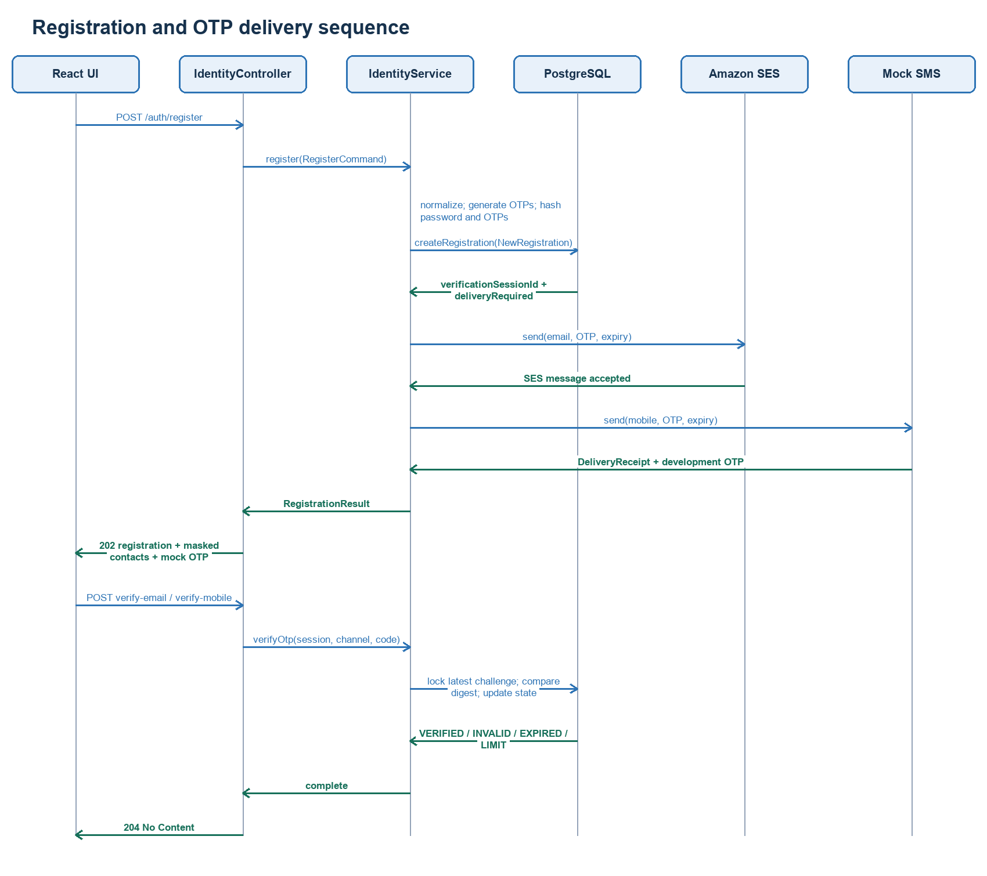
Figure 4. Registration, delivery and verification sequence.

OTP resend behavior
- Generate a new six-digit OTP and digest for the existing verification session and selected channel.
- Lock the latest active challenge; mark it superseded; insert the new challenge with a fresh expiry.
- Deliver via SES for EMAIL or return the development OTP from MockSmsOtpSender for MOBILE.
- Return 202 with a five-minute expiry; map delivery exceptions to AUTH_DEPENDENCY_UNAVAILABLE.

8. Login, authentication and logout
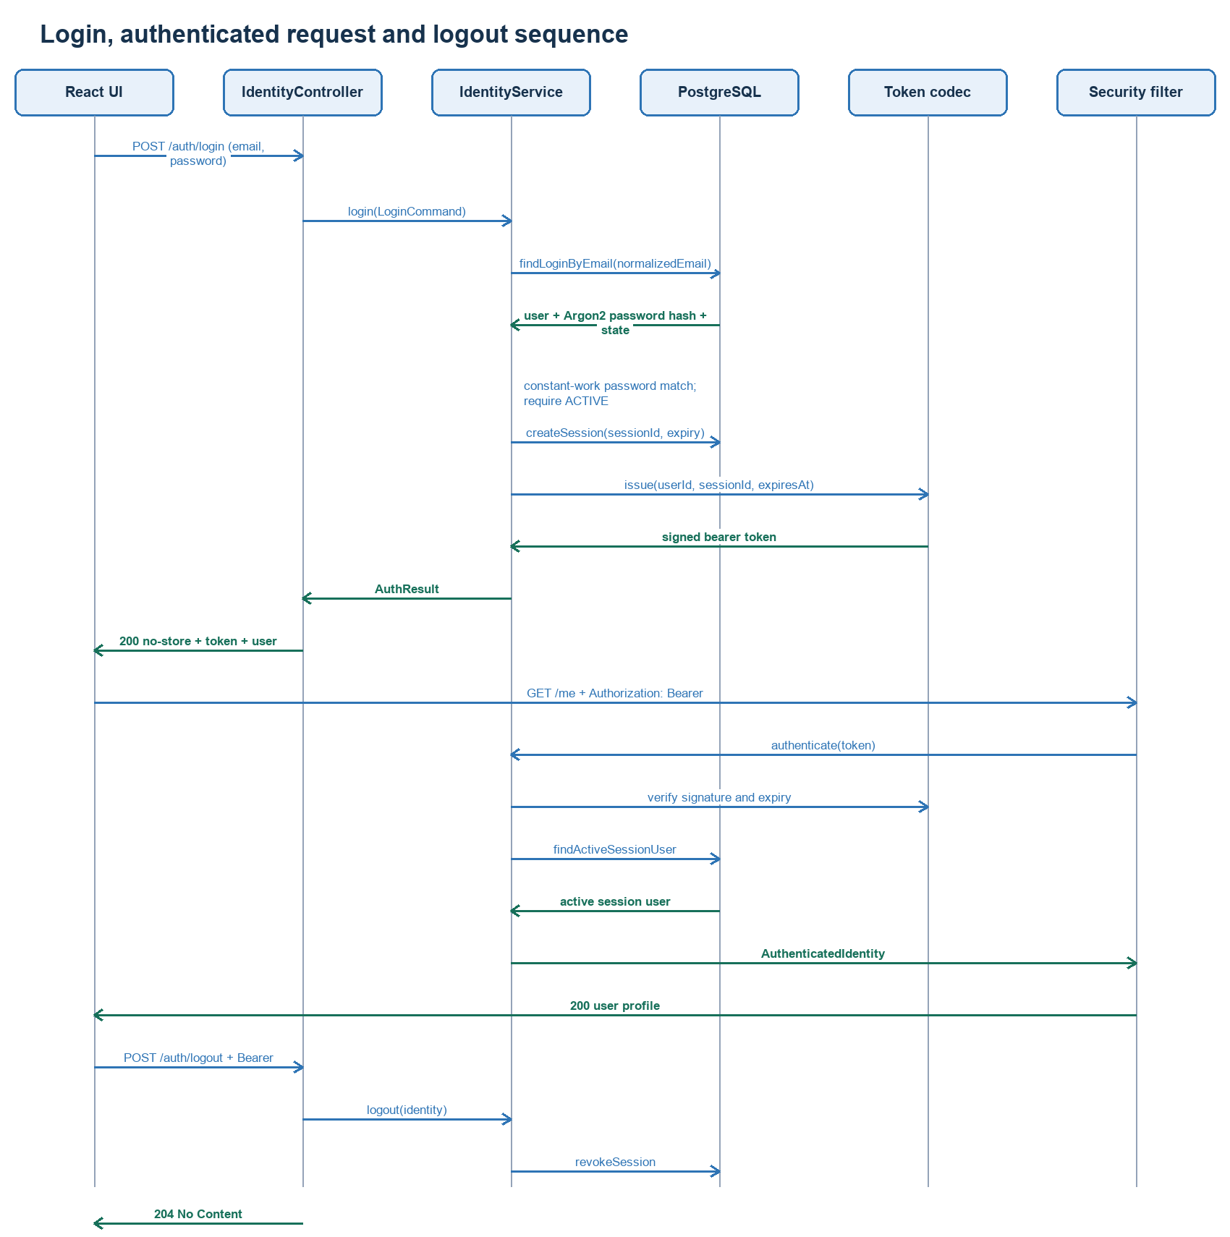
Figure 5. Login, bearer authentication, profile access and logout sequence.

Login decision path
candidate = findLoginByEmail(normalize(email))
passwordMatches = Argon2.matches(password, candidate.hash OR dummyHash)
if missing OR mismatch -> INVALID_CREDENTIALS
if state != ACTIVE -> ACCOUNT_UNAVAILABLE
create persisted session -> sign bearer token -> return no-store response

9. Data architecture
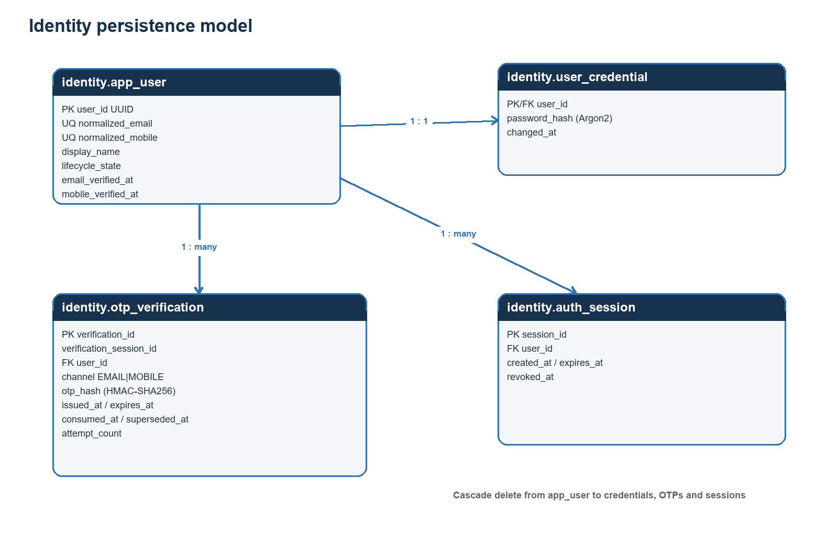
Figure 6. PostgreSQL identity schema and relationships.
Table | Key constraints and lifecycle
identity.app_user | Unique normalized email/mobile; E.164 check; state check; verification timestamps drive activation.
identity.user_credential | One credential per user; stores Argon2 encoded password only.
identity.otp_verification | Channel-constrained; expiry must follow issue time; one unsuperseded/unconsumed OTP per user and channel.
identity.auth_session | Session expiry invariant; partial index accelerates non-revoked lookup.

Account lifecycle
PENDING_VERIFICATION --(email verified AND mobile verified)--> ACTIVE
ACTIVE --(future administrative policy)--> LOCKED | SUSPENDED | CLOSED

10. Security architecture
Control | Current implementation | Assessment
Password storage | Argon2PasswordEncoder defaults for Spring Security 5.8. | Implemented
Unknown-user timing | A precomputed dummy Argon2 hash is checked when no account exists. | Implemented
OTP storage | HMAC-SHA256(sessionId:channel:otp); plaintext never persisted. | Implemented
OTP replay | Consumed and superseded timestamps; latest challenge locked FOR UPDATE. | Implemented
OTP limits | Five-minute default lifetime; five attempts by default. | Implemented
Activation gate | Login requires UserState.ACTIVE; both channels required for activation. | Implemented
Bearer authentication | Signed token plus persisted active-session lookup. | Implemented; custom format
Endpoint policy | Public auth endpoints; protected /me and logout; deny-all remainder. | Implemented
Secret handling | Environment configuration; .env is ignored locally. | Local implemented; production secret manager pending
CSRF | Disabled for stateless bearer API. | Appropriate for current transport; reassess if cookies are introduced

Sensitive values: Real AWS credentials, .env contents, OTPs and token-signing secrets are intentionally excluded from this document.

11. Configuration and deployment
Variable | Default / example | Purpose
PE_IDENTITY_OTP_SECRET | 32+ random characters | HMAC key for OTP digests.
PE_IDENTITY_ACCESS_TOKEN_SECRET | Different 32+ random characters | HMAC key for bearer tokens.
PE_IDENTITY_OTP_MINUTES | 5 | OTP validity window.
PE_IDENTITY_OTP_MAX_ATTEMPTS | 5 | OTP failure limit.
PE_IDENTITY_ACCESS_TOKEN_MINUTES | 15 | Bearer/session lifetime.
PE_EMAIL_PROVIDER | ses | Selects SES email adapter.
PE_SES_REGION | ap-south-1 | SES identity and endpoint region.
PE_SES_FROM_ADDRESS | verified sender | SES From identity.
PE_SMS_PROVIDER | mock | Selects development SMS adapter.
AWS_ACCESS_KEY_ID / SECRET / SESSION_TOKEN | Local credentials only | AWS default credential-chain inputs for development.

Docker request path
- Browser reaches Nginx web container on port 3000.
- Nginx serves React assets and proxies /api to platform-core:8080.
- platform-core connects to PostgreSQL using Compose service DNS and environment-provided credentials.
- SES calls leave platform-core through the AWS SDK; mock SMS remains in process.
Production guardrail: Application startup fails when the prod Spring profile is combined with PE_SMS_PROVIDER=mock.

12. Testing and verified behavior
Verification | Coverage / result | Status
IdentityServiceTest.registrationPersistsHashesAndRoutesBothOtpChannels | Asserts normalized email, masked response, persisted hash path and both sender calls. | Passed
IdentityServiceTest.invalidOtpUsesStableDomainFailure | Asserts INVALID store outcome becomes OTP_INVALID. | Passed
auth.test.ts | Asserts Indian mobile normalization for national and +91 input. | 2 tests passed
Frontend production build | TypeScript compilation and Vite bundle. | Passed
Docker health | web, platform-core, PostgreSQL and Redis health checks. | Healthy
SES adapter probe | Registration to SES mailbox simulator; no delivery warning. | Accepted
Mock mobile UI | OTP rendered, prefilled and verified through the live UI. | Passed
Disposable test data | Simulator registrations removed after testing. | Complete

The present automated suite is focused rather than comprehensive. Controller contracts, JDBC integration, token tamper/expiry, resend races and browser component behavior need broader regression coverage.

13. Known constraints and production backlog
Priority | Constraint / risk | Required follow-up
P0 before production | Mobile delivery is a mock and reveals the OTP to the frontend. | Complete DLT/TRAI and provider onboarding; implement a real SmsOtpSender; keep mock forbidden in prod.
P0 before commit decision | Duplicate/pending re-registration returns synthetic identifiers and does not resume a valid verification session. | Design an authenticated resume-verification/recovery flow or an expiry cleanup policy; add tests.
P0 before production | Access token uses a custom compact HMAC payload while advertising a JWT header. | Adopt a standards-compliant JWT library/claims or explicitly rename/version the token format.
P0 before production | No endpoint/IP/account rate limiting beyond OTP attempt counting. | Add layered registration, resend and login throttling plus abuse telemetry.
P1 | SES failures during initial registration are reduced to a user warning and not logged with provider diagnostics. | Add sanitized structured logging, metrics, message ID and delivery-event monitoring.
P1 | OTP delivery is synchronous. | Introduce outbox/broker delivery after this baseline without changing the public contract.
P1 | No password reset, email/mobile change or account recovery flow. | Design verified recovery journeys and security notifications.
P1 | Bearer token is memory-only with no refresh token. | Define session UX, refresh/re-auth policy and secure browser storage strategy.
P1 | Local environment permits placeholder signing secrets. | Use managed secrets and fail fast on known placeholder values outside local profile.
P2 | Redis is provisioned but unused by identity. | Remove from identity assumptions or adopt it deliberately for rate limiting/revocation caching.
P2 | Automated coverage is narrow. | Add API, database, security, email failure, resend, duplicate and browser tests.

Commit recommendation: The source can be committed as a development baseline if the commit message and artifact explicitly retain the mock-SMS and known-recovery limitations. It should not be tagged production-ready.

Appendix A. Source file inventory
Area | Implemented files (paths relative to backend/predictiveedge-parent or repository root)
Backend domain | identity-domain/.../IdentityFailure.java; OtpChannel.java; UserAccount.java; UserState.java
Backend application | identity-application/.../IdentityPolicy.java; IdentityPorts.java; IdentityService.java; IdentityServiceTest.java
Backend infrastructure | identity-infrastructure/.../ArgonPasswordHasher.java; HmacAccessTokenCodec.java; HmacOtpCodec.java; IdentityInfrastructureConfiguration.java; IdentityProperties.java; JdbcIdentityStore.java; MockSmsOtpSender.java; SesEmailOtpSender.java
Backend API | identity-api/.../IdentityBearerTokenFilter.java; IdentityController.java; IdentityExceptionHandler.java; PlatformSecurityConfiguration.java
Composition/data | platform-core-app/.../application.yml; db/migration/V002__identity_login.sql; platform-core-app/pom.xml
Frontend | predictiveedge-web/src/App.tsx; auth.ts; auth.test.ts; main.tsx; styles.css; otp.css
Runtime | docker-compose.yml; docker/Dockerfile.platform-core; docker/Dockerfile.web; docker/nginx.conf; .env.example
Operations | docs/LOGIN_LOCAL_SETUP.md

End of document.

