TECHNICAL DESIGN / RFC

PredictiveEdge Paper Trading Portal
  - Durable simulation, CORE AI strategy learning, and trader-intent backtesting

Version | Status | Owner | Updated
0.1 | Ready for implementation review | PredictiveEdge Architecture | 20 July 2026

FOUNDATIONAL DECISION Paper trading is the CORE AI module's controlled training and correction environment. Backtests are also consumed by CORE AI, but may start only from explicit, recorded trader intent. AI may propose and explain; the trader grants authority and controls promotion.

Purpose
This artifact is the development contract for the first paper trading portal. It translates the accepted broker framework into implementable frontend, application, domain, persistence, AI-integration, API, testing, and operating boundaries. It intentionally excludes live order execution.

Approval requested
- Approve the MVP scope and safety invariants.
- Approve trader-intent authorization as mandatory for backtest runs.
- Approve immutable strategy-version and experiment lineage before CORE AI integration.
- Resolve the market quote source for production-like paper fills before enabling them outside seeded or replay modes.

1. Executive summary
The portal is not a cosmetic wrapper around the existing in-memory adapter. It is a durable simulation subsystem that gives traders a safe workspace and gives CORE AI a governed environment in which strategies can learn from outcomes, diagnose errors, and propose corrected versions.
Outcome Build a persistent, long-only, INR paper account with market orders, positions, cash ledger, order history, explicit quote freshness, and immutable evidence linking trader intent, strategy version, execution, and evaluation.

The existing broker-domain, broker-spi, broker-paper-adapter, broker-backtest, and broker connection modules remain the baseline. The adapter's deterministic fill behavior is retained as the execution kernel, while persistence and orchestration move into dedicated application and infrastructure boundaries.
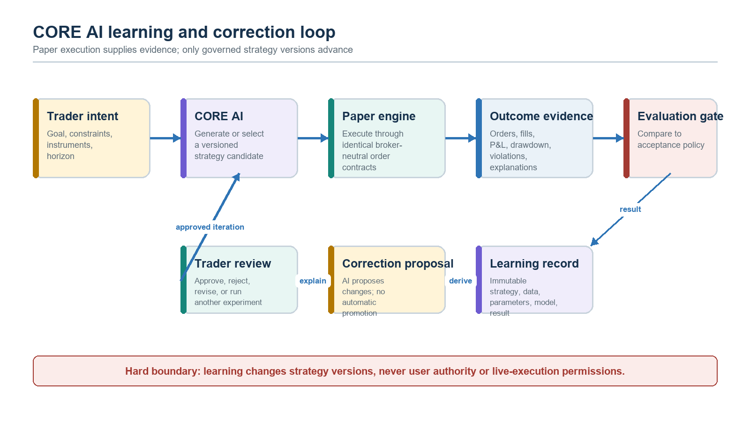
Figure 1. CORE AI uses paper outcomes to learn and propose corrections; promotion remains human-governed.

2. Scope and boundaries

MVP capabilities
- One durable paper account per user, base currency INR, configurable initial cash, and explicit reset history.
- Long-only market BUY and SELL orders with immediate fill or rejection.
- Positions, cash, cost basis, realized and unrealized P&L, orders, fills, and activity ledger.
- Seeded-development and replay quote sources; a provider-neutral fresh snapshot port for production-like paper trading.
- CORE AI strategy candidates executed through the same paper order contract as manual portal orders.
- Strategy version, model/runtime metadata, dataset hash, intent ID, parameters, order/fill lineage, metrics, and explanation evidence.
- Backtest runs created only after explicit trader confirmation of scope, strategy, dataset, budget, and expiry.
- Responsive web portal with visible PAPER mode, quote age/source, AI attribution, and LIVE LOCKED status.

Explicit non-goals
- Live broker order placement or any transport capable of placing a Zerodha order.
- Margin, short selling, derivatives, leverage, partial fills, limit/stop orders, corporate actions, or multi-currency accounting in v0.1.
- Unattended AI authority to launch backtests, mutate approved intent, promote a strategy, or move a strategy to live execution.
- Self-modifying production code or model weight training inside the transaction path. Learning means governed strategy/version iteration using captured evidence.

3. Architectural decisions
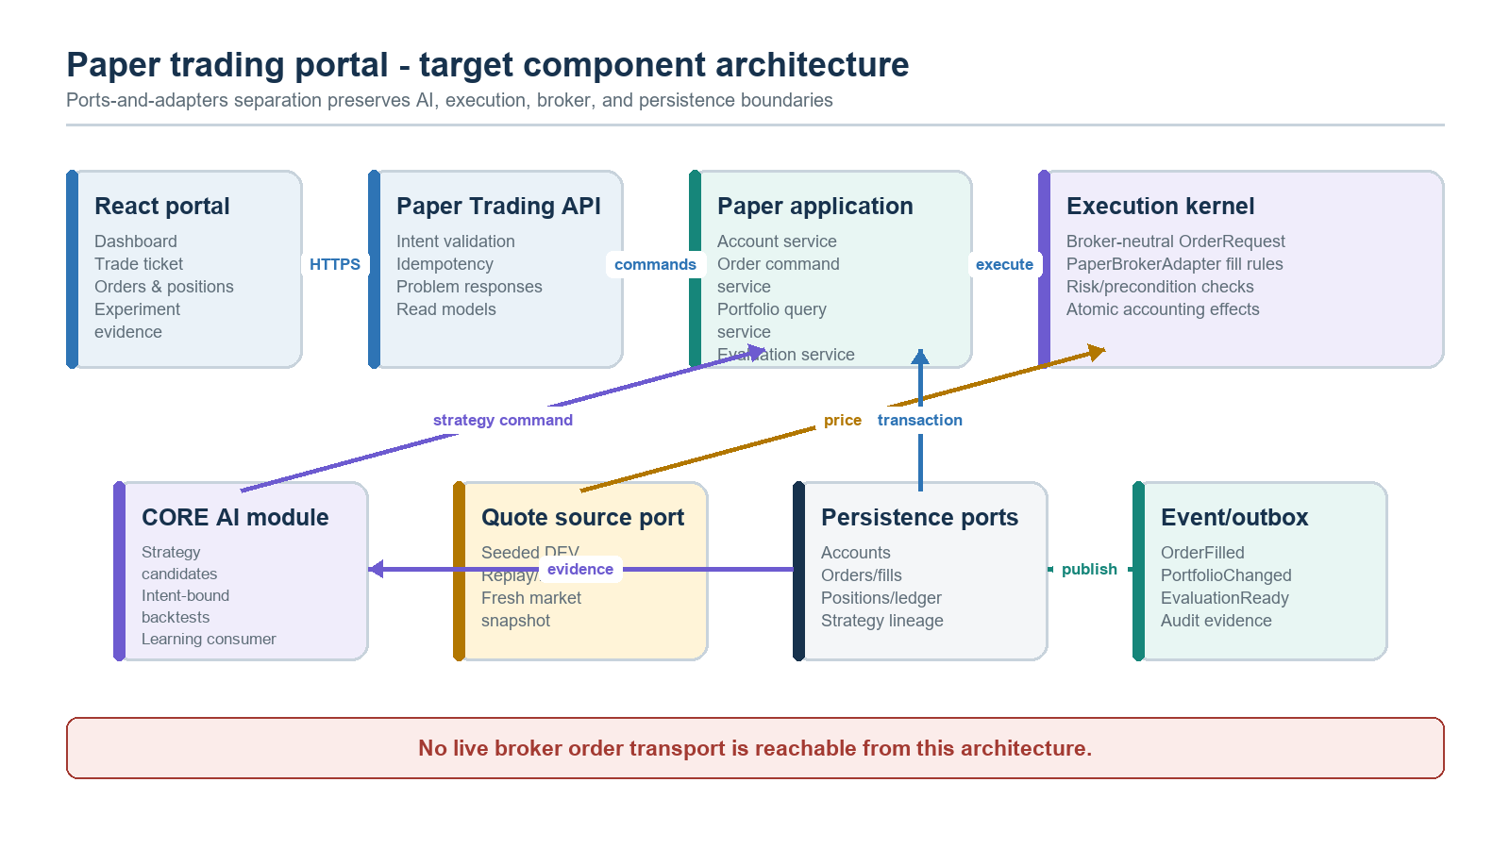
Figure 2. Target modular-monolith architecture and ports for UI, CORE AI, quotes, persistence, and events.
Decision | Rationale | Consequence
Durable application layer around the paper adapter | The current adapter owns in-memory state and is unsuitable for restart-safe user accounts. | Commands use repositories and a transaction boundary; the adapter remains a deterministic execution kernel.
CORE AI integrates through ports and events | Trading Intelligence must not depend on UI, persistence, or broker details. | AI submits versioned strategy commands and consumes immutable outcome evidence.
Trader intent is an authorization artifact | Human-in-control must be enforceable, not a UI convention. | Backtest jobs require a valid, confirmed, scoped intent token.
Ledger is authoritative | Mutable balances alone cannot explain or reconstruct outcomes. | Cash movements and fills are append-only; positions and account snapshots are projections.
Quote freshness is server enforced | Client prices are untrusted and stale fills corrupt learning. | Every fill stores source and as-of time; missing/stale prices reject without mutation.
Transactional outbox | AI evaluation and UI updates must not be lost after a committed fill. | Events commit with aggregates and publish asynchronously.

4. CORE AI contract and governance

Paper trading learning contract
- A strategy is immutable once executed. Corrections create a new strategy_version with parent lineage.
- Each order identifies actor type (TRADER or CORE_AI), strategy version when applicable, correlation ID, and originating intent or paper experiment.
- CORE AI consumes normalized execution evidence: pre-trade context, quote evidence, decision explanation, order result, portfolio effects, and evaluation metrics.
- Evaluation policies are versioned separately from strategies; a strategy cannot rewrite the criteria used to judge itself.
- Promotion states are DRAFT, CANDIDATE, VALIDATED, and RETIRED. Only a trader or future authorized governance workflow can move a version between states.
- Paper performance never implies live suitability; live enablement requires a separate architecture decision and execution-gateway controls.

Backtesting authorization
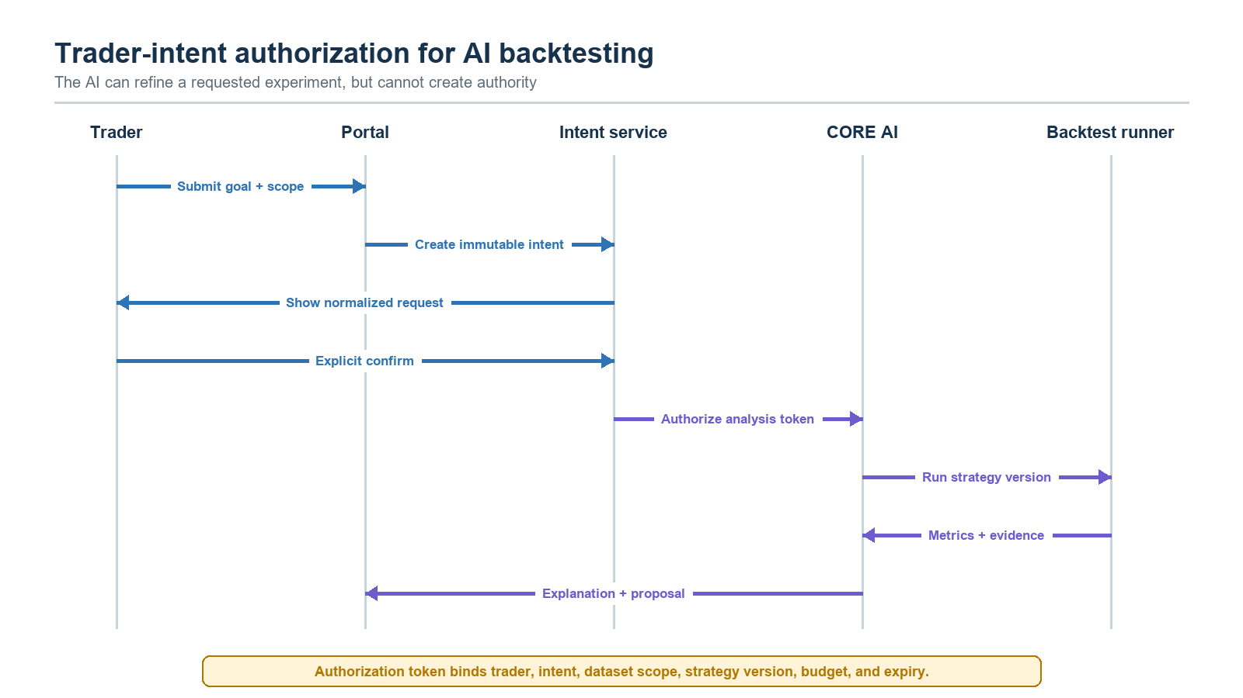
Figure 3. Trader-intent sequence for an AI-assisted backtest request.
Intent field | Required meaning
intent_id | Immutable server-generated identifier.
user_id | Trader granting the authority.
objective | Natural-language goal plus normalized machine-readable objective.
universe | Allowed exchanges/instruments; no silent expansion.
time_range / interval | Dataset scope and candle granularity.
strategy_version_id | Exact strategy version, or explicit permission for AI to propose one before confirmation.
compute_budget | Maximum scenarios, duration, or resource envelope.
confirmed_at / expires_at | Proof of explicit confirmation and bounded validity.
content_hash | Tamper-evident hash of the normalized authorization payload.

DENY BY DEFAULT Missing, expired, mismatched, or materially changed intent blocks the run. Parameter changes outside the confirmed envelope require a new confirmation.

5. Portal experience
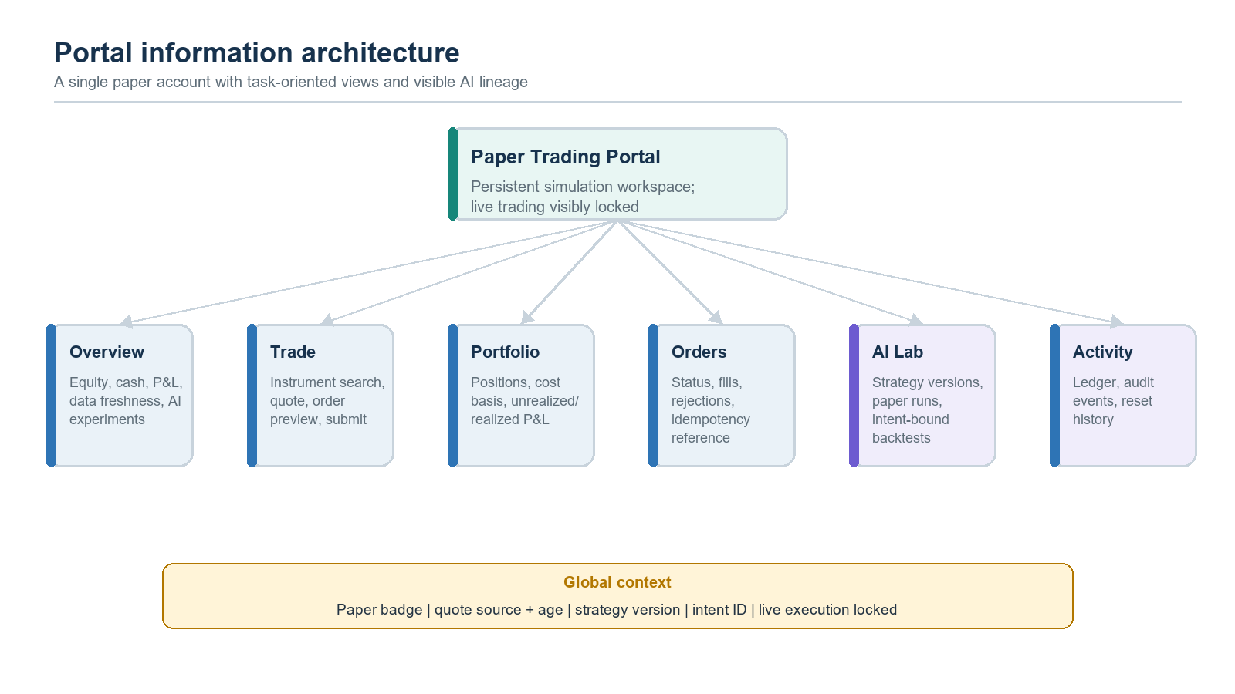
Figure 4. Portal navigation and persistent global safety context.
Route | Primary job | Critical states
/paper | Account and experiment overview | Loading, empty account, ready, degraded quote source.
/paper/trade/:exchange/:symbol | Preview and submit a manual or AI-attributed paper order | Fresh/stale quote, insufficient cash/position, duplicate request.
/paper/portfolio | Understand holdings and P&L | No positions, stale valuation, reconciliation warning.
/paper/orders | Inspect order and fill evidence | Filled, rejected, cancelled (future), idempotent replay.
/paper/ai-lab | Review strategy versions, experiments, and proposed corrections | Intent required, running, evaluated, policy pass/fail.
/paper/activity | Audit cash, fill, reset, and evaluation events | Cursor pagination, correlation drill-down.
/paper/settings | Starting cash/reset and simulation preferences | Typed reset confirmation, immutable reset event.

Interaction rules
- Show PAPER in the persistent shell and never reuse live-trading colors or labels.
- Show quote source and age next to every executable price and stored fill.
- Order preview is advisory; submission always causes a server-side reprice and validation.
- AI-originated actions show strategy version, intent/experiment link, explanation, and policy result.
- A reset creates a new account epoch; it never deletes historical orders, fills, or experiment evidence.
- Every destructive action uses explicit confirmation and returns a durable activity record.

6. Domain model and invariants
Aggregate / value | Responsibility | Key invariants
PaperAccount | Simulation identity, currency, epoch, configuration | One active account per user; optimistic version; reset creates new epoch.
PaperOrder | Intent and terminal execution result | Unique clientOrderId per account; immutable payload; actor and lineage required.
PaperFill | Executed quantity and price evidence | Positive quantity/price; one fill for MVP market order; source/asOf retained.
CashLedgerEntry | Append-only cash movement | Every filled BUY/SELL has balancing entry; balance_after reproducible.
Position | Quantity, average cost, realized P&L projection | No negative quantity in long-only MVP; version checked under lock.
StrategyVersion | Immutable executable strategy definition | Content hash unique within strategy lineage; parent pointer never changes.
TraderIntent | Bounded human authorization | Confirmed, unexpired, hash-matched, scope-matched before run.
ExperimentRun | Paper/backtest execution envelope | Pins strategy, intent where required, data hash, engine version, and seed.
Evaluation | Metrics and policy decision | Append-only for policy version; explanation references evidence.

Accounting rules
- BUY cash delta = -(fill quantity x fill price + modeled costs); SELL cash delta = +(proceeds - modeled costs).
- Available cash must remain non-negative. Position quantity must remain non-negative.
- For v0.1, costs default to zero but the schema stores cost components so later modeling does not rewrite history.
- Realized P&L is derived when reducing a position; unrealized P&L uses a separately timestamped valuation quote.
- Order, fill, ledger entry, position projection, account version, and outbox event commit atomically.
- All monetary calculations use BigDecimal with explicit scale/rounding; never double/float.

7. Order processing
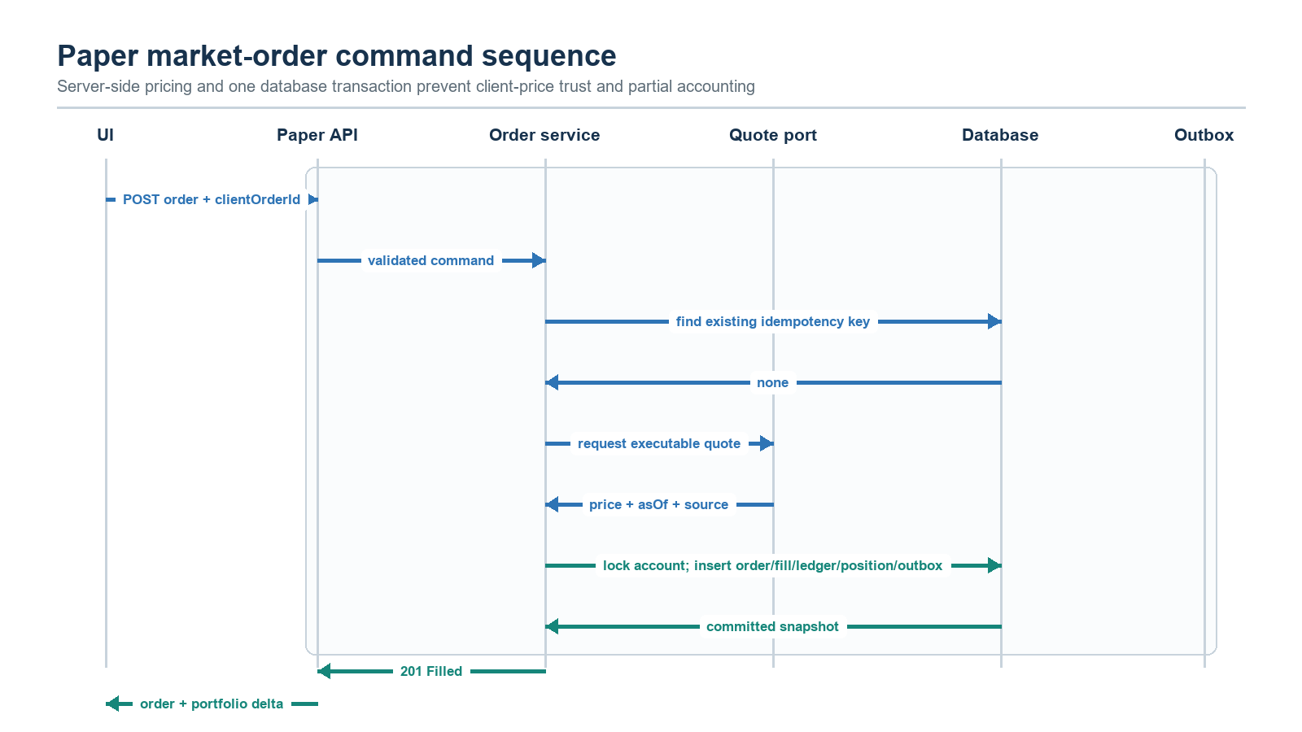
Figure 5. Immediate paper market-order processing with server-side price evidence and one transaction.

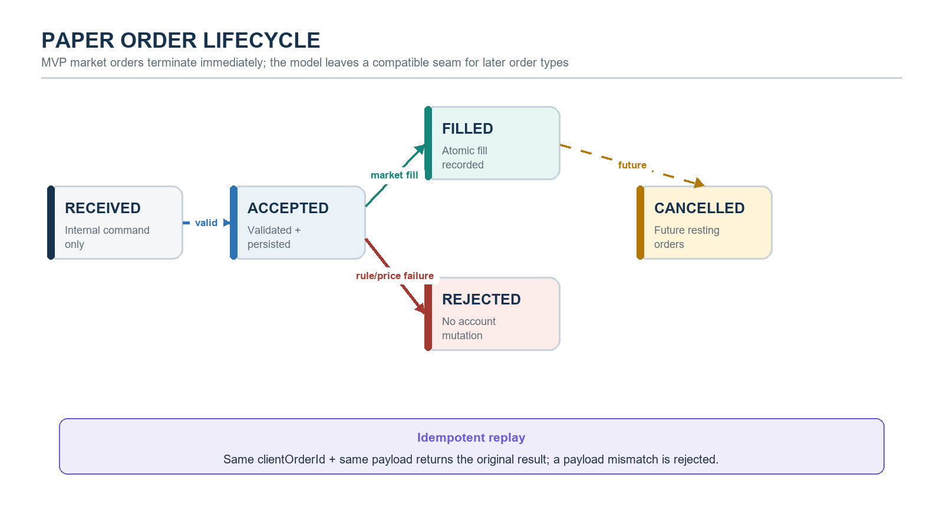
Figure 6. Paper order lifecycle and idempotency behavior.

Concurrency and idempotency
- The API requires clientOrderId; the database enforces UNIQUE(account_id, client_order_id).
- A repeated key with an identical normalized payload returns the original order and does not repeat effects.
- A repeated key with different instrument, side, type, or quantity returns 409 IDEMPOTENCY_CONFLICT.
- The service locks the account row or uses compare-and-swap versioning before funds/position checks and posting.
- Deadlocks and serialization failures may be retried inside a small bounded policy; the idempotency key remains constant.
- Rejected orders are persisted with a stable reason code and no fill/ledger/position effects.

8. Persistence design
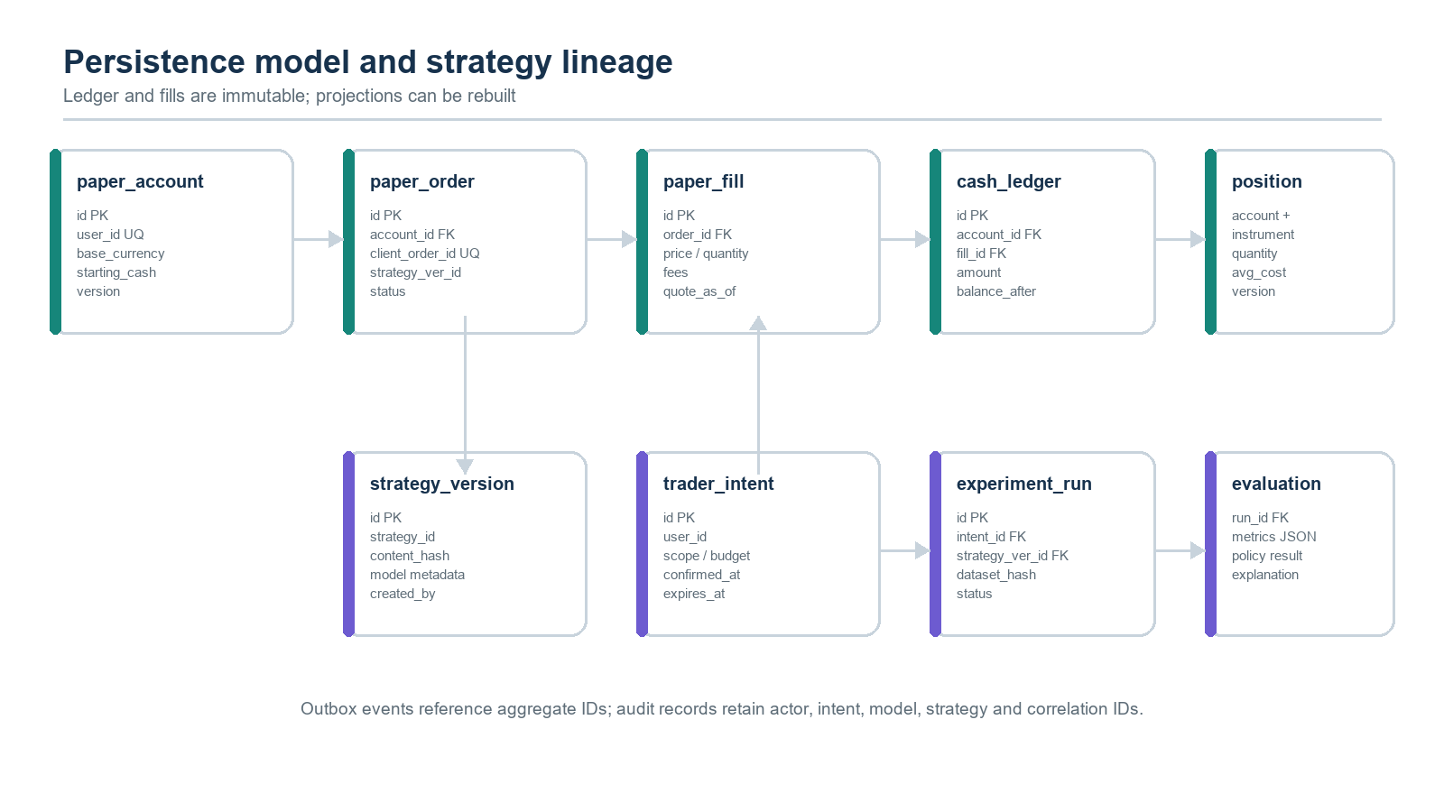
Figure 7. Core paper-account and AI strategy-lineage entities.
Table | Important constraints / indexes
paper_accounts | UNIQUE(user_id, active); version; epoch; base_currency='INR'; non-negative balances.
paper_orders | UNIQUE(account_id, client_order_id); indexes on created_at, status, strategy_version_id, intent_id.
paper_fills | UNIQUE(order_id) for MVP; positive price/quantity; quote source and quote_as_of.
paper_cash_ledger | Append-only; UNIQUE(fill_id, entry_type); ordered by account_id + sequence.
paper_positions | PK(account_id, exchange, symbol); non-negative quantity; optimistic version.
strategy_versions | Immutable content JSON/hash; parent ID; creator; model/runtime metadata.
trader_intents | Normalized payload JSON + hash; confirmation and expiry; status.
experiment_runs | Pins engine version, seed, dataset hash, strategy, intent, and lifecycle state.
evaluations | Metrics JSON with schema version; policy version and pass/fail decision.
event_outbox | Aggregate, event type/version, payload, correlation/causation IDs, publish attempts.

Migration plan
- V005 creates paper accounts, orders, fills, ledger, and positions.
- V006 creates strategy versions, trader intents, experiment runs, and evaluations.
- V007 creates the transactional outbox and read-model indexes.
- Migrations are additive. The current broker connection V003/V004 schema is untouched.

9. Quote and market data contract
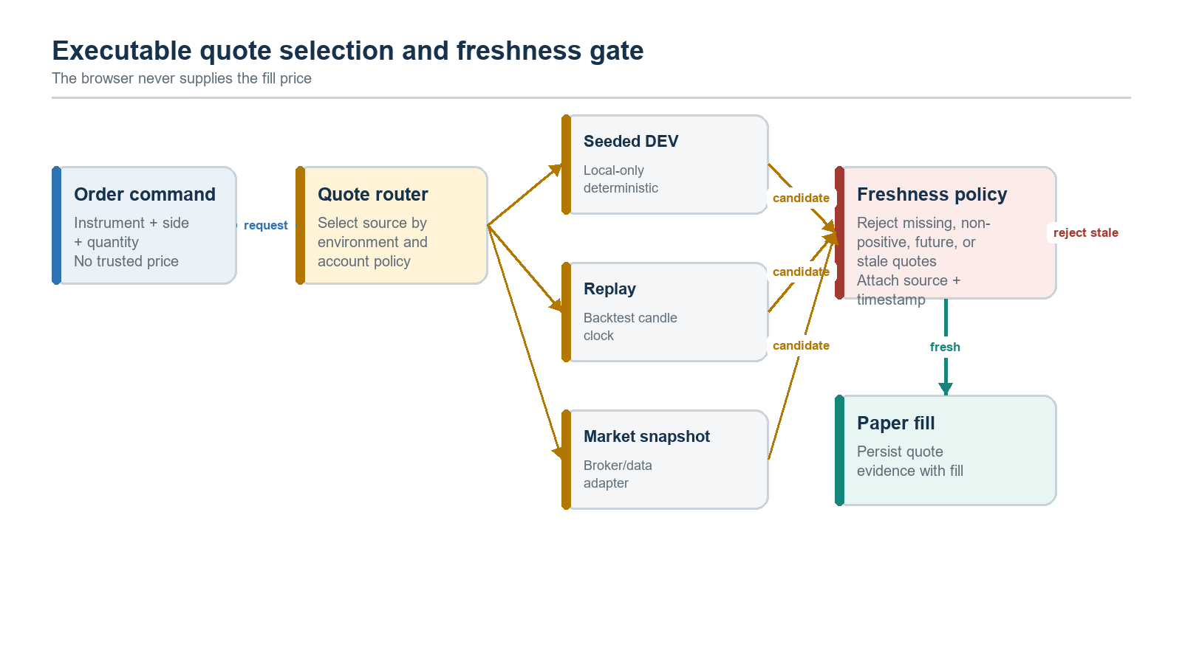
Figure 8. Provider-neutral executable quote routing and freshness policy.
Mode | Allowed use | Freshness / reproducibility rule
SEEDED_DEV | Local UI development and contract tests only. | Deterministic seed/version displayed; production profile refuses this source.
REPLAY | Backtesting and controlled CORE AI experiments. | Virtual clock equals candle timestamp; dataset hash and ordering are pinned.
MARKET_SNAPSHOT | Production-like paper trading after provider adapter exists. | Server timestamp, provider timestamp, source, and configurable max age are mandatory.

OPEN DEPENDENCY The existing Zerodha adapter provides historical candles, not a current executable quote. Public paper-order activation therefore depends on a CurrentMarketDataProvider implementation or another approved quote provider. Seeded and replay modes can proceed immediately.

10. API contract
Method | Path | Result
GET | /api/paper/v1/account | Account summary, cash, equity, data status, active epoch.
POST | /api/paper/v1/account | Create the user's initial account; idempotent.
POST | /api/paper/v1/account/reset | Create a new epoch after typed confirmation; retain history.
GET | /api/paper/v1/quotes/{exchange}/{symbol} | Snapshot, source, asOf, age, and executable flag.
POST | /api/paper/v1/orders | Submit market order with clientOrderId and optional strategy/experiment lineage.
GET | /api/paper/v1/orders/{orderId} | Order, rejection/fill evidence, correlation metadata.
GET | /api/paper/v1/orders?cursor= | Cursor-paginated order history.
GET | /api/paper/v1/positions | Positions with valuation timestamps and P&L.
GET | /api/paper/v1/activity?cursor= | Ledger and audit read model.
POST | /api/ai/v1/intents | Normalize a proposed backtest intent; not yet authorized.
POST | /api/ai/v1/intents/{id}/confirm | Record explicit confirmation and issue bounded authorization.
POST | /api/ai/v1/backtests | Start only with valid authorization and exact content hash.
GET | /api/ai/v1/experiments/{id} | Status, metrics, lineage, explanation, and evidence links.

Error envelope
Use application/problem+json with stable type, title, status, code, detail, instance, correlationId, and fieldErrors. Stable codes include QUOTE_STALE, QUOTE_UNAVAILABLE, INSUFFICIENT_FUNDS, INSUFFICIENT_POSITION, IDEMPOTENCY_CONFLICT, INTENT_REQUIRED, INTENT_EXPIRED, INTENT_SCOPE_MISMATCH, STRATEGY_VERSION_NOT_FOUND, and CONCURRENT_ACCOUNT_UPDATE.

11. Events, explainability, and evidence
Event | Consumers | Required evidence
PaperOrderFilled.v1 | Portal read model, CORE AI evaluator | Order/fill IDs, actor, strategy/intent/experiment IDs, quote evidence, account delta.
PaperOrderRejected.v1 | Portal, CORE AI evaluator | Stable reason, checked constraints, quote state, correlation ID.
PaperPortfolioChanged.v1 | Portfolio projector, UI notifications | Account version, cash delta, position delta, valuation dependency.
ExperimentCompleted.v1 | CORE AI, AI Lab read model | Strategy/data/engine hashes, metrics, policy version, artifact references.
StrategyCorrectionProposed.v1 | Trader review queue | Parent/new version, changed parameters/rules, evidence-backed rationale.
PaperAccountReset.v1 | Audit/activity, CORE AI lineage guard | Old/new epoch, actor, confirmation evidence, retained history links.

Every AI-facing evidence package must answer: what was intended, which immutable strategy/model/data versions acted, what the market context was, what decision was made and why, what execution occurred, what changed in the portfolio, which metrics resulted, and which policy accepted or rejected the outcome.

12. Security, authorization, and privacy
- All paper and AI endpoints require the authenticated PredictiveEdge user; resource IDs are always scoped by user at the repository query.
- The browser may display but never sign or mint trader-intent authorization. Confirmation and hashes are server generated.
- CORE AI receives capability-scoped service authority, not a reusable user bearer token.
- Prompt text, strategy content, model output, and explanations are treated as user-owned potentially sensitive data and excluded from routine logs.
- Audit logs store identifiers, hashes, decisions, and safe metadata; raw broker credentials and access tokens remain isolated in broker infrastructure.
- Rate limits apply per user and account to order submissions, quote reads, and backtest compute.
- A global configuration kill switch disables new paper orders or AI experiments without corrupting read access.
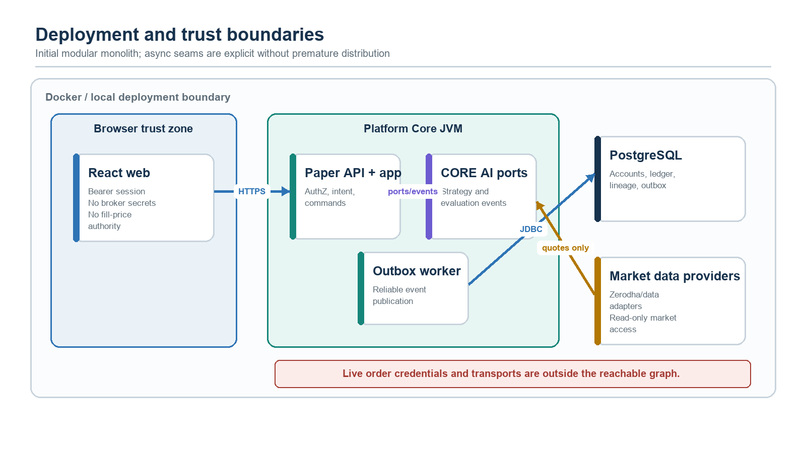
Figure 9. Initial deployment and trust boundaries; live broker order transports remain unreachable.

13. Reliability and failure behavior
Failure | Required behavior
Quote missing/stale/non-positive | Persist rejected order with safe code; no balance or position mutation.
Duplicate request after timeout | Return original result when payload matches; never execute twice.
Database conflict | Bounded retry; otherwise 409 with correlation ID; no partial accounting.
Outbox publisher unavailable | Order transaction still commits; event remains pending and is retried.
CORE AI consumer unavailable | Paper trading remains operational; evidence queues until consumer recovers.
Evaluation fails | Experiment is EVALUATION_FAILED, execution evidence remains immutable and retryable.
Intent expires during queueing | Job must validate at acceptance; a previously accepted run retains the authorization snapshot.
Application restart | Durable accounts/orders survive; pending outbox and experiments resume deterministically.
Reset racing with order | Account version/lock serializes operations; one succeeds against a specific epoch.
Market provider degradation | Portal exposes degraded state and disables executable submission; historical reads remain available.

14. Observability and operations
Signal | Minimum dimensions / alert
paper_order_total | status, reason, actor_type, quote_source; alert on rejection/error step-change.
paper_order_latency | p50/p95/p99 from API acceptance to committed terminal result.
quote_age_seconds | provider, exchange; alert when executable threshold is exceeded.
paper_account_reconciliation_failures | account epoch; any non-zero value is actionable.
outbox_lag_seconds | event type; alert when oldest pending event breaches SLO.
ai_experiment_total | status, strategy, engine version; monitor failures and budget denials.
intent_denial_total | reason; security signal for mismatch/replay attempts.
evaluation_policy_pass_ratio | policy/strategy version; analytical signal, never an auto-promotion trigger.

Structured logs include timestamp, severity, service/module, correlationId, causationId, user hash, accountId, orderId, experimentId, strategyVersionId, intentId, outcome code, and duration. They exclude access tokens, raw prompts by default, and full strategy payloads.

15. Testing strategy
Layer | Required tests
Domain | Money/quantity validation, long-only accounting, cost basis, P&L, terminal states, strategy immutability.
Application | Idempotency, lock/version conflict, stale quote rejection, reset/order race, intent scope/expiry, outbox atomicity.
Persistence | Testcontainers PostgreSQL migrations, constraints, row locking, pagination, append-only ledger, outbox claims.
Contract | REST schemas/problem codes, CORE AI ports/events, event compatibility, quote provider behavior.
Frontend | Route guards, PAPER/LIVE LOCKED visibility, quote age, optimistic-state prohibition, accessibility, responsive states.
End-to-end | Manual paper order, AI-attributed paper order, intent confirmation/backtest, restart recovery, provider degradation.
Property / model | Random order streams preserve cash/position invariants and reconcile ledger to projections.
Security | Cross-user ID access, forged/replayed intent, mutated content hash, log redaction, rate limits.

Definition of done
- No test can produce negative cash or long-only position quantity.
- A fault injected after any transaction statement leaves either all effects or none.
- Repeated identical clientOrderId has exactly one economic effect.
- Every AI-originated fill resolves to immutable strategy and experiment evidence.
- Every backtest resolves to confirmed trader intent; forged or changed scope is rejected.
- The portal remains useful after restart and clearly disables actions when data is stale.
- Accessibility checks cover keyboard operation, focus, labels, contrast, live regions, and reduced motion.

16. Delivery plan
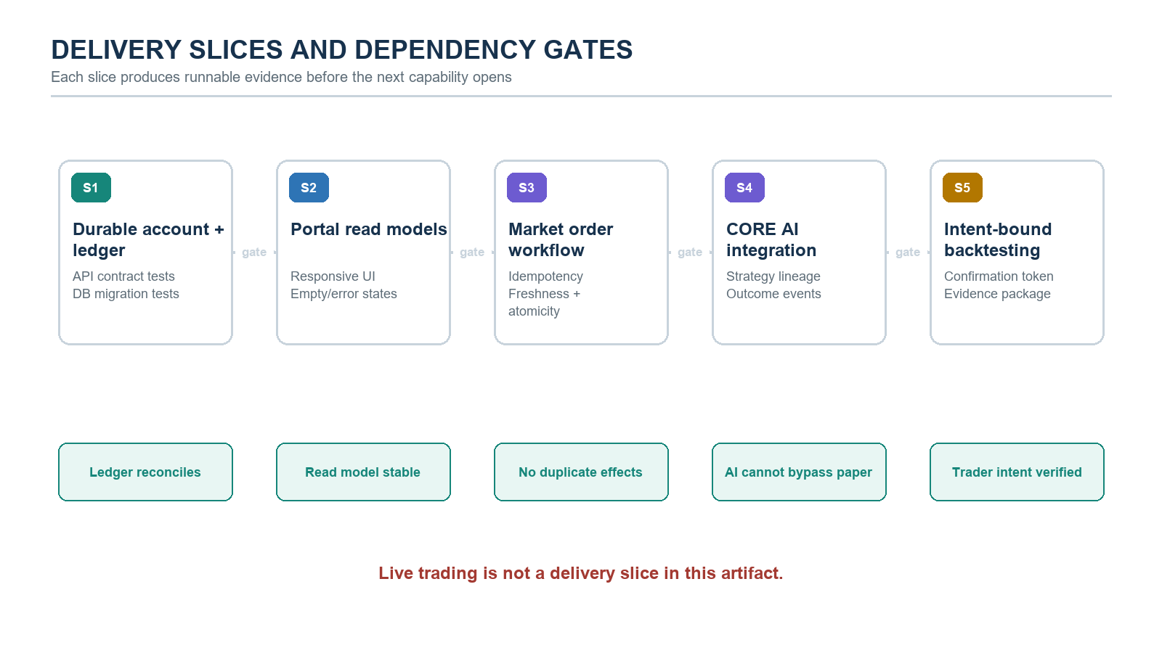
Figure 10. Incremental delivery slices and the evidence gate for each slice.
Slice | Code impact | Exit evidence
S1 Durable core | Extend broker domain; add paper application/infrastructure/API modules; V005. | Account/ledger reconciliation and migration tests pass.
S2 Portal shell | React paper feature routes, query layer, overview/portfolio/orders/activity. | Responsive and accessible empty/error/loaded states.
S3 Order workflow | Executable quote port, market order command, idempotency, transaction/outbox. | Concurrency and fault-injection suite passes.
S4 CORE AI learning | Strategy V006, lineage ports/events, evidence packages, evaluation policy. | AI cannot bypass paper gateway or mutate executed versions.
S5 Intent backtesting | Intent normalization/confirmation, authorization validator, experiment orchestration. | Backtest cannot run without matching confirmed intent.

17. Module and package plan
Module | Planned responsibility
broker-domain | Retain broker-neutral order concepts; add explicit execution/quote evidence only if shared by real adapters.
broker-paper-adapter | Deterministic fill policy; refactor state dependency behind a port or move accounting orchestration outward.
paper-trading-application (new) | Account, order, portfolio, reset, reconciliation, actor/lineage, and transaction use cases.
paper-trading-infrastructure (new) | JDBC repositories, quote adapters, transactional outbox, projectors, schedulers.
paper-trading-api (new) | Versioned REST contract, authentication/authorization mapping, problem responses.
broker-backtest | Replay engine; evolve to persist ExperimentRun and consume immutable strategy/input definitions.
trading-intelligence/core-ai (future/new) | Strategy proposal, evaluation, correction proposal; depends only on declared ports/events.
platform-core-app | Composition root, configuration, migrations, scheduling, feature/kill switches.
predictiveedge-web | Paper feature slice, routes, state/query clients, AI Lab and evidence views.

18. Acceptance criteria
- A user can create, view, restart, and reset a durable paper account without losing audit history.
- A manual market order fills once at a server-selected fresh quote or rejects without any economic mutation.
- Cash, ledger, positions, fills, and account equity reconcile for every committed order stream.
- CORE AI can submit a paper strategy command, consume outcome evidence, and propose a child strategy version without promoting it.
- A backtest job is impossible without a confirmed trader intent whose hash, scope, strategy, budget, and expiry match.
- The UI distinguishes trader and AI actions and links each AI action to explanation and lineage.
- Seeded/replay modes are visibly labeled; production profile cannot silently use seeded prices.
- No paper module can reach a live order transport; live trading remains locked in UI and dependency graph.
- All critical failure paths are observable through stable error codes, metrics, correlation IDs, and retained evidence.

19. Open decisions before S3/S4
Decision | Required by | Recommended default
Production-like current quote provider and freshness thresholds | Before S3 public activation | Introduce CurrentMarketDataProvider; exchange-specific max age; reject on uncertainty.
Initial cash and reset policy | S1 | INR 1,000,000 configurable; reset creates a new epoch after typed confirmation.
Cost model | S3 | Zero cost in v0.1 schema-compatible MVP; add versioned Indian fee/tax model before strategy claims.
CORE AI strategy representation | S4 | Immutable JSON DSL plus semantic/schema version and content hash; no executable arbitrary code in JVM.
Evaluation metrics and promotion policy | S4 | Return, max drawdown, win rate, turnover, exposure, violation count; manual promotion only.
Backtest compute budget vocabulary | S5 | Max instruments, candles, scenarios, wall time, and concurrency per intent.

IMPLEMENTATION START CONDITION S1 and S2 can begin after this design is approved. S3 may ship in seeded/replay mode while the current-quote provider decision is resolved. S4 requires the immutable strategy representation decision. S5 requires the intent budget vocabulary.

Appendix A. Current baseline and gaps
Existing capability | Location | Gap addressed by this design
Broker-neutral orders/accounts | broker-domain | No durable paper portfolio, fill evidence, actor or strategy lineage.
Adapter SPI and clientOrderId seam | broker-spi | No application transaction, persistence, API, or event contract.
In-memory paper market fills | broker-paper-adapter | State disappears on restart; quote freshness and fees are absent.
Chronological backtest replay | broker-backtest | No persisted runs, trader intent, strategy version, metrics policy, or evidence lineage.
Zerodha historical data/login | broker-zerodha-adapter + connection modules | No current quote provider; deliberately no live order adapter.
Broker workspace card | React App.tsx / broker.ts | Paper card is informational only; no portal routes or read/command models.

Alignment references
- PredictiveEdge Constitution v1.0: Human-in-Control, broker independence, explainability, event-driven and auditable AI.
- PredictiveEdge System Architecture v1.0: Trading Intelligence Layer, Trade Execution Gateway, Broker Adapter Framework, and Continuous Learning lifecycle.
- ADR-0001: broker-neutral adapter boundary, mandatory client-generated order IDs, and no live execution before gateway controls.
- ADR-0002: Zerodha data, paper trading, and deterministic backtesting precede live trading.
- Broker connection lifecycle: credentials remain backend-only and paper/backtest capabilities do not expose live-order endpoints.

Appendix B. Review checklist
- Product: scope, portal journeys, reset behavior, and visible AI attribution accepted.
- Architecture: module boundaries, ports, transaction/outbox model, and no-live dependency graph accepted.
- AI: learning semantics, immutable lineage, evaluation policy ownership, and human promotion accepted.
- Security: intent authorization, cross-user isolation, service capability, redaction, and rate limits accepted.
- Data: quote source/freshness, accounting model, schema/migrations, and reconciliation accepted.
- Engineering: delivery slices, API/events, test strategy, observability, and open-decision owners assigned.

