Deploying website and database on heroku - Django – Python

Step 1

Install Git cmd in your system

Link : <https://github.com/git-for-windows/git/releases/download/v2.37.0.windows.1/Git-2.37.0-64-bit.exe>

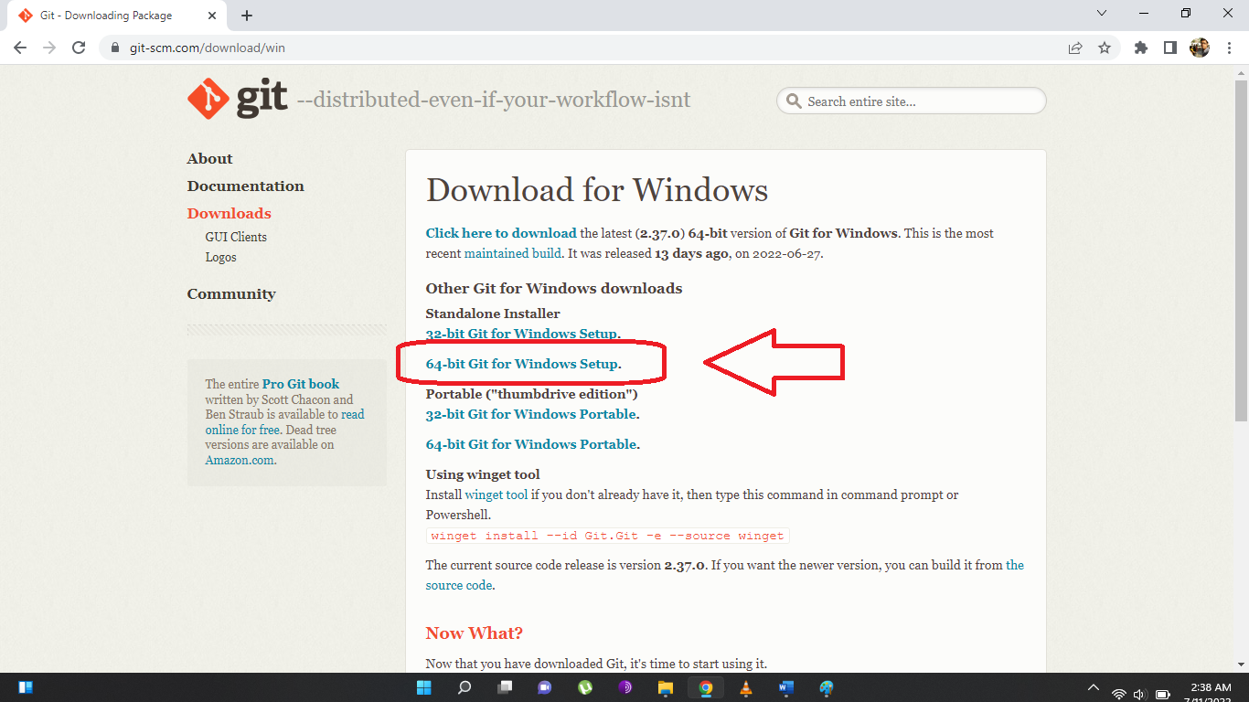

Step 2

Create project in separate Repository

To create your project

Create project in virtual Enviroment ( Recommended )

Step 3

Make sure virtual environment is activated befor begin deployment process

Install all the dependencies libraries on your virtual environment

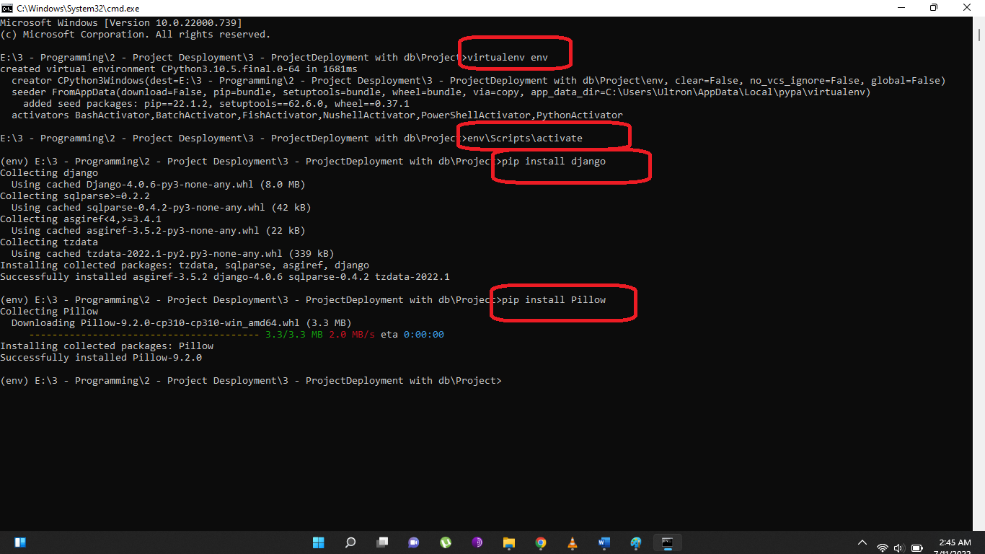

Step 4

Goto Outer project Folder

**>>> cd comp_project**

Create requirements.txt

**>>> pip freeze > requirements.txt**

**Step 5**

Add changes to settings.py for static files

Import os

STATIC_ROOT = os.path.join(BASE_DIR , ‘static’ )

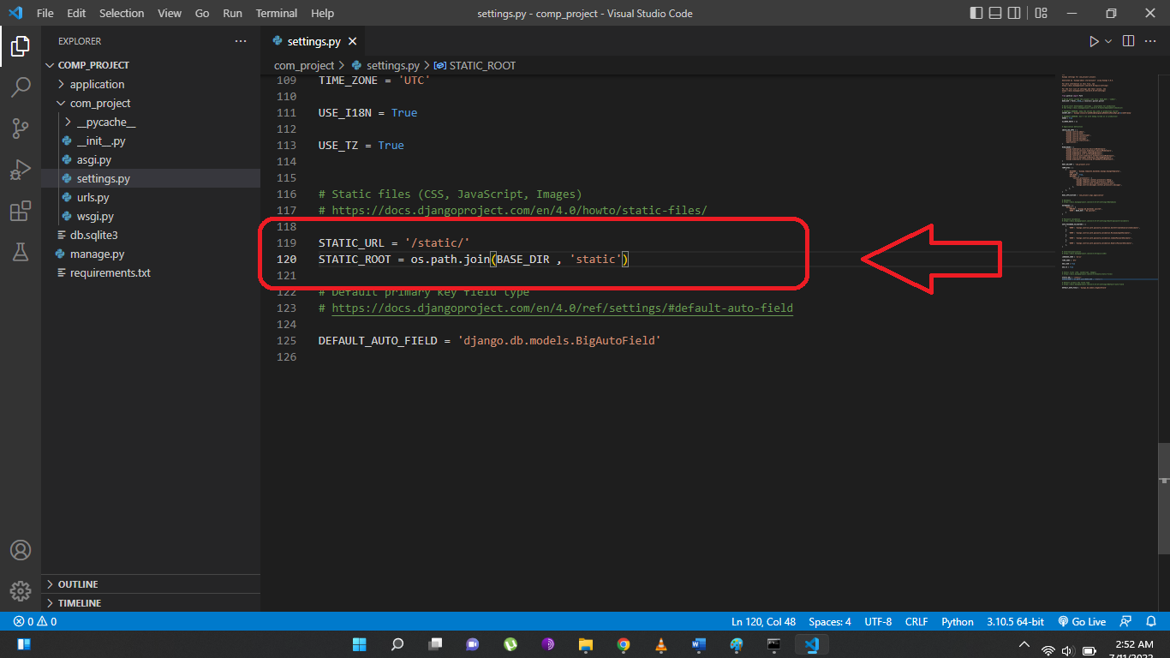

Step 6

Create Heroku Account

Link : <https://id.heroku.com/login>

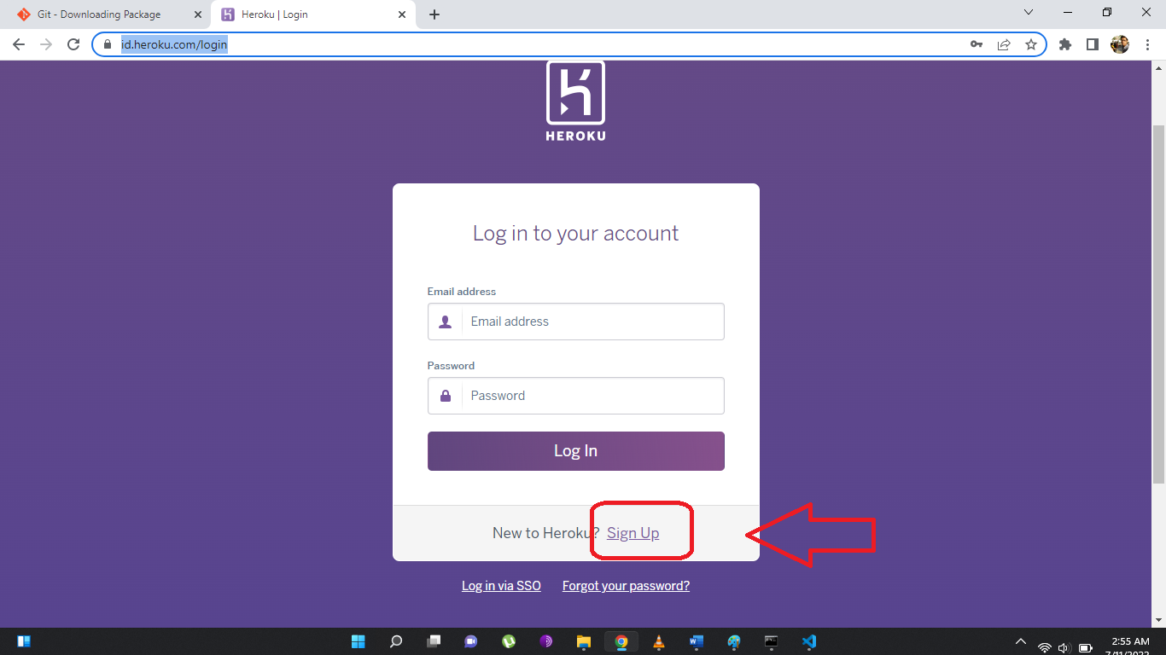

Step 7

Install Heroku CLI

Link : <https://devcenter.heroku.com/articles/heroku-cli>

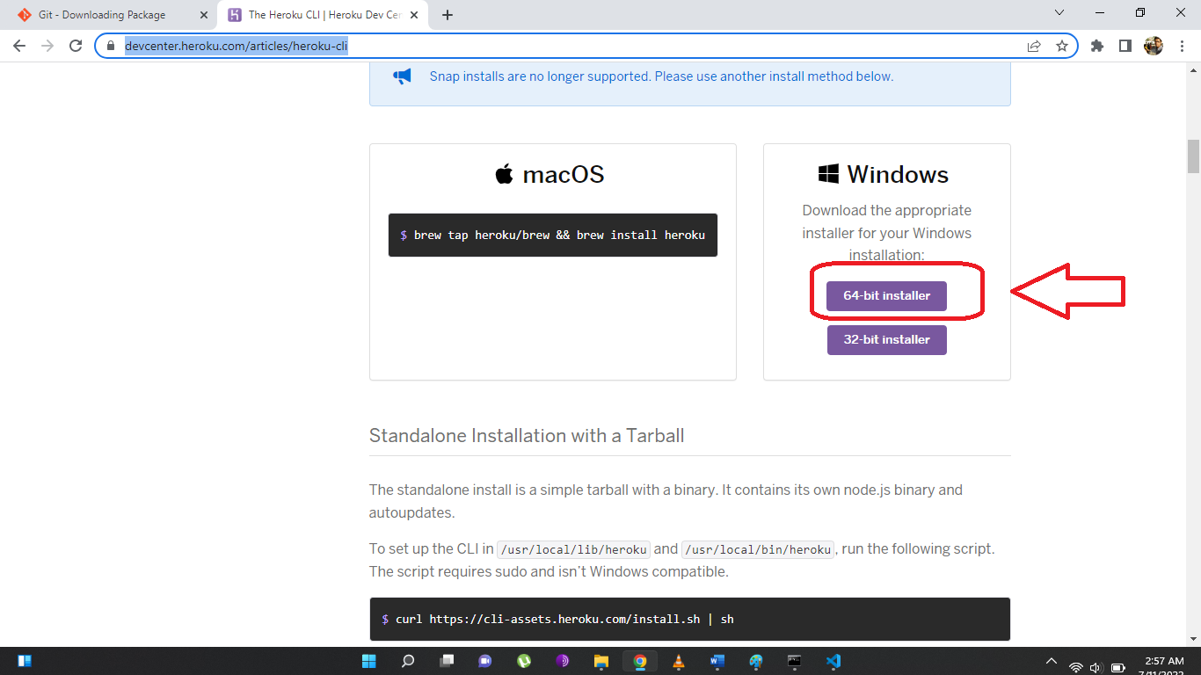

Step 8

Configure Django Heroku

Link : <https://devcenter.heroku.com/articles/django-app-configuration>

# create Procfile named file in your outer project folder

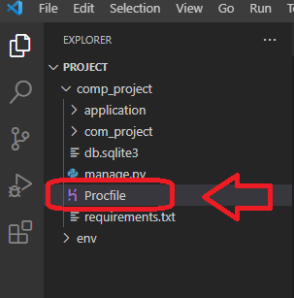

And add configuration code

web: gunicorn myproject.wsgi

here myproject is your inner project folder name

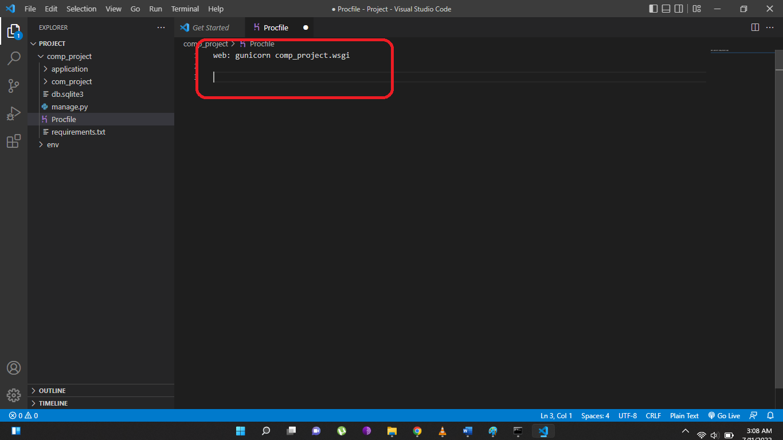

**Installing gunicorn**

**Goto terminal and type this command in your virtual environment**

**>>>** pip install gunicorn

Now add this requirement into requirements.txt

**>>> freeze > requirements.py**

>>> pip install Django-heroku

>>> freeze > requirements.py

Step 9

Add Django-heroku library in your settings.py

import Django_heroku

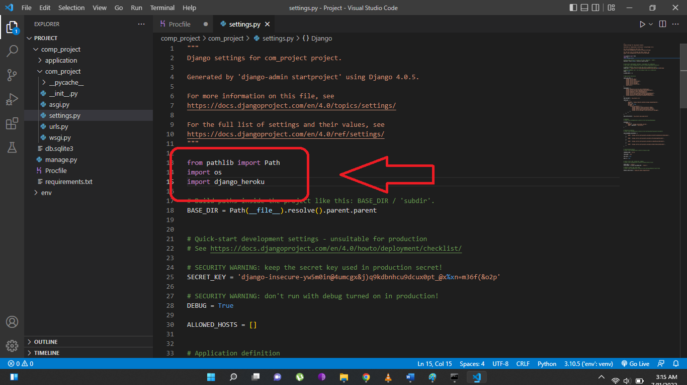

Activate Django Heroku

Open settings.py and add this code

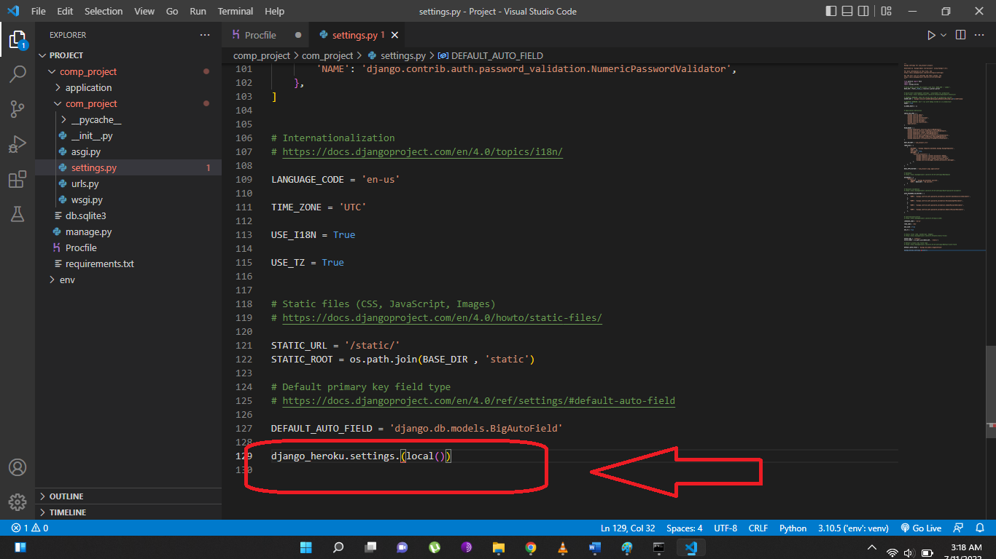

Step 10

Type these commands in your terminal in virtual environment

>>> git init

>>> git add .

>>> git commit -m “first commit”

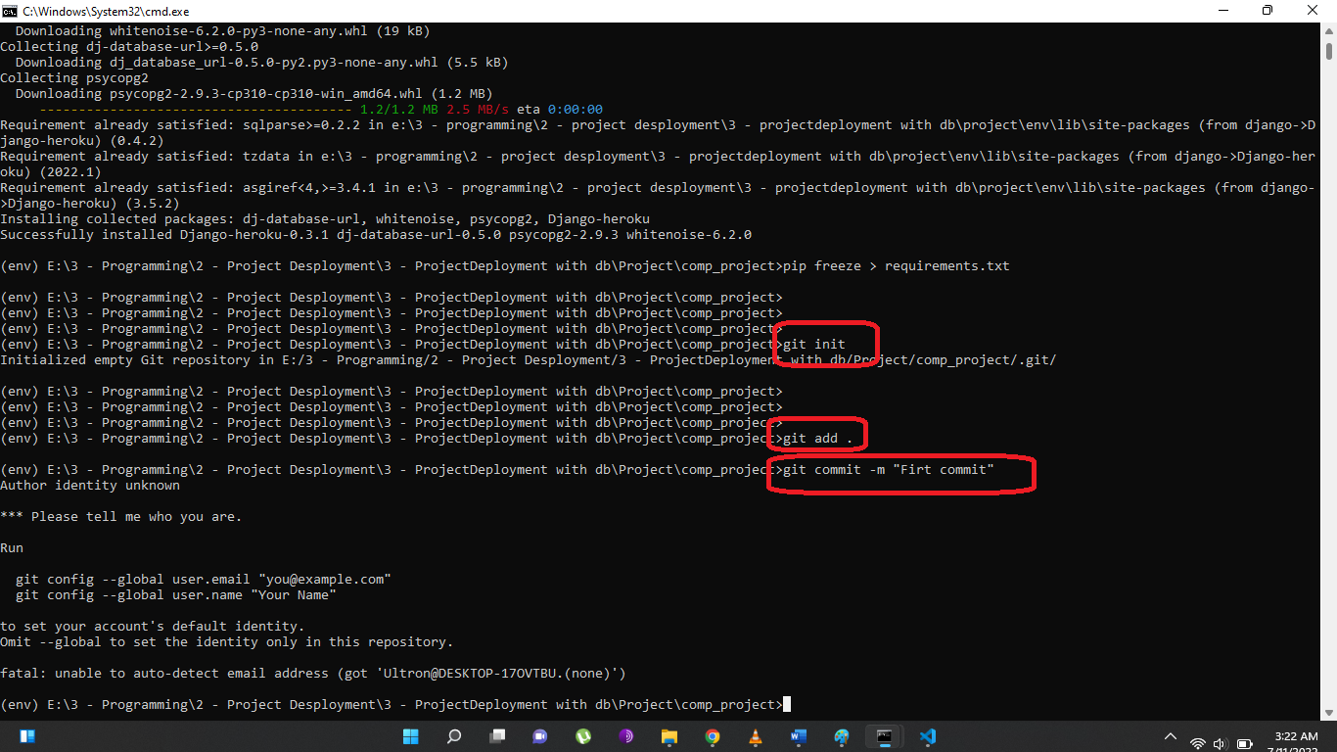

Now add global username and email

By typing these commands

>>> git config --global user.email [you@example.com](mailto:you@example.com)

>>> git config --global user.name "Your Name"

Step 11

Login to Heroku

>>> heroku login

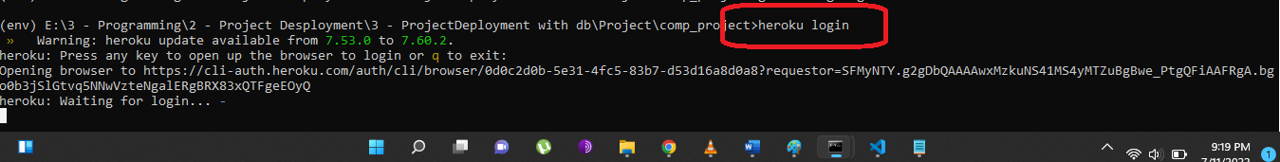

Then it will redirect you to browser

Login your Heroku account

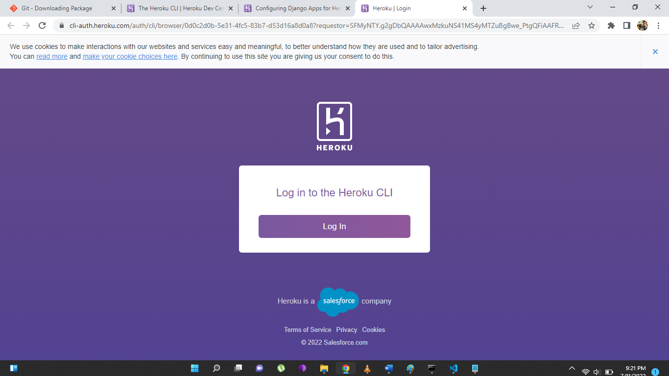

Step 12

Create your app

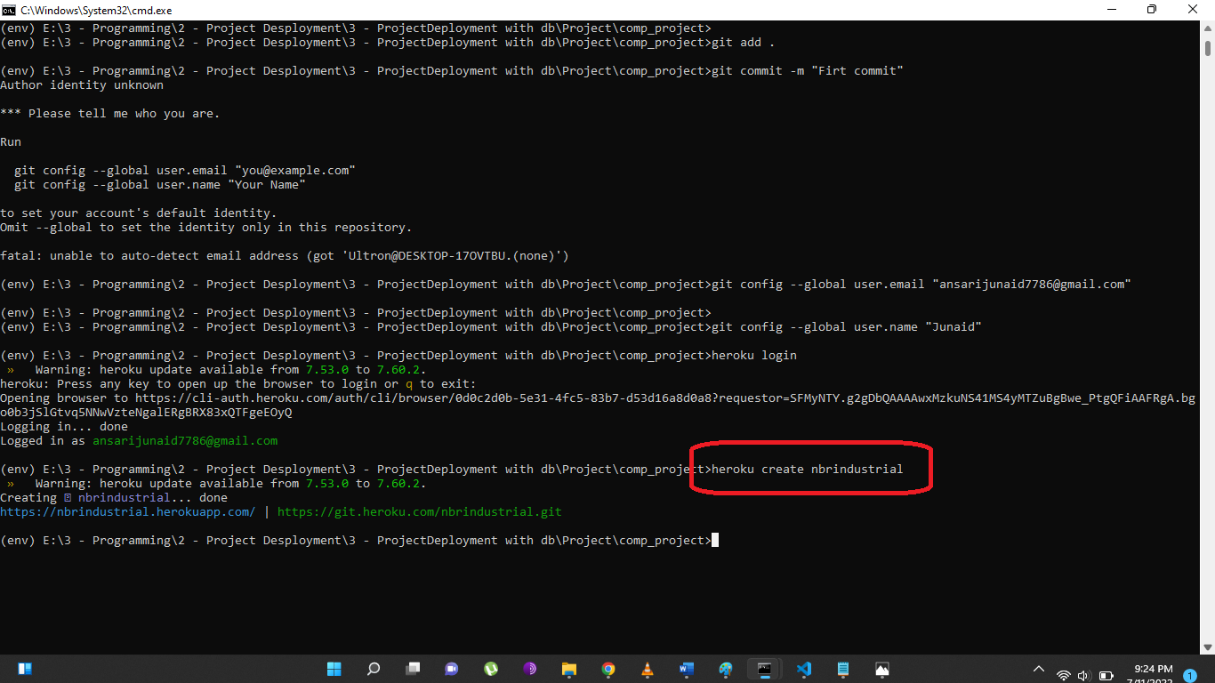

**>>> heroku git:remote -a nbrindustrial**

**( nbrindustrial app name )**

Project name should be proper

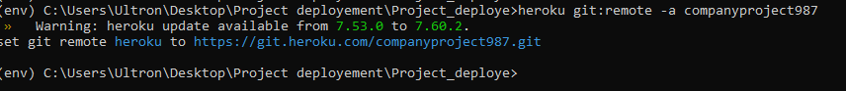

Step 13

Push repository

>>> git push Heroku master

Step 14

>>> open heroku

**Database Connection**

Step 15

**>>> heroku run python manage.py migrate**

its important to database connectivity

Step 16

**>>> heroku run python manage.py createsuperuser**

