ADOORA LEGAL SERVICES
Website and Client Portal
A plain-language guide: what the firm has, where each part is, and how it works behind the scenes
Prepared for: the partners and staff of ADOORA Legal Services
Status as of: 1 October 2026
Keep this guide with the project. It describes the system as built; if something changes, update the section it belongs to.
Contents
1. The system at a glance 4
How the pieces fit 4
2. Signing in 6
Three separate sign-ins 6
How people prove who they are 6
Who can sign in: the Team page panel 7
Staying signed in, and stopping access 7
3. Who can do what 8
4. The public website 9
What visitors see 9
Rules the website follows 9
5. The admin console, section by section 10
Clients & court cases 10
Website 11
6. Cases and the court's own record 12
How to add a case 12
How to add a client 15
How to add a lawyer (or anyone at the firm) 17
How to link lawyers and clients to a case 18
Checking who has access 20
Updating a case from the court 20
Things worth knowing 20
7. Documents 22
Folders 22
Safety 22
8. The lawyer workspace 23
9. The client dashboard 24
What a client cannot do 24
On phones 24
10. Articles and AI 25
Finding topics: trending leads 25
Drafts 25
Cover images 25
11. What it costs to run 26
12. Behind the scenes, in plain terms 27
What happens when someone presses a button 27
Jobs that run by themselves 27
Settings that change behaviour 27
Safeguards 28
13. Where things are kept in the project 29
How changes are published 29
14. Current limits and next steps 30
15. Glossary 31

1. The system at a glance
The firm has one website with four parts. Each part is reached at its own address and, where a sign-in is needed, has its own sign-in page.
Part | Who uses it | Address | What it is for
Public website | Anyone | adoora-web-production.up.railway.app (your own domain once connected) | The firm's practice areas, people, articles (Insights), careers and contact details.
Admin console | Owners and administrators | /admin  Sign in: /admin/login | Running the firm's side: cases, clients, lawyers, documents, enquiries, jobs, articles.
Lawyer workspace | The firm's lawyers (owners and administrators too, for cases assigned to them) | /lawyer  Sign in: /lawyer/login | The cases a lawyer is assigned to: court updates, documents, client questions.
Client dashboard | The firm's clients | /dashboard  Sign in: /login | A client follows their own cases: hearing dates, court orders, documents, questions to their lawyer.

How the pieces fit
Think of the system as a small office building:
- The front desk (the website). Everything people see and click. It shows pages and forms, but keeps no records of its own.
- The back office (the server). Every button that saves, fetches or changes something asks the back office. It checks who is asking and whether they are allowed, then does the work.
- The filing room (the database). All records: cases, clients, hearings, orders, articles, enquiries and the audit log.
- The strong room (the secure file store). The documents themselves (PDFs, scans, Word files), locked with encryption before they are stored.
- Outside services the back office calls on: Google (sign-in, and Gemini for AI drafting and images), the courts' own websites (case status and orders), MSG91 (mobile sign-in codes), and eCourtsIndia (a paid backup for court data).
All of it is hosted on Railway, a cloud hosting service. The website and the back office run as two separate services, so a problem in one does not take the other down; the public pages keep working even if the back office is briefly unavailable.

2. Signing in

Three separate sign-ins
There are three sign-in pages. Each one works on its own: signing in or out of one never affects the other two.
Sign-in page | Who can use it | Where it leads
/login  (the Login button on the website) | Anyone, as a client | The client dashboard
/lawyer/login  ('Lawyer login' in the website's Login box) | People on the Team page with access Lawyer, Admin or Owner | The lawyer workspace: only the cases assigned to that person
/admin/login  (not linked anywhere on the website) | People on the Team page with access Owner, Admin or Editor | The admin console

- All three at once. Each area keeps its own sign-in, so one person, for example an owner, can be signed in to the admin console, the lawyer workspace and (with a client account) the client dashboard in the same browser at the same time.
- Signing out of one area leaves the other two signed in.
- Owners and administrators in the lawyer workspace work exactly as a lawyer does there: they see only the cases they are assigned to. They see every case in the admin console.
- The admin page is not advertised. It is reached only by typing /admin/login; the website and the other sign-in pages do not link to it.

How people prove who they are
Sign-in | Mobile code (OTP) | Continue with Google
Client | Any mobile number. A new number creates a new client account; a known one signs in. | Any Google account. A new one creates a client account and is asked once to add and confirm a mobile number.
Lawyer and admin | Only the mobile number saved for that person on the Team page. | Only the email saved for that person on the Team page.

- Firm members are never created by signing in. An owner or administrator adds them first on the Team page, with their email and mobile number, and chooses their access (Owner, Admin, Lawyer, Editor or No sign-in).
- Someone not on the Team page, or whose access does not allow that page, is told the email or number is not registered with the firm and to ask the administrator.
- The first owner is created automatically the first time an email listed in the server setting ADMIN_EMAILS signs in at the admin page.
- There are no passwords to send, reset or leak.

Who can sign in: the Team page panel
Admin console → Team (Lawyers) opens with a Who can sign in panel. It lists every email that can open the admin console and every email that can open the lawyer workspace (lawyers, administrators and owners), with each person's access and when they last signed in, plus any ADMIN_EMAILS that have not signed in yet. To give or remove access, change the person's access with Edit; it applies on their next click, without them signing out.

Staying signed in, and stopping access
- Firm sessions last 12 hours; client sessions last 7 days.
- Deactivating an account (Team or Clients → Edit → Account → Deactivated) signs that person out of every area at once. Their history is kept.

3. Who can do what
Who | Can see | Can do | Cannot do
Owner | Everything | Everything, including adding or changing owners and administrators | —
Administrator | Every case, client, document, enquiry and article | Open cases, assign lawyers, link clients, manage lawyers and the website | Change an owner's or another administrator's account
Lawyer (and owners or administrators in the lawyer workspace) | Only the cases they are assigned to, including internal files | Update a case from the court, edit its details, upload and organise documents, add timeline notes, answer client questions | Open new cases, change who is on a case, link client accounts, see other lawyers' cases
Editor | Website content | Website content work | See any case or client
Client | Their own linked cases, and only files shared with them | Read hearings and orders, upload documents, add notes, raise questions | Add a case, update from the court, see internal files, see prices

These rules are enforced by the back office on every request, not just by hiding buttons. A case someone may not see behaves as if it does not exist.

4. The public website

What visitors see
Section | What is there | Where it is changed
Disclaimer | The Bar Council of India disclaimer every visitor must accept before seeing firm information. The wording is the firm's own. | Fixed text; change only with the firm's sign-off.
Home page | A slideshow of five slides: Our people (team photograph, 'Experienced Minds, Trusted Counsels'), Pro bono, Our services, Counsel and Careers. On phones the team photograph is shown three people at a time, one slide each. Then the firm's introduction, practice areas, featured people and latest articles. | Slide text and images are set in the website's content; the team photograph can be replaced by a file of the same name (with the number of people in it updated).
Practices | One page per practice area, with the lawyers ticked for it. | Website content; lawyers are ticked in Team (Lawyers).
Insights | The firm's articles. Each article shows its cover beside the title, and an 'On this page' list that highlights the section being read. | Admin console → Articles.
About Us | The firm and its people. | People: Admin console → Team (Lawyers).
Community | The firm's pro bono and community work: legal aid, awareness camps, support for NGOs, and how organisations can work with the firm. | Website content.
Careers | What the work is like, open roles and an application form. | Roles: Admin console → Jobs. Page text: website content.
Contact | Offices, phone, email and an enquiry form. | Enquiries arrive in Admin console → Enquiries.

Rules the website follows
- No advertising language: no 'best', 'leading' or promises of results, in line with the Bar Council's rules. This applies to page text, article drafts and AI images alike.
- Every article carries a 'not legal advice' note.
- The firm's line, 'Legal Expertise. Trusted Guidance. Lasting Protection.', appears on the home page and in the footer.
- Cookies: only necessary cookies are set unless a visitor accepts optional ones.

5. The admin console, section by section
The console has a menu on the left in two groups: the firm's work (clients and court cases) and the public website. On a phone the menu folds into a Menu button in a bar that stays at the top of the screen.

Clients & court cases

Overview
Counts at a glance (open cases, new enquiries, new applications and so on), each linking to its section, and a button to open a case.

Cases
Every case the firm holds. Opening a case shows five tabs:
- Overview: case details, parties, court status, the lawyers on the case and the client accounts that can see it (with Change buttons).
- Court record: hearings and orders as one list, newest first. Each order sits on the hearing of the same date, with its PDF.
- Documents: the case's folders (see section 7).
- Timeline: every change and note, in order.
- Edit details: the case form, with the lawyer and client-account cards beside it.
Opening a case. Type the case's CNR number, then the court website's captcha. The court's own record fills in the form, and its order PDFs are saved when the case is created. The system allows only one case per CNR: adding one that exists already points you to it.

Documents
A drive of every case's folders, plus a 'Team shared' folder for templates, precedents and forms used across the firm.

Clients
Client accounts (step by step in section 6). 'Add client' asks whether the client is an individual (name, phone, email) or an organisation (organisation name, contact person, phone, email, office address), and which cases to link. Clients sign in with that email or their mobile.

Client queries
Questions clients raise from their dashboard, for the firm to answer.

Team (Lawyers)
Everyone at the firm, in one list, and the only place people are added or edited (step by step in section 6). It opens with the Who can sign in panel. One form covers:
- Photo, name, position, email, phone, Bar Council enrolment number. The email and phone are what the person signs in with.
- Access: Owner, Admin, Lawyer, Editor, or No sign-in (for someone who only appears on the website).
- 'Show on the website', which opens their public profile: practice areas, qualification, experience, office, biography, education, memberships, display order and whether they feature on the home page.

Website
Section | What it does
Enquiries | Messages from the website's contact form.
Jobs | Two tabs: Job openings (post, edit, close or delete a role; open roles appear on the Careers page) and Applications (review each, set its status, add an internal note). Counts at the top show open roles and new applications.
Lawyer profiles | A view-only list of the people the website shows, in order. Changes are made in Team (Lawyers).
Articles | Writing, reviewing and publishing Insights articles, including AI drafts and cover images (section 10).
SEO & Analytics | The search phrases the firm's articles target. Google Search Console and Analytics connect once the site is on the firm's own domain.
Audit log | A record of who did what and when: sign-ins, downloads, changes, deletions.

6. Cases and the court's own record
This section shows, step by step, how to add a case, a client and a lawyer, how to link them to each other, and how access is given. The screenshots are from the admin console with fictional sample data (every name ends '(Demo)').
Only owners and administrators do the steps in this section, from the admin console (/admin). Lawyers and clients cannot open cases or link accounts.

How to add a case

Step 1: open the New case window
- Sign in to the admin console at /admin/login.
- Click Cases in the menu on the left (or stay on Overview).
- Click the gold New case button at the top right.
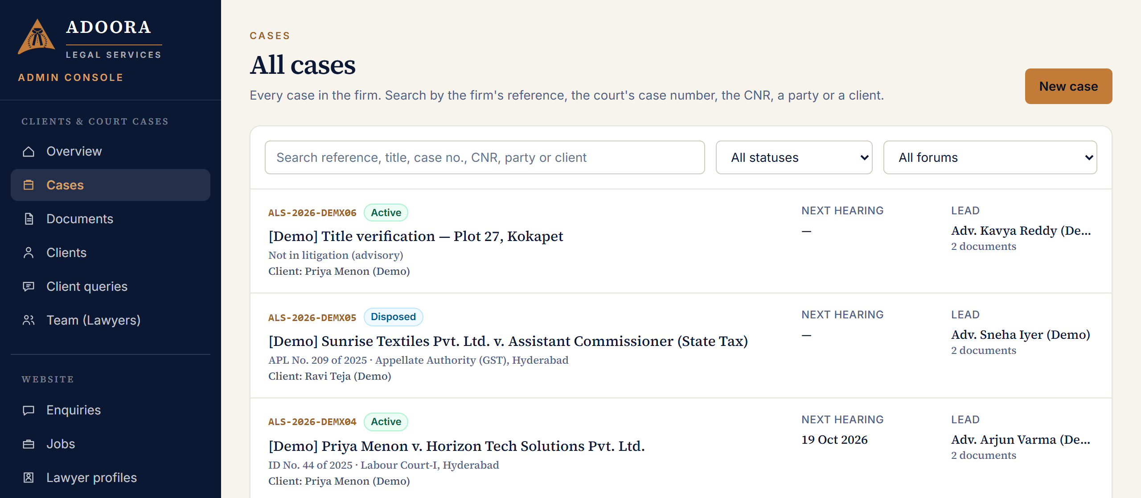
Admin console → Cases. The New case button is at the top right.

Step 2a: a case already filed in court (with a CNR)
The CNR is the 16-character number printed on the court's case status page and on its orders, for example HBHC010516652019.
- Type the CNR in CNR number.
- Click Next: the court's captcha. The court's captcha picture appears.
- Type the letters shown in the picture and click Fetch case details. The system reads the case from the court's own website and fills in the form for you.
- Check what was filled in (a gold note at the top says 'Filled in from the court's record'). If a red note says Already on file, the case exists already: open that one instead.
- If the court's website is not working, the link Use the eCourtsIndia backup (paid) fetches the same details for about ₹1.50.
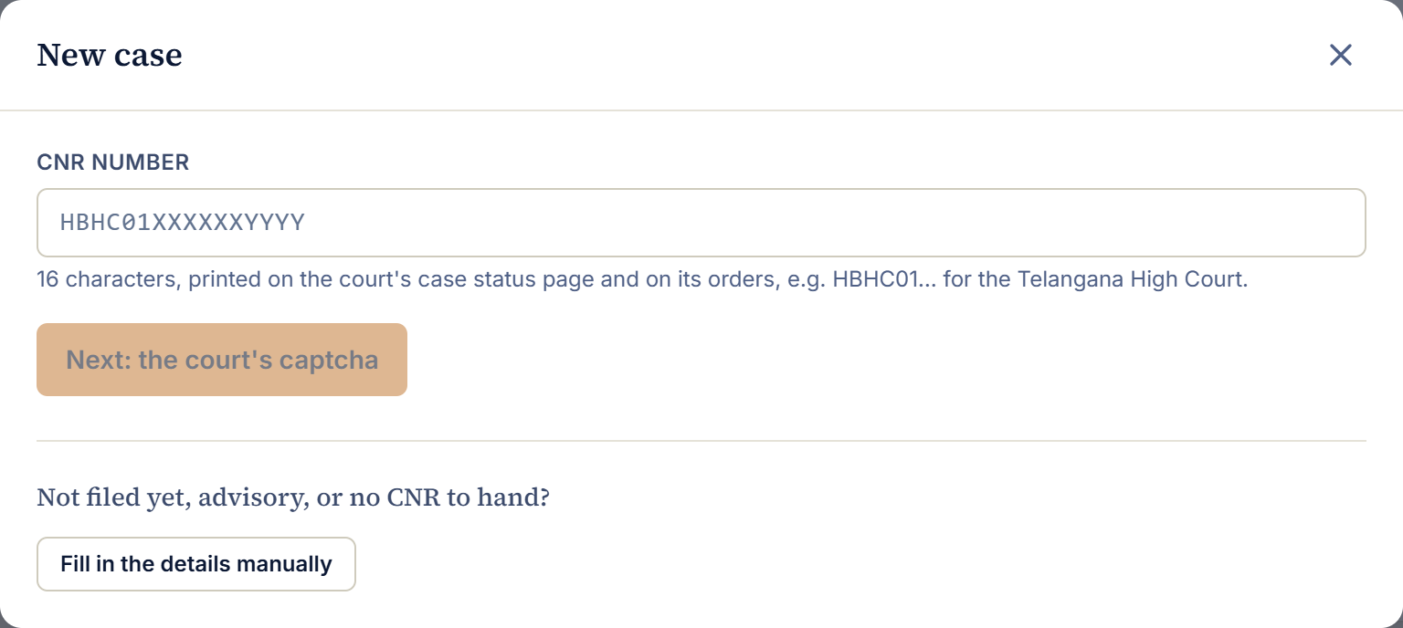
The first screen of New case: type the CNR, or fill in the details by hand.

Step 2b: no CNR yet (not filed, advisory work, or the number is not to hand)
- Click Fill in the details manually.
- The case: a Title is the only required field, usually the cause title, e.g. 'Ravi Kumar v. State of Telangana'. Add a short summary, the practice area, status and stage.
- Court or forum: where the case is or will be heard. Choose 'Not in litigation (advisory)' for advisory work. Once a court is chosen, the case number fields appear.
- Parties: click + Petitioner, + Respondent and so on, type each name as in the cause title, and tick the party the firm acts for.
- Law and relief: acts and sections (one per line) and the relief sought.
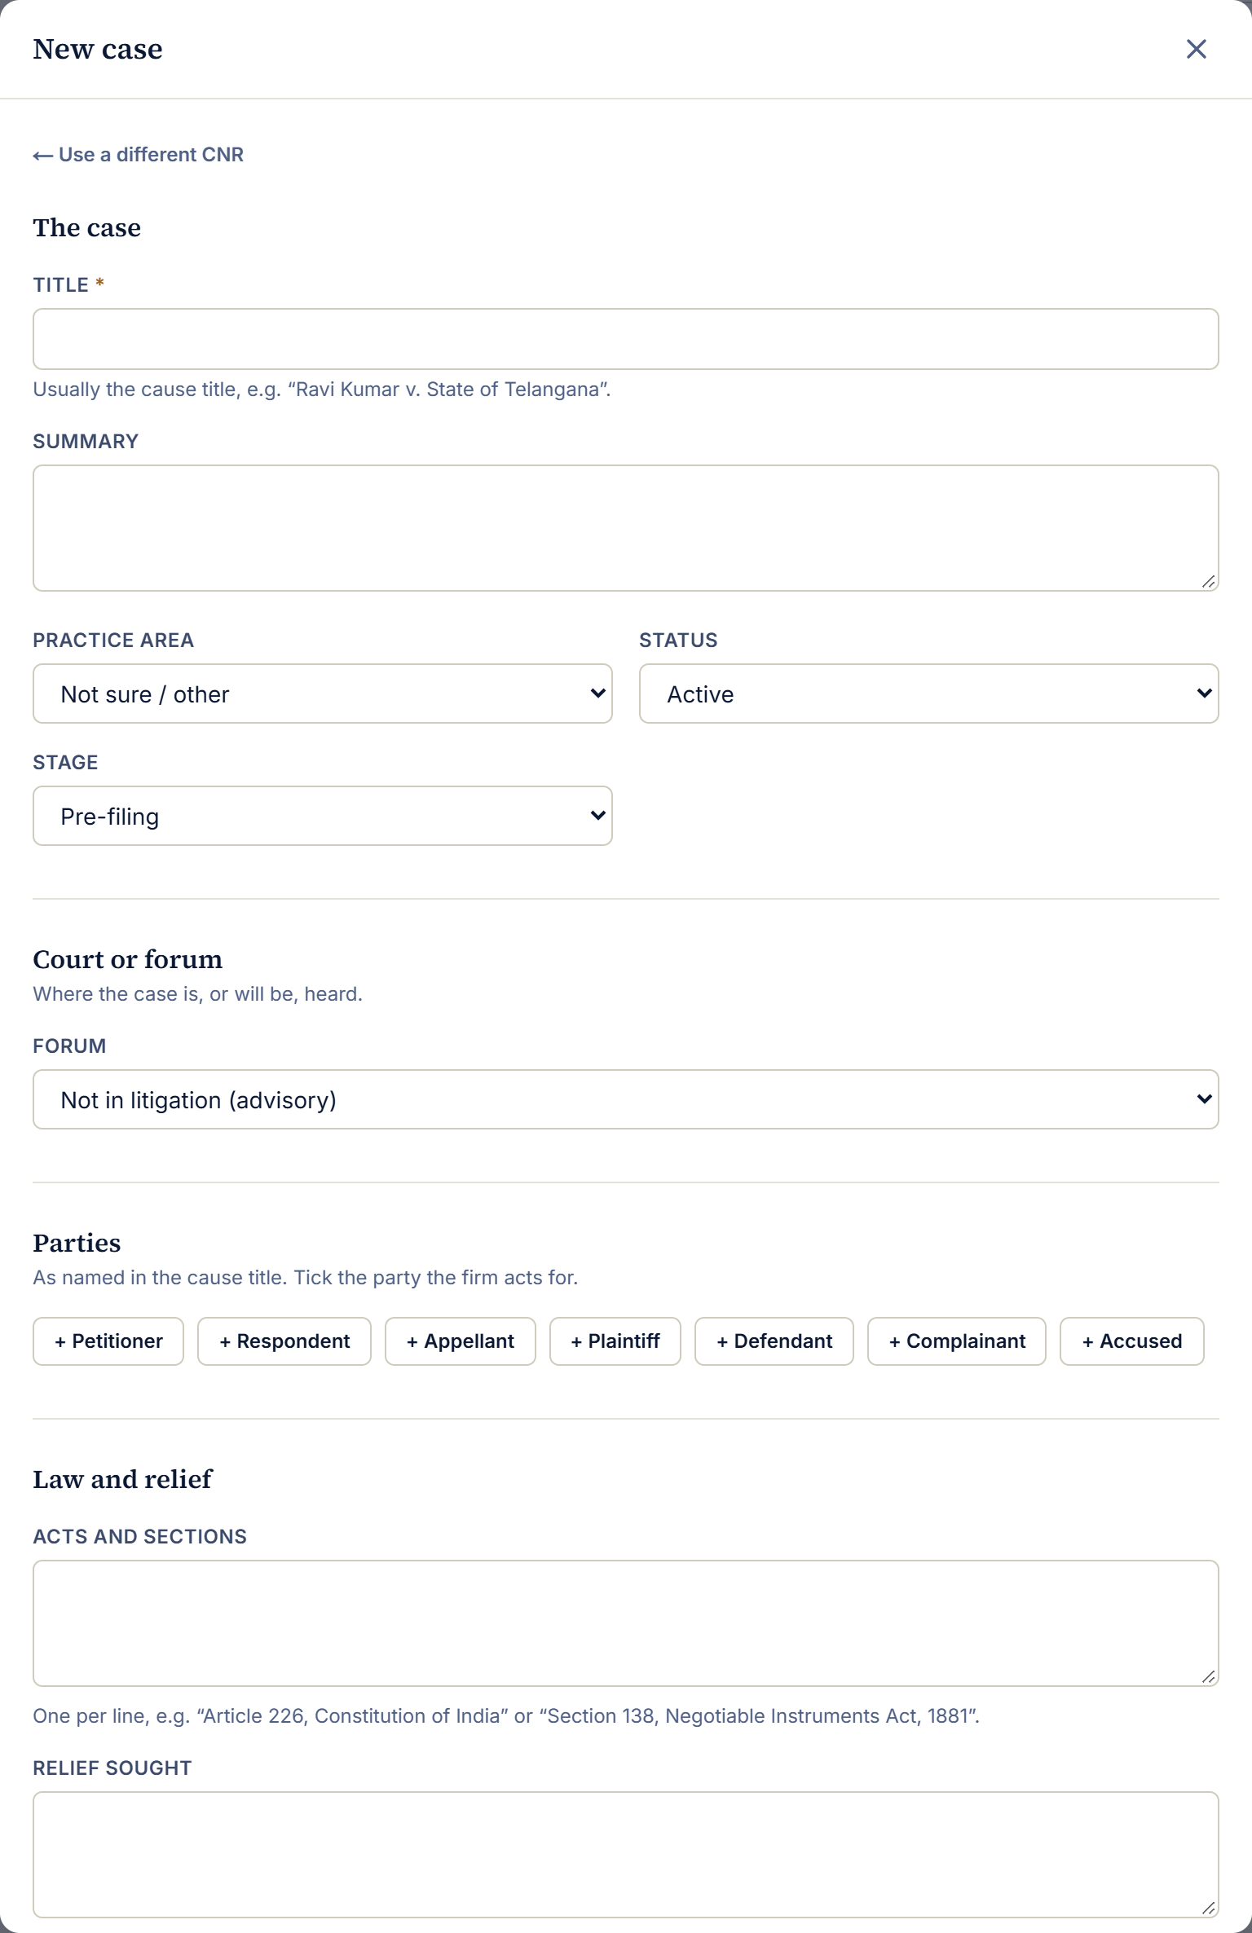
Filling in a case by hand: the case, the court, the parties, the law.

Step 3: the team and the client, then create
At the bottom of the same window is Team and client:
- Lawyers on the case: pick a lawyer from + Add a lawyer. Repeat for each lawyer; the first is the lead. Every lawyer added sees the case in their lawyer workspace.
- Client account: pick the client who should see the case, or leave it on Link later. The client must already be under Clients (see 'How to add a client' below).
- Click Create case. The case opens on its own page with the firm's reference, for example ALS-2026-ABC12. If you came in by CNR, the hearing history and the court's order PDFs are saved with it.
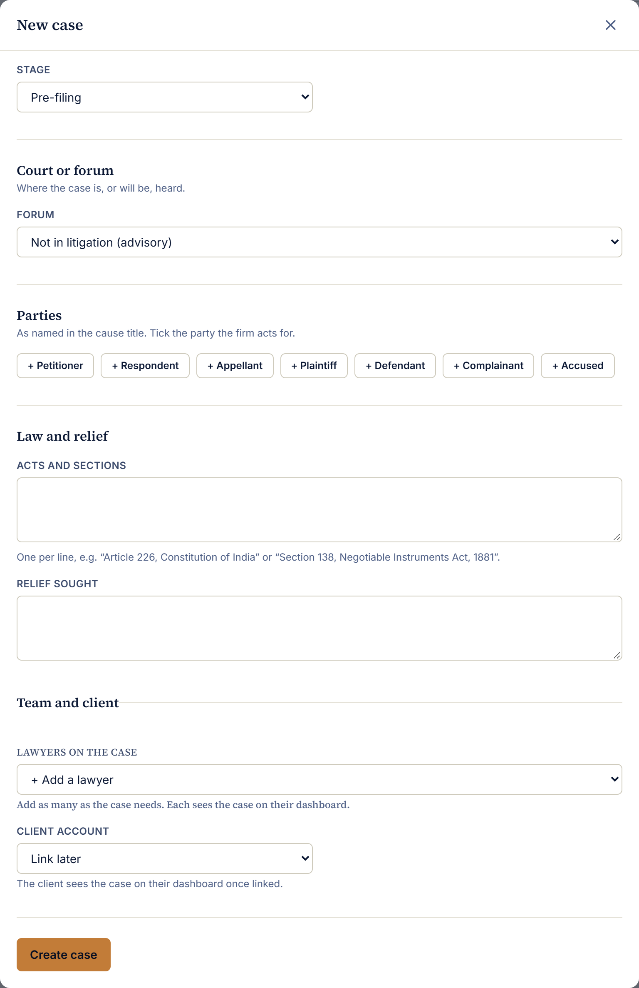
The end of the New case window: lawyers, client account, Create case.

How to add a client
- In the admin console click Clients, then Add client.
- Under Client is, choose An individual or An organisation.
- For an individual: Name and Email are required; add the Phone too. For an organisation: Organisation name, Contact person, Email, phone and Office address.
- The Email is what the client signs in with through Google, and the Phone is the number their mobile sign-in code goes to. Check both carefully.
- Optional: under Cases, choose + Link a case to attach their case now, so it is waiting when they first sign in. Repeat for more cases.
- Click Add client.
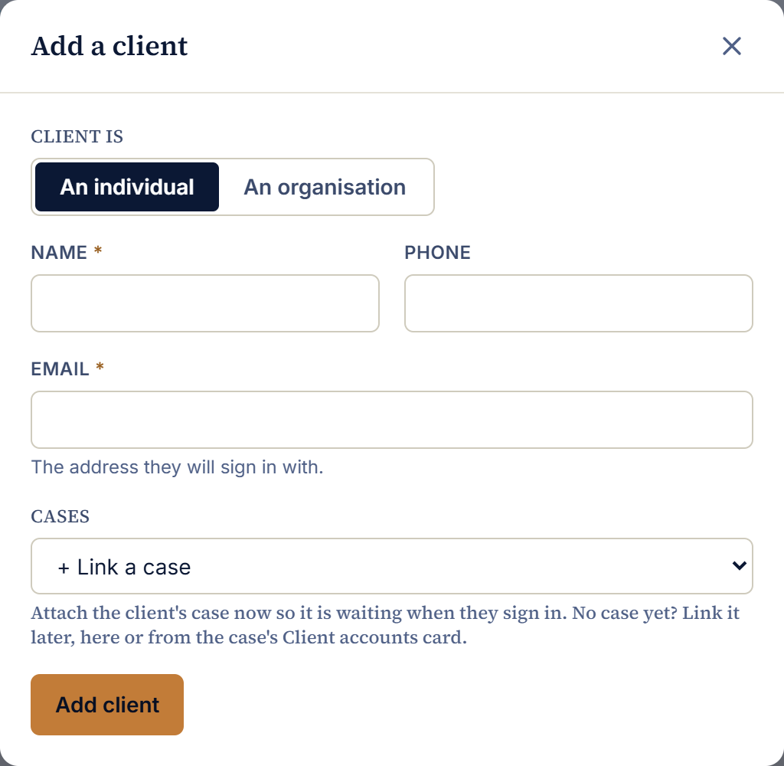
Add a client: an individual.
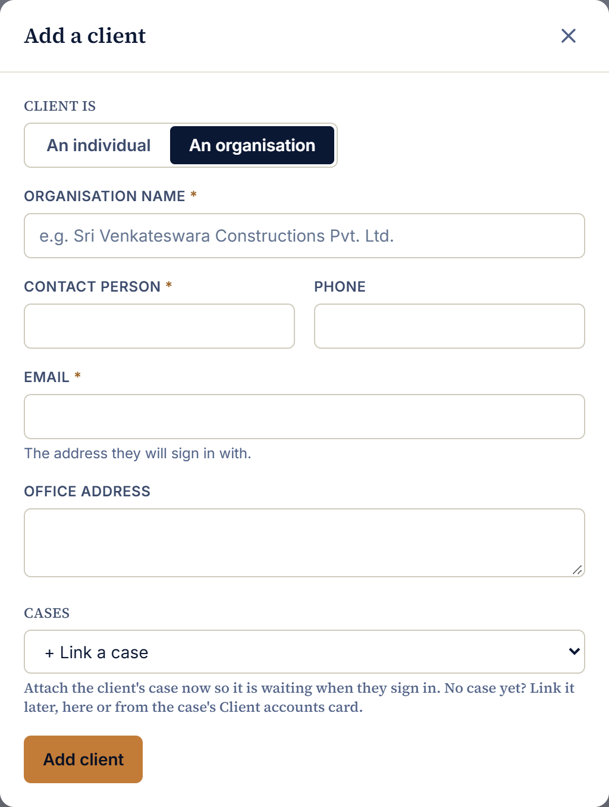
Add a client: an organisation, with its contact person and office address.
- Clients can also sign themselves up. Anyone who signs in at the website's Login with a new mobile number or Google account gets a client account. They then appear in Clients, and you link their case to them.
- Changing a client later: Clients → Edit on their row. The sign-in email cannot be changed; everything else can, including their cases and Account: Deactivated, which signs them out at once.

How to add a lawyer (or anyone at the firm)
- In the admin console click Team (Lawyers), then Add a person.
- Add a photo (optional), the Name as it should appear (e.g. 'Adv. K. L. Ganesh Raghavendra') and the Position (e.g. Senior Associate).
- Email: the Gmail address they will use for 'Continue with Google'.
- Phone: the mobile number they will use for a sign-in code. A lawyer can sign in only with the email or phone saved here.
- Bar Council enrolment no. (optional).
- Access to the portal: choose what they may open (see the table below). For a lawyer, choose Lawyer.
- Tick Show on the website if they should appear on the About page and practice pages; their public profile fields then open below.
- Click Add to the team. They can sign in straight away at /lawyer/login, or with Lawyer login in the website's Login box.
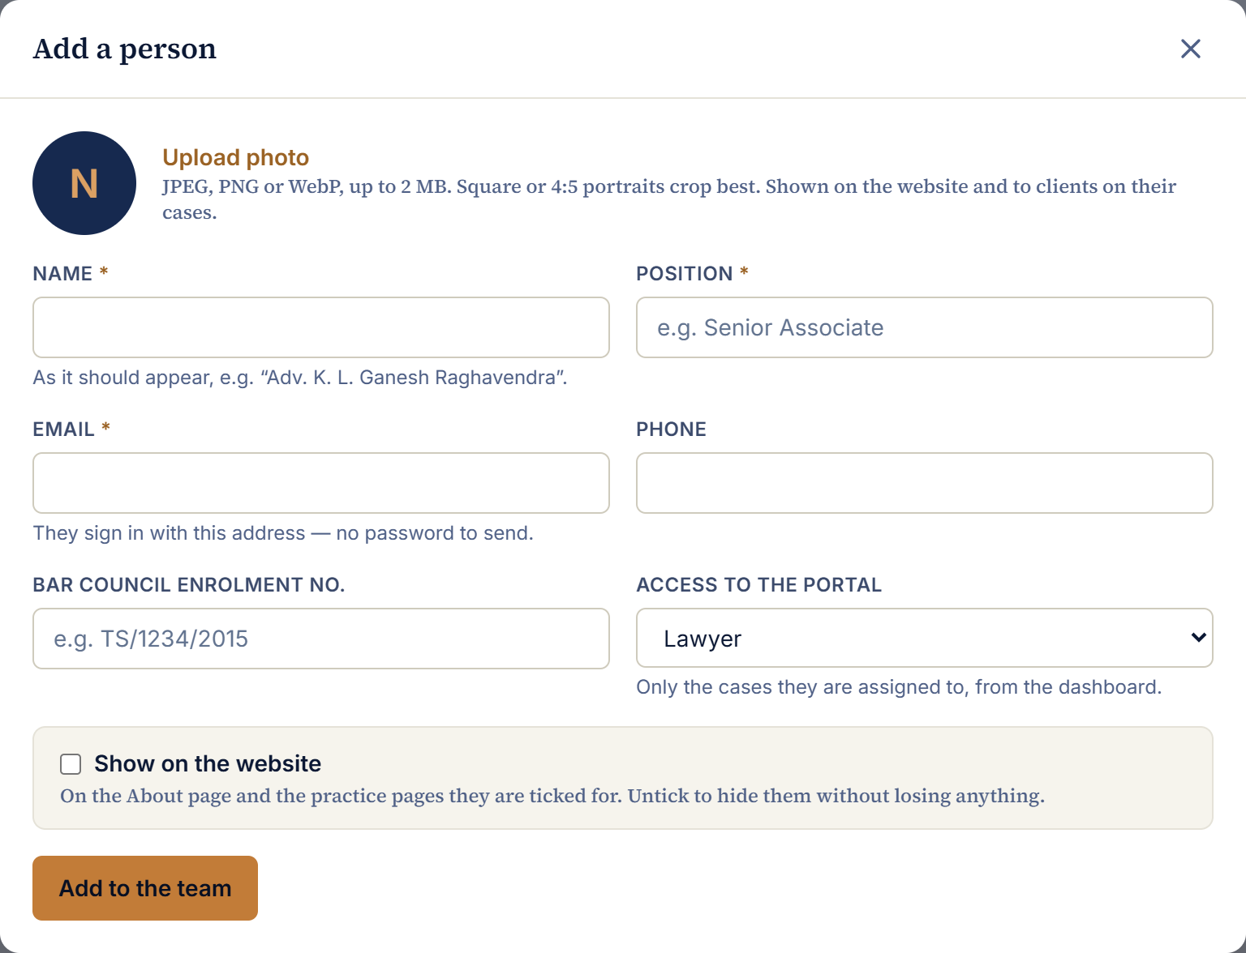
Add a person: who they are, how they sign in, and what they may open.
Access to the portal | What it opens
Owner | Everything, including managing owners and admins. Can also use the lawyer workspace for cases assigned to them.
Admin | All cases, documents, clients, lawyers and the console. Can also use the lawyer workspace for cases assigned to them.
Lawyer | Only the cases they are assigned to, in the lawyer workspace.
Editor | Website content only. No case access.
No sign-in | Shown on the website only; cannot open the portal.

Only an owner can change an owner's or an administrator's access, and nobody can change their own.

How to link lawyers and clients to a case
A lawyer sees a case only once they are on it, and a client sees a case only once their account is linked to it. There are three places to do this; use whichever is handy.

When creating the case
Use Team and client at the bottom of the New case window (Step 3 above).

On the case's own page
Open the case (Cases → click it). On the Overview tab, the right-hand side has two cards, each with a Change button.
- Lawyers on this case → Change. Choose + Add a lawyer for each lawyer, set each one's role (Lead, Associate or Support), or Remove someone. Click Save team.
- Client accounts → Change. Choose + Link a client account, or Remove one. Click Save access. If the client is not in the list, add them under Clients first, using the email they will sign in with.
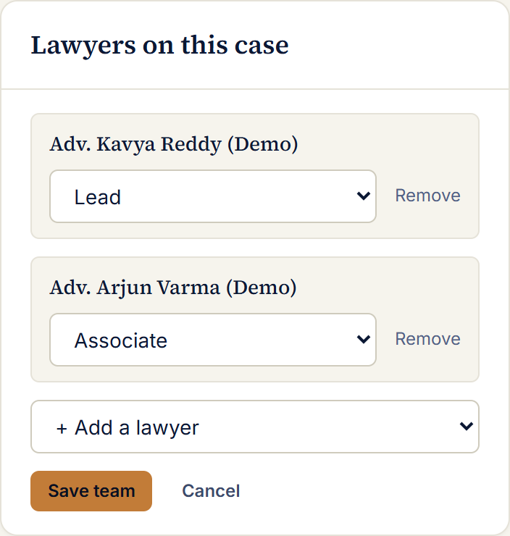
Lawyers on this case, after clicking Change.
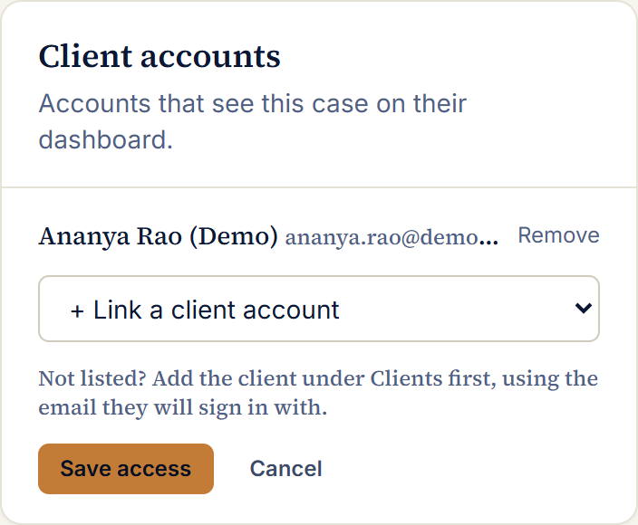
Client accounts, after clicking Change.

From the client's side
Clients → Edit on the client's row → Cases → + Link a case (or Remove) → Save client.
Once linked… | …they see
A lawyer | The case in their lawyer workspace: all its details, the court record, every folder including Internal, the timeline and the client's questions.
A client | The case on their dashboard: details, hearings and orders, and the Case files folder only (never Internal).

Checking who has access
Team (Lawyers) opens with the Who can sign in panel. It lists every email that can open the admin console and every email that can open the lawyer workspace, with their access and when they last signed in.
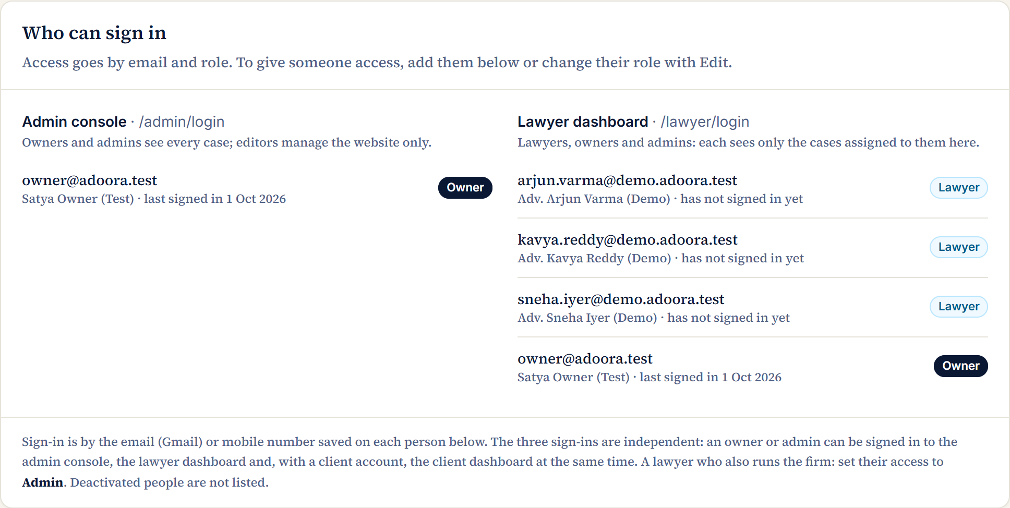
The Who can sign in panel at the top of Team (Lawyers).
- To give access: add the person (above), or Edit them and change Access to the portal.
- To take access away: Edit them and set Access to the portal to No sign-in, or Account to Deactivated. Either applies at once; deactivating also signs them out everywhere.

Updating a case from the court
- A lawyer or administrator presses Update from court on a case with a CNR number.
- The system opens the right court website: the district courts' eCourts site, or the High Courts' site. It decides from the CNR, for example HBHC is the Telangana High Court, APHC the Andhra Pradesh High Court, and TSHC the Hyderabad city civil courts.
- The court's captcha picture is shown; the person types it. The system never solves captchas by itself.
- The system reads the case page: status, stage, next date, judge, parties and advocates, the full hearing history and the list of orders.
- Every order PDF the court has uploaded is downloaded and saved into the case's Case files folder, where the client can see it. PDFs already saved are not downloaded again.
- A message reports what changed: new hearings, new orders, PDFs saved, and any the court has not uploaded yet.

Things worth knowing
- It is free. The courts' websites charge nothing.
- A 10-minute pause. After a successful update, the same case cannot be updated again for 10 minutes, so the court's site is not hit repeatedly. This is the system's own rule, not the court's. It is skipped if any PDF failed to download, so the missing ones can be retried at once.
- 'Not uploaded by the court' means the court lists the order but has not put its PDF online yet. Try again later.
- The eCourtsIndia backup. A paid service (about ₹1.50 for full details, ₹0.15 per refresh) kept switched on for staff for now, while the court websites prove reliable. It can be switched off with one server setting (ECOURTS_BACKUP=false). Clients never see it or its prices.
- Only the firm updates cases. Clients see the results; they have no update button.

7. Documents

Folders
Each case has two folders:
Folder | Who sees it | What goes there
Case files | The firm and the client | Court order PDFs (automatically), everything the client uploads, and whatever the firm shares with the client.
Internal | The firm only | Working papers, notes and drafts the client must not see.

- The firm can make its own folders inside either one (for example Pleadings, Evidence, Correspondence). A folder inside Case files is visible to the client; one inside Internal is not.
- Every file carries a tag showing where it came from: From the court, From the client or From the firm.
- Make internal / Share with client moves a file between the two sides. Move to puts it into one of the firm's folders.
- Deleting a folder never deletes its files; they move up a level.
- New version keeps the earlier version; nothing is overwritten.
- Removing a document takes it off the case but keeps the stored file for the record.

Safety
- Every file is encrypted before it is stored, and decrypted only when someone allowed to see it opens it.
- Every view and download is written to the audit log.
- Uploads can be up to 25 MB: PDF, Word, Excel, images and text.

8. The lawyer workspace
A lawyer signs in at /lawyer/login (with the Gmail or mobile number saved on the Team page) and sees four tabs. Owners and administrators can sign in here too, to work on the cases assigned to them.
- Overview: their open cases, document count, the next hearing and upcoming hearings.
- My cases: only the cases they are assigned to. In each case they can update it from the court, edit its details, keep its documents and folders, and add timeline entries.
- Documents: the folders of their cases, and the firm's Team shared folder.
- Client queries: questions from the clients on their cases.
New cases are opened by an owner or administrator, who then assigns the lawyer (case → Overview → Lawyers on this case → Change).

9. The client dashboard
A client signs in at /login and sees:
- Overview: their open cases, the next hearing and recent documents.
- My cases: each linked case with its details, court status, hearing history and orders. Court PDFs open directly.
- Documents: a folder per case. Inside, Case files and any folders the firm made there. Clients upload into Case files.
- My queries: questions to their lawyers, with the replies.

What a client cannot do
- Add a case: cases are linked to their account by the firm (Clients → Edit, or the case's Client accounts card).
- Update a case from the court, or see any update or backup buttons.
- See Internal files, firm prices or other clients' cases.
A client with no linked case sees: 'No case is linked to your account yet. Please contact us to set up a meeting with the team', with buttons to set up a meeting or call the firm.

On phones
The website, the admin console, the lawyer workspace and the client dashboard all work on a phone. Lists that are tables on a computer (clients, team, enquiries, jobs, documents) become one card per row, each value labelled; numbers sit two to a row; a case's sections (Overview, Court record, Documents, Timeline) wrap as buttons so none is hidden off the screen.

10. Articles and AI

Finding topics: trending leads
Every 3 hours the system reads the headlines of legal news sources (LiveLaw, Bar & Bench, Verdictum and Google News searches for Supreme Court and High Court judgments). It reads headlines and links only, never the articles themselves, and groups stories about the same judgment into 'leads', ranked by how widely they are being reported.

Drafts
- Every morning at 06:30 (India time) up to three article drafts are written from the best leads by Google's Gemini AI, which researches the judgment with Google Search and keeps its sources with the draft.
- Write now on a lead, or a topic typed in, asks for a draft straight away.
- Drafts follow the firm's rules: inform rather than advertise, name the court, bench and date, never name victims or minors, no comment on pending cases beyond what the court said.
- Nothing is published automatically. Every draft lands 'In review', with the time it arrived, for a lawyer to check, edit and publish. Drafts can be deleted from the list.

Cover images
Each article's cover appears on its card, beside its title and when the link is shared. In the article editor's Cover image panel you can:
- Upload an image, or
- Generate with AI, in two clicks so nothing is paid for by accident:
  - Suggest a prompt from the article: Gemini reads the article and describes a suitable picture. You can edit the description.
  - Generate image: draws it in about 10 seconds and sets it as the cover. Press Save to keep it.
Every generated cover follows fixed rules: no text in the picture, no faces or real people, no logos, flags or emblems, no gavels, nothing graphic, in the firm's navy and gold. Always look at the picture before saving.

11. What it costs to run
Beyond hosting, some actions cost a small amount each time they are used. Prices are those published by the providers in September 2026.
Action | Provider | Approximate cost | When it is charged
Update from court | The courts' websites | Free | —
eCourtsIndia backup: full details | eCourtsIndia | ₹1.50 | Only when staff press the backup button
eCourtsIndia backup: refresh | eCourtsIndia | ₹0.15 | Only when staff press the backup button
AI article draft | Google Gemini | A few rupees per draft | Morning drafts (up to 3 a day) and Write now
AI cover image | Google Gemini (Flash Lite Image) | About $0.034 (≈ ₹3) per image | Only on 'Generate image'
AI image prompt | Google Gemini | A fraction of a rupee | On 'Suggest a prompt'
Mobile sign-in codes | MSG91 | Per SMS, as per the MSG91 plan | Each mobile sign-in (clients, lawyers and admins)
Hosting, database, file store | Railway | Monthly, as per the Railway plan | Continuously

Each generated image and its actual cost is recorded in the audit log.

12. Behind the scenes, in plain terms

What happens when someone presses a button
- The page in the browser sends a short request to the back office, for example 'save this case' or 'give me this document'.
- The back office checks the person's sign-in and whether their role allows it, for the specific case or file.
- It reads or writes the filing room (database), or the strong room (file store) for documents, and records the action in the audit log.
- It sends back the result, and the page shows it.

Jobs that run by themselves
When | What
Every 3 hours | Read the legal news headlines and update the trending leads.
06:30 India time, daily | Write up to three article drafts from the best leads, for review.

These run inside the back office itself, so there is no extra service to pay for. They can be switched off with one setting (JOBS_ENABLED=false).

Settings that change behaviour
A few switches live in the hosting settings (Railway → adoora-api → Variables), not in the pages. Changing one takes effect after the service restarts.
Setting | What it controls
ADMIN_EMAILS | Emails that become owners on their first sign-in at the admin page.
ALLOW_CLIENT_SIGNUP | Whether new clients can create their own account by signing in.
ECOURTS_BACKUP | Whether the paid eCourtsIndia backup is offered to staff (true / false).
GEMINI_API_KEY, GEMINI_MODEL | The Google AI key and model used for article drafts.
GEMINI_IMAGE_MODEL | The model used for cover images (default: the cheapest, about $0.034 each).
JOBS_ENABLED | Whether the 3-hourly news reading and morning drafts run.

Keys and passwords in these settings are secret. Never paste them into emails, chats or documents.

Safeguards
- Sign-in through Google or a mobile code: no passwords to leak.
- Documents encrypted at rest; every download logged.
- Each person reaches only what their role and cases allow, checked on every request.
- Deactivating an account ends its sessions immediately.
- Repeated sign-in attempts and court look-ups are rate-limited.

13. Where things are kept in the project
For whoever maintains the system. The project is one repository with two applications.
Folder | What is in it
apps/web | The website: public pages, the admin console, the lawyer workspace and the client dashboard.
apps/web/src/content | Fixed website text: practice areas, home page slides, the disclaimer, firm details.
apps/web/public | Pictures used by the website, for example hero-team.jpg for the home page team photograph.
apps/api | The back office: sign-in, cases, documents, court look-ups, articles and AI, background jobs.
apps/api/prisma | The layout of the database, and the step-by-step changes made to it over time.
docs | Documentation, including this guide and a technical architecture note (ARCHITECTURE.md).

How changes are published
- Work is done on the development branch ('dev'). Pushing to it publishes the website and back office on Railway automatically.
- The 'main' branch is kept for production and is not worked on directly.
- Changes to the database layout are applied automatically when the back office starts.

14. Current limits and next steps
- Enquiry emails. Website enquiries and applications are saved in the console, but no email alert is sent yet. That needs an email-sending service connected.
- Own domain. Google Search Console and Analytics connect once the site moves to the firm's own domain.
- Editors. Editors can sign in at the admin page, but the console's sections are built for owners and administrators. If editors should manage website sections only, that access needs to be added.
- eCourtsIndia backup. Switch it off (ECOURTS_BACKUP=false) once the courts' websites have proved reliable, to avoid paid look-ups.

15. Glossary
Term | Meaning
CNR | Case Number Record: the 16-character number the eCourts system gives every case, for example HBHC010516652019.
Captcha | The distorted-letters picture a court website shows to check a person is using it. Always typed by a person here.
Case files / Internal | A case's two folders: shared with the client, and firm only.
Lead | A judgment or development several news sources are reporting, suggested as an article topic.
In review | An article that is written but not published, waiting for a lawyer.
Audit log | The record of who did what, and when.
Railway | The cloud service that hosts the website, back office, database and file store.
Gemini | Google's AI, used for article drafts and cover images.
MSG91 | The service that sends mobile sign-in codes.
OTP | One-time password: the code sent by SMS to sign in with a mobile number.

