SOLVING PROBLEMS BY
3 SEARCHING

PROBLEM-SOLVING

AGENT

In which we see how an agent can find a sequence of actions that achieves its goals.

The simplest agents discussed in Chapter 2 were the reßex agents, which base their actions on a direct mapping from states to actions. Such agents cannot operate well in environments for which this mapping would be too large to store and would take too long to learn. Goal-based agents, on the other hand, can succeed by considering future actions and the desirability of their outcomes.

This chapter describes one kind of goal-based agent called a problem-solving agent. Problem-solving agents decide what to do by Þnding sequences of actions that lead to de-sirable states. We start by deÞning precisely the elements that constitute a ÒproblemÓ and its Òsolution,Ó and give several examples to illustrate these deÞnitions. We then describe several general-purpose search algorithms can be used to solve these problems and compare the advantages of each algorithm. These algorithms are uninformed, in the sense that they are given no information about the problem other than its deÞnition. Chapter 4 deals with informed search algorithms that have some idea of where to look for solutions.

This chapter uses concepts from the analysis of algorithms. Readers unfamiliar with the concepts of asymptotic complexity (that is, notation) and NP-completeness should consult Appendix A.

- PROBLEM-SOLVING AGENTS

Intelligent agents are supposed to maximize their performance measure. As we mentioned in Chapter 2, achieving this is sometimes simpliÞed if the agent can adopt a goal and aim to satisfy it. Let us Þrst look at why and how an agent might do this.

Imagine an agent in the city of Arad, Romania, enjoying a touring holiday. The agentÕs performance measure contains many factors: it wants to improve its suntan, improve its Ro-manian, take in the sights, enjoy the nightlife (such as it is), avoid hangovers, and so on. The decision problem is a complex one involving many tradeoffs and careful reading of guide-books. Now, suppose the agent has a nonrefundable ticket to ßy out of Bucharest the follow-

62

Section 3.1. Problem-Solving Agents 63

GOAL FORMULATION

PROBLEM
FORMULATION


SEARCH

SOLUTION

EXECUTION

ing day. In that case, it makes sense for the agent to adopt the goal of getting to Bucharest. Courses of action that donÕt reach Bucharest on time can be rejected without further consid-eration and the agentÕs decision problem is greatly simpliÞed. Goals help organize behavior by limiting the objectives that the agent is trying to achieve. Goal formulation, based on the current situation and the agentÕs performance measure, is the Þrst step in problem solving.

We will consider a goal to be a set of world statesÑjust those states in which the goal is satisÞed. The agentÕs task is to Þnd out which sequence of actions will get it to a goal state. Before it can do this, it needs to decide what sorts of actions and states to consider. If it were to try to consider actions at the level of Òmove the left foot forward an inchÓ or Òturn the steering wheel one degree left,Ó the agent would probably never Þnd its way out of the parking lot, let alone to Bucharest, because at that level of detail there is too much uncertainty in the world and there would be too many steps in a solution. Problem formulation is the process of deciding what actions and states to consider, given a goal. We will discuss this process in more detail later. For now, let us assume that the agent will consider actions at the level of driving from one major town to another. The states it will consider therefore correspond to being in a particular town.¹

Our agent has now adopted the goal of driving to Bucharest, and is considering where to go from Arad. There are three roads out of Arad, one toward Sibiu, one to Timisoara, and one to Zerind. None of these achieves the goal, so unless the agent is very familiar with the geography of Romania, it will not know which road to follow.² In other words, the agent will not know which of its possible actions is best, because it does not know enough about the state that results from taking each action. If the agent has no additional knowledge, then it is stuck. The best it can do is choose one of the actions at random.

But suppose the agent has a map of Romania, either on paper or in its memory. The point of a map is to provide the agent with information about the states it might get itself into, and the actions it can take. The agent can use this information to consider subsequent stages of a hypothetical journey via each of the three towns, trying to Þnd a journey that eventually gets to Bucharest. Once it has found a path on the map from Arad to Bucharest, it can achieve its goal by carrying out the driving actions that correspond to the legs of the journey. In general, an agent with several immediate options of unknown value can decide what to do by first examining different possible sequences of actions that lead to states of known value, and then choosing the best sequence.

This process of looking for such a sequence is called search. A search algorithm takes a problem as input and returns a solution in the form of an action sequence. Once a solution is found, the actions it recommends can be carried out. This is called the execution phase. Thus, we have a simple Òformulate, search, executeÓ design for the agent, as shown in Figure 3.1. After formulating a goal and a problem to solve, the agent calls a search procedure to solve it. It then uses the solution to guide its actions, doing whatever the solution recommends as

Notice that each of these ÒstatesÓ actually correspond to large sets of world states, because a real world state speciÞes every aspect of reality. It is important to keep in mind the distinction between states in problem solving and world states.

We are assuming that most readers are in the same position, and can easily imagine themselves as clueless as our agent. We apologize to Romanian readers who are unable to take advantage of this pedagogical device.

c 2002 by Russell and Norvig. DRAFT---DO NOT DISTRIBUTE

64 Chapter 3. Solving Problems by Searching

function SIMPLE-PROBLEM-SOLVING-AGENT( percept) returns an action inputs: percept, a percept

static: seq, an action sequence, initially empty

state, some description of the current world state goal, a goal, initially null

problem, a problem formulation

state UPDATE-STATE(state, percept)

if seq is empty then do

goal FORMULATE-GOAL(state)

problem FORMULATE-PROBLEM(state, goal) seq SEARCH( problem)

action FIRST(seq) seq REST(seq) return action

Figure 3.1 A simple problem-solving agent. It Þrst formulates a goal and a problem, searches for a sequence of actions that would solve the problem, and then executes the actions one at a time. When this is complete, it formulates another goal and starts over.

the next thing to doÑtypically, the Þrst action of the sequenceÑand then removing that step from the sequence. Once the solution has been executed, the agent will formulate a new goal.

We Þrst describe the process of problem formulation, and then the bulk of the chapter is devoted to various algorithms for the SEARCH function. We will not discuss the workings of the UPDATE-STATE and FORMULATE-GOAL functions further in this chapter.

Before plunging into the details, however, let us pause brießy to see where problem-solving agents Þt into the discussion of agents and environments in Chapter 2. The agent design in Figure 3.1 assumes that the environment is static, because formulating and solving the problem is done without paying attention to any changes that might be occurring in the environment. The agent design also assumes that the initial state is known, which is easiest if the environment is observable. The idea of enumerating Òalternative courses of actionÓ assumes that the environment can be viewed as discrete. Finally, and most importantly, the agent design assumes that the environment is deterministic. Solutions to problems are single sequences of actions, so they cannot handle any unexpected events; moreover, solutions are executed without paying attention to the percepts! An agent that carries out its plans with its eyes closed, so to speak, must be quite certain of what is going on. (Control theorists

OPEN-LOOP call this an open-loop system, because ignoring the percepts breaks the loop between agent and environment.) All these assumptions mean that we are dealing with the easiest kinds of environments, which is one reason why this chapter comes early on in the book. Sec-tion 3.6 takes a brief look at what happens when we relax the assumptions of observability and determinism. Chapters 12 and 17 go into much greater depth.

c 2002 by Russell and Norvig. DRAFT---DO NOT DISTRIBUTE

Section 3.1. Problem-Solving Agents 65

PROBLEM

INITIAL STATE

SUCCESSOR
FUNCTION

STATE SPACE

PATH

GOAL TEST

PATH COST

STEP COST

SOLUTION

OPTIMAL SOLUTION

Well-defined problems and solutions

A problem can be formally deÞned by four components:

The initial state that the agent starts in. For example, the initial state for our agent in Romania might be described as .

A description of the possible actions available to the agent. The most common for-mulation³ uses a successor function. Given a particular state , SUCCESSOR-FN

returns a set of action successor ordered pairs, where each successor is a state that can be reached from . For example, from the state In Arad , the successor function for the Romania problem would return

GoTo Sibiu In Sibiu GoTo Timisoara In Timisoara GoTo Zerind In Zerind

Together, the initial state and successor function implicitly deÞne the state space of the problemÑthe set of all states reachable from the initial state. The state space forms a graph in which the nodes are states and the arcs between nodes are actions. (The map of Romania shown in Figure 3.2 can be interpreted as a state space graph if we view each road as standing for two driving actions, one in each direction.) A path in the state space is a sequence of states connected by a sequence of actions.

The goal test, which determines whether a given state is a goal state. Sometimes there is an explicit set of possible goal states, and the test simply checks if the given state is one of them. The agentÕs goal in Romania is the singleton set In Bucharest . Sometimes the goal is speciÞed by an abstract property rather than an explicitly enumerated set of states. For example, in chess, the goal is to reach a state called Òcheckmate,Ó where the opponentÕs king is under attack and canÕt escape.

A path cost function that assigns a numeric cost to each path. The problem-solving agent chooses a cost function that reßects its own performance measure. For the agent trying to get to Bucharest, time is of the essence, so the cost of a path might be its length in kilometers. In this chapter, we assume that the cost of a path can be described as the sum of the costs of the individual actions along the path. The step cost of taking action
to go from state to state is denoted by . The step costs for Romania are shown in Figure 3.2 as route distances. We will assume that step costs are nonnegative.⁴

The preceding elements deÞne a problem and can be gathered together into a single data structure that is given as input to a problem-solving algorithm. A solution to a problem is a path from the initial state to a goal state. Solution quality is measured by the path cost function, and an optimal solution has the lowest path cost among all solutions. For the moment, we will leave it to the reader to determine the optimal way to get to Bucharest.

Formulating Problems

In the preceding section we proposed a formulation of the problem of getting to Bucharest in terms of the initial state, successor function, goal test, and path cost. This formulation seems

An alternative formulation uses a set of operators that can be applied to a state to generate successors. The implications of negative costs are explored in Exercise 3.17.

c 2002 by Russell and Norvig. DRAFT---DO NOT DISTRIBUTE

66 |  |  |  |  |  |  | Chapter 3. |  | Solving Problems by Searching
 |  | 71 |  |  | Oradea |  |  | Neamt
75 |  |  | Zerind |  |  | 151
 |  |  |  |  |  | 151 |  |  |  | 87
 |  |  |  |  |  |  |  |  |  |  |  | Iasi
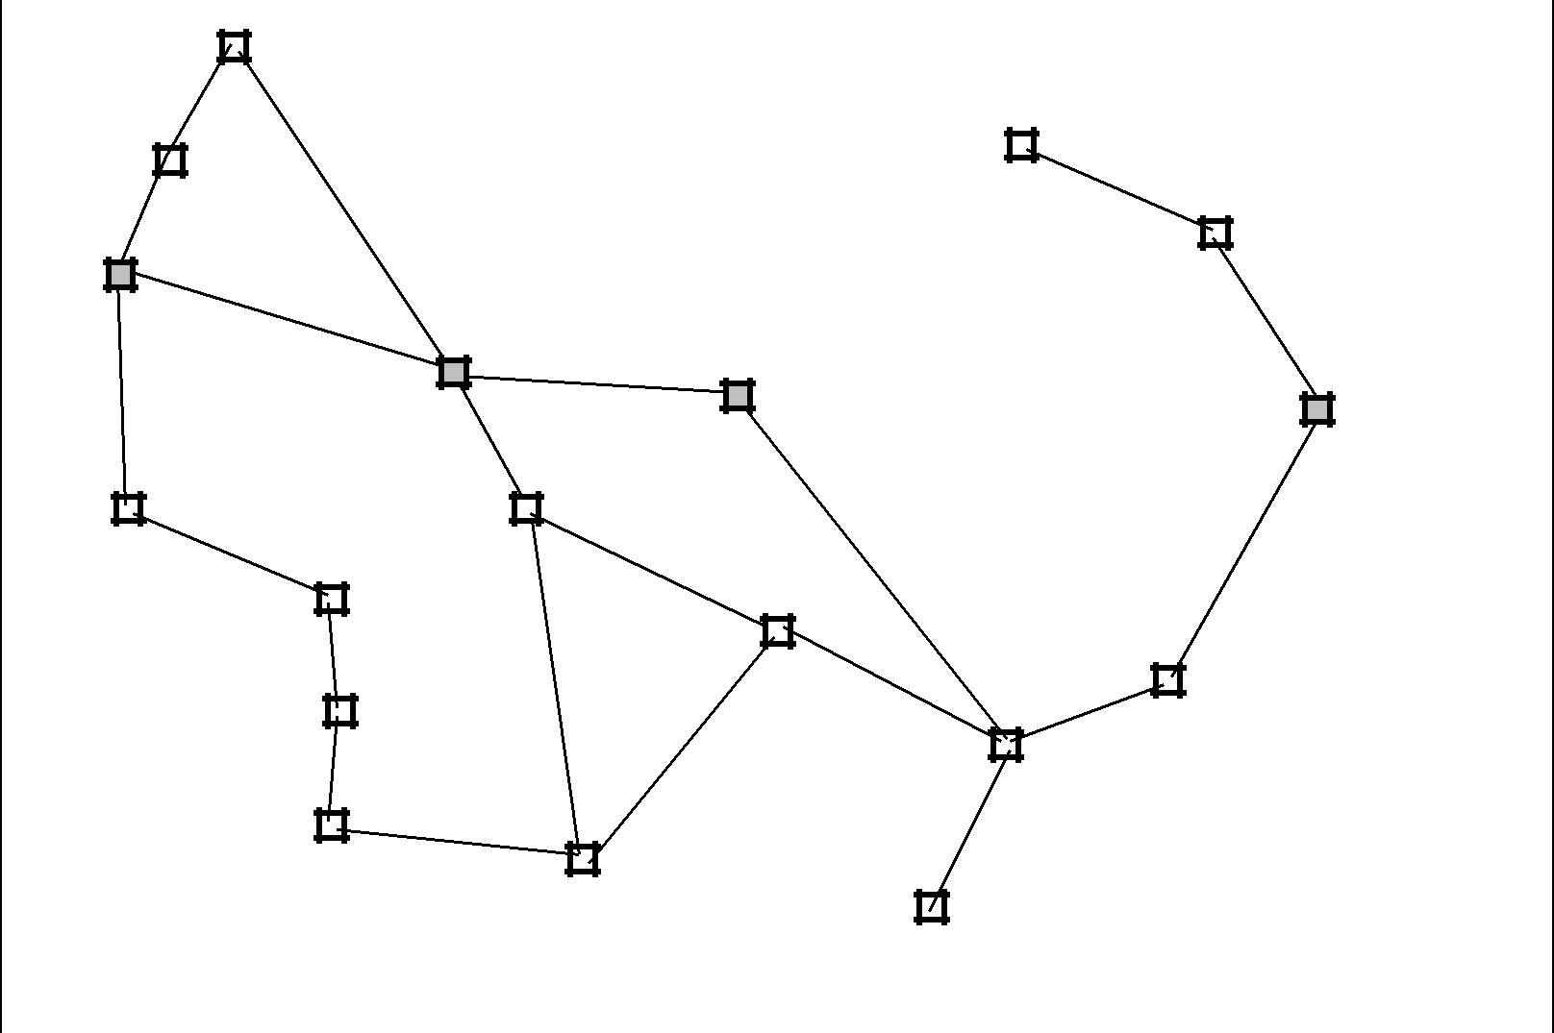
Arad | 140
 | 140 |  | 92
 | Sibiu |  | 92
 | Sibiu | 99 | Fagaras
118 |  |  | Vaslui
 | 80 |  | Vaslui

 | Timisoara |  |  |  |  |  | Rimnicu Vilcea
 |  |  |  |  |  |  |  |  |  |  |  |  |  | 142
111 |  |  |  |  | Lugoj |  |  |  |  | 97 | Pitesti |  |  | 211
70 |  |  |  |  |  |  |  |  |  |  |  |  |  | 98 |  |  |  |  |  |  |  | Hirsova
 |  |  |  |  | Mehadia | 146 |  |  |  |  | 101 |  |  | 85
 |  |  |  |  | Mehadia |  |  |  |  |  |  |  |  |  |  |  |  | Urziceni
75 |  |  |  |  |  |  |  |  |  | 138 |  |  |  |  |  |  |  |  |  |  | 86
 |  |  |  |  |  |  |  |  |  | 138 |  |  |  |  |  |  | Bucharest
 |  |  |  | 120
 | Dobreta |  |  |  |  |  |  |  | Craiova |  |  |  |  | 90
 |  |  |  |  |  |  |  |  |  |  |  |  |  |  |  | Giurgiu |  |  |  |  |  | Eforie
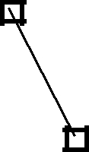
Figure 3.2 A simpliÞed road map of part of Romania.

ABSTRACTION

reasonable, yet it omits a great many aspects of the real world. Compare the simple state description we have chosen, In(Arad), to an actual cross-country trip, where the state of the world includes so many things: the travelling companions, what is on the radio, the scenery out of the window, whether there are any law enforcement ofÞcers nearby, how far it is to the next rest stop, the condition of the road, the weather, and so on. All these considerations are left out of our state descriptions because they are irrelevant to the problem of Þnding a route to Bucharest. The process of removing detail from a representation is called abstraction.

As well as abstracting the state description, we must abstract the actions themselves. A driving action has many effects. Besides changing the location of the vehicle and its occu-pants, it takes up time, consumes fuel, generates pollution, and changes the agent (as they say, travel is broadening). In our formulation, we take into account only the change in location. Also, there are many actions that we will omit altogether: turning on the radio, looking out of the window, slowing down for law enforcement ofÞcers, and so on. And of course, we donÕt specify actions at the level of Òturn steering wheel to the left by three degrees.Ó

Can we be more precise about deÞning the appropriate level of abstraction? Think of the abstract states and actions we have chosen as corresponding to large sets of detailed world states and detailed action sequences. Now consider a solution to the abstract problem: for example, the path from Arad to Sibiu to Rimnicu Vilcea to Pitesti to Bucharest. This abstract solution corresponds to a large number of more detailed paths. For example, we could drive with the radio on between Sibiu and Rimnicu Vilcea, and then switch it off for the rest of the trip. The abstraction is valid if we can expand any abstract solution into a solution in the more detailed world; a sufÞcient condition is that for every detailed state that is Òin Arad,Ó

c 2002 by Russell and Norvig. DRAFT---DO NOT DISTRIBUTE

