



**Oasis**

**Travel Management System**

b y

Aadit Raj Gupta (1641101)

Aman Agarwal (1641107)

Anuja Mitruka (1641111)

Harsh Lakhanpal (1641122

Database Design

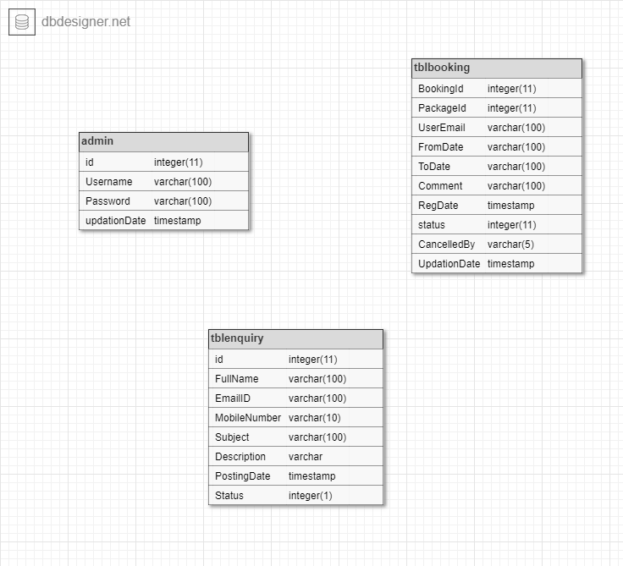

* Admin Table

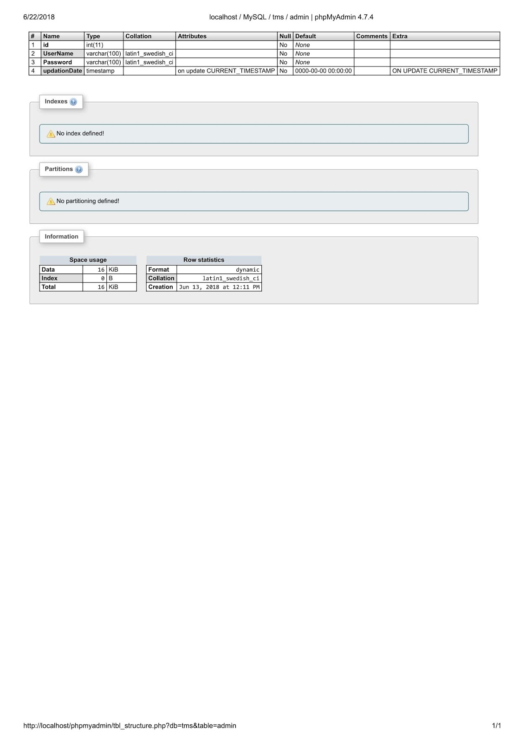

* Booking Table

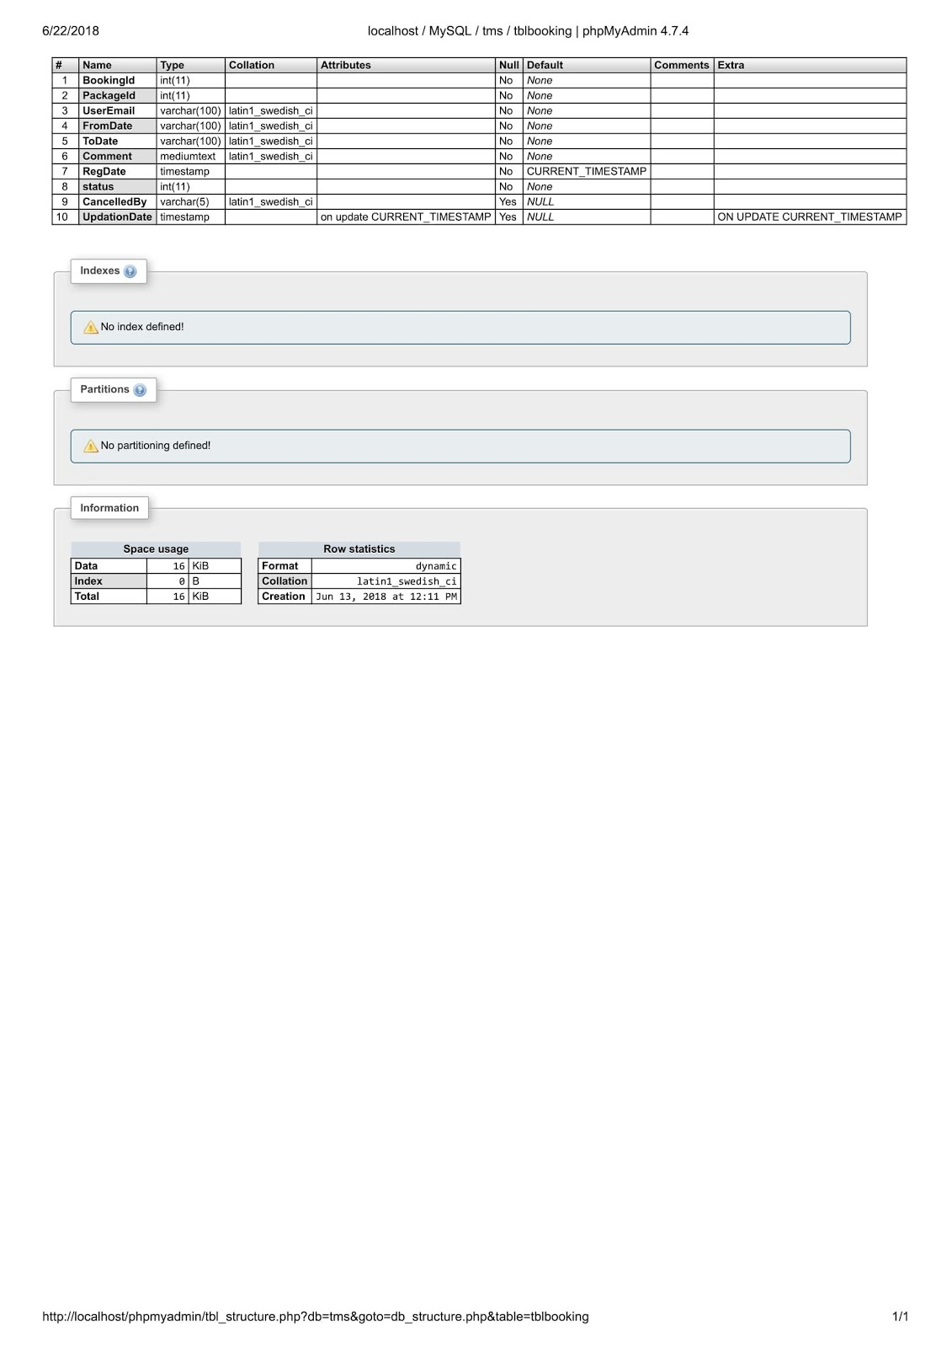

* Enquiry Table

