

**SCOOT**

**(Electric Scooter Rides Startup)**

**SYNOPSIS**

***SMART MOBILITY***

***MADE SIMPLE***

By,

Mukul Ishwar(1641138)

Nandi Satyaraj Reddy(1641139)

Sarthak Raj(1641152)

Suman Rath(1641158)

**ABSTRACT:**

Our idea was founded on a simple question: How do we ensure future generations will not only be able to live on a healthy planet, but thrive?

Our company aims to provide a sustainable solution to the first and last mile transportation problem by helping people move around their cities in an affordable and convenient way while eliminating their carbon footprint. We are here to empower future generations to change their behavior so we can save this planet together.

Scoot is a disruptive electric scooter sharing technology platform to solve this last mile problem. Helps people cover a short distance without any wait at a very nominal cost. Just pick up a scoot by scanning QR through the app, ride and park it sensibly anywhere. Scoot’s vision is to make India a greener & fitter cycling nation.

Following are the steps to book a scoot:

1. **Find a scoot -** Open the app and find all the scoot’s around you.
2. **Tap and scan -**  When you’re at the scoot, tap the “unlock” button and scan the QR code to automatically unlock the scoot.
3. **Park and lock -** At your destination, simply park your scoot safely and legally, and manually lock it to automatically end the trip.

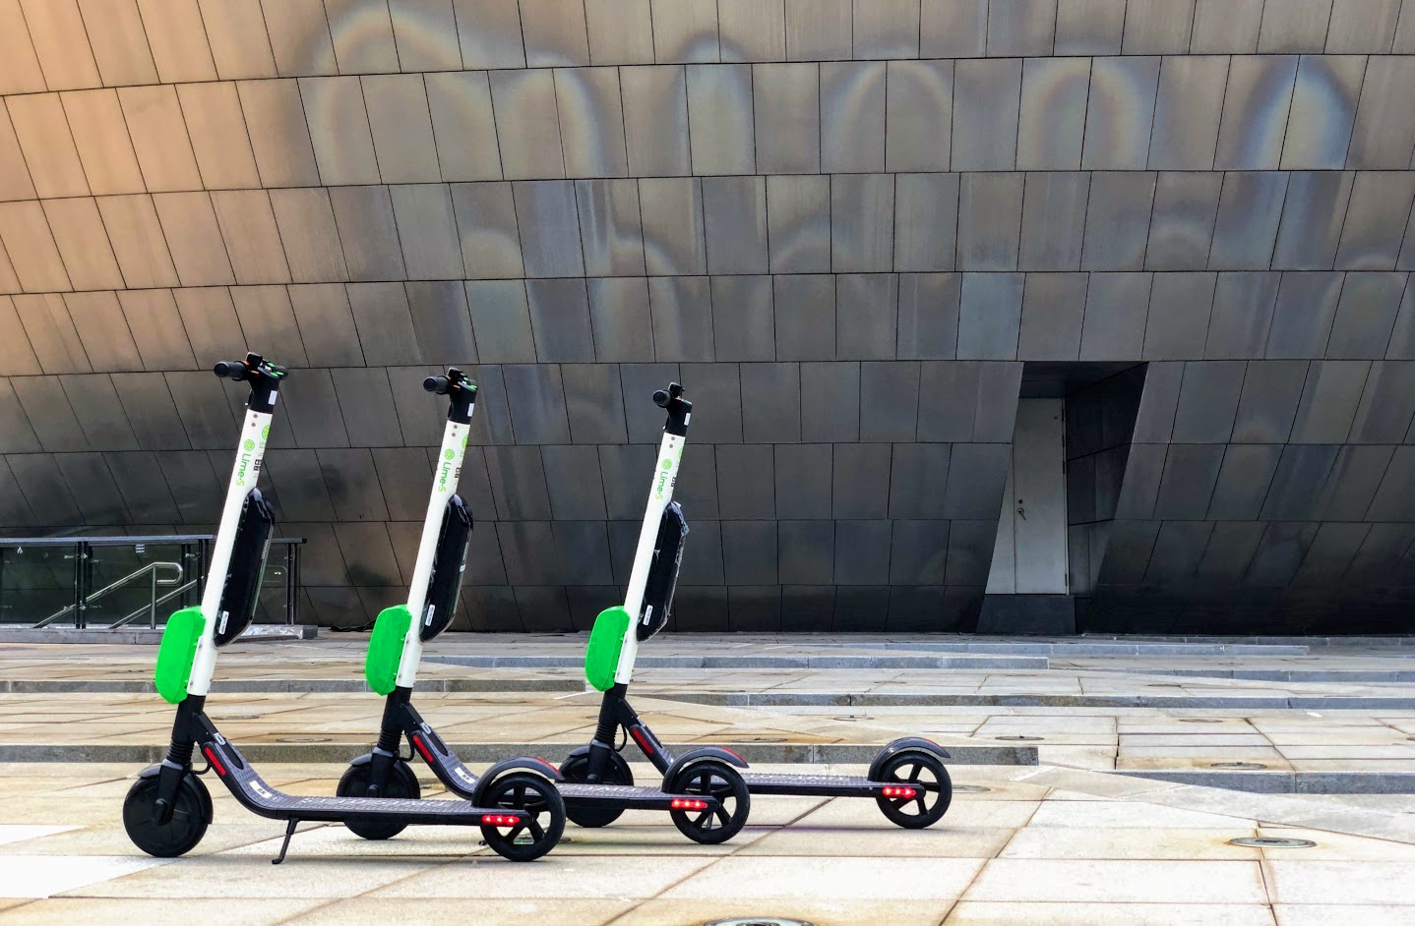

**KEYWORDS:**

* HTML,CSS,JAVASCRIPT,BOOTSTRAP,NODEJS,JQUERY,SQL – Languages & technologies used.
* Dreamweaver.

**EXISTING SYSTEM:**

**MOBYCY:**

* Mobycy is a bicycle sharing technology platform to solve this last mile problem which helps people cover a short distance without any wait at a very nominal cost. Mobycy is a dockless bicycle sharing app. Just pick up a bicycle by scanning QR through the app, ride and park it sensibly anywhere.

**OLA/UBER:**

* The existing ride sharing platforms cause traffic menace in the city. Also they use petrol/diesel for the cars. Since they have a lot of cars in the city operating as cabs, they occupy space and contribute to the traffic.

**PROPOSED SYSTEM:**

**SCOOT:**

* Unlike Mobycy which only has bicycles in it’s platform, we aim to include both bicycles and electric scooter to make our venture an impeccable mobility solution.
* Serving cities is at the core of Scoot’s mission. From electric scooters to smart bikes, our smart mobility solutions reduce traffic congestion, promote healthy living, and solve the all-important challenge of the first and last mile. And that’s just the beginning.
* With our comprehensive GPS data, cities have a powerful resource to help plan for and maintain safer roads and bikeways. We can also serve all areas of the community, including those traditionally underserved by public transportation or traditional bike shares.
* Unlike traditional dock-based systems, Scoot requires no public funding or subsidies, meaning we’re able to deliver a world-class smart mobility service at absolutely no cost to cities.
* The majority of existing Bicycle sharing networks have fixed docking stations - permanently installed Bicycle racks spread out over a city. These cost cities millions of rupees to maintain and operate, so stations are few and far between. We believe there’s a better way-by partnering with local governments and stakeholders, Scoot eliminates docking stations, creating a broadly distributed system, with bicycles & electric scooters that are more accessible and affordable to all.
* In this system, we don’t have the hassle of depending on someone to drive since you are the one who drives the bikes.
* Green Power – On every ride, we aim to donate 1% of the ride fare to ‘Being Green’ NGO.

**MODULES:**

* **Ride:**

Find a scooter nearby. Use our website to find scooters nearby using GPS. Scan any scooter to unlock and start your ride. Park wherever a scooter is allowed. Close the back lock to finalize your trip. And end the trip on the web application.

* **Parking:**

Do not place the scooter on the ground. Do park by the sidewalk pavement. Do park near a bike rack or designated area. Do not block pedestrian or wheelchair path, access, driveways, crosswalks, loading zones. Do not park at bus stops or street corners.

* **Safety:**

Riding a scooter is easy, but when it comes to responsible scooter share behavior a little refresher never hurts. Check out videos on proper parking and hand signals to help keep your ride smooth and your community clean.

* **GPS:**

With our comprehensive GPS data, cities have a powerful resource to help plan for and maintain safer roads and bikeways. Also it’s useful for our company where to place the scooters depending on more traffic.

* **Etiquette for riding the scoot:**

The rider must be 18+ to ride. Driver’s license required to ride. Traffic laws to be followed. The rider shouldn’t attempt stunt riding. The rider must be mindful of road obstructions such as potholes.

* **Juicer:**

Any person can collect the low battery drained scooters to their homes using their own vehicles. The scooters can be charged with any standard electric outlet at home. We will intimate the person where to deploy the fully charged scooters.

**CONCLUSION:**

**Quick Short commute | Green Tech | No pollution | Less Traffic | Fitness**

* Riding a Scoot will always be beneficial for you as its better than walking in terms of speed. Also, it helps reduce pollution & traffic which are the two biggest menaces of our modern world.
* We’re creating a green cycling revolution in India. On every 100 Scoot rides, we have pledged to plant a tree in the name of our 100th rider. Riding scoot will give this sense of pride that you’re contributing to a better future & a greener India.