**PIPING MODULE**

*Development Environment*

Software Location: \\sg-srv-soft\General

|  |  |  |
| --- | --- | --- |
| Communication | Microsoft Teams |  |
| Communication | Outlook |  |
| Team & Task Management | Excel | * Path   [https://bitbucket.org/senecaglobal/piping.module/src/master/](https://bitbucket.org/senecaglobal/piping.module/src/master/TaskManagement/PipingModuleTasks.xlsx)  [TaskManagement/PipingModuleTasks.xlsx](https://bitbucket.org/senecaglobal/piping.module/src/master/TaskManagement/PipingModuleTasks.xlsx) |
| Code Repository | Bit Bucket | * Install   \\sg-srv-soft\General\syndigo\Git-2.21.0-64-bit.exe   * Repository   <https://bitbucket.org/senecaglobal/piping.module/src/master/> |
| VPN | FortiClient | * Install   <https://www.forticlient.com/downloads> |
| Web API IDE | Visual Studio 2019 |  |
| Web APP IDE | Visual Code | * Install   \\sg-srv-soft\General\syndigo\VSCodeSetup-x64-1.22.2.exe |
| DB IDE | Pg Admin | * Install   \\sg-srv-soft\Opensource\Database\postgresql\postgresql-9.6.0-rc1-windows-x64 |
| Web Server | IIS Express |  |
| Web Browser | Chrome |  |
| API framework | .Net Core 3.0 | * Install   <https://dotnet.microsoft.com/download/visual-studio-sdks?utm_source=getdotnetsdk&utm_medium=referral> |
| Angular | Node JS | * Install   \\sg-srv-soft\General\syndigo\node-v12.3.1-x64.msi |

* Git Clone the PipingModule code

<https://bitbucket.org/senecaglobal/piping.module/src/master/>

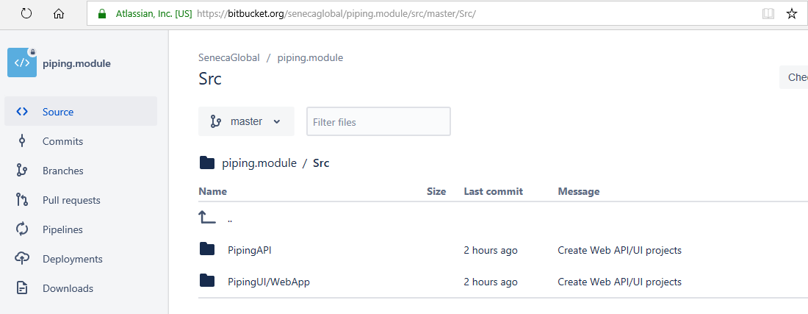

**Applications:**

* Database (Postgresql)
* ORM (EF Core 3,0 – Code First)
* Web API (.Net Core 3.0)
* Client APP (Angular 8)

**Piping DB**

* Open Visual Studio 2019
* Open Solution - “..\piping.module\Src\PipingAPI\PipingWeb.sln
* Migrate initial DB script
* From VS2019 menu, select Tools » NuGet Package Manager » Package Manager Console.
* Set Default project to “Piping.Repository” from dropdown.
* Type command “update-database” and press enter.

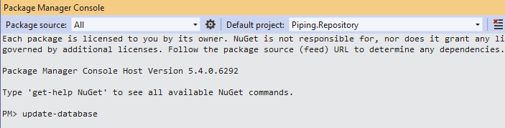

* Piping_Local DB created.

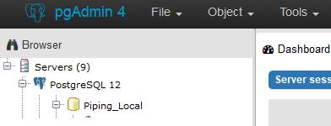

**Piping Web API**

* Open Visual Studio 2019
* Open Solution - “..\piping.module\Src\PipingAPI\PipingWeb.sln

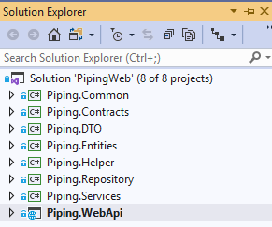

* Run Web API
* Install .net core 3.0 sdk, if get error
* Web API (Swagger) is running.

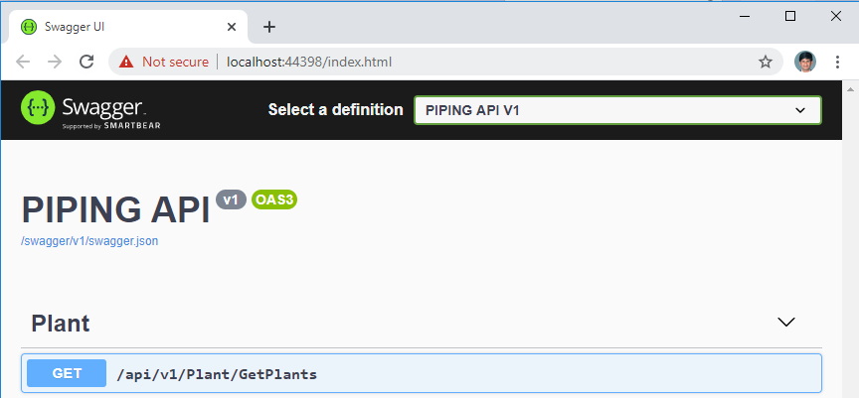

**Piping Web APP**

* Open Visual Code
* Open folder “..\piping.module\Src\PipingUI\WebApp”.
* Goto **View** » **Integrated terminal** and run command **npm i**
* After install, Run application **ng serve -o**