Practical Week 11
Aim
To develop a multithreaded counter application using POSIX threads (pthread_create() and pthread_join()) and demonstrate a race condition when multiple threads update a shared variable concurrently.
Program:
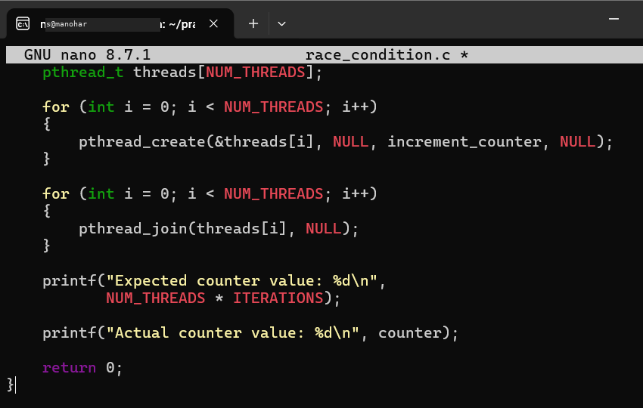
Output:

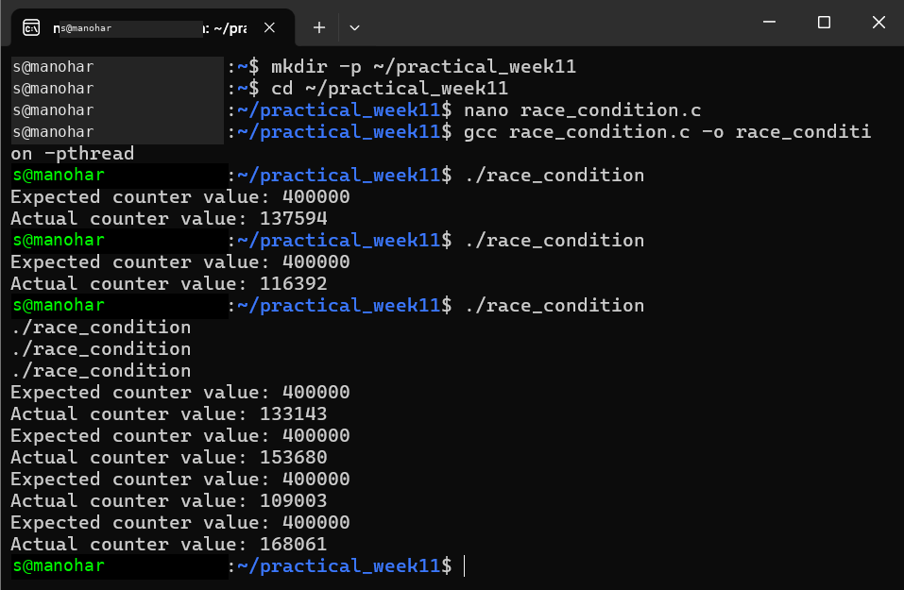

Observation
Multiple POSIX threads were created using pthread_create(). The threads simultaneously modified the shared counter variable. Because no synchronization mechanism was used, a race condition could occur and the final counter value may differ from the expected value.
Result
A multithreaded counter application was successfully implemented using POSIX threads, and the race condition caused by concurrent access to a shared variable was demonstrated.

Aim
To synchronize access to a shared variable using a POSIX mutex and eliminate the race condition.
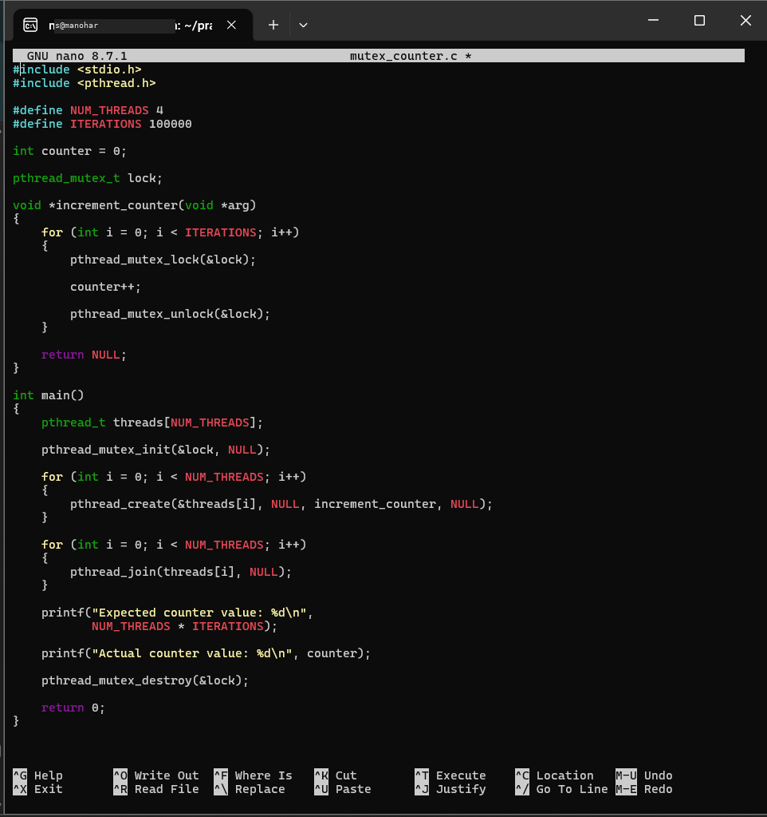
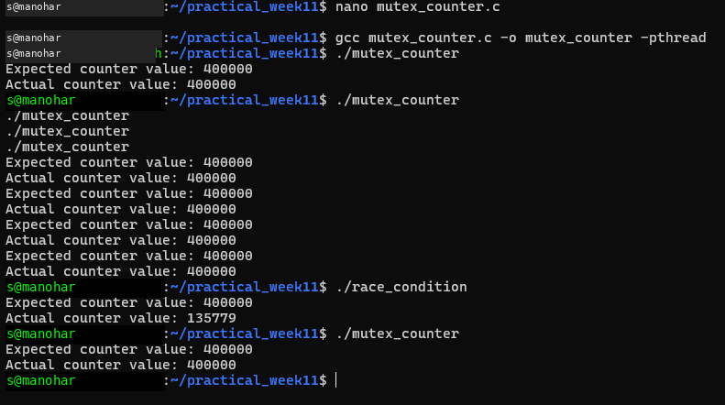
Observation
Without synchronization, multiple threads can access the shared counter simultaneously, causing a race condition. With the mutex, access to the shared counter is protected, and the final value consistently reaches the expected value.
Result
The race condition was successfully eliminated using POSIX mutex synchronization, and the synchronized program produced the expected counter value.

