Practical Week 10
Aim
To investigate Linux inode structures using ls -i, stat, and find, and understand the difference between hard links and symbolic links.
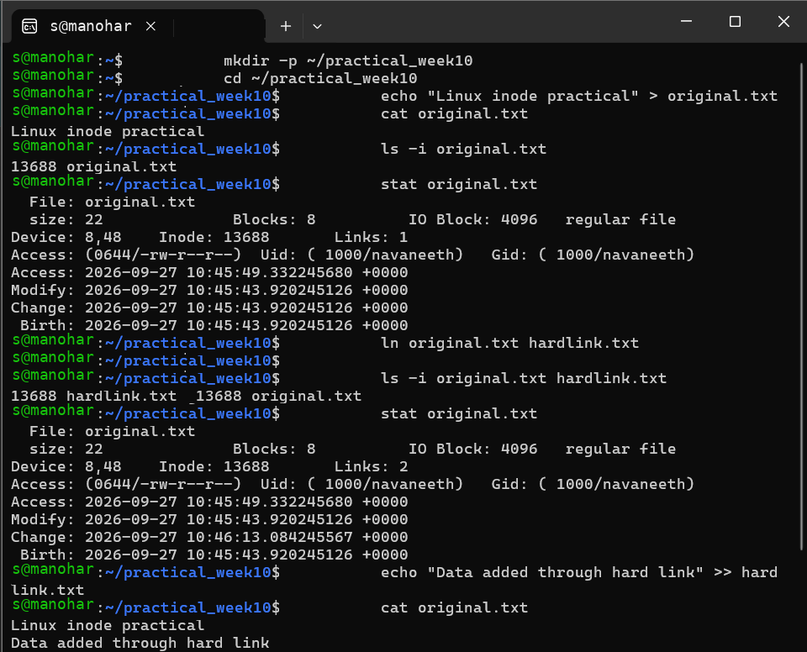
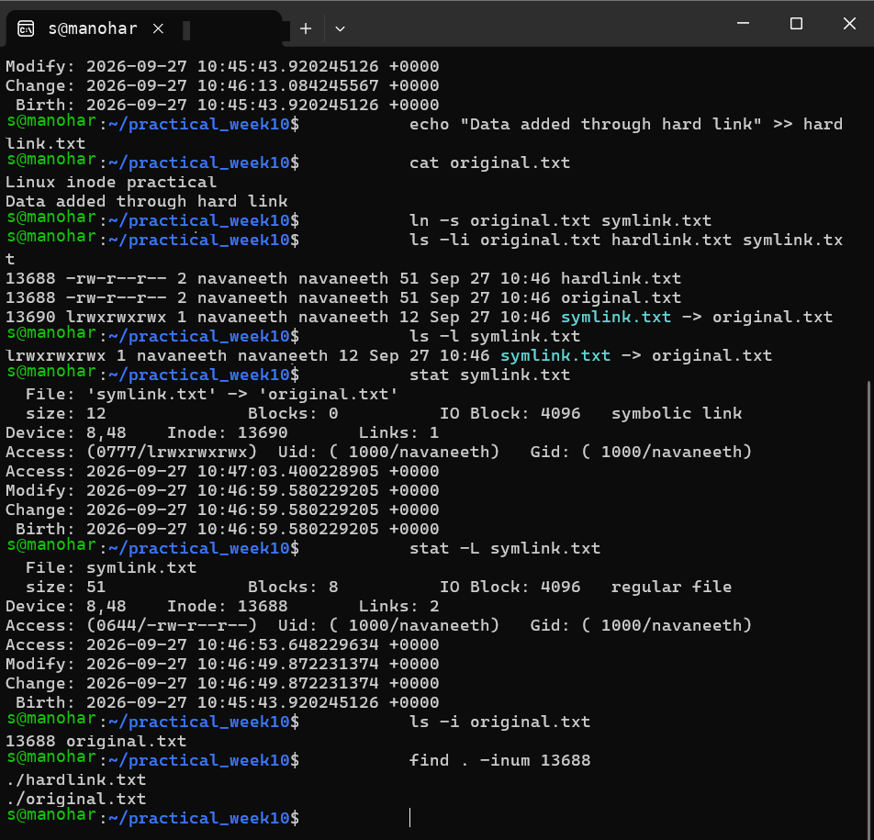
Observation
- original.txt and hardlink.txt have the same inode number.
- The hard link increases the link count.
- symlink.txt has a different inode and points to original.txt.
- find -inum can locate directory entries associated with an inode.

Result
Linux inode information was successfully examined, and hard links and symbolic links were created and verified using Linux commands.

Aim
To use the Linux mmap() system call for reading and writing a file and understand its difference from traditional read() and write() operations.

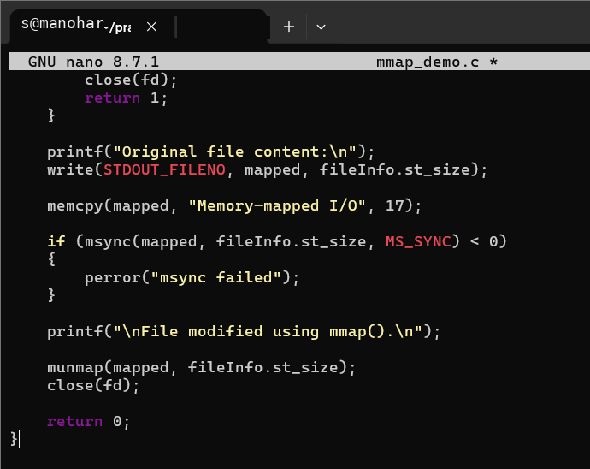

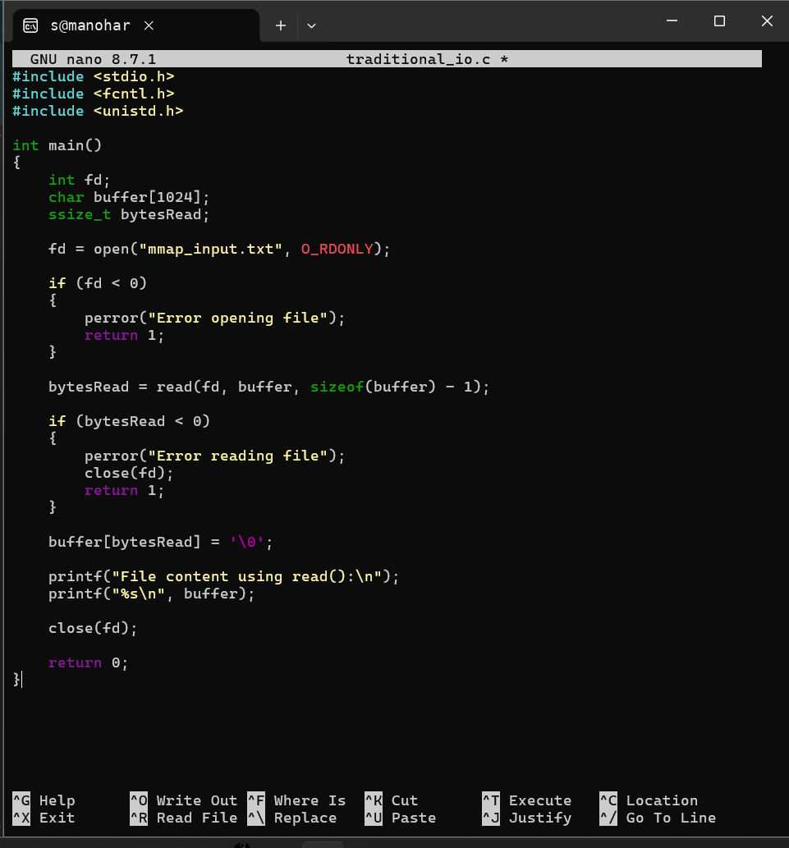

Observation
The file was successfully mapped into memory using mmap(). The program accessed and modified the mapped memory, and the changes were synchronized back to the file using msync(). A traditional read() program was also implemented for comparison.
Result
File reading and writing using mmap() was successfully implemented and compared with traditional read()/write() file I/O.

