Practical Week 12
Aim
To implement the Producer–Consumer problem using POSIX threads and counting semaphores, and understand synchronization and buffer management.
Program:
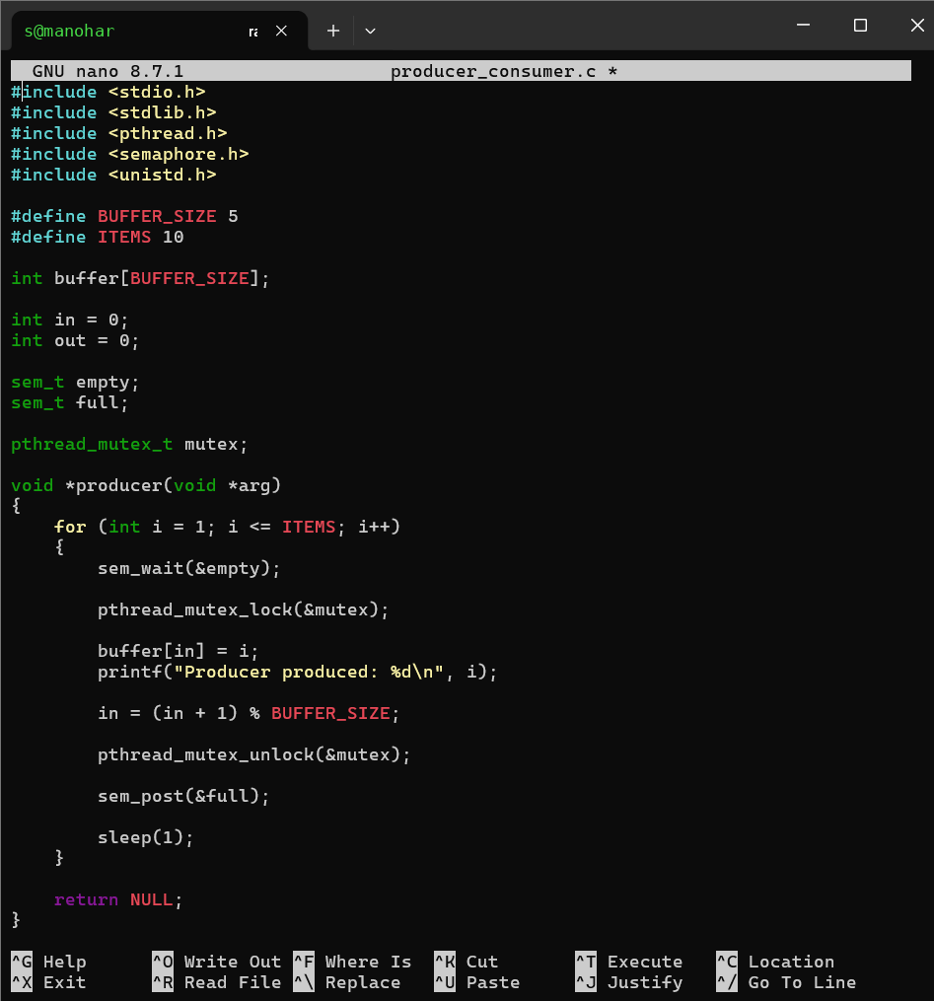

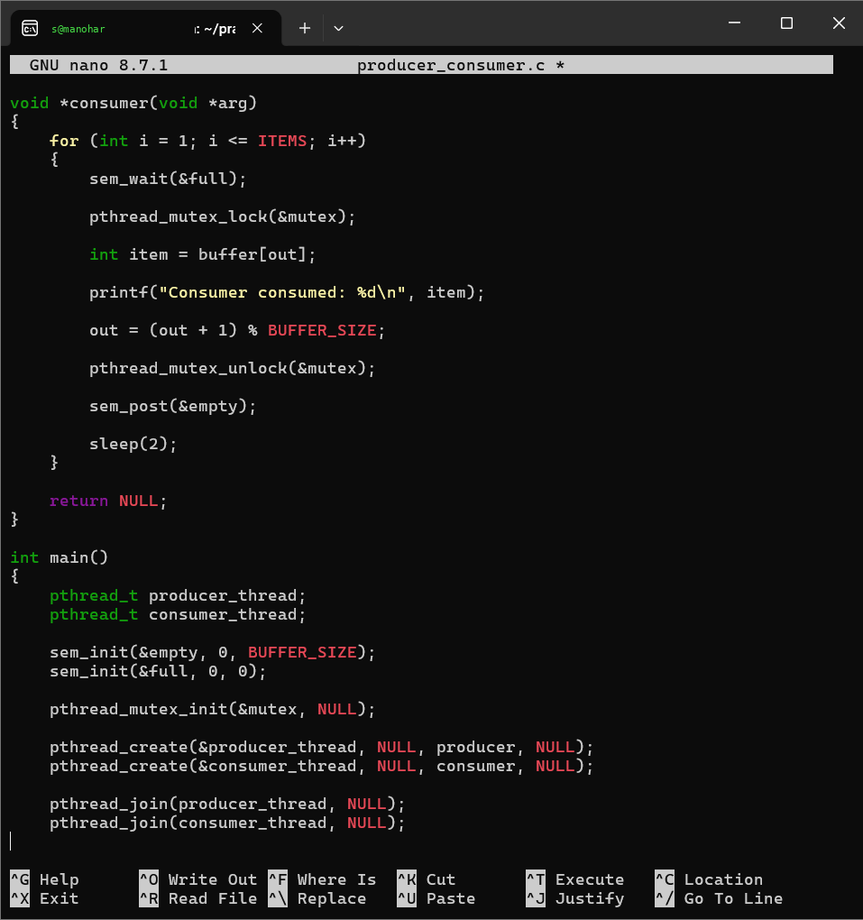

Output:
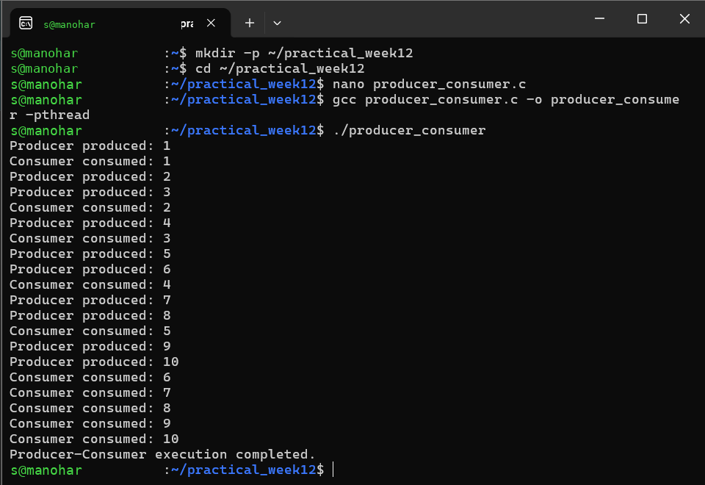
Observation
The producer adds items to the shared buffer while the consumer removes them. Counting semaphores control the number of empty and full buffer positions, while the mutex protects the shared buffer from simultaneous access.
Result
The Producer–Consumer problem was successfully implemented using POSIX threads, counting semaphores, and mutex synchronization.

Aim
To create a deadlock scenario involving multiple threads competing for shared resources, identify the four necessary conditions for deadlock, and prevent deadlock using resource ordering.

Program:
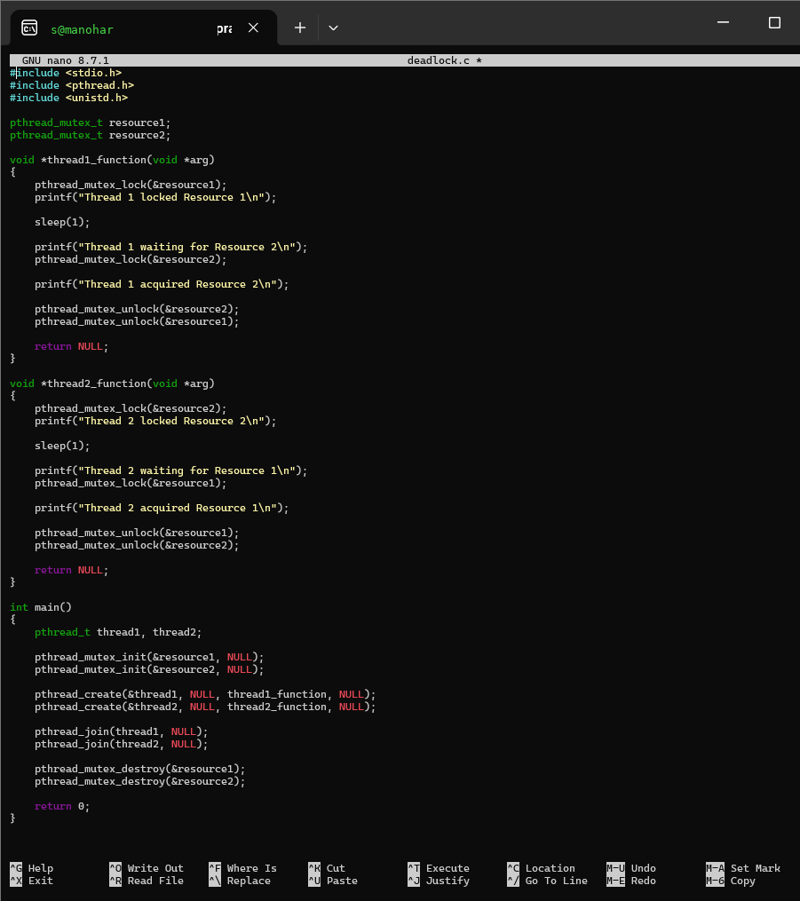

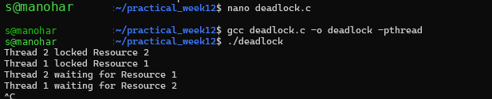

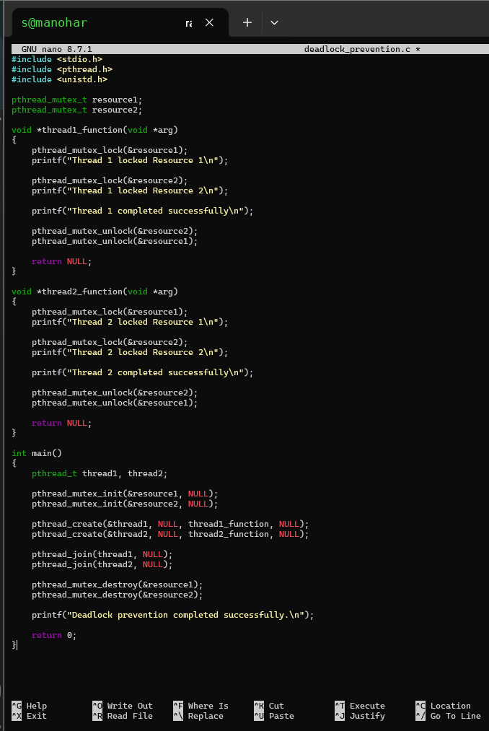

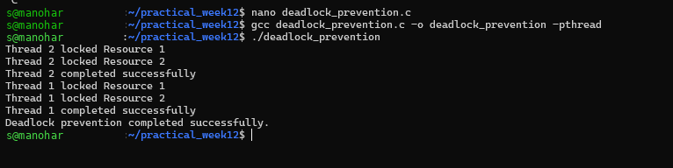

Observation
The first program demonstrated a deadlock because the two threads acquired the resources in opposite orders. The second program acquired resources in the same predefined order, preventing circular waiting and allowing both threads to complete.
Result
A deadlock scenario was successfully demonstrated, the four necessary conditions were identified, and deadlock was prevented using resource ordering.

