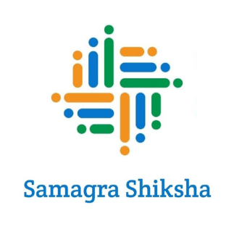 | Memorandum of Collaboration (MoC)  Between  Samagra Shiksha – Kasturba Gandhi Balika Vidyalayas (KGBVs)  Government of Telangana  And  Give For Society (NGO) | 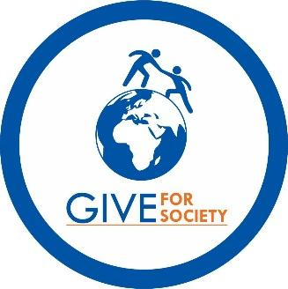

1. Preamble
This Memorandum of Collaboration (MoC) is entered into on this ___ day of __________ 2025, by and between:
- Samagra Shiksha – Kasturba Gandhi Balika Vidyalayas (KGBV), Government of Telangana, represented by its Director (hereinafter referred to as “Samagra Shiksha – KGBVs”);
- and Give For Society (NGO), a registered non-profit organization working for rural education and dignity-centered school health initiatives.
Collectively referred to as the “Parties”, this MoC expresses mutual understanding and collaboration to implement the Sthree Swabhiman – Menstrual Hygiene and Dignity Initiative across all KGBVs in Telangana.

2. Purpose and Program Scope
The Sthree Swabhiman initiative seeks to embed menstrual hygiene awareness, education, and starter support into the academic environment of KGBVs. The objective is to empower adolescent girls through structured Menstrual Hygiene Management (MHM) sessions, product access, and school-led sustainability frameworks.
This MoC establishes a state-wide partnership for program rollout across all 245 KGBV institutions covering ~99,423 girls (Grades VI–X).

3. Roles and Responsibilities

3.1. Give For Society (GIVE NGO) Shall:
- Design and deliver annual MHM awareness sessions in each KGBV
- Provide starter sanitary napkin kits (12 packs per girl/year) to all newly enrolled girls
- Conduct Training of Trainers (ToT) sessions for school staff and peer mentors
- Supply Telugu-language IEC materials for reuse and continued awareness cycles
- Carry out monitoring and reporting, submitting periodic activity briefs to district/state officers
- Independently mobilize CSR or philanthropic funding for full program delivery

3.2. Samagra Shiksha Shall:
- Samagra Shiksha – KGBVs shall facilitate school-level coordination, schedule approval, and basic administrative support.
- Extend institutional support to reinforce peer learning and behavioral outcomes

4. Monitoring and Feedback
The program will be incorporated:
- A feedback loop from students, wardens, and staff
- Optional surveys on knowledge retention, absenteeism reduction, and hygiene behavior
- Periodic implementation reports shared with the Samagra Shiksha leadership team

5. Duration and Termination
This MoC shall remain valid for three (3) years from the date of signing and may be renewed upon mutual agreement.
Either Party may withdraw from the collaboration by giving 30 days' written notice.

6. Alignment with National and State Goals
This initiative directly contributes to:
- Samagra Shiksha’s focus on gender equity and school health
- National Education Policy (NEP 2020) emphasis on health and hygiene
- UN Sustainable Development Goals, especially:
  - SDG 3 – Good Health and Well-being
  - SDG 4 – Quality Education
  - SDG 5 – Gender Equality
  - SDG 6 – Sanitation
  - SDG 10 – Reduced Inequalities

7. Signatures

For – Kasturba Gandhi Balika Vidyalayas | For Give For Society (NGO)
Name: ___________________________ | Name: ___________________________
Designation: Director, Samagra Shiksha | Designation: _____________________
Signature: _______________________ | Signature: _______________________
Date: ___________________________ | Date: ___________________________

